Angular + Spring Boot + MySQL CRUD Application

GitHub link: click here

Title:
User Management POC – Full Stack Connectivity

Scope Covered
Demonstrate how:
- Data is entered from Angular UI
- Sent to Spring Boot REST APIs
- Stored in MySQL database
- Fetched back and displayed on UI

Architecture Flow:
Angular UI (Form)
↓
Angular Component
↓
Angular Service (HttpClient)
↓
Spring Boot Controller (REST API)
↓
Service Layer
↓
Repository (JPA)
↓
MySQL Database
↑
Response (JSON)
↑
Angular Service
↑
Angular Component
↑
UI Updated

Code Implementation:
- User Model (User.ts)
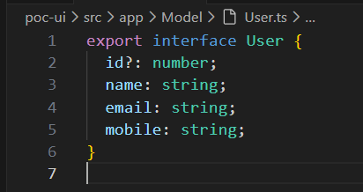
Purpose:
- Defines data structure
- Used by component & service
- Matches backend entity

- User Service (user.service.ts)
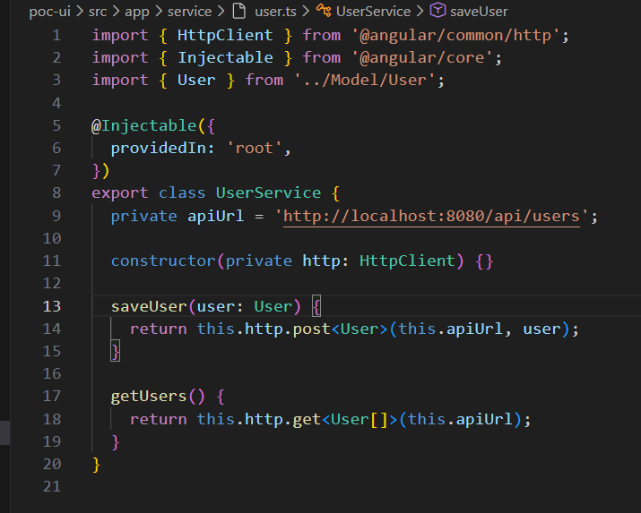
Purpose
- Handles API calls
- Keeps component clean
- Follows separation of concerns

- User Component (user-component.ts)
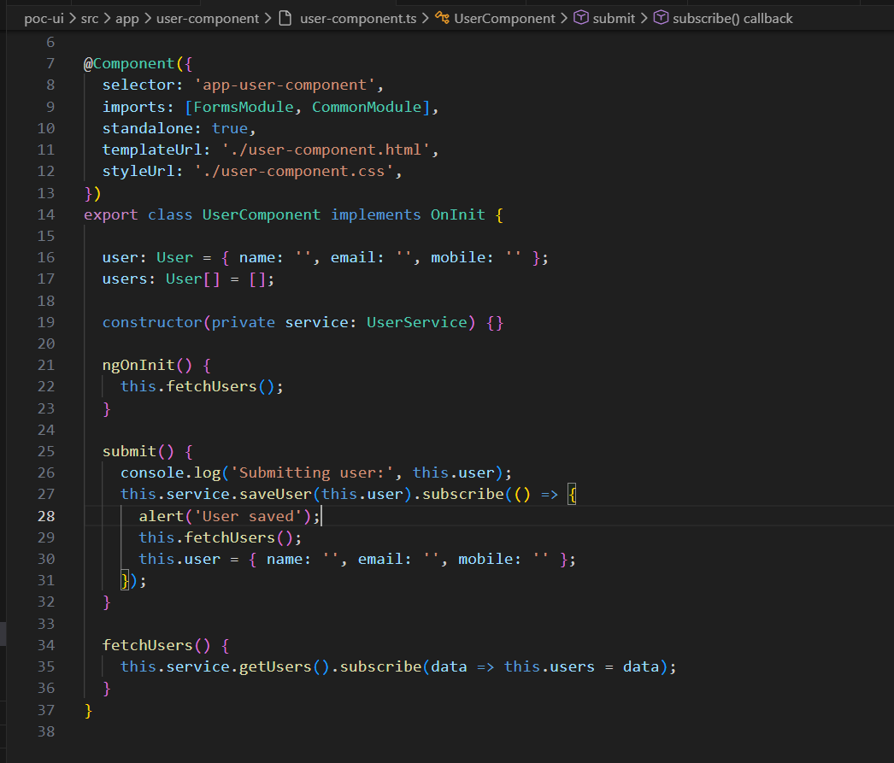
Responsibilities:
- Handles UI logic
- Subscribes to APIs
- Updates UI state

- HTML Template (user-component.html)
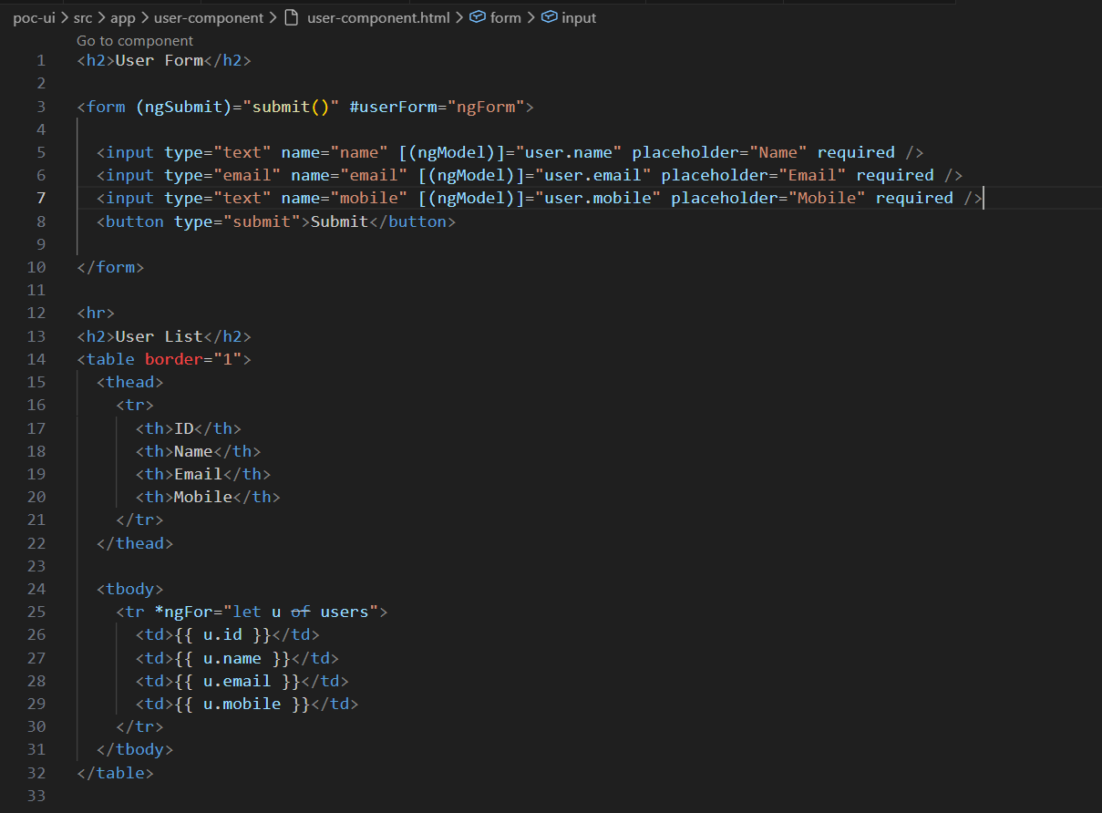
Purpose:
- Collect input
- Display saved data
- Uses ngFor and ngModel

- Backend (Spring Boot) – Code Used
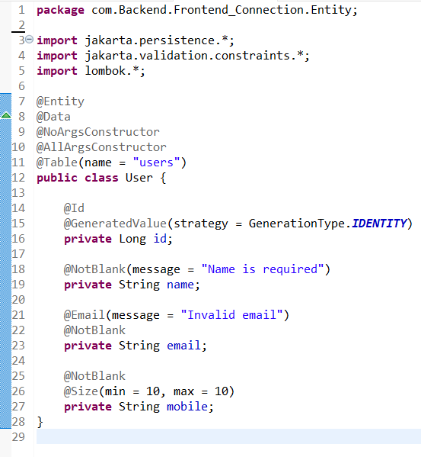
Purpose:
- Maps Java object → DB table
- Validation ensures clean data

- Repository
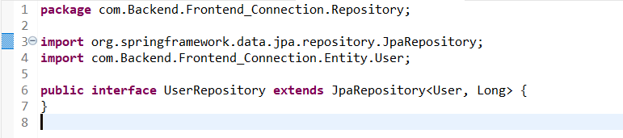
Purpose:
- Handles DB operations
- No SQL needed
- Uses JPA

- Service Layer
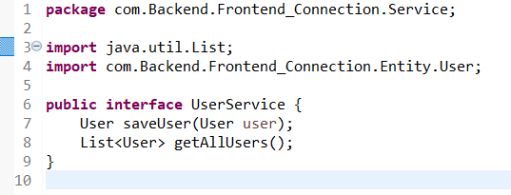
Purpose:
- Business logic
- Acts as middle layer

- Controller
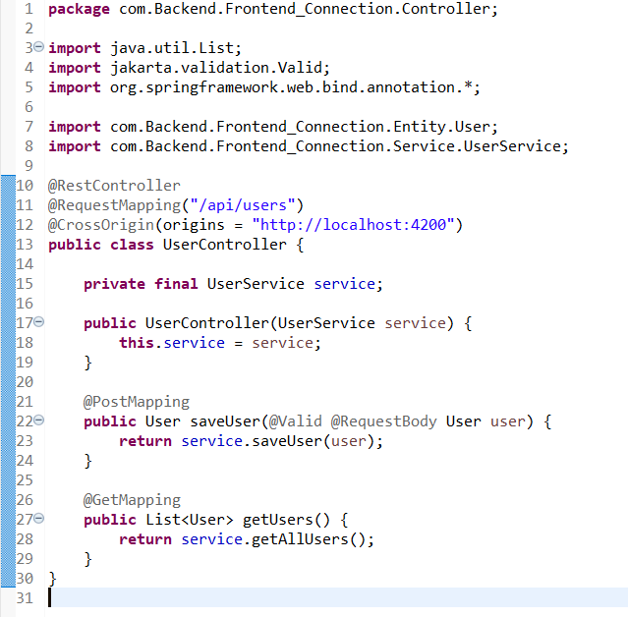
Purpose:
- Exposes REST APIs
- Communicates with frontend

- Database (MySQL)
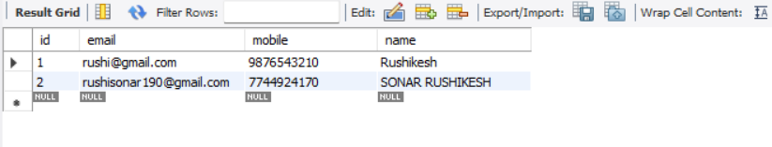
- Output :
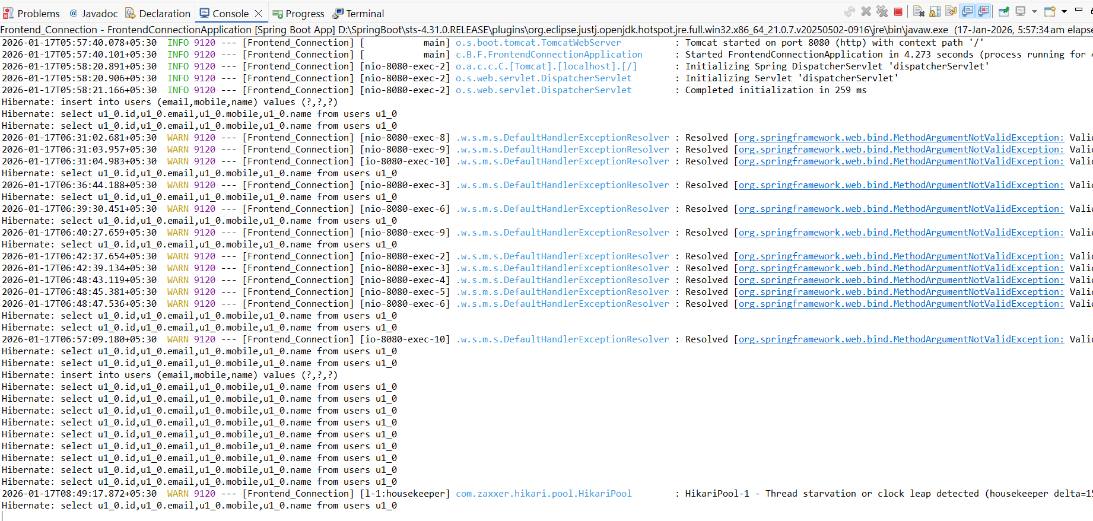

Complete Data Flow (Step-by-Step)
SAVE FLOW
- User enters data in Angular form
- Clicks Submit
- submit() method runs
- Angular service sends POST request
- Spring Boot receives request
- Data validated
- Saved into MySQL
- Response sent back
- Angular refreshes user list
FETCH FLOW
- Component loads (ngOnInit)
- fetchUsers() called
- Angular sends GET request
- Backend fetches data from DB
- Sends JSON response
- UI updates table

