POC: STRT_WJ_025 – StringBuilder & StringBuffer POC

GitHub link: click here
https://github.com/RushikeshGirishSonar/StartAhb_Company/blob/main/StartAhb_Assignments/src/STRT_WJ_025/MutableStringPOC.java

Title:
Mutable String Classes in Java: String, StringBuilder, and StringBuffer

Scope Covered
- Immutability and security of String
- Mutability of StringBuilder and StringBuffer
- Large string modification performance
- Best performance comparison
- Multithreaded environment behavior
- Shared mutable string data handling
- Thread safety comparison

- String => Does not modify existing value; creates new object
- StringBuilder => Modifies same object (non-synchronized)
- StringBuffer => Modifies same object (synchronized)

Methods used in this and the Description:
- Append() – Adds text at the end of the string
- insert() – Inserts text at a specific position
- delete() – Removes characters from a specified range
- length() – Returns number of characters
- toString() – Converts builder/buffer to string

Advantages and Disadvantages
- String
  - Advantages
    - Immutable and secure
    - Thread-safe by default
    - Memory efficient due to String Constant Pool
  - Disadvantages
    - Poor performance in repeated modifications
    - Creates multiple objects in memory

- StringBuilder
  - Advantages
    - Best performance for large string operations
    - Mutable (same object is modified)
    - No synchronization overhead
  - Disadvantages
    - Not thread-safe
    - Unsafe in multithreaded environments

- StringBuffer
  - Advantages
    - Thread-safe (synchronized methods)
    - Safe for shared mutable string data
    - Mutable like StringBuilder
  - Disadvantages
    - Slower than StringBuilder
    - Synchronization overhead

Code Implementation:
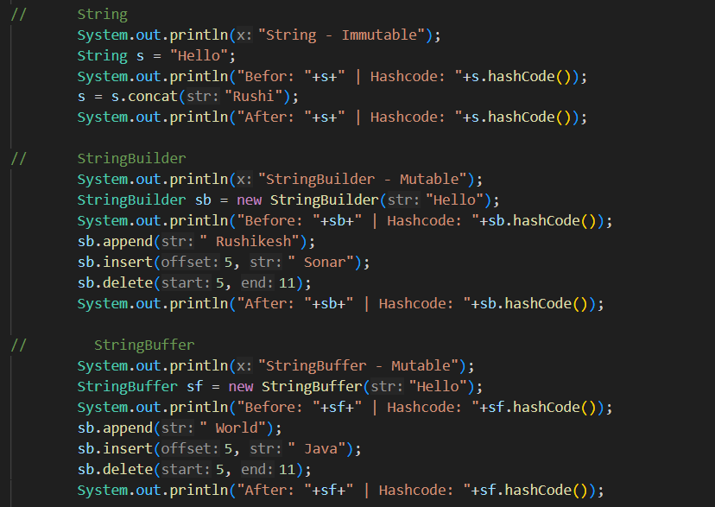

Performance Testing:
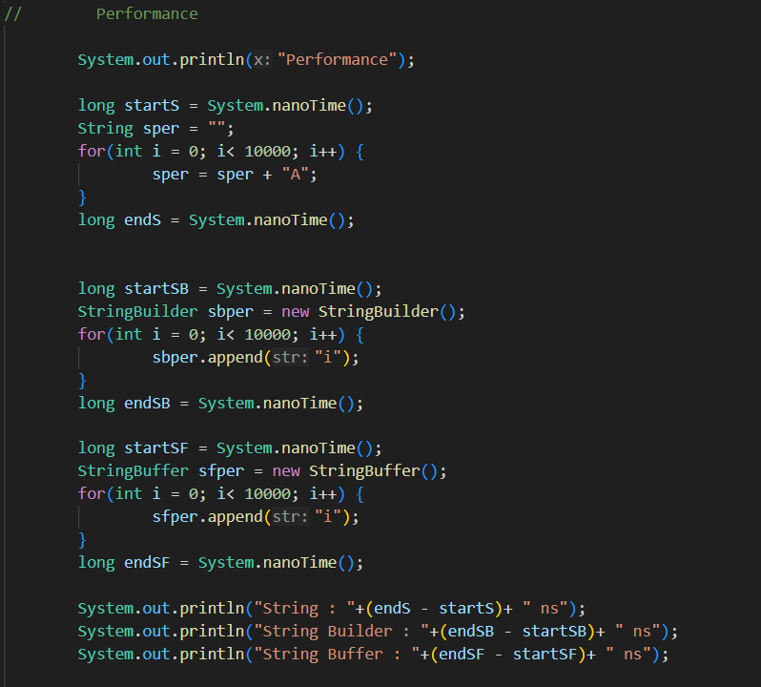

Security :
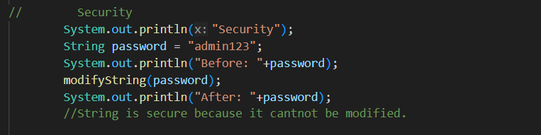

Multithread and thread safety:
Figure 1 - StringBuilder
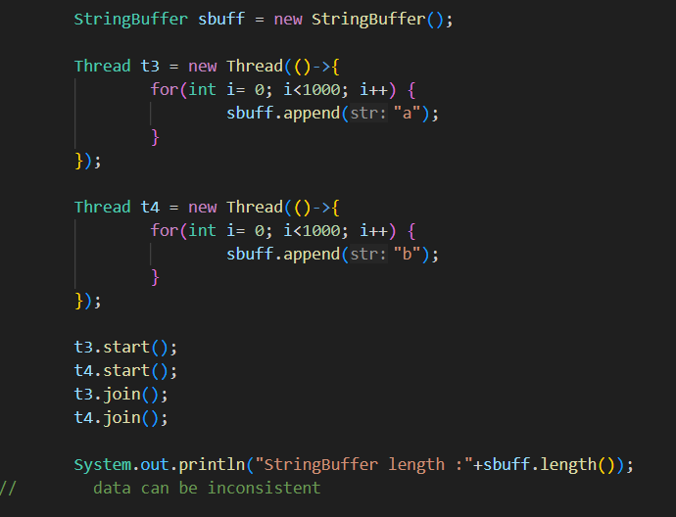

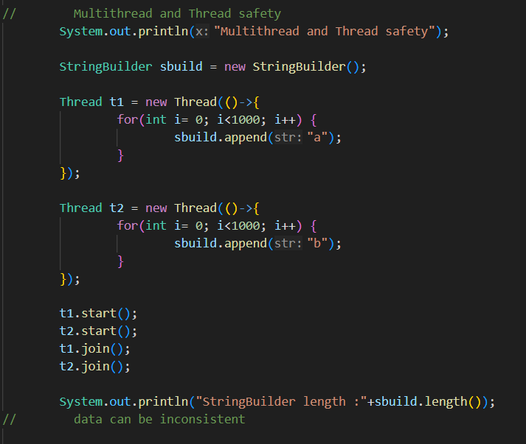
Figure 2 - StringBuffer

