GitHub Link:
github.com/RushikeshGirishSonar/StartAhb_Company

Code screenshot :
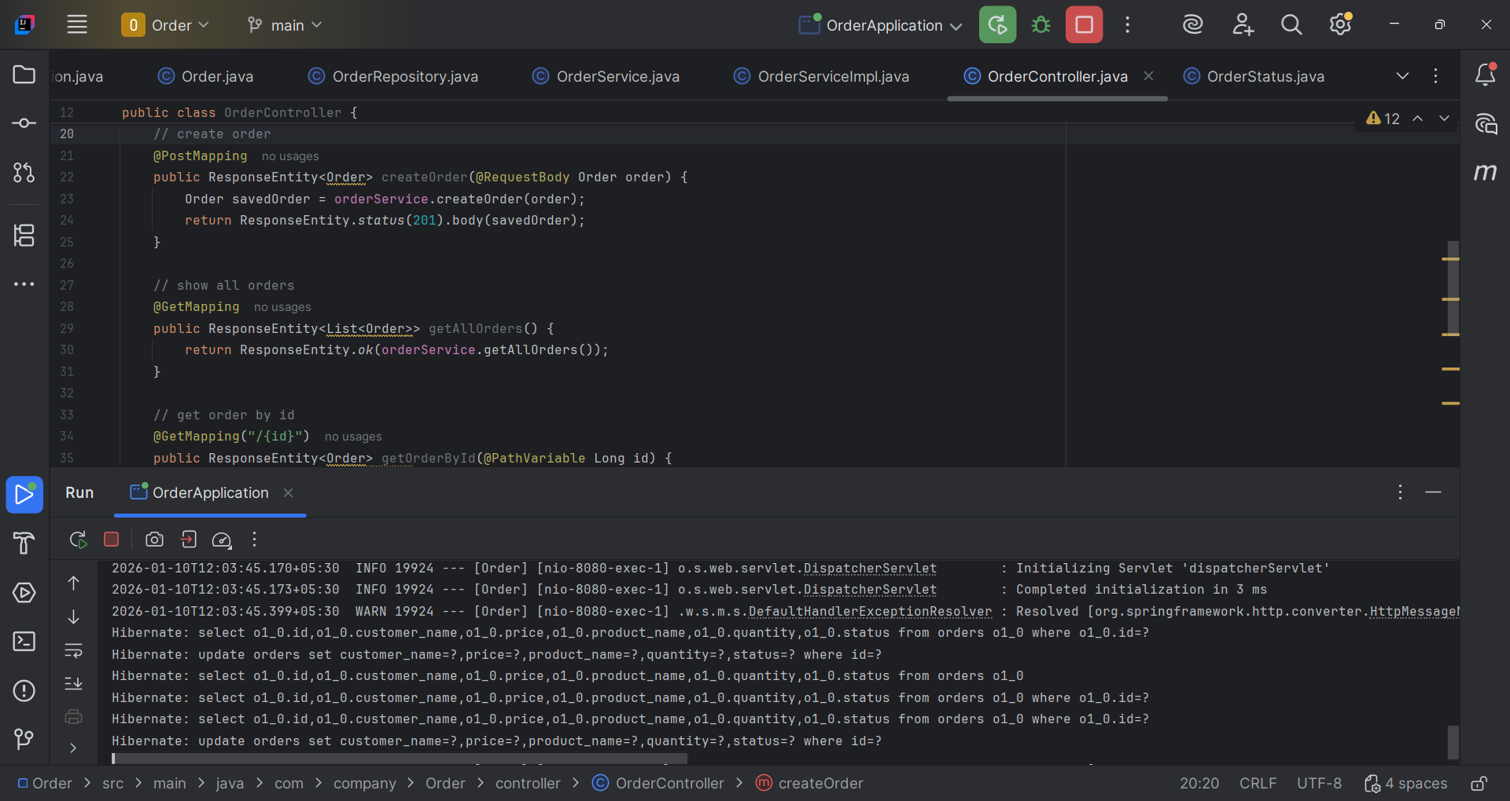

Postman Output :
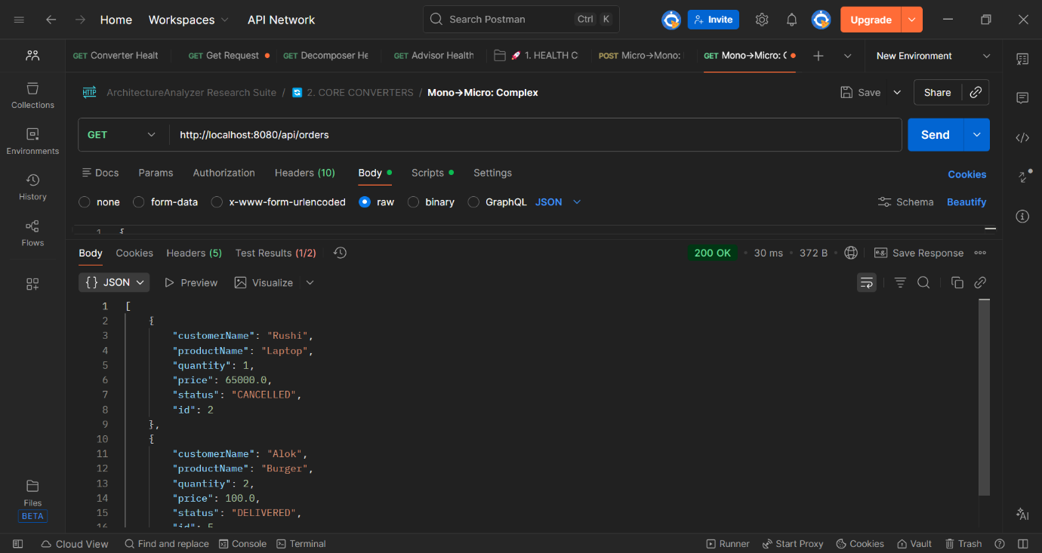
Figure 1 GET http://localhost:8080/api/orders
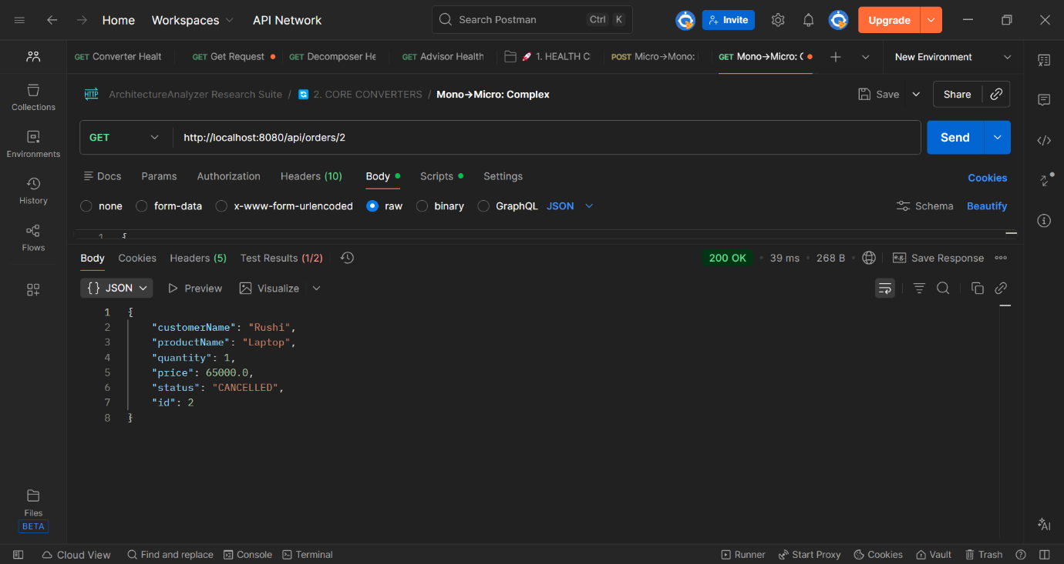
Figure 2 GET http://localhost:8080/api/orders/{id}
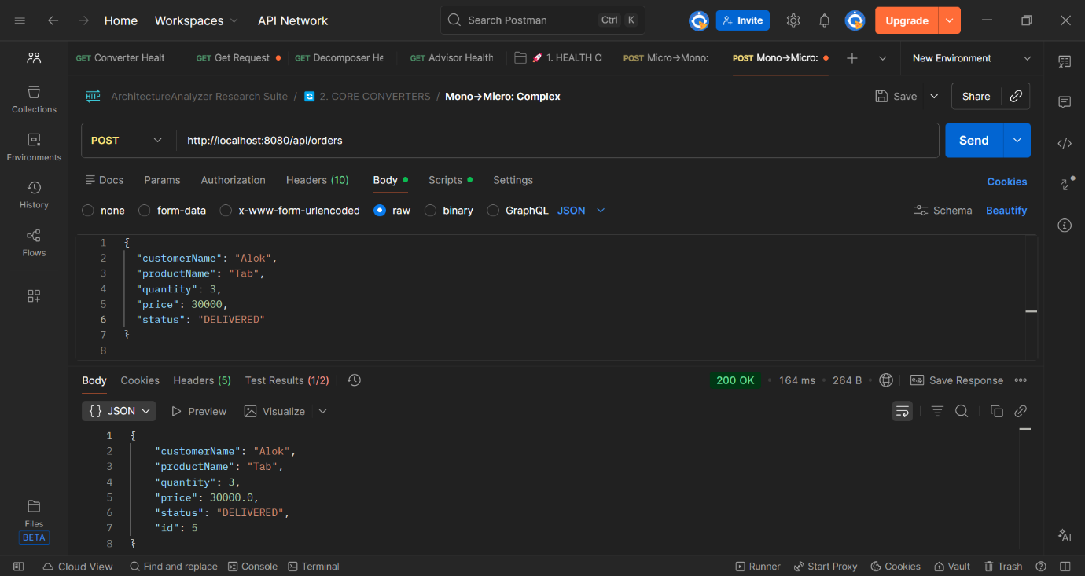
Figure 3 POST http://localhost:8080/api/orders

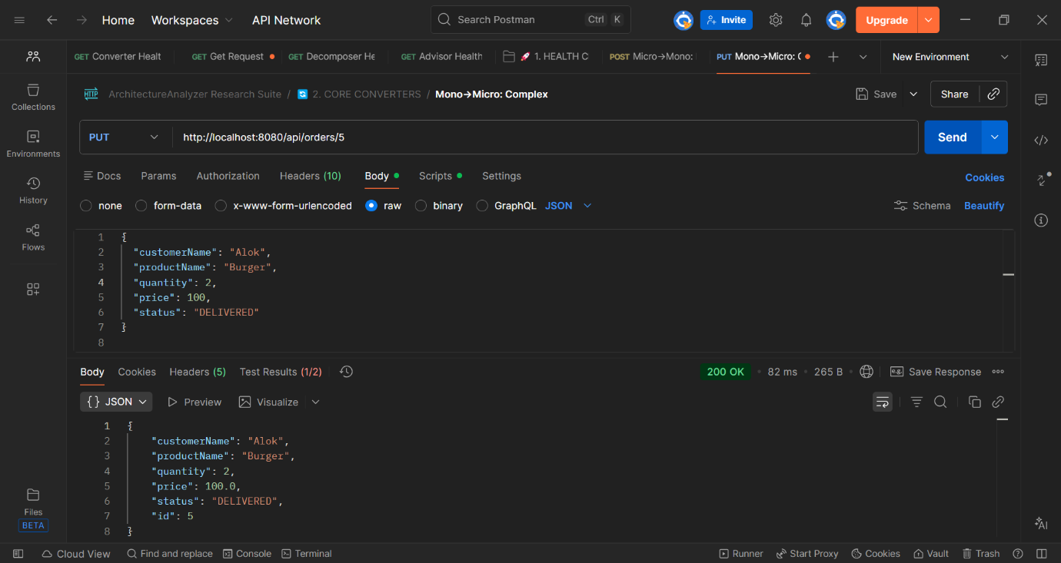
Figure 4 PUT http://localhost:8080/api/orders/{id}
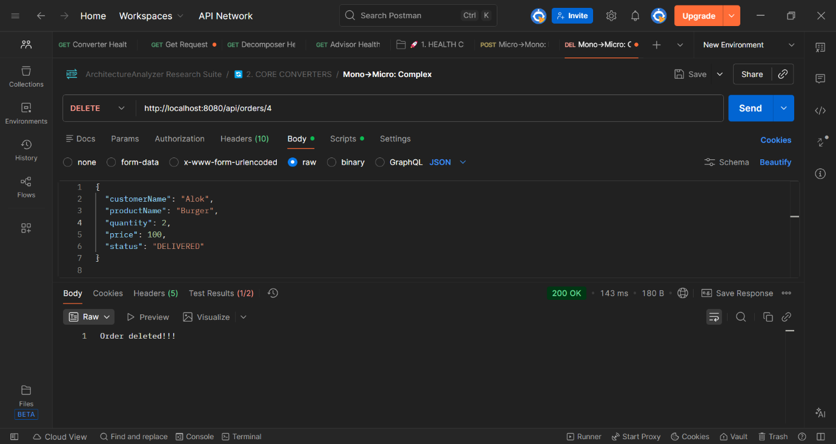
Figure 5 DELETE http://localhost:8080/api/orders/{id}

