POC on Functional Interfaces and Lambda Expressions in Java

GitHub link: click here
https://github.com/RushikeshGirishSonar/StartAhb_Company/blob/main/STRT_WJ_016/Functional_Interface.java
Objective: To demonstrate the usage of Functional Interfaces and Lambda Expresiions in Java

Scope :
- Definition and usage of Functional Interfaces
- Single Abstract Method(SAM) concept
- Creation and implementation of custom functional interface.
- Usage of built-in functional interfaces
  - Predicate
  - Function
  - Consumer
  - Supplier
- Implementation of lambda expression for all functional interfaces.

Concepts Covered:
- Functional Interface and @FunctionalInterface annotation.
- Difference between functional and non-functional interfaces.
- Lambda expressions as an alternative to anonymous classes.
- Built-in functional interfaces provided by java.util.function package
  - Function
  - Consumer
  - Supplier
  - Predicate

- Function Interface:
Used to convert one value into another like converting string into integer.
System.out.println("\n3. Function Interface");

Function<String, Integer> calculateLength = text -> text.length();
System.out.println("Length of 'Rushikesh': " + calculateLength.apply("Rushikesh"));

- Consumer:
Here, Consumer accepts input and performs an action without returning any result.
System.out.println("\n4. Consumer Interface");
Consumer<String> printMessage = message -> System.out.println("Message: " + message);
printMessage.accept("I am using Functional Interfaces");

- Predicate:
Predicate is used to test a condition and return a boolean result.
- Predicate<Integer> isAdult = age -> age >= 18;
System.out.println("Age 20 is adult: " + isAdult.test(20));
System.out.println("Age 15 is adult: " + isAdult.test(15));

- Supplier:
This provides data without taking any input
Supplier<Double> generateRandomNumber = () -> Math.random();
System.out.println("Random Number: " + generateRandomNumber.get());

Code:
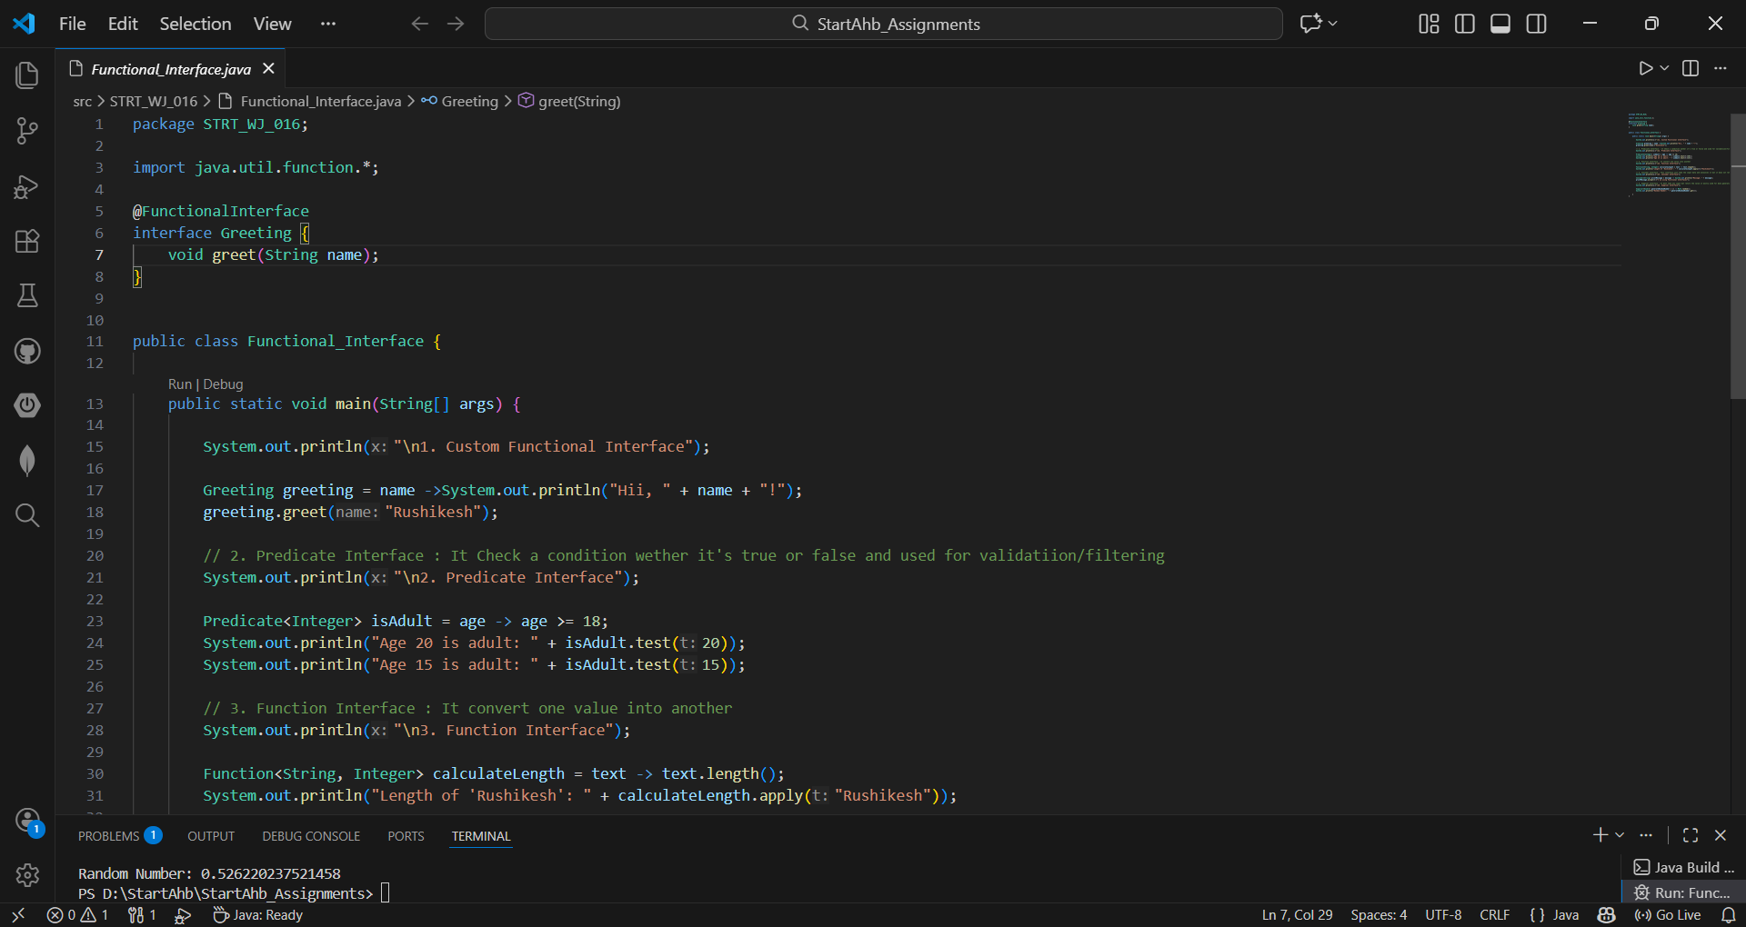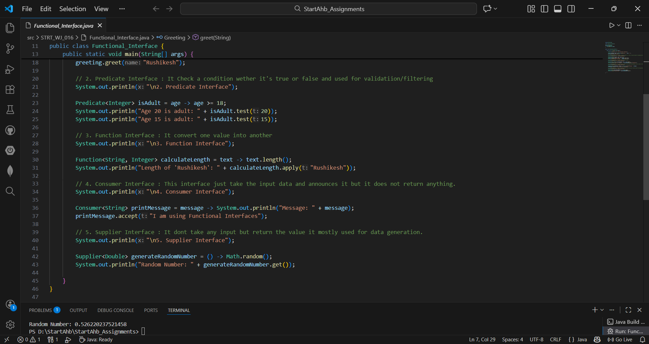

Output:
