POC: Transaction Management, JPA Auditing, and Global Exception Handling in Spring Boot

GitHub link: click here
https://github.com/RushikeshGirishSonar/StartAhb_Company/tree/main/Order
Objective: To demonstrate the implementation of transaction management, JPA auditing, and global exception handling in a Springboot application to ensure data consistency, automatic entity lifecycle tracking, and centralized error handling.

Scope :
- Transaction management using @Transactional
- Automatic auditing using JPA annotations.
- Centralized exception handling using @RestControllerAdvice
- Rollback behavior on failure

Concepts Covered:
- Transaction management and ACID properties
- Usage of @Transactional for atomic operations
- JPA Auditing using:
  - @CreatedDate
  - @LastModifiedDate
- Entity lifecycle tracking using AuditingEntityListener.
- Global exception handling using:
  - @RestControllerAdvice
  - @ExceptionHandler
- Best practices for service and controller layer responsibilities.
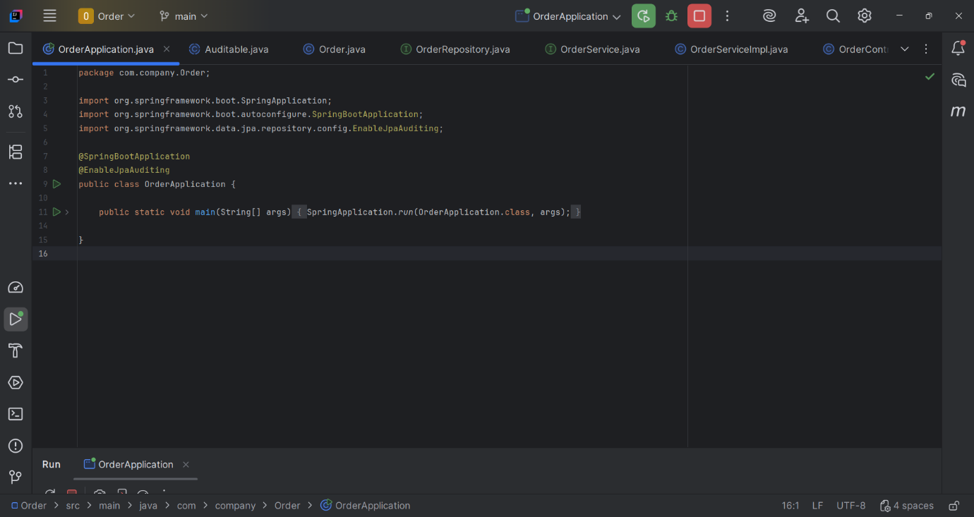
Figure 1 OrderApplication.java
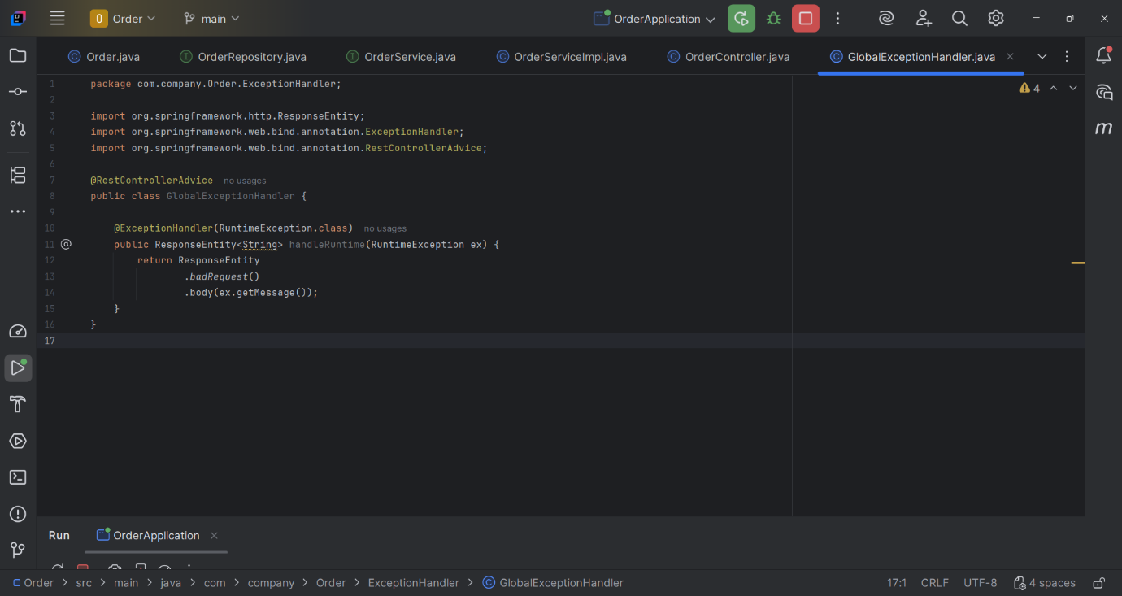
Figure 2 GlobalExceptionHandler.java
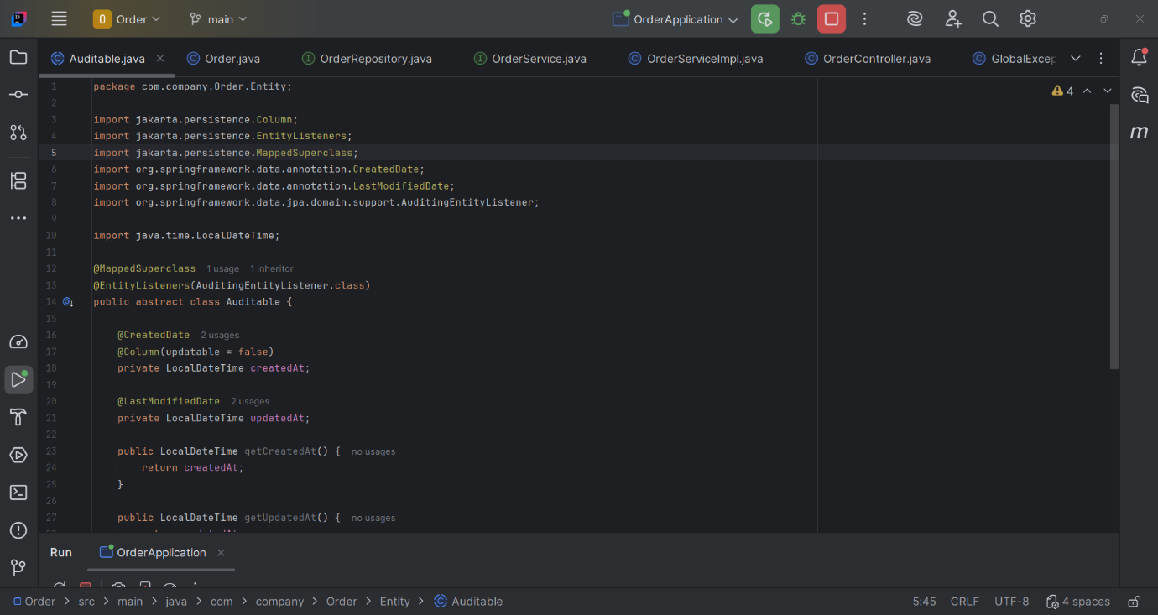
Figure 3 Auditable.java
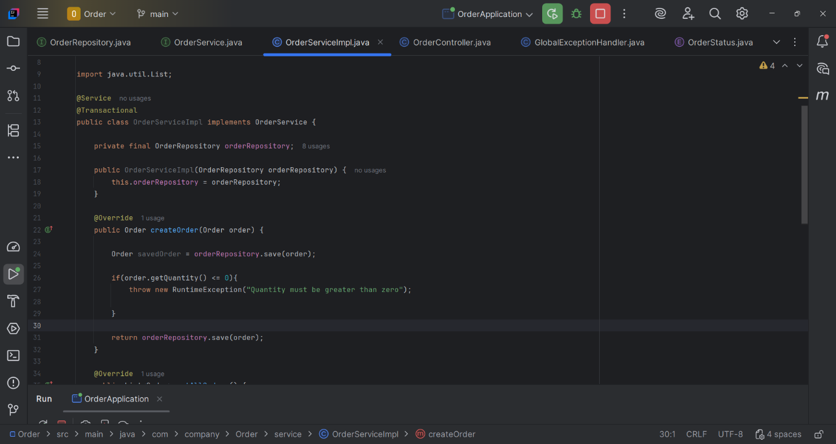
Figure 4 OrderServiceImpl.java
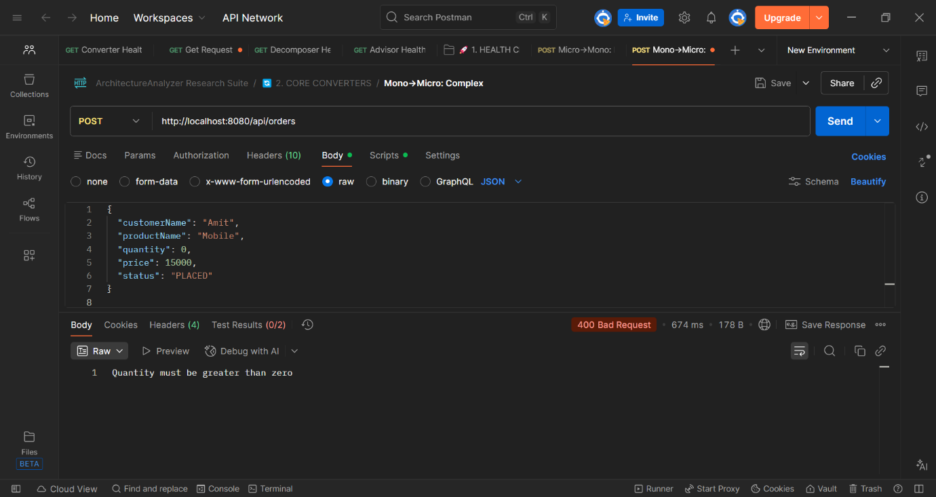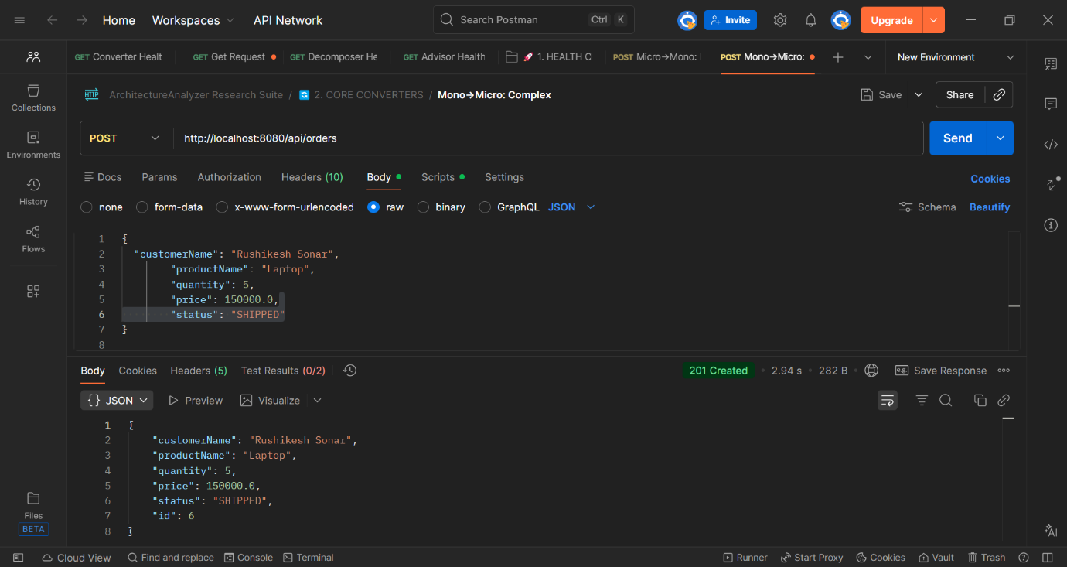
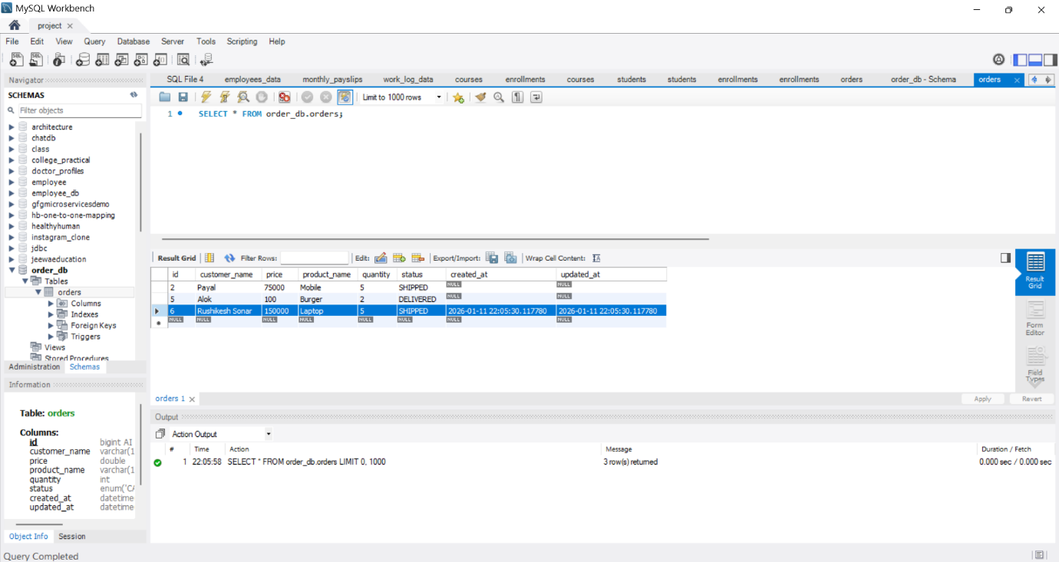
Figure 7 MySQL Workbench/order_db

