STRT_WS-014: Update DAO Layer Used by Servlets
GitHub link: click here
https://github.com/RushikeshGirishSonar/StartAhb_Company/tree/main/Order
Task Discription: Modify DAO classes used by servlets to reflect schema changes.
Update SQL queries, parameters, and result mappings accordingly.

Description :
Modify DAO classes used by servlets to reflect schema changes. Update SQL queries, parameters, and result mappings accordingly.

Acceptance Criteria:
- DAO queries updated
- Schema changes reflected correctly
- No SQL errors
- Data fetched and stored correctly

Concepts Covered:
- Understand how to handle schema changes effectively using JPA entity mapping.
- Learned to write and use custom JPQL queries in the repository layer.
- Gained clarity on the imprtance of service-layer validation before database operations.
- Understood the difference between Entity and DTO responsibilities
- Learned how primitive data types can cause JSON parsing issues during partial updates.

Work Done Today
- Updated the Order entity to match the latest database schema changes by adding and mapping new columns such as deliveryAddress and totalAmount using JPA annotations.
- Modified the DAO layer (JPA Repository) to reflect schema changes and added a custom JPQL query to fetch orders based on total amount conditions.
- Updated the service layer logic to correctly handle new schema fields and ensure data validation before persistence.
- Implemented a dedicated API endpoint to update only the order status without affecting other entity fields, ensuring proper parameter handling.
- Verified that all DAO queries are correctly mapped to entity fields and execute without SQL or mapping errors.
- Tested all updated APIs using Postman to confirm successful data insertion, retrieval, and update operations.
- Resolved build and runtime issues caused by Java version mismatch to ensure stable execution.

Code:
Figure 1 - Added new lombok dependency here and used it in entity and dto file
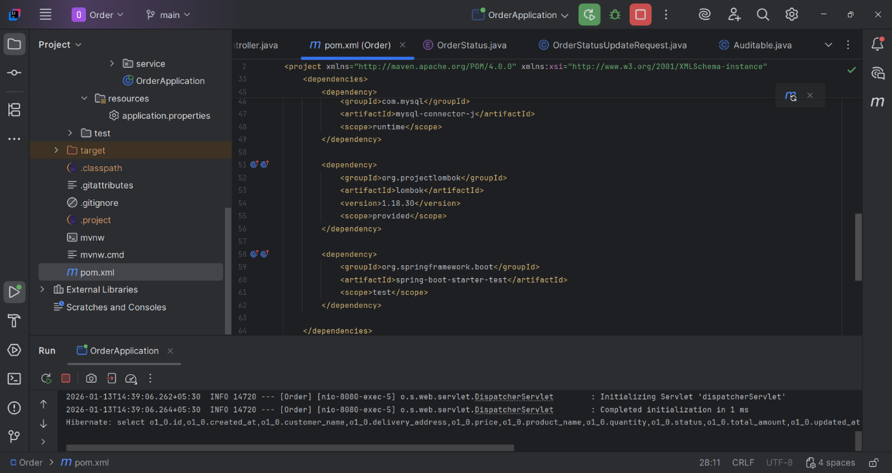
Figure 2 - added two new methods : 1.updateOrderStatus, 2.getOrdersAboveAmount
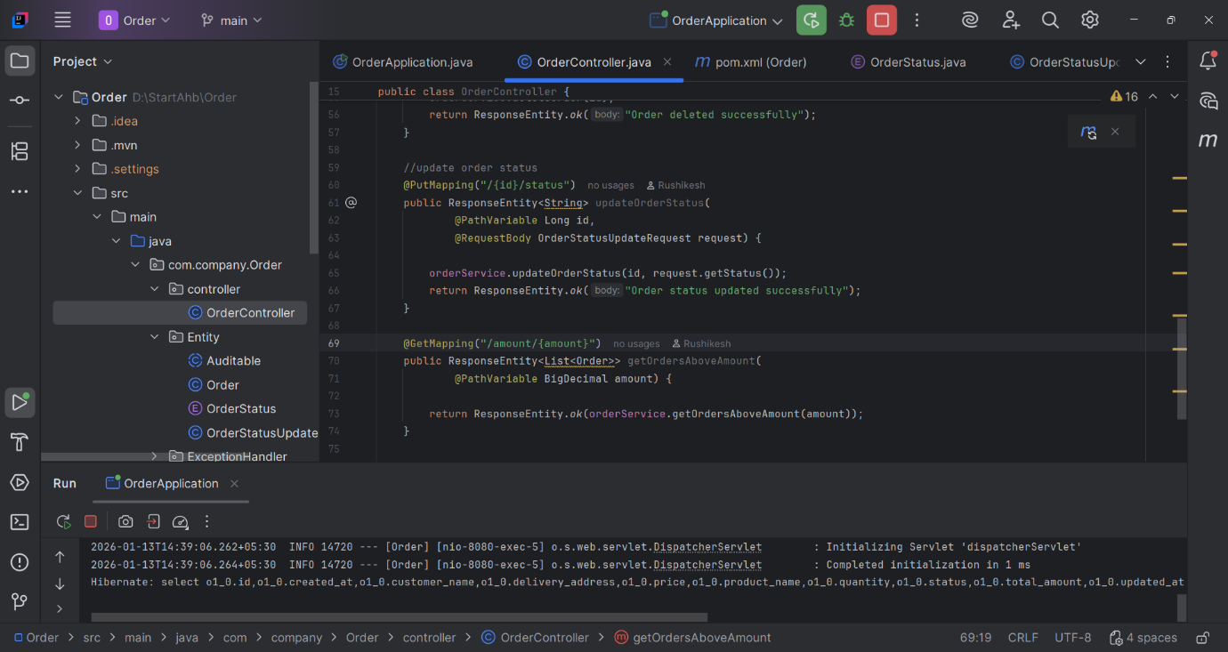

Figure 3 - added new class: OrderStatusUpdateRequest.java
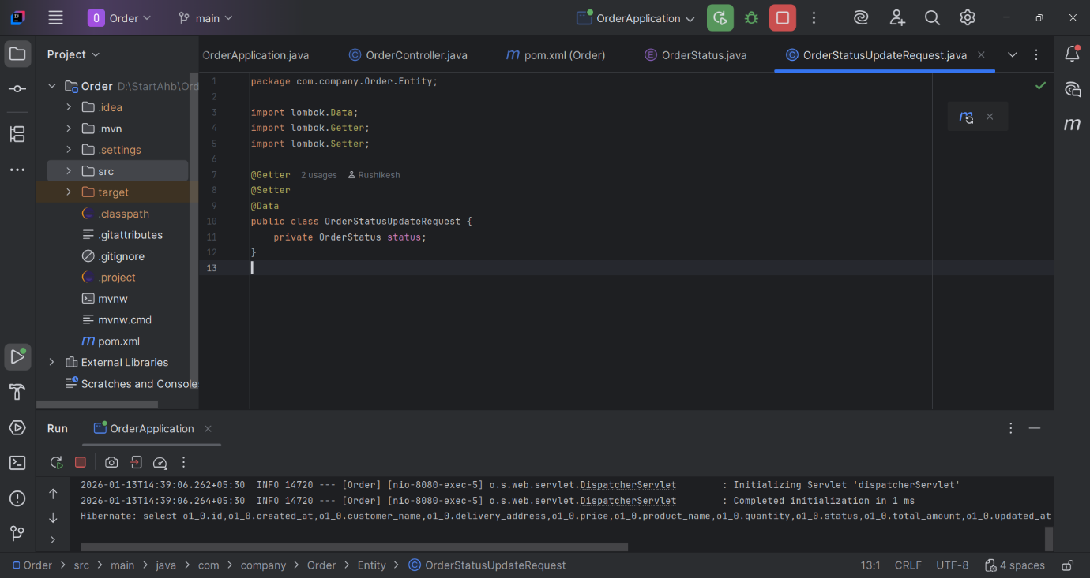
Figure 4 - added new custom query for finding order which is greater than a perticular amount
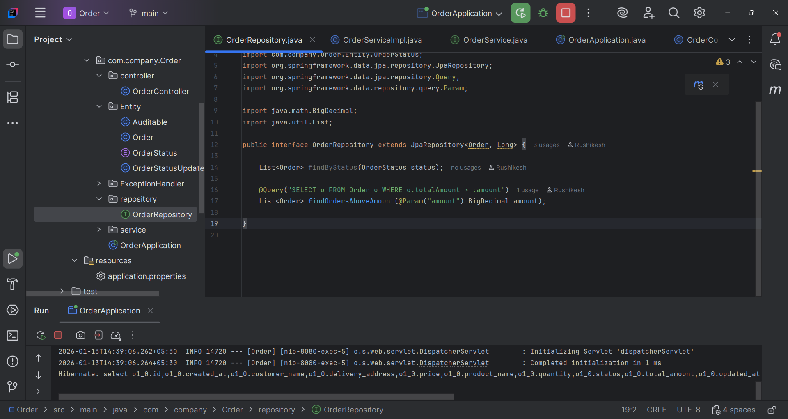

Figure 5 - service logic for getOrdersAboveAmount and updateOrderStatus
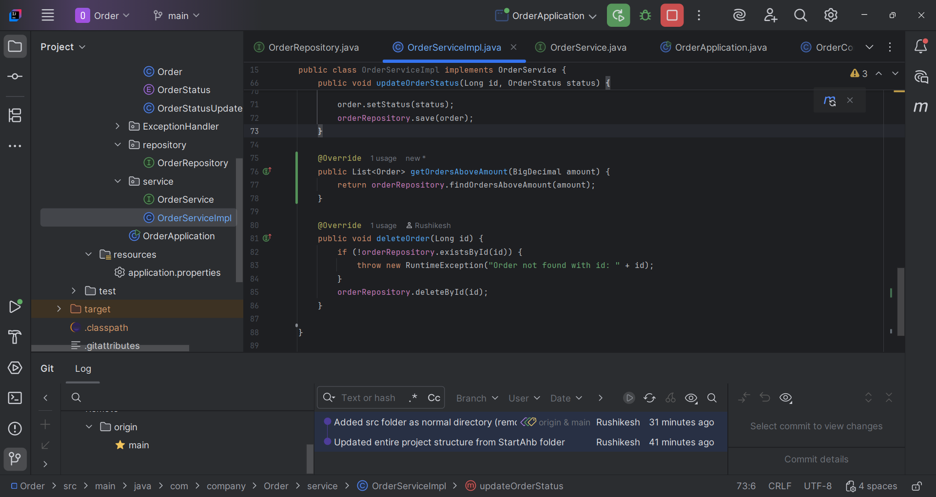

Postman Output:
Figure 6 - Output of updating the status of a perticular order - updateOrderStatus
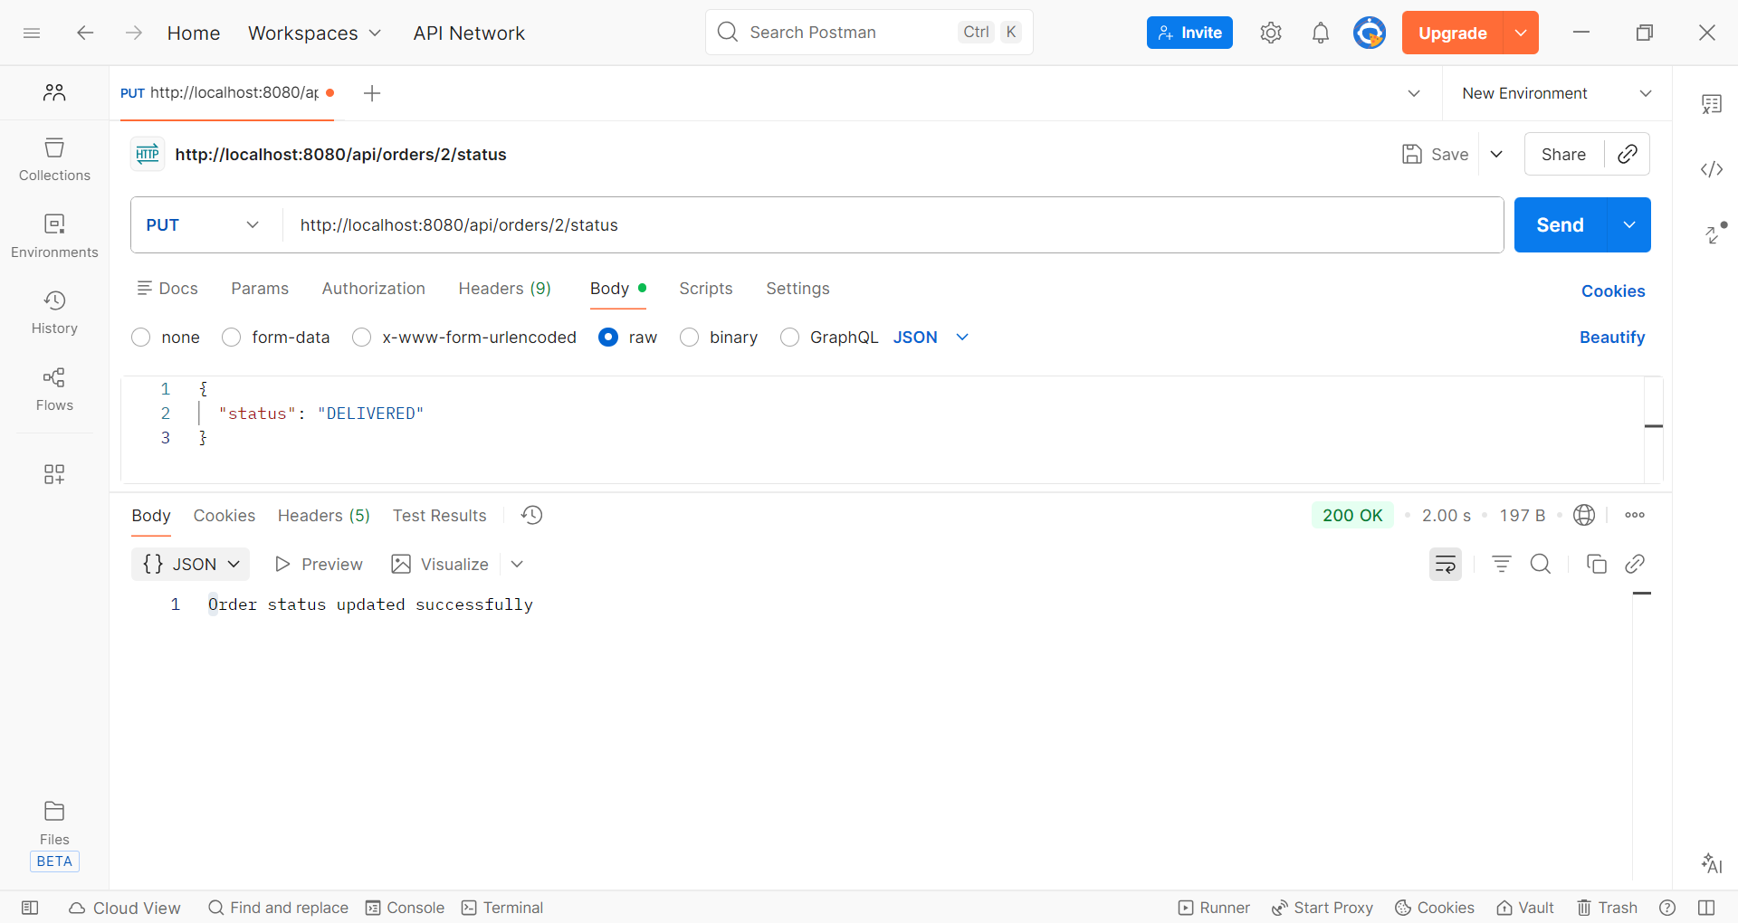

Figure 7 - output for finding order which is greater than a perticular amount - getOrdersAboveAmount
