Code GitHub Link: RushikeshGirishSonar/StartAhb_Company /STRT_WJ_011
https://github.com/RushikeshGirishSonar/StartAhb_Company/tree/main/STRT_WJ_011
Description: STRT_WJ_011 – Stream API POC
I have created two classes in this file: the first represents an Item and the second represents an Order. In the main class, I utilize the Java Stream API to process the data.
First, I initialized a list of orders, where each order contains its own list of items, showing the products purchased and their prices. I then defined a category for blocked products and initiated a stream to process the required data.
The stream processing follows these steps:
peek: Used to print the Order ID for tracking purposes.
flatMap: Used to convert the list of items within each order into a single, continuous stream of items.
filter: Used to remove any products that belong to the blocked category.
map: Used to extract only the names of the items.
distinct: Used to eliminate any duplicate item names.
sorted: Used to arrange the items in their natural alphabetical order.
skip: Used to bypass the first item in the sorted list.
limit: Used to restrict the output to a maximum of three items.
collect: Used to gather the processed results into a final list.
forEach: Finally, I used this to iterate through and display each product in the resulting list.

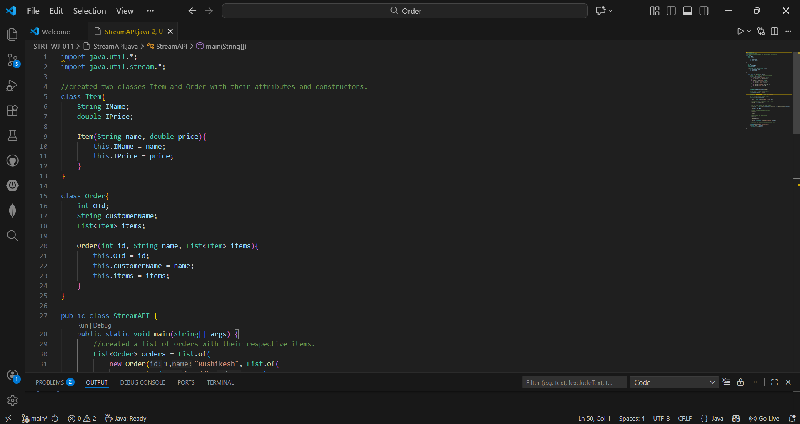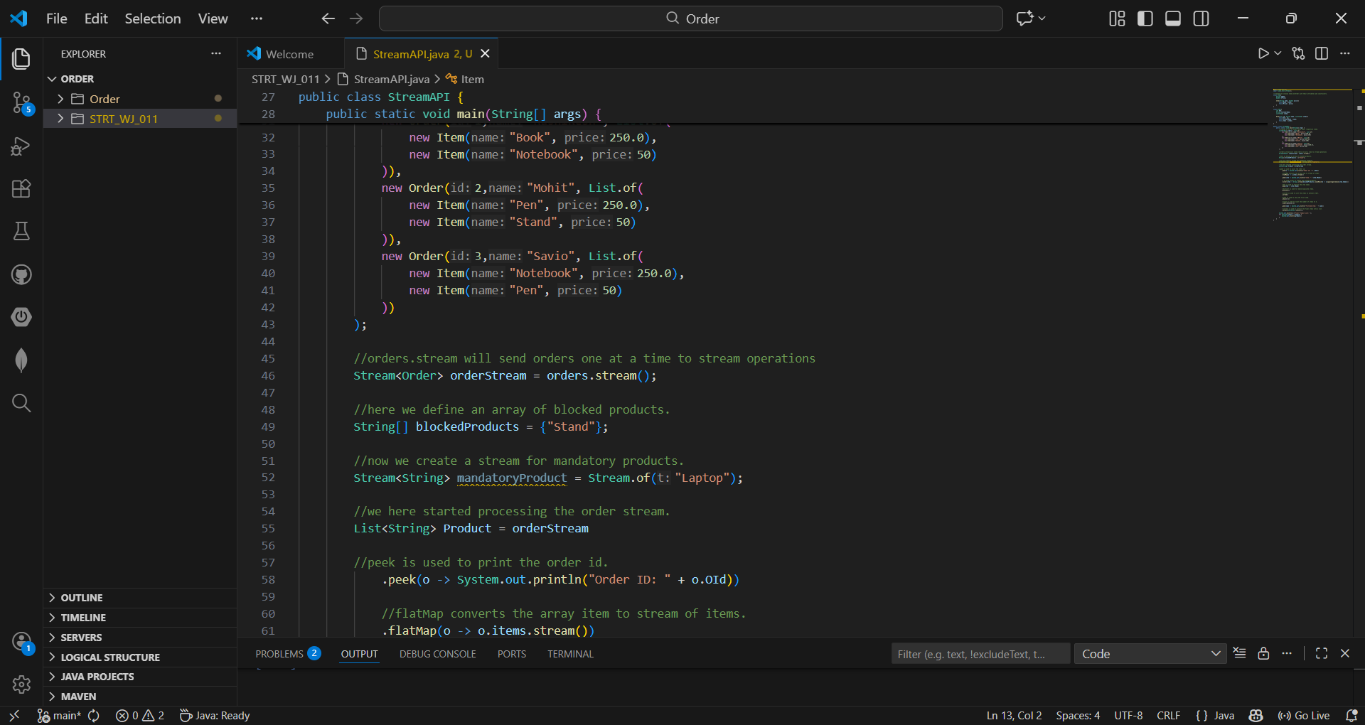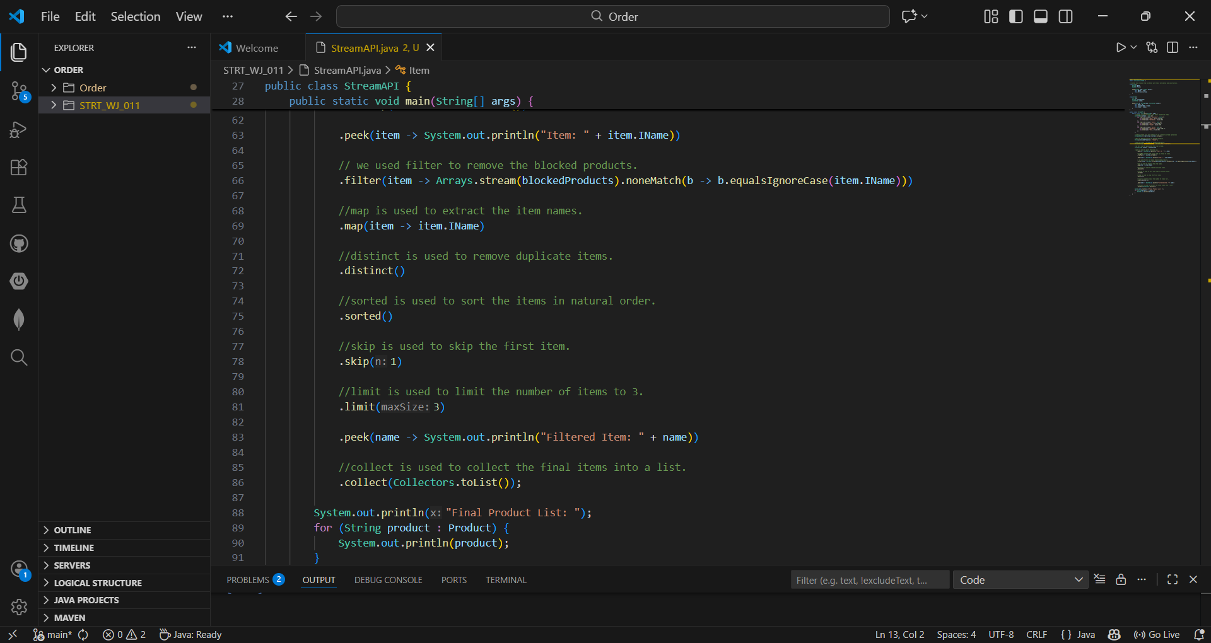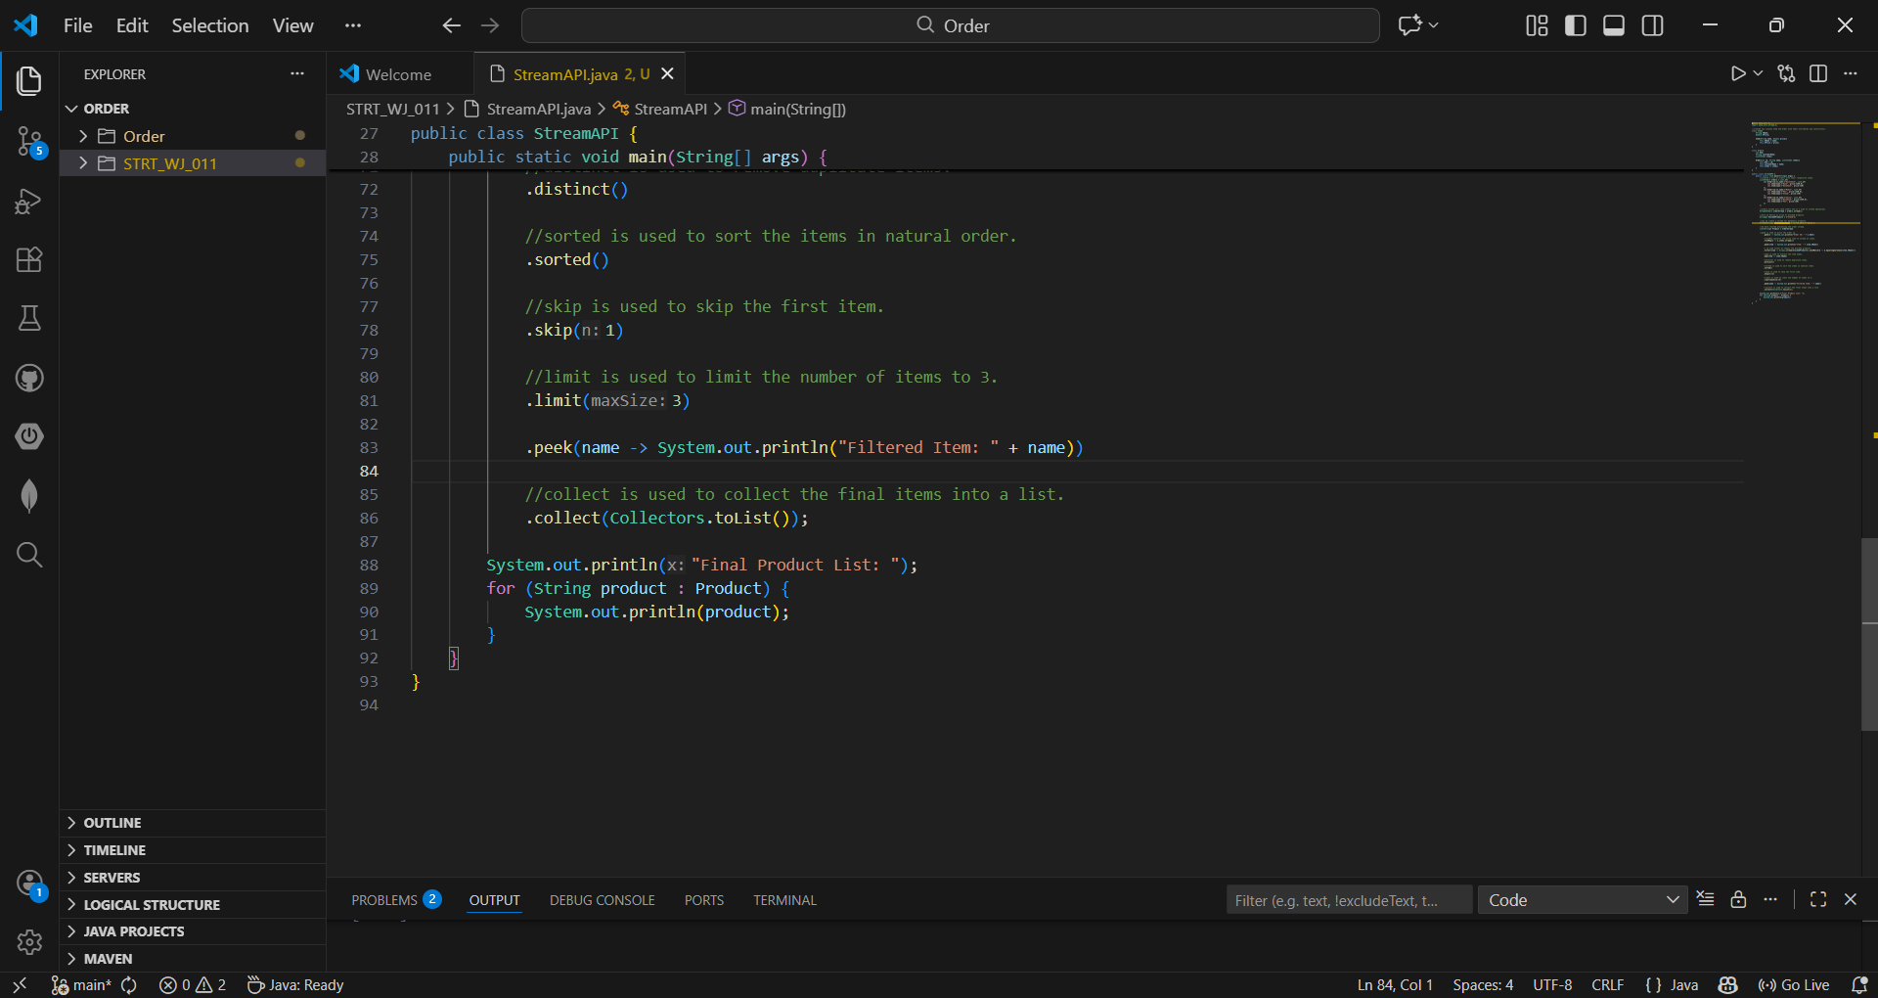Output: 