**Project Name: Digital Platform for Pet Dogs Adoption and Care**

**Project Members:**

|  |  |
| --- | --- |
| **PRN No.** | **Name** |
| **220343120039** | **Rushikesh Rajendra Jadhav** |
| **220343120088** | **Rahul Kashinath Zunjar** |
| **220343120105** | **Prachi Raju Sonone** |
| **220343120111** | **Shrinivas Narayan Vader** |

**Introduction of Project:**

Pawsome is here for every dog in need. We believe that every dog deserves the best. This is a platform where we offer Adoption & Care facility at single click for abandoned dogs, newly born puppies & existing pet dogs. We believe we can transform their quality of life through kindness and compassion.

**Objective and Scope of Project:**

**These are the major aspects**

**1. Community:-**

It is driver wheel of this project. Community is group of people working towards welfare of stray dogs. Bigger the community Greater the impact.

However one big community is harder to manage as this solution require access to different location and different people at same time therefore this solution focuses on creating local community for different locations which makes it easier to access different locations at same time.

**2. Motivation & Sources for Adoption:-**

Now days if anyone want to post photos and location of dog for adoption then he can’t get right platform/resource to post. This application main motive is to give a right resource to that person who wants to adopt a dog or post details of dog ready for adoption.

**3. Health Care:-**

As a dog owner, it’s your responsibility to know what your dog’s needs are and how to fulfil them. This includes everything from basic how a healthy dog diet is to veterinary care and more.

Here you’ll find valuable information for a dog including tips for how to take proper care of them. You’ll receive valuable tips for all stages of your dog’s life from puppy to adult dog, including nutrition, grooming, and healthcare tips along the way. We offer services of Adoption, Medical Treatment and Overall Health Care for Dogs.

**Modification and improvement over the existing Implementation:**

Present State

1. Login option for existing user, Signup option for new user. We will ask location to user and with the help of user location we will show available community in that area, if community is not available in user area then we provide option of create community.

2. Community: In the community there are different options for admin and user. In that community user will post details of dogs and see the post of adoption of dogs, also user can chat with other members of community.

3. Adoption page, in this page user see all list and details of dogs those available for adoption.

4. Feed: In that user will see & upload the post of his/her dogs, other user will like and comment on shared post.

5. Profile: Every user will have unique profile in this page we can see the post of the user, in which community he has member and also we can see the adoption and donation options.

After implementation of project

**(Note – Please make a list or highlight the main points which you are going to implement)**

**Project Plan:**

No. of User’s and Modules

User:

1. Admin:-

* Admin will have full authority of application.
* Admin will have access to remove any community or member of a particular community.

2. User/Member:-

* + The person who can join community.
  + User can create new community or join existing community according to his location.
  + User can send photos and location and post on that community.
  + User can send message of various camping in community regarding vaccination or health check of stray dogs.

**Modules** -

1. Login/Sign up:-

It will have login and sign up options for user and admin.

2. Feeds:-

Feeds will be graphically interactive tab for viewing/displaying all the post and feeds posted by registered users in form of text, video and photo. It will act of front page/slide of application.

3. Adoption:-

If any user posts the adoption post on community then this post will get displayed to everyone automatically on Adoption Module.

Inside adoption module user will get complete list of stray dogs ready for adoption.

4. Profile:-

In profile data of user will get display in form of feeds. In profile page there are various functionality for user likes adoption details, post, his community.

5. Community Forum:-

In Community forum user can chat with all members of community. He can interact with other members via different multimedia options.

**Technology:**

Frontend- React

Backend- Java

Database- MySQL/NoSQL

Others – CSS using Bootstrap Classes.

**Roles and Responsibilities:**

|  |  |  |
| --- | --- | --- |
| **Roles And Responsibilities** | | |
| 1 | Role | Frontend,Backend & Database |
| Member Name | Rushikesh Rajendra Jadhav |
| PRN No | 220343120039 |
| Description |  |
| 2 | Role | Frontend,Backend & Database |
| Member Name | Rahul Kashinath Zunjar |
| PRN No | 220343120088 |
| Description |  |
| 3 | Role | Frontend,Backend & Database |
| Member Name | Prachi Raju Sonone |
| PRN No | 220343120105 |
| Description |  |
| 4 | Role | Frontend,Backend & Database |
| Member Name | Shrinivas Narayan Vader |
| PRN No | 220343120111 |
| Description |  |

**Data Flow Diagram (DFD):**

Level 0:

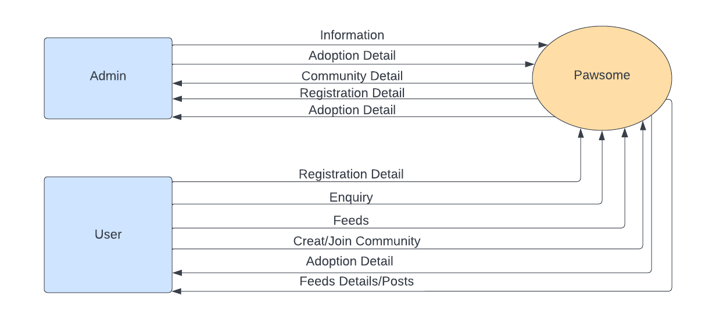

Level1:

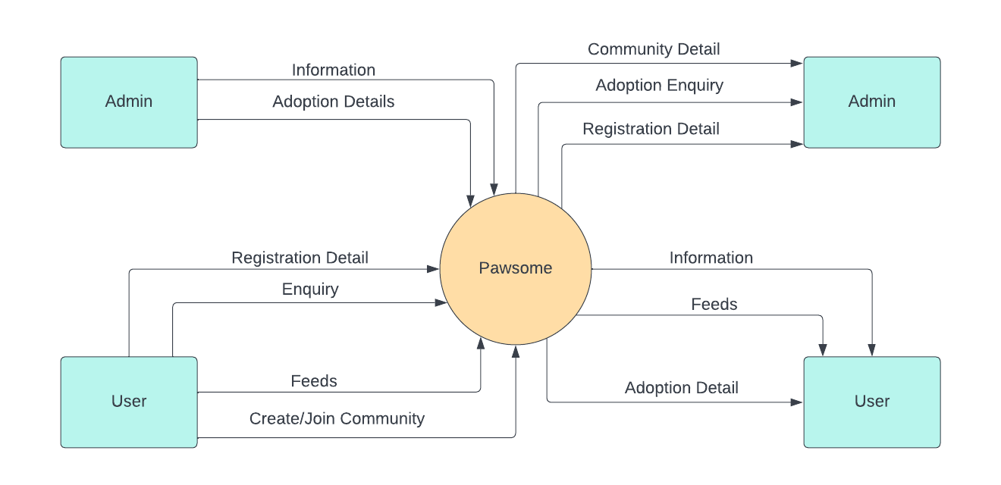

Level2:

User

**ERD / Database Tables:**

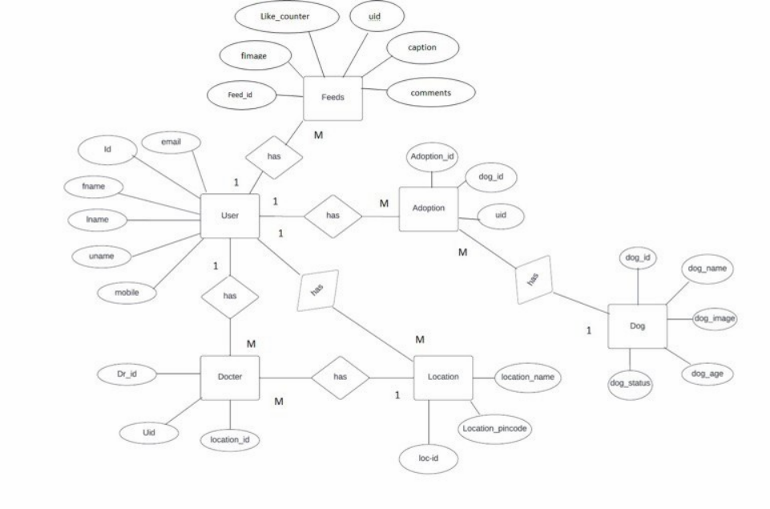

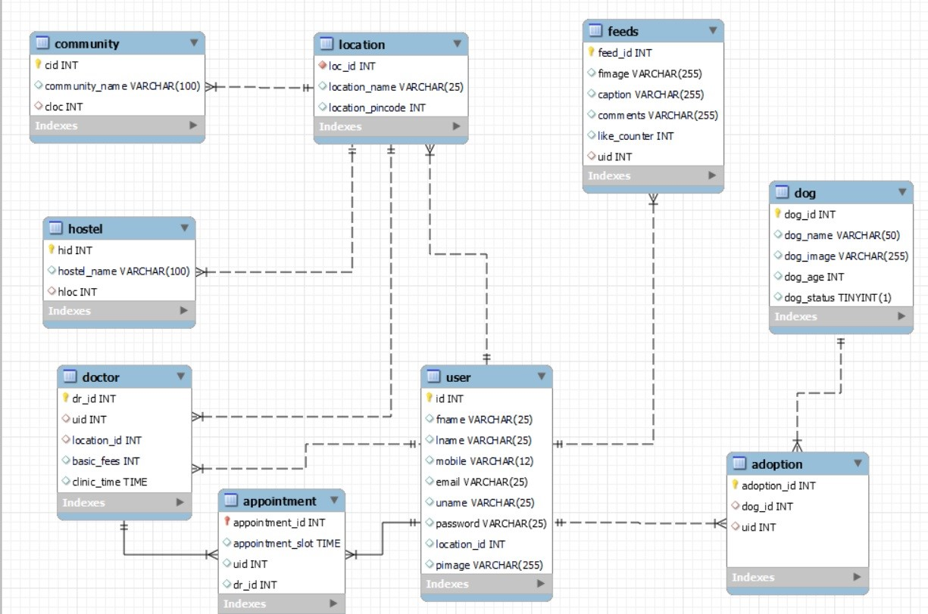

**Future Scope:**

1. We will add donation option. This will add some financial help to NGO.

2. We will add volunteer module in that we encourage volunteers to participate in charity activities to help the stray animals.

3. NGO’s will use this application.

4. This platform is also useful for other homeless animal Ex cat.

5. To help pet owners find their lost pets by allowing owners to share the pictures of their lost animals.