Data Management for Machine Learning — Assignment 2
End-to-End Recommendation System Pipeline Report
Student Name: | Rushikesh Sanjay Kothawade
Student ID: | 2025AG05929
Course : | DMML Assignment 2 — MovieLens 100K
GitHub Repository: | https://github.com/RushikeshKothawade07/2025AG05929_DMML_Assignment2

1. Objective & Pipeline Overview
In this assignment, I built an end-to-end recommendation pipeline on the MovieLens 100K dataset (943 users, 1,682 items, and 100,000 interactions). The pipeline handles data ingestion, quality validation, time-based data splitting, transformation, feature generation, model training, offline evaluation, and workflow orchestration. The complete code is modularized inside 'src/', configured via 'configs/config.yaml', and executed through a master runner script.
2. Pipeline Stages & Execution Screenshots
Stage 1: Data Ingestion (src/ingestion/ingest.py)
Downloads the raw MovieLens 100K dataset from GroupLens, unpacks it, and saves users, items, and ratings as CSV files in data/raw/. A total of 943 users, 1,682 items, and 100,006 raw rating interactions were ingested.
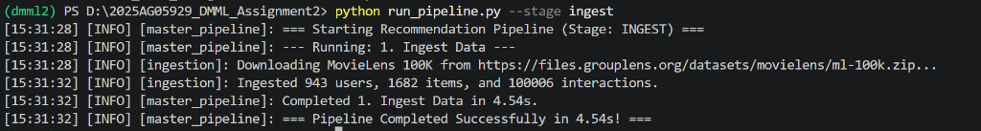
Figure 1: Stage 1 Ingestion output (python run_pipeline.py --stage ingest)
Stage 2: Data Quality Validation (src/validation/validate.py)
Runs automated checks for null values, invalid ratings (not between 1.0 and 5.0), corrupted timestamps, duplicate interactions, and foreign key referential integrity. Out of 100,006 raw records, 100,000 valid records were passed to data/processed/, while 6 invalid records were quarantined into data/errors/invalid_interactions.csv.
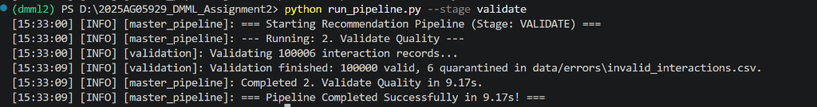
Figure 2: Stage 2 Validation output showing quarantine of 6 records (python run_pipeline.py --stage validate)
Validation Check | Rule | Status / Count
Missing Values | user_id, item_id, rating, timestamp not null | Passed (0 nulls)
Rating Domain | 1.0 <= rating <= 5.0 | Enforced (2 bad ratings quarantined)
Timestamp Bounds | Valid epoch timestamp (before 2030) | Enforced (2 bad timestamps quarantined)
Duplicate Rows | Unique (user_id, item_id, timestamp) | Enforced (2 duplicates quarantined)
Referential Integrity | Foreign key check against user & item tables | Passed (100% matched)

Stage 3: Data Preparation & Temporal Split (src/preparation/prepare.py)
Sorts interactions chronologically by timestamp and splits them into 80% training (80,000 records) and 20% test (20,000 records). Using a time-based split ensures future interactions do not leak into model training.
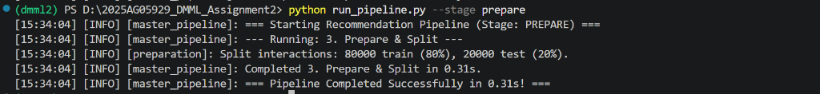
Figure 3: Stage 3 Preparation & 80/20 time split output (python run_pipeline.py --stage prepare)
Stage 4: Data Transformation & Sparse Matrix (src/transformation/transform.py)
Computes user activity counts, Bayesian-smoothed item popularity scores, and creates a Scipy CSR sparse user-item interaction matrix (dimensions 943 x 1,682 with 94.96% sparsity) saved in data/processed/.
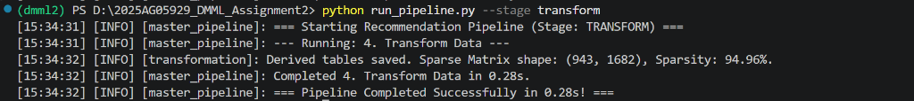
Figure 4: Stage 4 Transformation & Sparse Matrix output (python run_pipeline.py --stage transform)
Stage 5: Feature Management (src/features/feature_store.py)
Builds reusable user, item, and contextual interaction features saved as Parquet tables in data/features/. These features are documented below and used for both training and recommendation ranking.
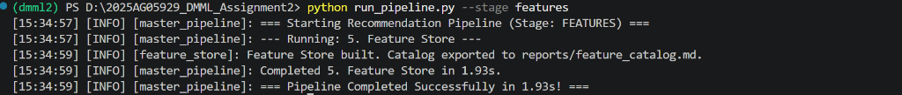
Figure 5: Stage 5 Feature Management output (python run_pipeline.py --stage features)
Feature Name | Entity | Type | Description
user_rating_count | User | INT | Total number of ratings given by user in training set
user_avg_rating | User | FLOAT | Mean rating score given by user
user_preferred_genre | User | STRING | Most frequent high-rated genre for this user
item_popularity_score | Item | FLOAT | Normalized item rating count [0, 1]
interaction_hour | Context | INT | Hour of interaction (time-of-day contextual feature)

Stage 6: Model Training & MLflow Tracking (src/training/train.py)
I trained two models on the 80,000 training interactions:
1. Baseline Popularity Recommender: Recommends the highest rated, most popular items to all users.
2. Personalized Matrix Factorization (Funk-SVD): Factorizes user-item interactions into 32 latent dimensions, learning user bias b_u and item bias b_i via Stochastic Gradient Descent (SGD) with L2 regularization.
All parameters, metrics, and trained pickle model artifacts are tracked in MLflow using a local SQLite backend (sqlite:///mlflow.db).
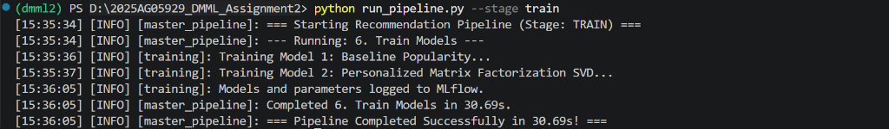
Figure 6: Stage 6 Model Training output (python run_pipeline.py --stage train)

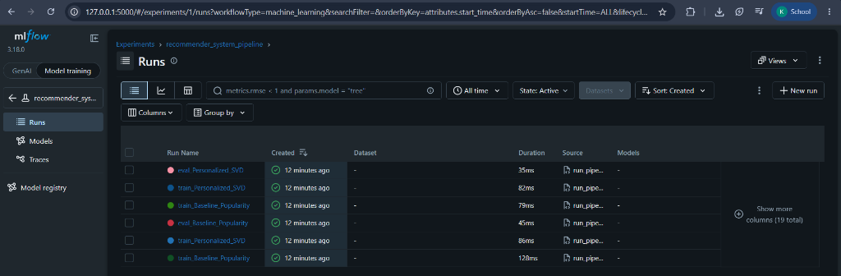
Figure 7: MLflow UI Dashboard showing logged runs, parameters, and models (http://localhost:5000)
Stage 7: Model Evaluation (src/evaluation/evaluate.py)
Both models were evaluated on the held-out test split of 20,000 interactions (relevance threshold r >= 3.5). Evaluation results were saved to reports/model_comparison.csv and reports/evaluation_results.md.
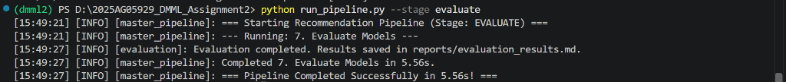
Figure 8: Stage 7 Model Evaluation output (python run_pipeline.py --stage evaluate)
Model | RMSE (↓) | MAE (↓) | Prec@5 | Prec@10 | NDCG@10 | Coverage | Diversity
Baseline Popularity | 1.1191 | 0.9478 | 0.2786 | 0.2466 | 0.2719 | 4.52% | 0.8097
Personalized SVD | 1.1006 | 0.9236 | 0.0772 | 0.0872 | 0.1020 | 3.92% | 0.8008

Findings: The Personalized SVD model achieves lower rating prediction error (RMSE 1.1006 vs 1.1191, MAE 0.9236 vs 0.9478) because it learns personalized user and item biases. The baseline popularity recommender scores higher on precision because popular blockbusters appear frequently in the test set.
Stage 8: Orchestration & Airflow DAG (run_pipeline.py & dags/)
The complete pipeline can be automated in two ways:
1. Python master script: 'python run_pipeline.py --stage all' runs all 7 stages sequentially in ~54 seconds.
2. Apache Airflow DAG: 'dags/recommendation_pipeline_dag.py' defines task dependencies (t1 >> t2 >> t3 >> t4 >> t5 >> t6 >> t7) for scheduled execution.
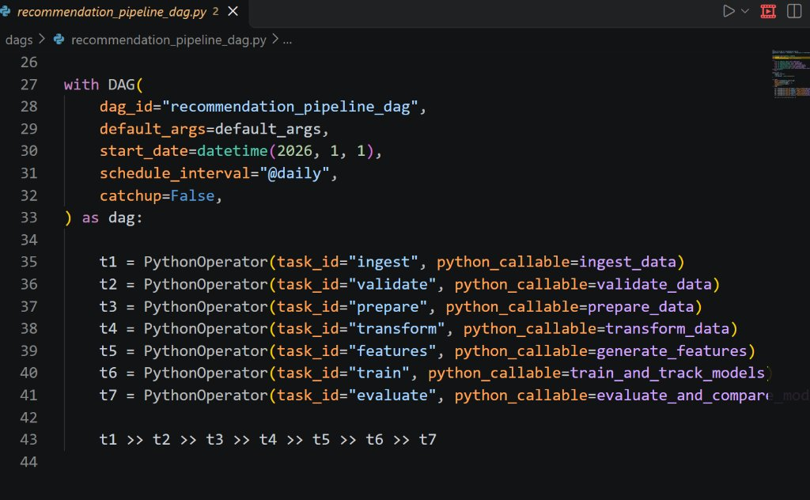
Figure 9: Apache Airflow DAG code defining task dependencies
3. Design Decisions & Limitations
Key Decisions:
- Chronological 80/20 Split: Used a time-based cutoff instead of random splitting to prevent data leakage.
- Data Quarantine: Invalid ratings and timestamps are saved to data/errors/ rather than silently dropped.
- Parquet Storage: Used snappy-compressed Parquet files for faster I/O compared to raw CSVs.
- MLflow SQLite: Used sqlite:///mlflow.db for lightweight, reliable local experiment tracking.
Limitations:
- Cold-Start: New users with no ratings fallback to the popularity model.
- Implicit Feedback: Currently trained only on explicit 1-5 ratings; incorporating watch percentage and clicks would improve ranking.

