

BRACT Vishwakarma Institute of Information Technology, Pune

Department of Artificial Intelligence and Data Science

**Viz-A-Thon**

**in Collaboration with**



|  |  |
| --- | --- |
| Team Id: 38 | Team Name: Mechlyzers |
| College Name: Vishwakarma Institute of Information Technology | |
| Number of members in a team: 4 | Problem Statement Id: 2 |

Team members details

|  |  |  |
| --- | --- | --- |
| Name | Mobile Number | Mail Id |
| Kewal Patil | 7558519688 | kewal.22120131@viit.ac.in |
| Rushikesh Kothawade | 9511606016 | rushikesh.22120201@viit.ac.in |
| Aman Shaikh | 9423428528 | aman.22120153@viit.ac.in |
| Laxmikant Baviskar | 7875681463 | laxmikant.22120142@viit.ac.in |

**INDEX**

|  |  |  |
| --- | --- | --- |
| **Sr. No.** | **Contents** | **Page No.** |
| **1** | **TITLE/ PROBLEM STATEMENT** | **3** |
| **2** | **OUTPUT SCREEN SHOTS WITH EXPLANATION** | **4-6** |
| **3** | **TWITTER HANDLE** | **7** |
| **4** | **SKILLS USED, LEARNINGS AND TOOLS FUNCTIONALITIES** | **8** |

**2. IPL (Indian Premier League)**

**Problem statement –**

BCCI has asked to analyse the all-season IPL data and come with visualization which helps to plan next season matches more Competitive.

**Task –**

To create an interactive and informative dashboard containing the following details and explanation with the help of visualizations using Tableau.

1. Performance of the teams across all seasons
2. Performance of a team compared to top 3 teams across all seasons
3. Including all-season data, based on performance statistics, which team has performed well despite not winning trophy
4. Teams Win/Loss ratio in every season
5. Best batter and Bowler across all seasons based on performance
6. Best batters by teams across all seasons
7. Best Performance of teams as per Venue

**OUTPUT SCREEN SHOTS WITH EXPLANATION**

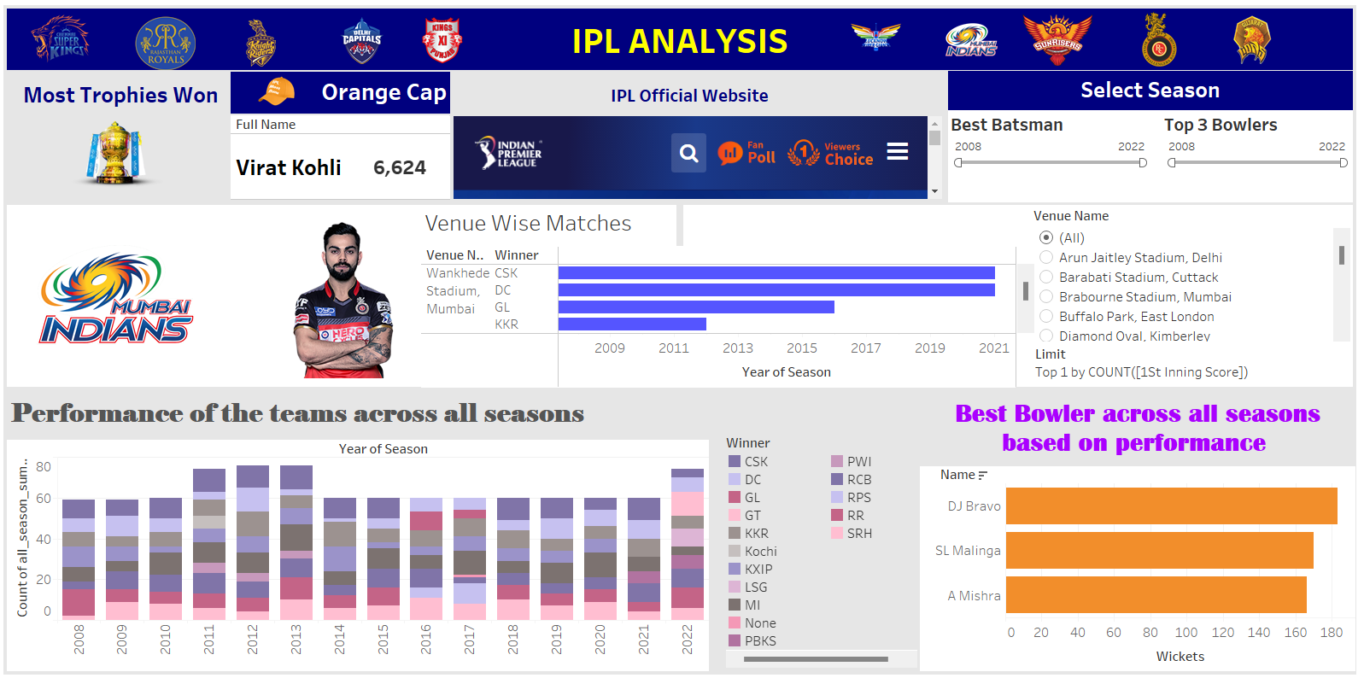

The above dashboard contains –

1. The best performing batsman across all the seasons. The slider at the right side is used to select the season accordingly and the batsman’s name will appear.
2. Venue wise performance of the teams. The option bar on the right gives the option to change the venue accordingly.
3. The best bowler based on maximum wickets.
4. The dashboard also contains the official website of IPL
5. Performance of the teams across all seasons

Dashboard link and sources - <https://drive.google.com/file/d/1g3UM9uVVbwXeRJcZ36vsTfMydrBfMj_o/view?usp=sharing>

**Twitter handle –**

Dashboard link - <https://twitter.com/Kewal2315/status/1569289650971496448?s=20&t=VW0tvlXPYemXS3JsFFgpHA>

Twitter id - Kewal2315

Tools used –

To create this interactive dashboard we have used Tableau.