Project Report
Introduction
- The Project Name is “Digital Input Output and Light Controller” This System Provide Some Functionality for Light Controlling and Digital Input Output Checking.
- The Light Controller Provide such functionality as
- Soft Switch :
- Control Light using Software On Off Switch.
- Hard Switch :
- Triggered by the external sensor, the light is on when the trigger input is on, the light is off while the trigger input is off.
- External Trigger :
- The light is triggered when the trigger input on the rising edge, but the duration is set by the holding time.
- Soft Trigger :
- In Trigger Mode Light is On in Particular Time in Millisecond according to set holding time. After that light is automatically Off.
- The Digital Input Output Functionality are
- Digital Input :
- The DI (Digital Input) Provide functionality to accept digital input and show status according to channel number.
- Digital Output :
- In DO (Digital Output) accept input from software On or Off and according to that input On Off particular Light or any other Device.

Project UI Screen and Explanations

- Login Form :
- The login form provide Name of NODKA Industrial PC Model Number in series of NP-61XX.
- According To Model Number Select Particular nkio_config.ini file configure all information.
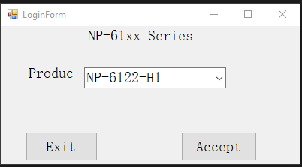
- Light Control :
- The Light control provide many functionality in light controlling such as
- Soft Switch :
- Control Light using Software On Off Switch.
- Hard Switch :
- Triggered by the external sensor, the light is on when the trigger input is on, the light is off while the trigger input is off.
- External Trigger :
- The light is triggered when the trigger input on the rising edge, but the duration is set by the holding time.
- Soft Trigger :
- In Trigger Mode Light is On in Particular Time in Millisecond according to set holding time. After that light is automatically Off.
- Inside light control there are 4 channels name as
- CH0 : CH0 light control id is (0x01)
- CH1 : CH1 light control id is (0x02)
- CH2 : CH2 light control id is (0x04)
- CH3 : CH3 light control id is (0x08)
- By default software all control is disable, but after click on connect button the light control connection is open and after that all control is automatically enable. In case not connect particular Model series industrial PC then connection is not open.

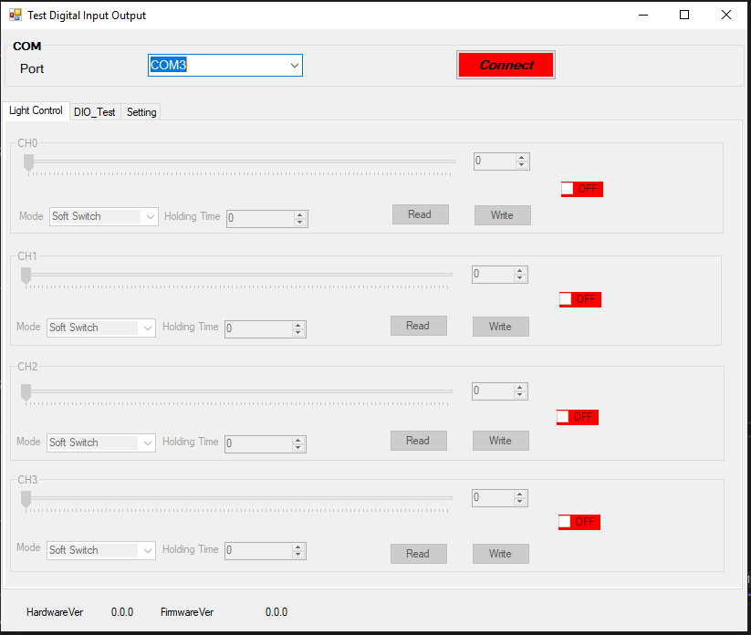
After Connecting all functionality are enable and user can use.
- Mode : Inside Mode Section There are 4 different mode.
- Soft Switch
- Hardware Switch
- External Trigger
- Hardware Trigger
- Holding Time : Inside Holding time set trigger time in particular milliseconds in Range of 0 To 255.
- Track-bar : The Track-bar is use to set light brightness in the range of 0 to 100.
- Read : The read is use to read all previously write data information such as software mode , holding time , and brightness level.
- Write : The write is use to write all set information after write all information is store automatically. After open software again all previous data information is set automatically.
- ON_OFF : The on off it is a switch to ON OFF the light.

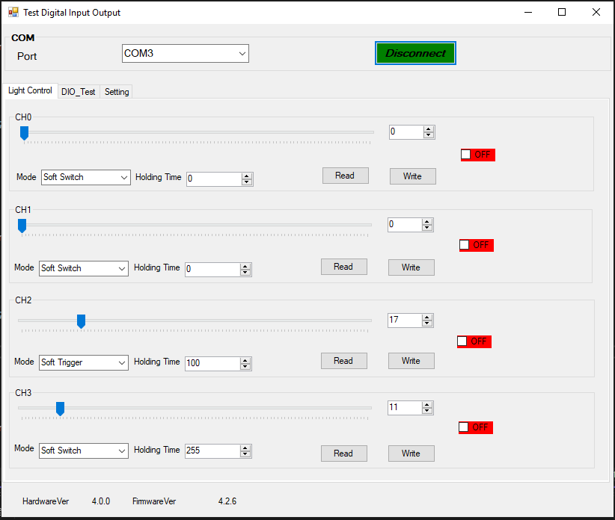

- Digital Input Output Test :
- Digital Input (DI) :
- Inside Digital Input give input externally using button sensor etc.
- According to the input show output signal in desktop.
- Digital Output (DO) :
- Inside digital output give input from software and according to that input hardware device on off.
- For Example : light Sensor etc.
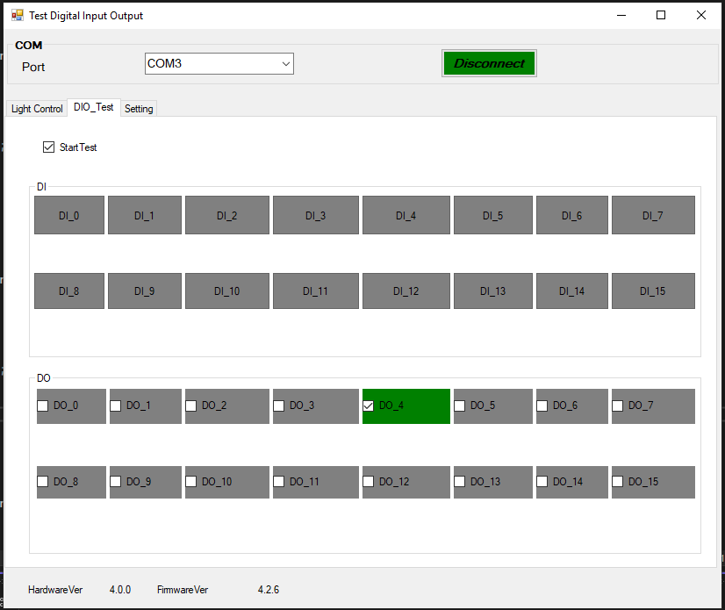

- Settings :
- Inside setting provide all light controller setting. This setting panel provide functionality to set holding time. ( Holding time is a trigger time means light on of in milliseconds)
- There are 4 choose to set holding time.
- 1000ms
- 100ms
- 10ms
- 1ms
- By default 1000ms is selected.
- Write is used to write holding time in channel wise and store inside Controller API.
- Read is used to Read all Previously store information.
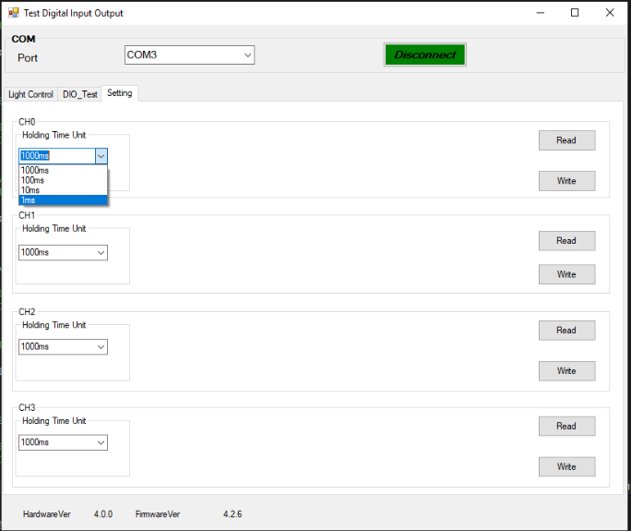

Hardware and Software Requirement :
- Software Requirement :
  - Visual Studio C#
- Hardware Requirement :
  - NODKA Industrial PC in NP-61XX Series

