📊 Prometheus + Grafana Monitoring Stack (with Node Exporter)
This setup runs Prometheus, Grafana, and Node Exporter using Docker Compose to monitor host metrics like CPU, RAM, disk, and more.

🚀 Prerequisites
- Docker
- Docker Compose

📁 Project Structure
.
├── docker-compose.yml
└── prometheus.yml
You can clone the repo:
https://github.com/RushikeshSable05/Prometheus-Grafana-Monitoring-Stack
Clone the below 2 files from GIT repo
prometheus.yml
docker-compose.yml
▶️ Start the Monitoring Stack
docker-compose up -d
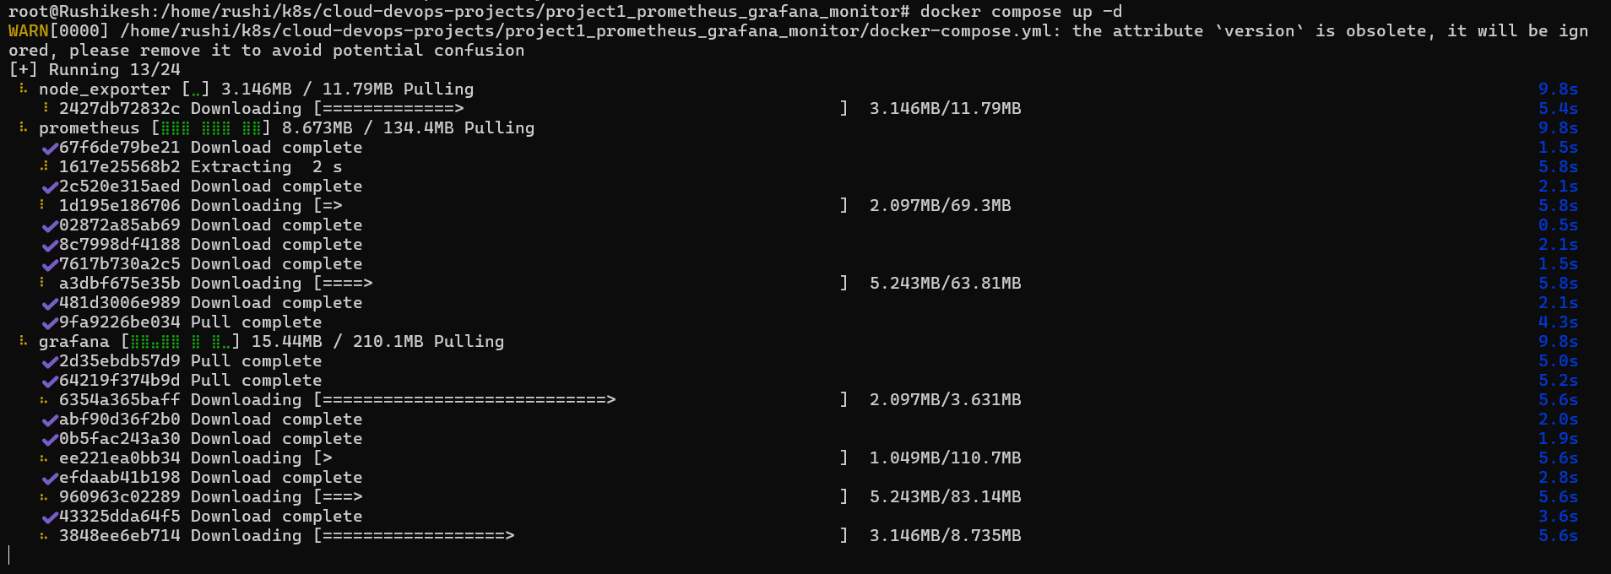
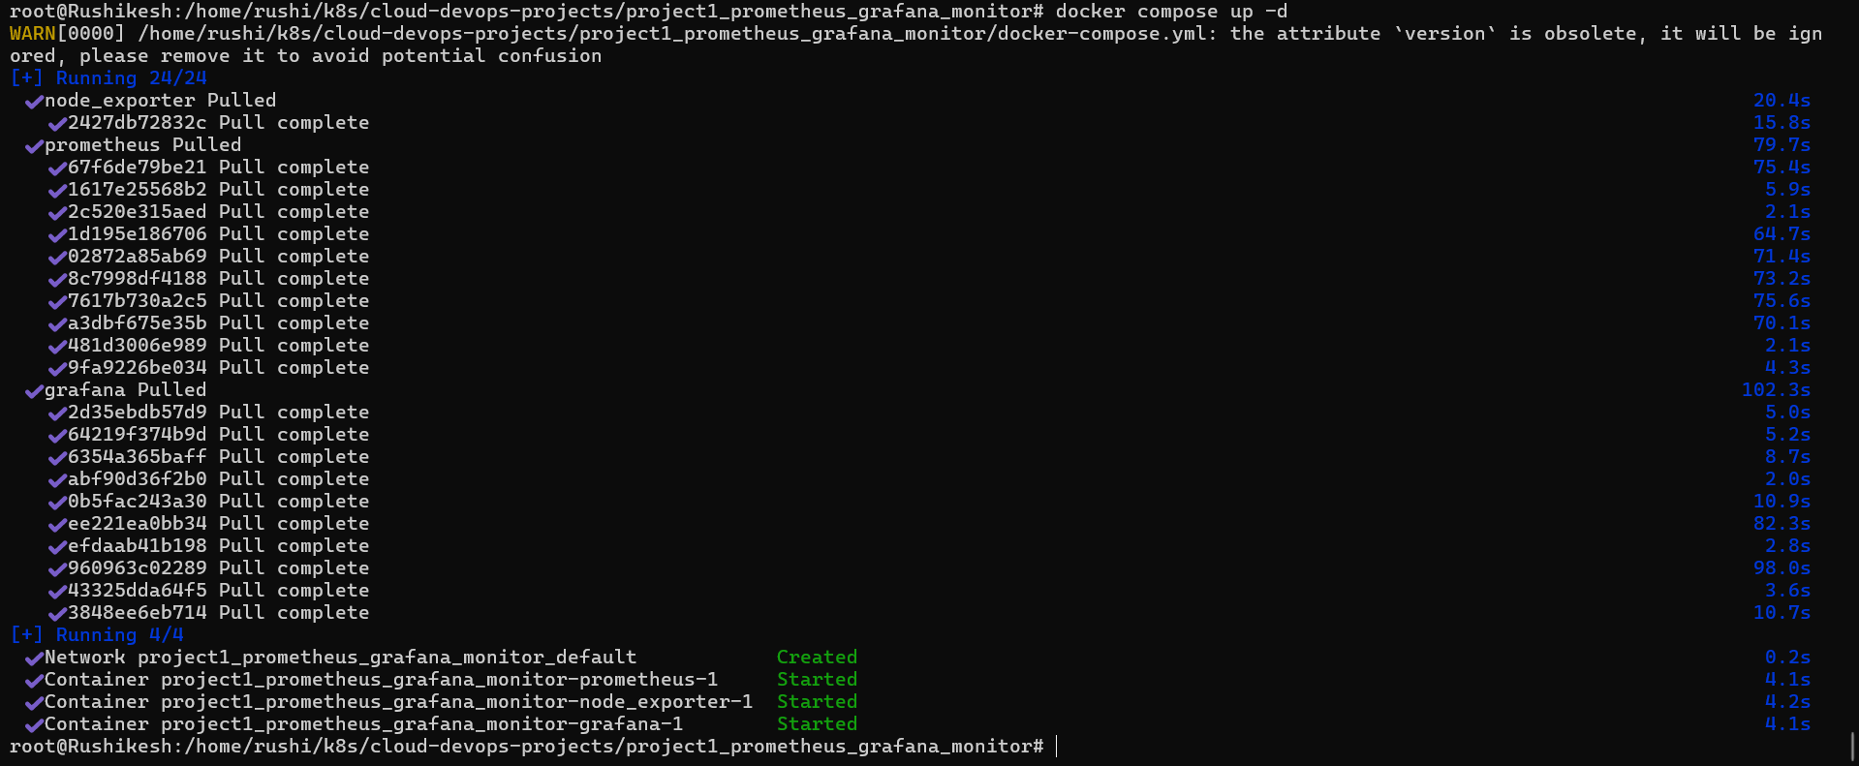

Add Prometheus as a Data Source
You add Prometheus as a data source to collect, store, and query time-series data for monitoring and alerting. It enables you to gain insights into your systems' performance and health by allowing you to create visualizations, dashboards, and alerts based on the metrics Prometheus collects.
Open the Grafana URL (http://localhost:3000)
⚠️ Important:
Use prometheus:9090 (container name), not localhost.
Docker Compose automatically creates a network where services can talk using names.
Simply give your Prometheus URL (http://prometheus:9090)
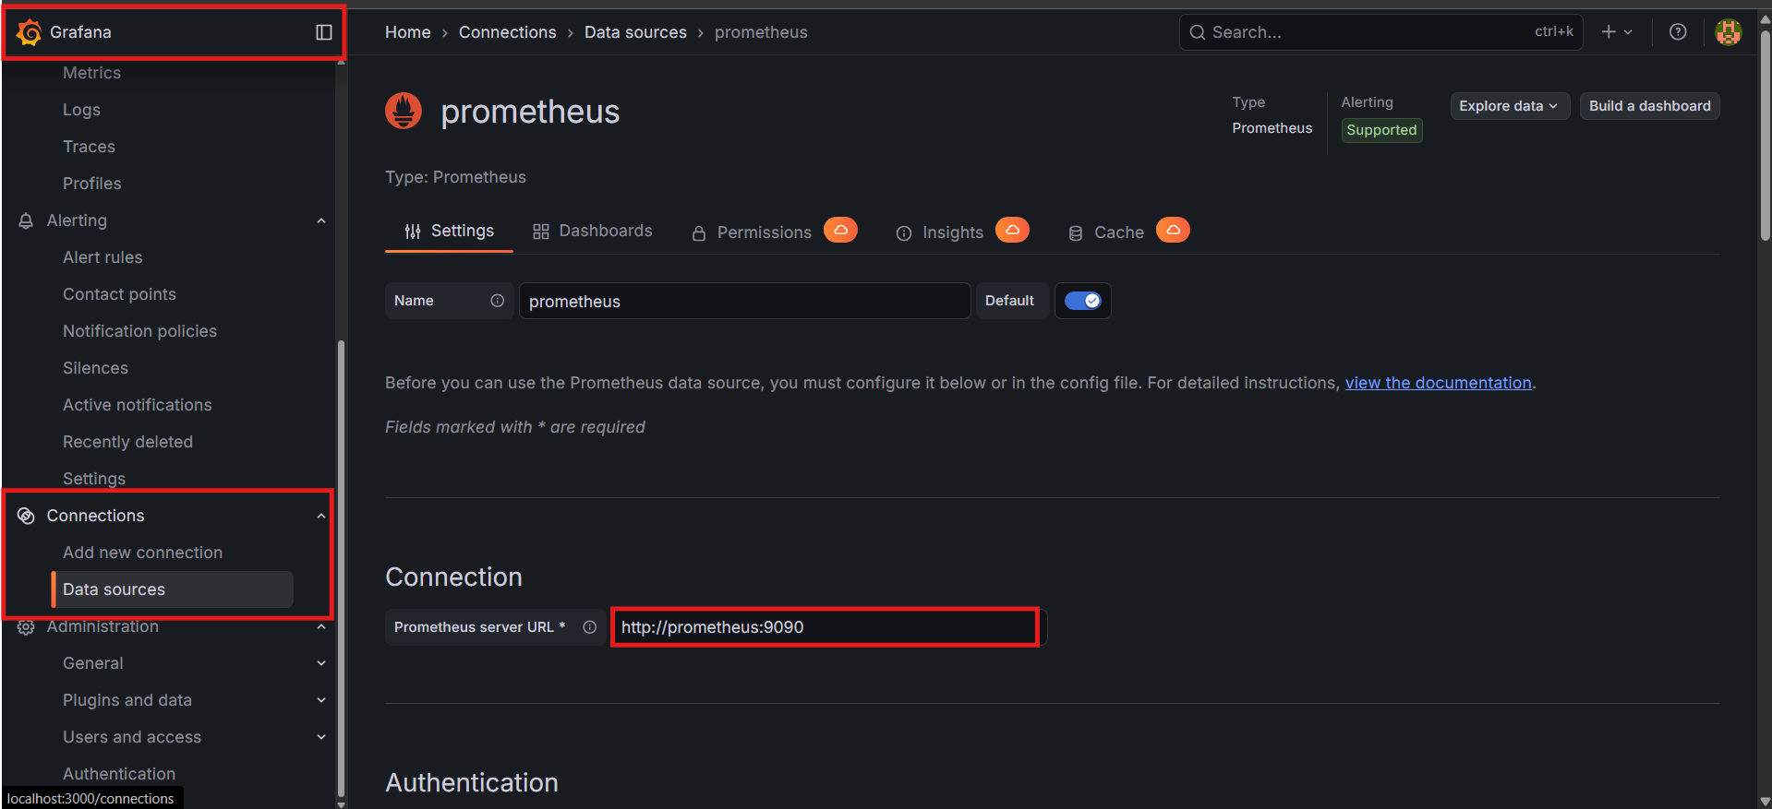
Click save and Test
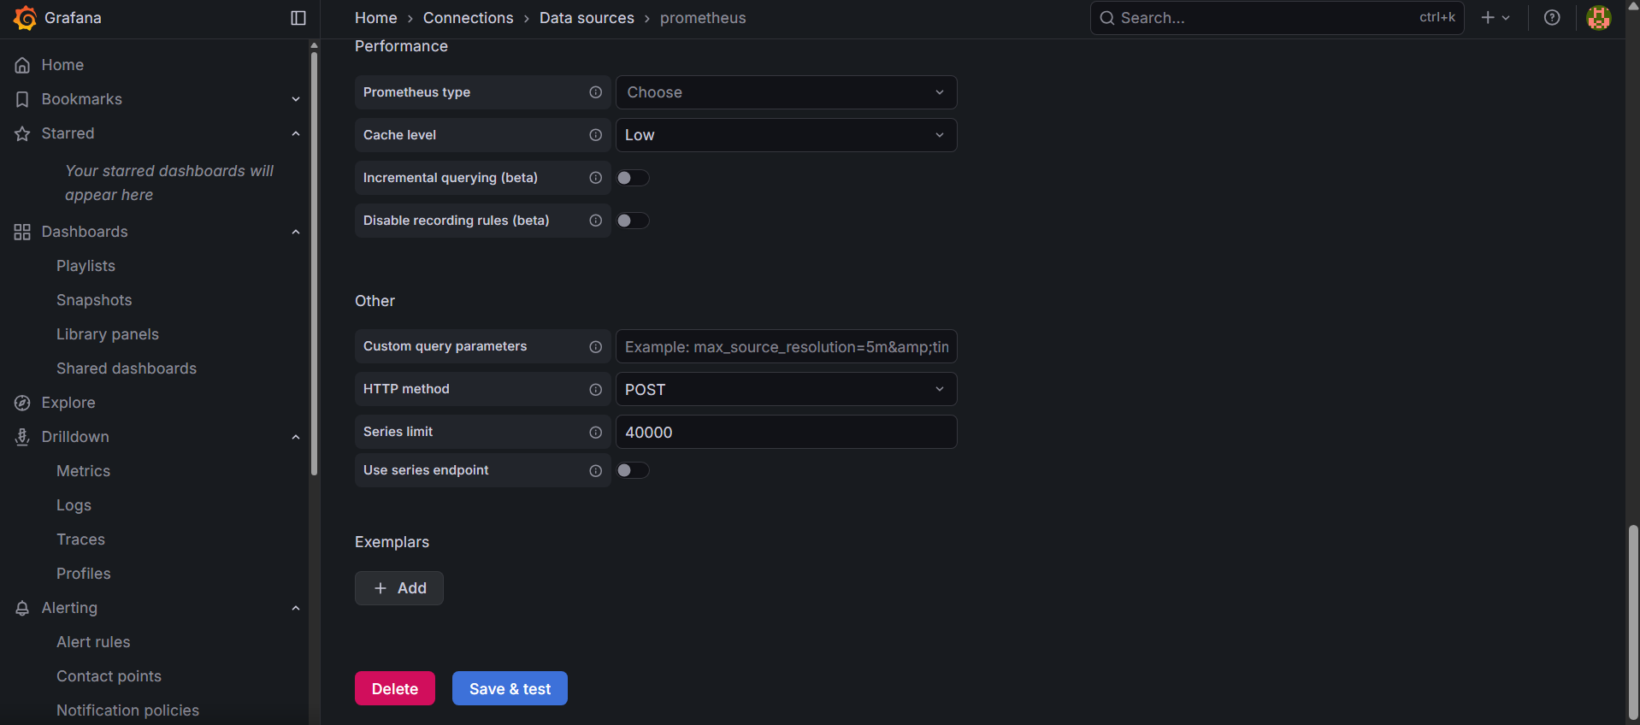

✅ 1. Build a Dashboard (Manual Method)
Step 1 — Create a new dashboard
Left sidebar → Dashboards → New → New Dashboard
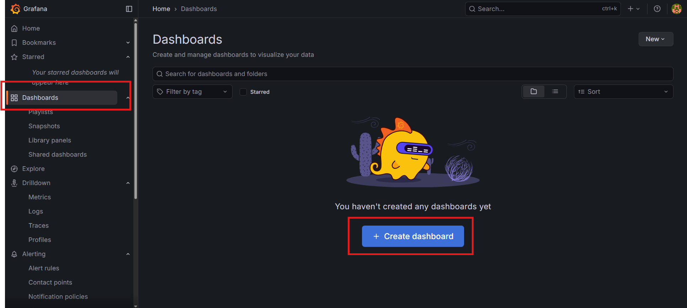
Step 2 — Add a panel
Click “Add Visualization”
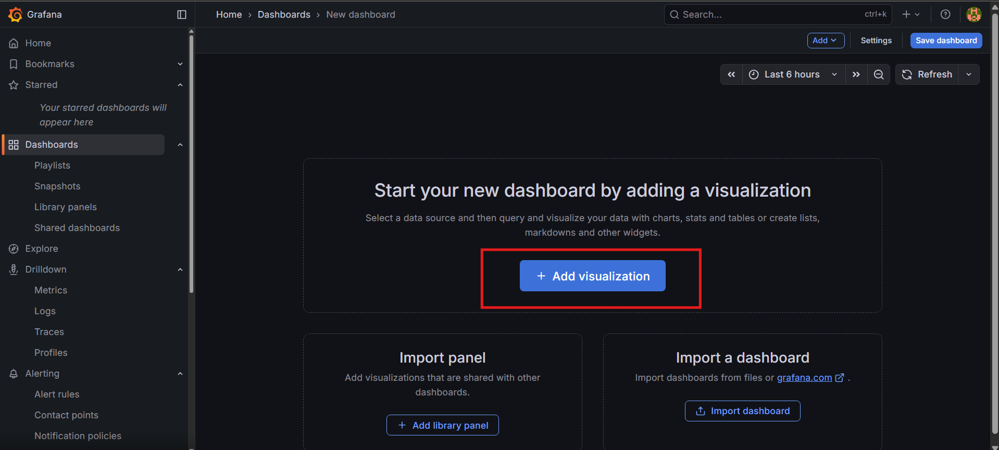

Step 3 — Select metrics
In the query editor, type any Prometheus metric like:
- up
- node_cpu_seconds_total
- node_memory_MemAvailable_bytes
(If node_exporter is running, you will see node metrics.)
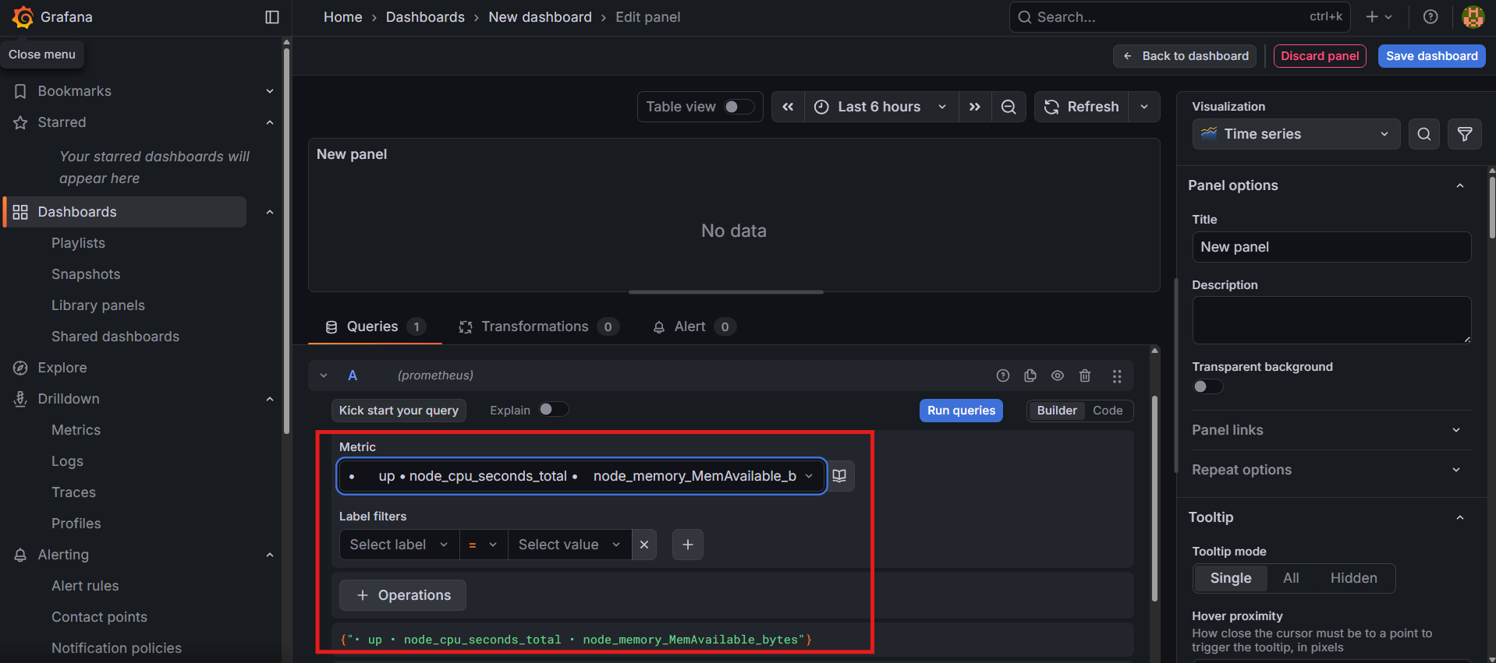
Step 4 — Save the dashboard
Top-right → Save → Give name → Save
After saving you can see the dasboard
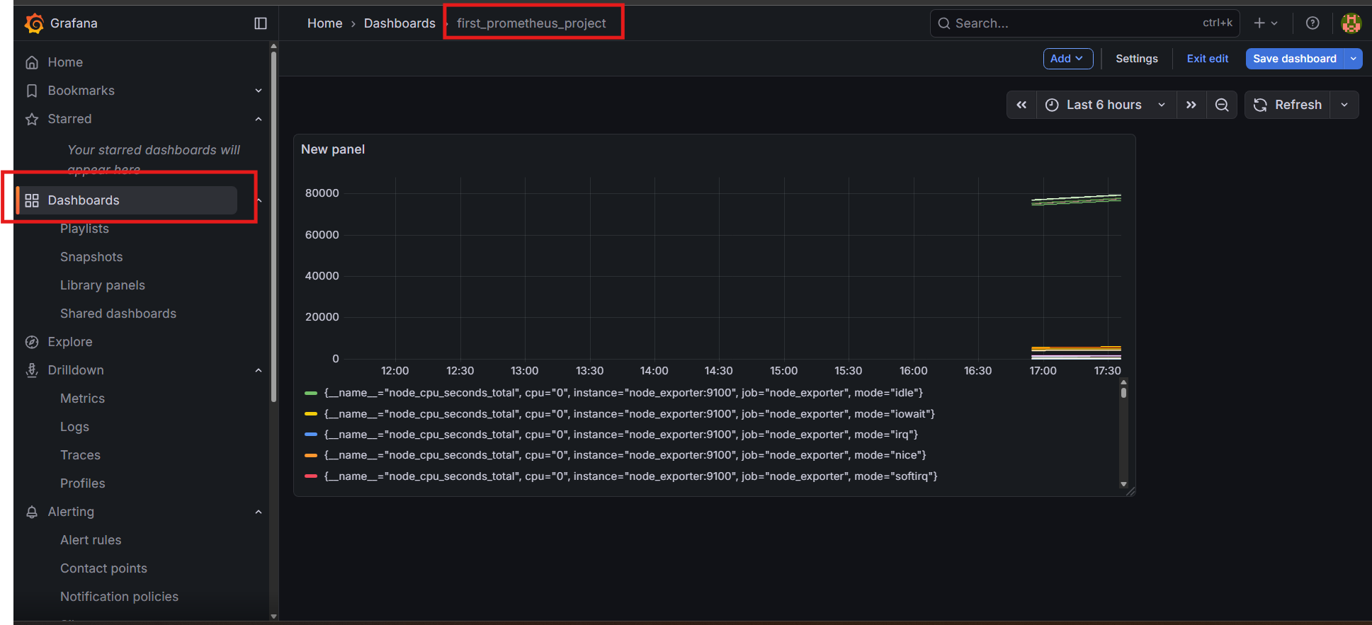

📥 2. Import a Pre-built Node Exporter Dashboard (Recommended)
This gives you CPU, memory, disk, network panels instantly.
Step 1 — Go to
Left sidebar → Dashboards → Import
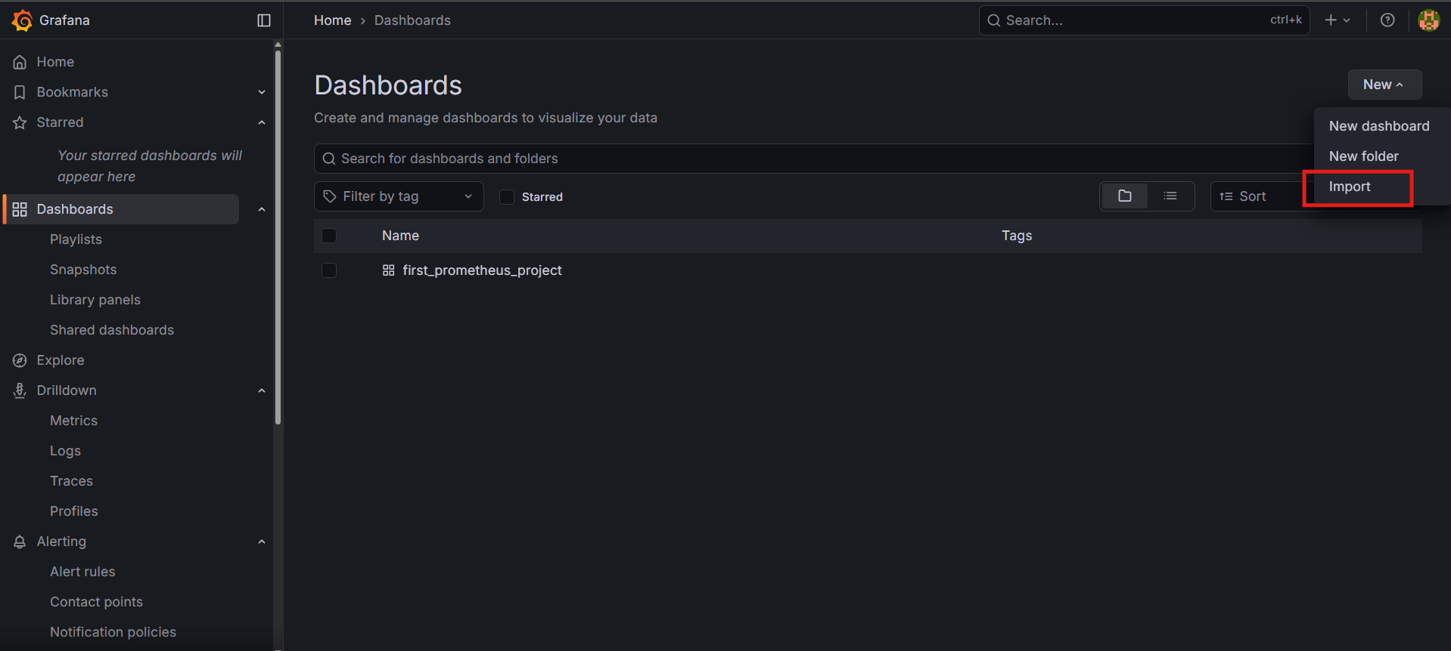
Step 2 — Enter Dashboard ID:
👉 1860
(Name: Node Exporter Full)
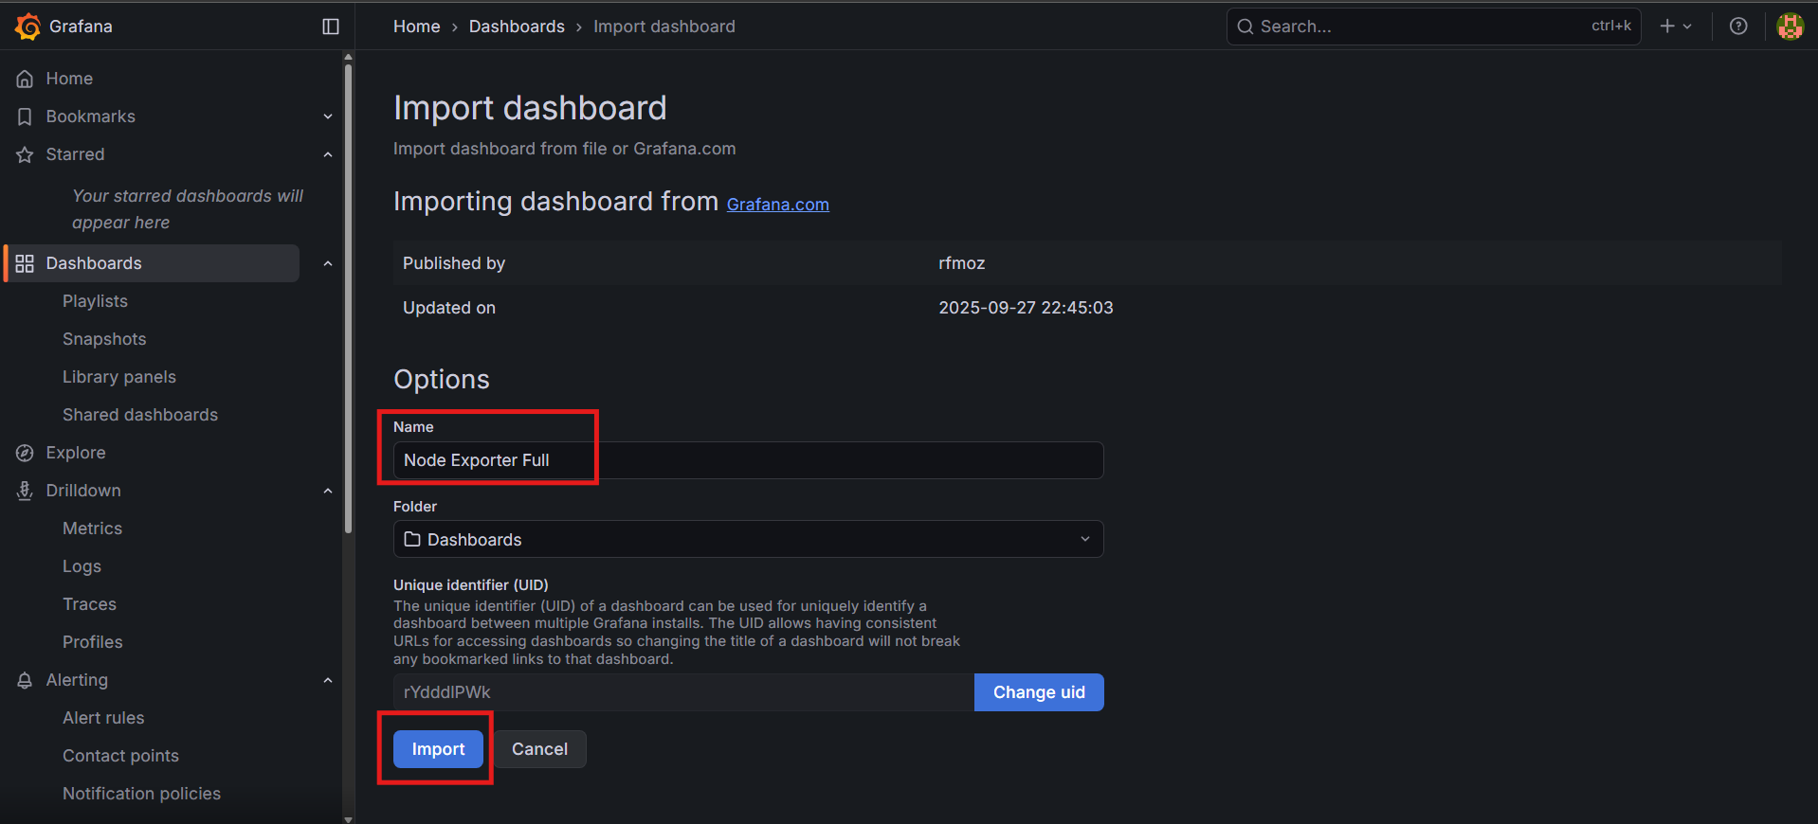

Step 3 — Select Prometheus as data source
Choose your Prometheus datasource → Import
Now you get a full monitoring dashboard.
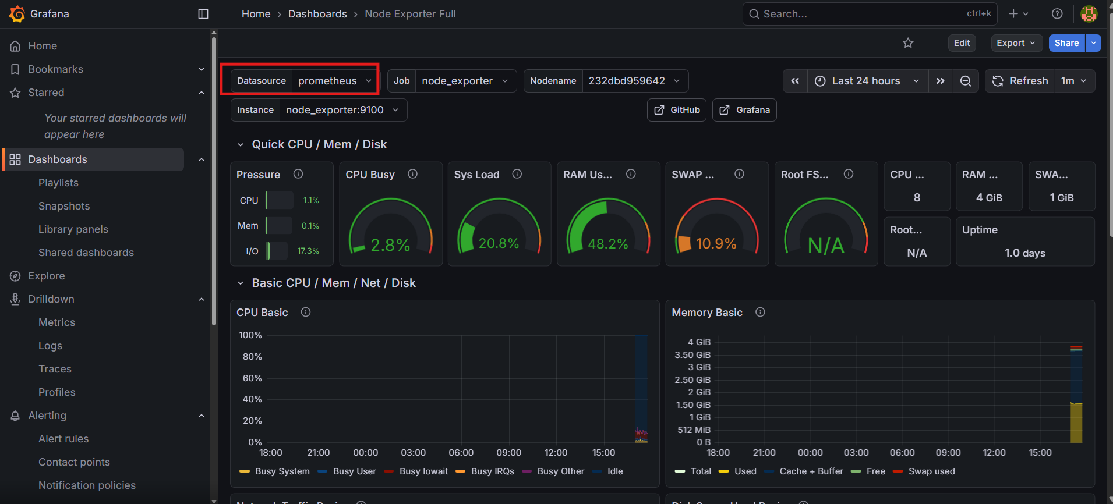
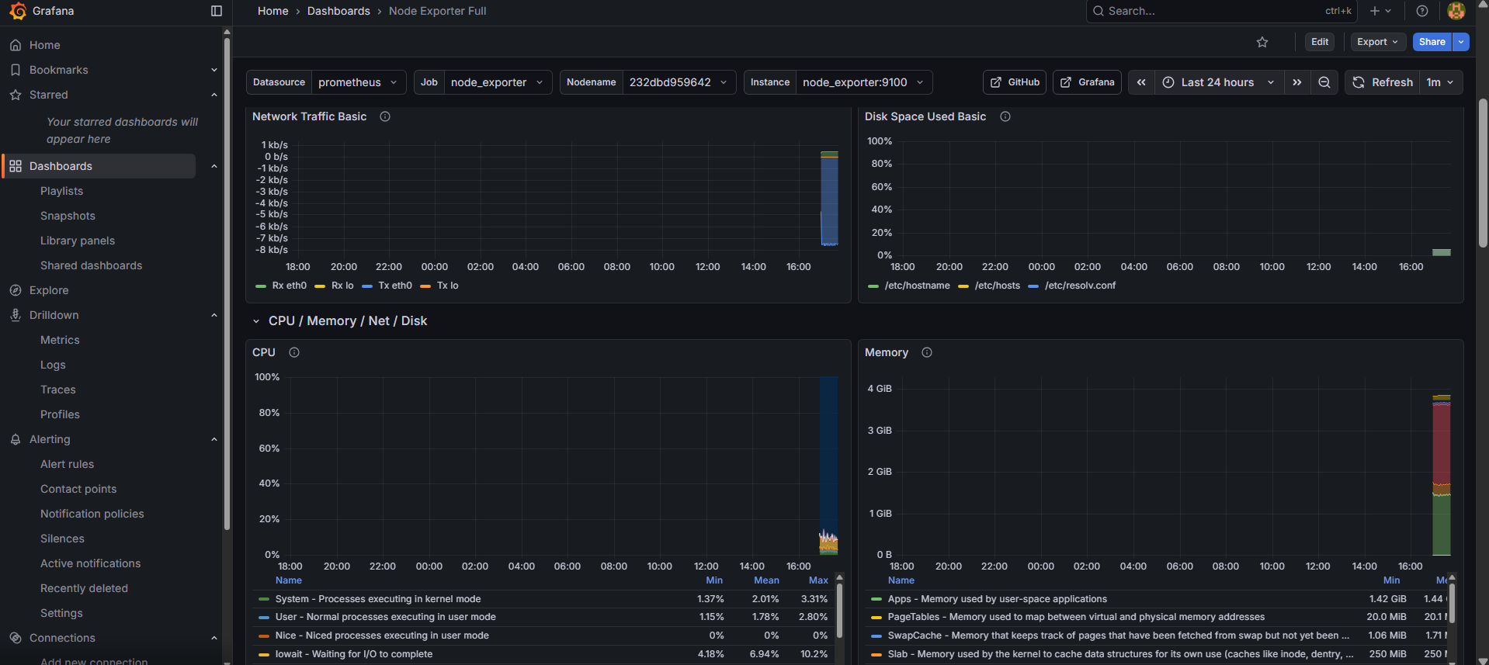

🔍 3. Verify Node Exporter Metrics (Optional)
If you want to check if node_exporter is working:
In Prometheus UI
Go to: http://localhost:9090
Query:
# node_cpu_seconds_total
If you see time-series data → node_exporter is working.
