**MINIPROJECT LOGBOOK**

GROUP MEMBERS

1. Omkar Sawant

2. Anmol Sawlani

3. Rushikesh Sarap

Supervisor

Prof. Dr. Jayant Gadge

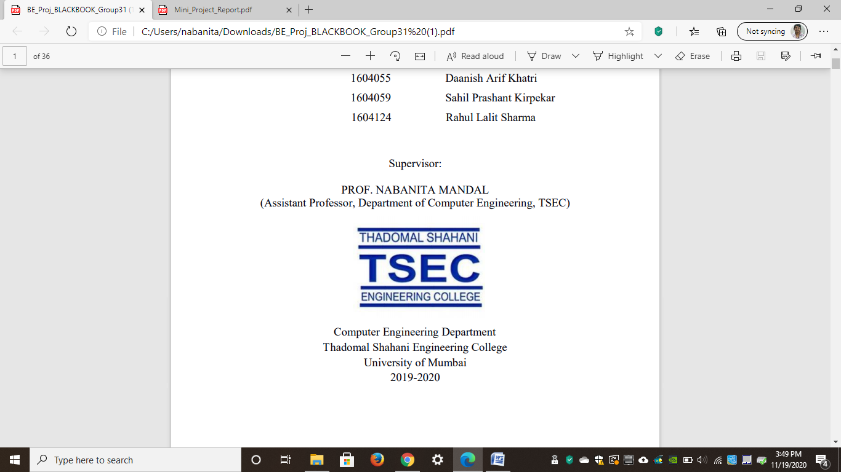

**Computer Engineering Department**

**Thadomal Shahani Engineering College**

**Bandra(w), Mumbai - 400 050**

**University of Mumbai**

**(AY 2025-26)**

**STUDENT INFORMATION**

## Project Title: AI Chatbot for college admission

|  |  |  |  |
| --- | --- | --- | --- |
|  | **Student 1** | **Student 2** | **Student 3** |
| **Roll No** | 2303154 | 2303156 | 2303151 |
| **Name** | Omkar Sawant | Anmol Sawlani | Rushikesh Sarap |
| **Class with Division** | C3 | C3 | C3 |
| **Contact No.** | 94219 40948 | 77983 13004 | 98921 18649 |
| **E-mail** | sos75268@gmail.com | anmolksawlani12@gmail.com | rajendrasarap4070@gmail.com |
| **Address** | A6, 2-14Mangalmurti CHS., | Bk no 293, near Vidhata APT, | 1401, New Navneet Sadan phase-2, |
| Sector 18A, Nerul, | Awatchowk, Khemani, | Sai Vihar, T. P. Road, |
| Navi Mumbai - 400706 | Ulhasnagar - 421002 | Bhandup (W) - 400078. |
|  |  |  |

# DECLARATION

I declare that this project represents my ideas in my own words and wherever others' ideas or words have been included, I have adequately cited and referenced the original sources. I also declare that I have adhered to all principles of academic honesty and integrity and have not misrepresented or fabricated or falsified any idea/data/fact/source in my project work. I promise to maintain minimum 75% attendance, as per the University of Mumbai norms. I understand that any violation of the above will be cause for disciplinary action by the Institute.

Yours Faithfully

1. Omkar Sawant

2. Anmol Sawlani

3. Rushikesh Sarap

(Signature of Students)

# Letter of Acceptance

I undersigned, Prof. Dr. Jayant Gadge working in Computer Engineering department, willing to guide the project titled AI chatbot for college admission

for the mini project-1B Semester IV respectively for the academic year 2025-26. The names of the students are:

1. Omkar Sawant

2. Anmol Sawlani

3. Rushikesh Sarap

Dr. Jayant Gadge Prof. Vaibhav Ambhire Dr. Tanuja Sarode

(Project Guide) (Mini Project Coordinator) (HOD Computer)

.

**SCHEDULE FOR MINI PROJECT**

|  |  |  |  |  |
| --- | --- | --- | --- | --- |
| **Date** | **Week** | **Contents** | **Remark** | **Guide Sign** |
|  | 1 | Formulation of problem statement |  |  |
|  | 2 | Study of Literature review |  |  |
|  | 3 | Drawing flowchart of the website |  |  |
|  | 4 | Coding |  |  |
|  | 5 | Design user interface |  |  |
|  | 6 | Implemented real-time Admission help chatbot |  |  |
|  | 7 | Final changes |  |  |
|  | 8 | Report writing |  |  |
|  | 9 | Log Book writing |  |  |
|  | 10 |  |  |  |
|  | 11 |  |  |  |
|  | 12 |  |  |  |

**PROGRESS/ATTENDANCE REPORT**

|  |  |
| --- | --- |
| Title of the Project: AI chatbot for college admissions | |
| Name of Student 1: Omkar Sawant |
| Name of Student 2: Anmol Sawlani |
| Name of Student 3: Rushikesh Sarap |
| Name of the Supervisor: Dr. Jayant Gadge |

|  |  |  |  |  |  |
| --- | --- | --- | --- | --- | --- |
| Sr. No | Date | Attendance | | | Progress/Suggestion |
|  |  | 1 | 2 | 3 |  |
| 1 |  | P | P | P | Formulation of problem statement |
| 2 |  | P | P | P | Study of Literature review |
| 3 |  | P | P | P | Drawing block diagram |
| 4 |  | P | P | P | Design user interface |
| 5 |  | P | P | P | Constructing Backend |

|  |  |  |  |  |  |
| --- | --- | --- | --- | --- | --- |
| 6 |  | P | P | P | Integrating VectorDB and Embedding Model |
| 7 |  | P | P | P | Report writing |
| 8 |  | P | P | P | Log Book writing |
| 9 |  |  |  |  |  |
| 10 |  |  |  |  |  |
| 11 |  |  |  |  |  |
| 12 |  |  |  |  |  |

Sign of the Supervisor