CHATBOT FOR COLLEGE ADMISSION PROCESS

Submitted in partial fulfillment of the requirements of the degree
BACHELOR OF ENGINEERING INCOMPUTER ENGINEERING

By

Rushikesh Sarap 2303151
Omkar Sawant 2303154
Anmol Sawlani 2303156

Supervisor
Dr Jayant Gadge

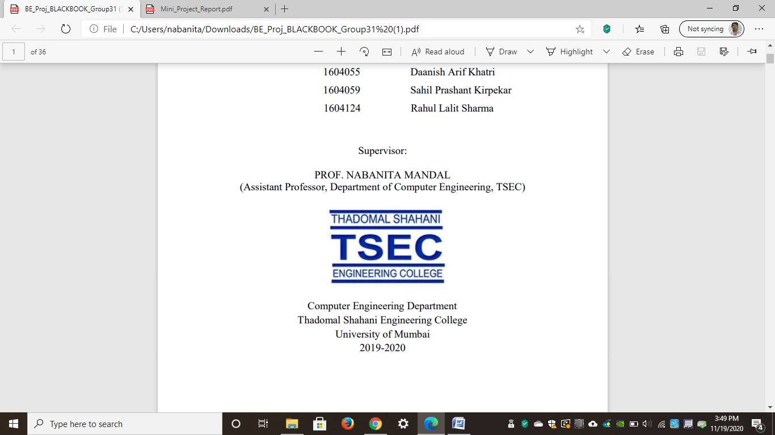

Computer Engineering Department
Thadomal Shahani Engineering College
Bandra(W), Mumbai - 400 050
University of Mumbai
(AY 2025-26)

CERTIFICATE

This is to certify that the Mini Project entitled “Chatbot for college admission process” is a bonafide work of Rushikesh Sarap 2303151, Omkar Sawant 2303154, Anmol Sawlani 2303156 submitted to the University of Mumbai in partial fulfillment of the requirement for the award of the degree of “Bachelor of Engineering” in “Computer Engineering”.

Prof. Jayant Gadge
Supervisor

Dr. Tanuja Sarode Dr. G. T. Thampi
(Head of Department) (Principal

Mini Project Approval

This Mini Project entitled “Chatbot for College Admission Process” By Rushikesh Sarap 2303151, Omkar Sawant 2303154, Anmol Sawlani 2303156 is approved for the degree of Bachelor of Engineering in Computer Engineering.

Examiners

1………………………………………
(Internal Examiner Name & Sign)

2…………………………………………
(External Examiner name & Sign)

Date:
Place:

Contents

Abstract ii

Acknowledgments iii

List of Figures iv

Introduction 1
  - Introduction
  - Motivation
  - Problem Statement & Objectives
  - Organization of the Report

Literature Survey 3
  - Survey of Existing System
  - Limitation Existing system or research gap
  - Mini Project Contribution

Proposed System 4
  - Introduction
  - Architecture/ Framework
  - Algorithm and Process Design
  - Details of Hardware & Software
  - Experiment and Results
  - Conclusion and Futurework.

References 6

Abstract

The admission process in colleges often involves repetitive queries from students and parents regarding eligibility criteria, courses offered, admission dates, fee structures, and other related information. Handling these queries manually can be time-consuming and may lead to delays in response. To overcome this, a chatbot-based system is developed to automate the admission enquiry process.

This chatbot uses natural language processing (NLP) techniques and predefined responses to interact with users in a conversational manner. It provides instant replies to common admission-related questions and guides users with accurate information about courses, application procedures, and deadlines. The system can be integrated into the college website or mobile application, making it accessible anytime and reducing the workload on administrative staff.

By implementing this chatbot, colleges can enhance user experience, improve communication efficiency, and ensure that students receive timely and reliable information throughout the admission process.

Acknowledgement

We would like to express our gratitude and thanks to Prof. Jayant Gadge for his valuable guidance and help. We are indebted for his guidance and constant supervision as well as for providing necessary information regarding the project. We would like to express our greatest appreciation to our principal Dr. G.T. Thampi and head of the department Dr. Tanuja Sarode for their encouragement and tremendous support. We take this opportunity to express our gratitude to the people who have been instrumental in the successful completion of the project.

Rushikesh Sarap
Omkar Sawant
Anmol Sawlani

List of Figures

Figure 3.1: Architecture diagram of website 4
Figure 3.2: Flow of website 5
Figure 3.3: Result page on website 7
Figure 3.4: Result Page with query 7

Chapter 1
Introduction

This chapter explains the aim, objectives, and scope of the proposed system.

Introduction
In recent years, chatbots have become one of the most effective tools for providing automated communication and information assistance. A chatbot for the college admission enquiry process is designed to respond instantly to students’ questions related to admissions, courses, fees, deadlines, and faculty details. The chatbot aims to reduce the workload on administrative staff and offer 24/7 assistance to students. It uses predefined responses and artificial intelligence concepts to interact with users in a conversational manner through a simple and user-friendly interface.

Motivation
Every year, colleges receive thousands of admission-related queries through phone calls, emails, and in-person visits. Handling these manually takes a lot of time and resources, often causing delays and confusion. Students also face difficulties getting timely responses, especially after office hours.

To overcome these challenges, a chatbot can act as an automated digital assistant that provides accurate and quick answers anytime. This motivation led to the development of a College Admission Enquiry Chatbot that improves communication, saves time, and enhances the admission experience for both students and staff.

Problem Statement & Objectives

Problem Statement

Students and parents often find it difficult to obtain instant and accurate information about college admissions, such as eligibility criteria, fee structure, important dates, and required documents. The manual process of enquiry is time-consuming and inefficient.

Objectives:

To design and develop a chatbot that can respond to frequently asked admission related queries.

To provide details such as admission process, fee structure, eligibility criteria, and document requirements.

To ensure 24×7 availability of information to prospective students.

To reduce the workload on administrative staff.

Organization of the Report
This report is organized as follows:
- Chapter 1 gives an overview of the project, including motivation, problem statement, and objectives.
- Chapter 2 presents a literature survey of existing systems, their limitations, and highlights the contribution of this mini project.
- Chapter 3 describes the proposed system, including its architecture, algorithms, hardware and software details, experimental results, and conclusion.

Chapter 2
Literature Survey

This chapter explains the concepts used in this project, study of existing system and contribution of this project

Survey of Existing System
In the existing system, admission enquiries are handled manually through emails, phone calls, or in-person visits to the college office. Some institutions use simple FAQ web pages, but they are static and do not support interactive communication. A few advanced colleges have started implementing chatbots, but most are limited to basic responses without personalization or dynamic data updates.

Manual systems are time-consuming, require human involvement, and are not available round the clock.

Limitation of existing system
- Lack of real-time and interactive communication.
- No support for handling multiple queries simultaneously.
- Limited access to information outside office hours.
- High dependency on human staff for responses.
- Absence of a centralized automated platform for admission enquiries.

Mini Project Contribution

This mini project introduces a chatbot that can provide instant responses to admission-related queries. The chatbot contains pre-fed information about admission dates, fee structure, eligibility criteria, faculty details, and required documents.

It improves accessibility by being available 24×7 and reduces the effort of the college’s administrative department. The chatbot enhances user experience by allowing natural text-based interaction through a simple web or console interface.

Chapter 3
Proposed System

This chapter consists of detailed description about the methodology used, the hardware and software components, the tools used and the screenshots of the project

Introduction
The proposed College Admission Enquiry Chatbot is a conversational system that assists students by answering queries related to the admission process. The chatbot is programmed to understand user input and match it with stored responses from a knowledge base. It can handle queries such as:
- “What is the last date for admission?”
- “What is the fee structure for Computer Engineering?”
- “What documents are required during admission?”
- “Who is the Head of Computer Engineering Department?”

This system provides immediate, reliable, and consistent responses to all users.

Architecture
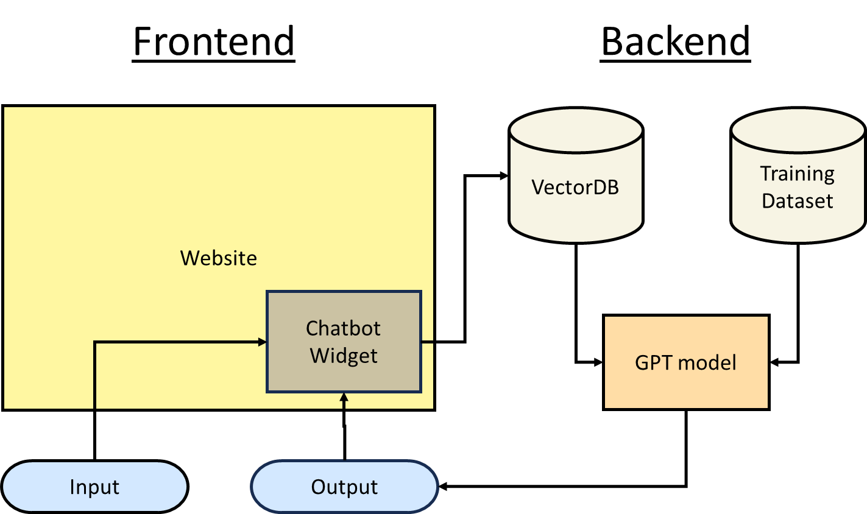
Figure 3.1: Architecture diagram of website

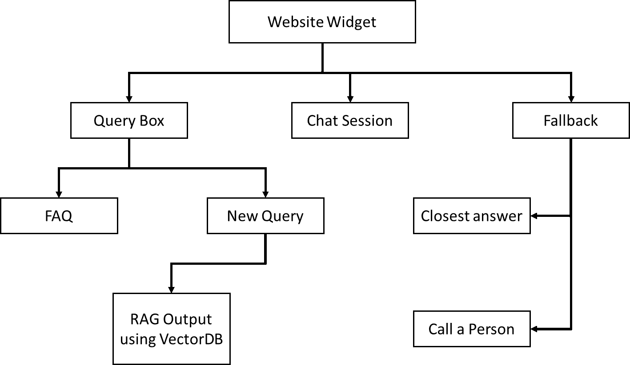
Figure 3.2: Flow of website

Algorithm and Process Design

Formulating the Problem Statement:
In this step, we identified the main issue that students face during the admission process — difficulty in getting quick and accurate answers to their queries. The problem was formulated as the need for an automated chatbot system that can provide instant admission-related information without human assistance.

Understanding the Framework and Requirements:
We studied how chatbots work and what components are needed to build one. We understood the functional requirements like user interaction, question handling, and response generation, along with non-functional requirements such as ease of use and quick response time.

Identifying Tools/Technology to be Used:
For developing the chatbot, we decided to use Python along with Natural Language Toolkit (NLTK) for text processing. We also planned to use a web-based interface for interaction and simple data storage for FAQs and responses.

Finalizing the Features to be Included:
The main features finalized were: responding to frequently asked questions about admission, displaying course details, eligibility criteria, important dates, and contact information. The chatbot was also designed to provide polite greetings and guide users step by step.

Development:
In this phase, we developed the chatbot using Python. We created a database of common queries and responses and programmed the chatbot to match user input with the correct answer. We also worked on making the responses more natural and user-friendly.

Testing:
The chatbot was tested with various admission-related queries to check if it responded accurately and promptly. We corrected mismatched responses and improved question recognition during this phase.

Evaluation:
Finally, we evaluated the chatbot based on accuracy, response time, and user satisfaction. The system successfully provided relevant answers to most queries and proved helpful in reducing the manual workload of admission staff.

Details of Hardware & Software
Hardware Requirements:
- Processor: Intel i3 or higher
- RAM: Minimum 4 GB
- Hard Disk: 100 MB free space
- Display: Any standard monitor

Software Requirements:
- Programming Language: Java Script
- Database: (Optional) SQLite / MySQL
- Operating System: Windows / Linux
- Tools: Pinecone (for VectorDB), Mistral embed model (for embedding), Mistral AI (for creating chat responses)

Results

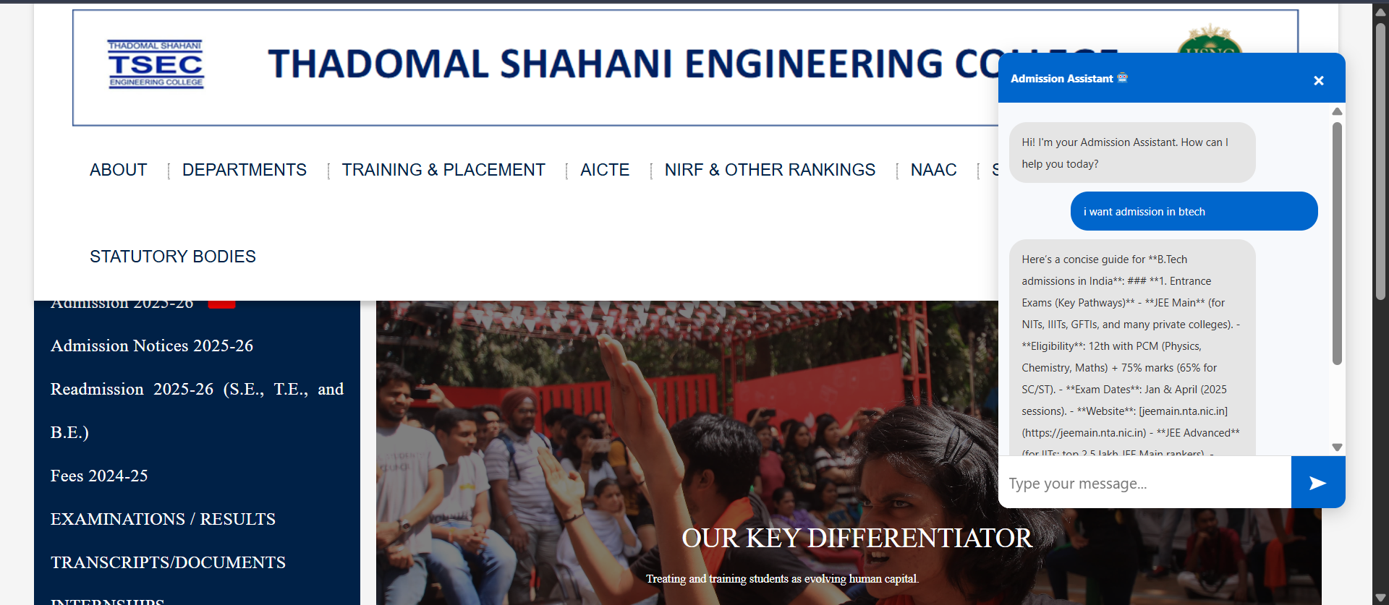
Figure 3.3: Result page on website

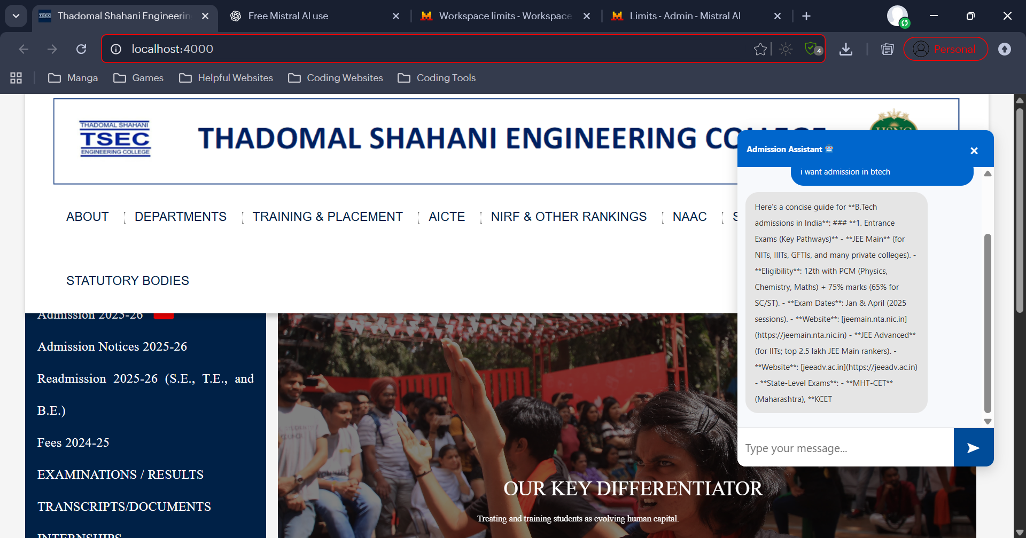
Figure 3.4: Result Page with query

Conclusion and Future Work
The developed College Admission Enquiry Chatbot successfully automates the process of answering admission-related questions. It helps students get instant information about fees, deadlines, and documents without the need for manual support.

This system reduces administrative workload and improves communication between the institution and applicants.

Future Enhancements:
- Integration of voice-based interaction.
- Connection to a live database for real-time updates.
- Addition of multilingual support.

References

[1] P. Lewis et al., ―Retrieval-Augmented Generation for Knowledge-Intensive NLP
Tasks,‖ arXiv preprint, arXiv:2005.11401, May 2020.
[2] N. Reimers and I. Gurevych, ―Sentence-BERT: Sentence Embeddings using Siamese
BERT-Networks,‖ arXiv preprint, arXiv:1908.10084, Aug. 2019.
[3] ―faiss: A library for efficient similarity search and clustering of dense vectors,‖ GitHub,
2017–, [Online]. Available: https://github.com/facebookresearch/faiss. [Accessed: Sep. 22,
2025].
[4] LangChain Developers, ―LangChain Documentation,‖ [Online]. Available:
https://docs.langchain.com. [Accessed: Sep. 22, 2025].
[5] ―sentence-transformers/all-MiniLM-L6-v2 — Model Card,‖ Hugging Face, [Online].
Available: https://huggingface.co/sentence-transformers/all-MiniLM-L6-v2. [Accessed:
Sep. 22, 2025].
[6] ―OpenRouter API Reference and Quickstart,‖ OpenRouter, [Online]. Available:
https://openrouter.ai/docs/api-reference/overview. [Accessed: Sep. 22, 2025].
[7] J. S. Vine, ―pdfplumber — plumb a PDF for detailed information and extract
text/tables,‖ GitHub, [Online]. Available: https://github.com/jsvine/pdfplumber. [Accessed:
Sep. 22, 2025].
[8] ―python-docx — Documentation,‖ [Online]. Available: https://python-
docx.readthedocs.io/en/latest/. [Accessed: Sep. 22, 2025].
[9] ―python-pptx — Documentation,‖ [Online]. Available: https://python-
pptx.readthedocs.io/. [Accessed: Sep. 22, 2025].
[10] The Pandas Development Team, ―pandas — Python Data Analysis Library —
Documentation,‖ PyData, [Online]. Available: https://pandas.pydata.org/docs/. [Accessed:
Sep. 22, 2025].

