**S3 Static Website Hosting: Downtime RCA**

**Step1: Create new bucket on AWS S3**

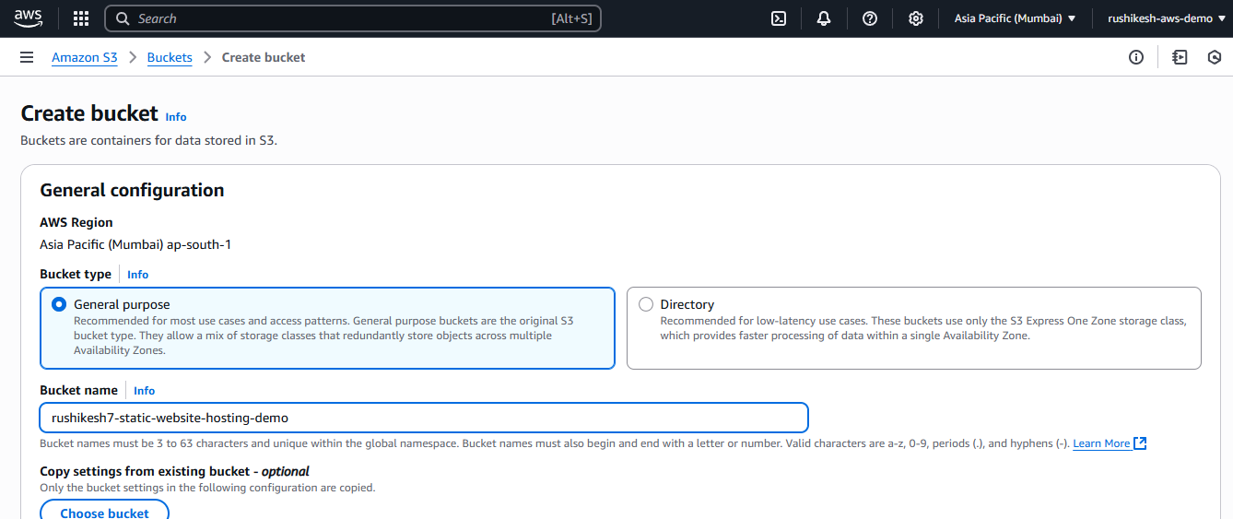

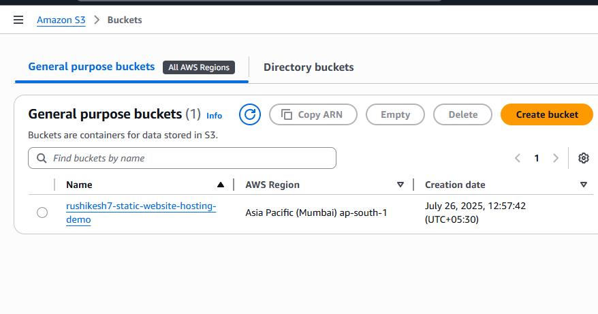

**Step2: Create .html file on local & upload created .html files to S3**

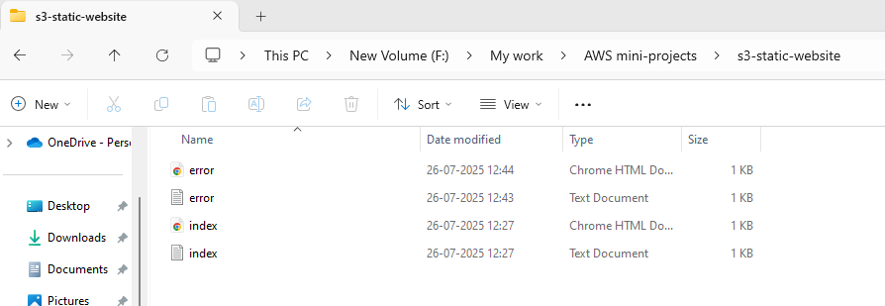

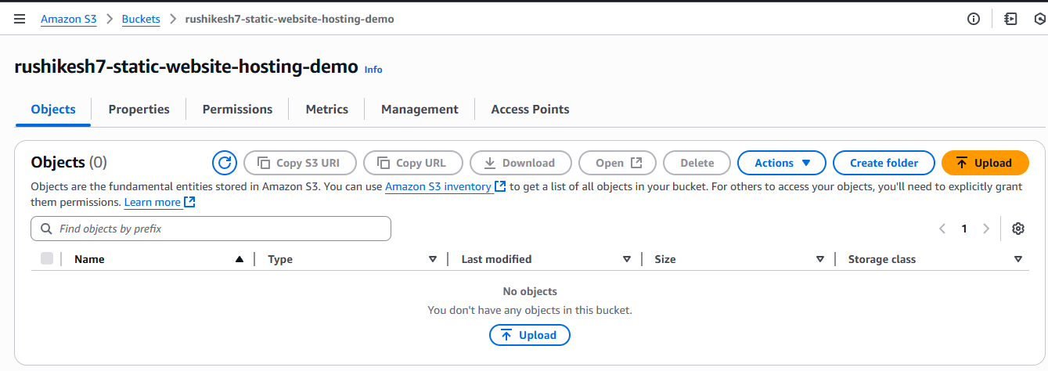

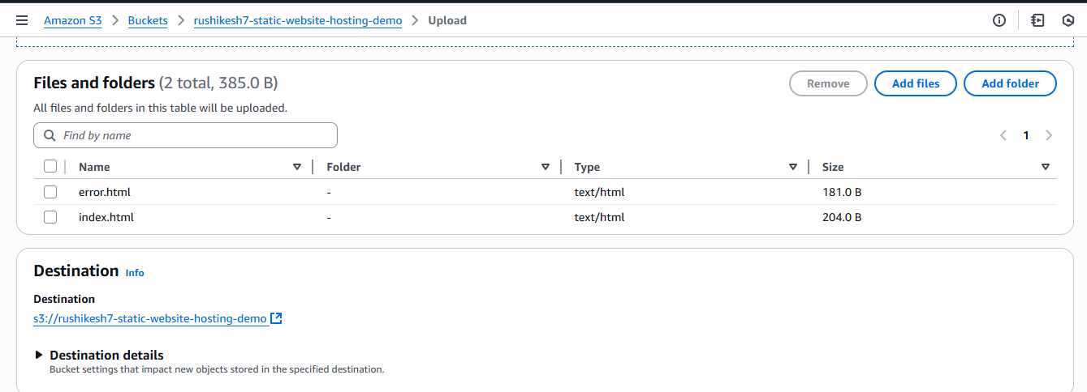

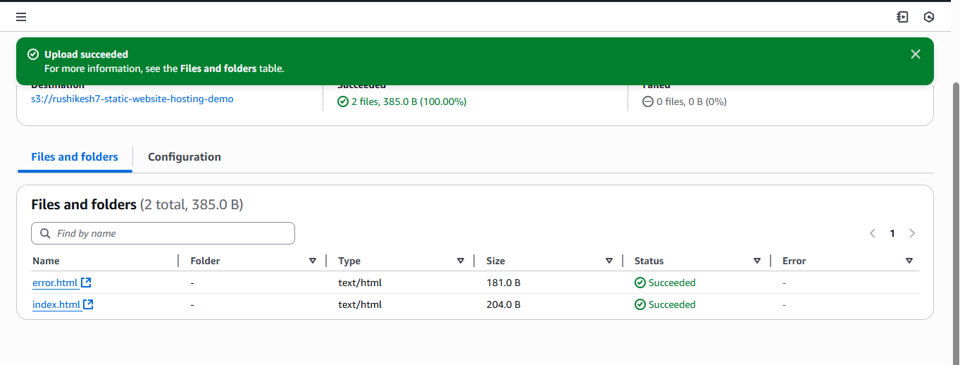

**Step 3: Enable static website hosting in S3**

Properties => Static website hosting => Edit enable =>

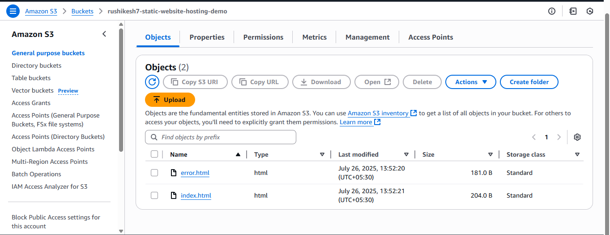

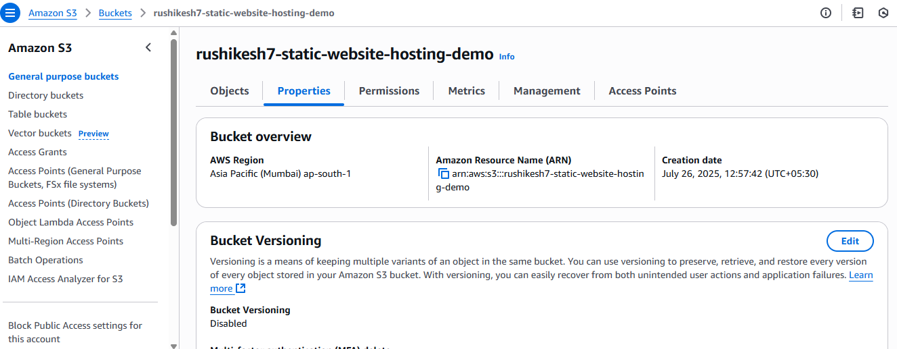

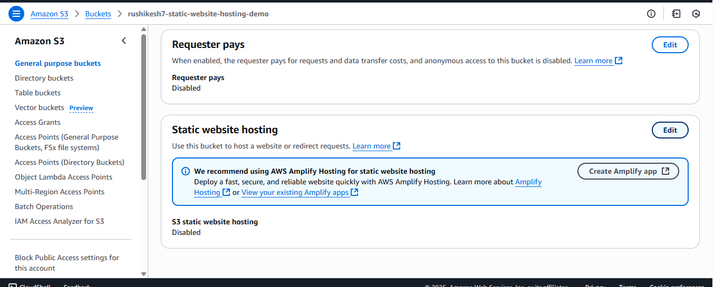

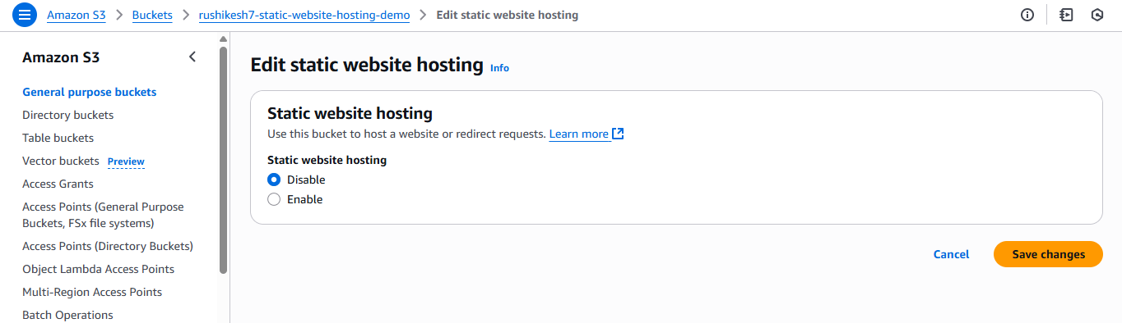

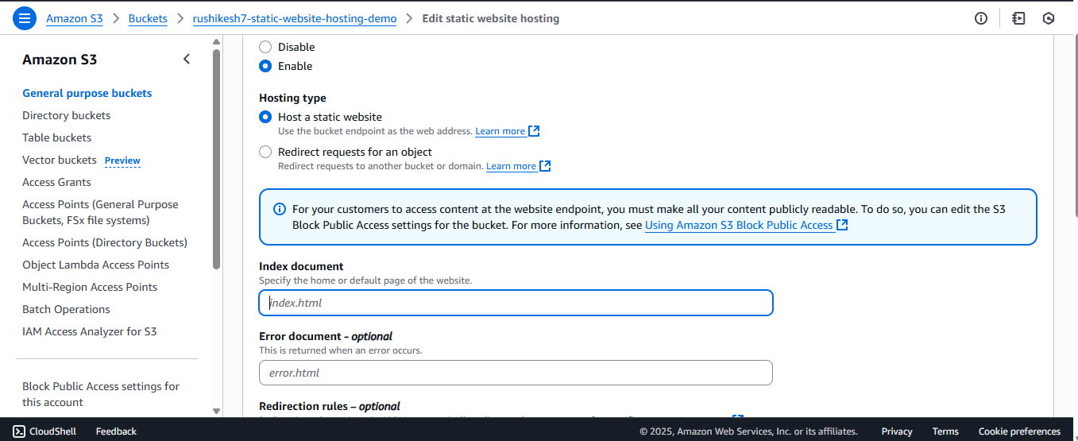

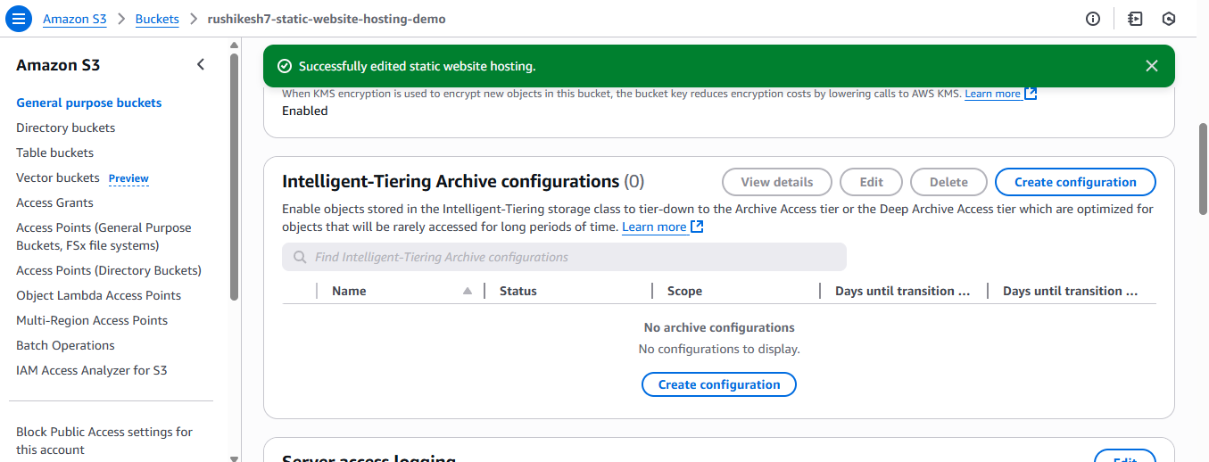

Once you enabled the static website hosting, you can see the bucket website endpoint URL.

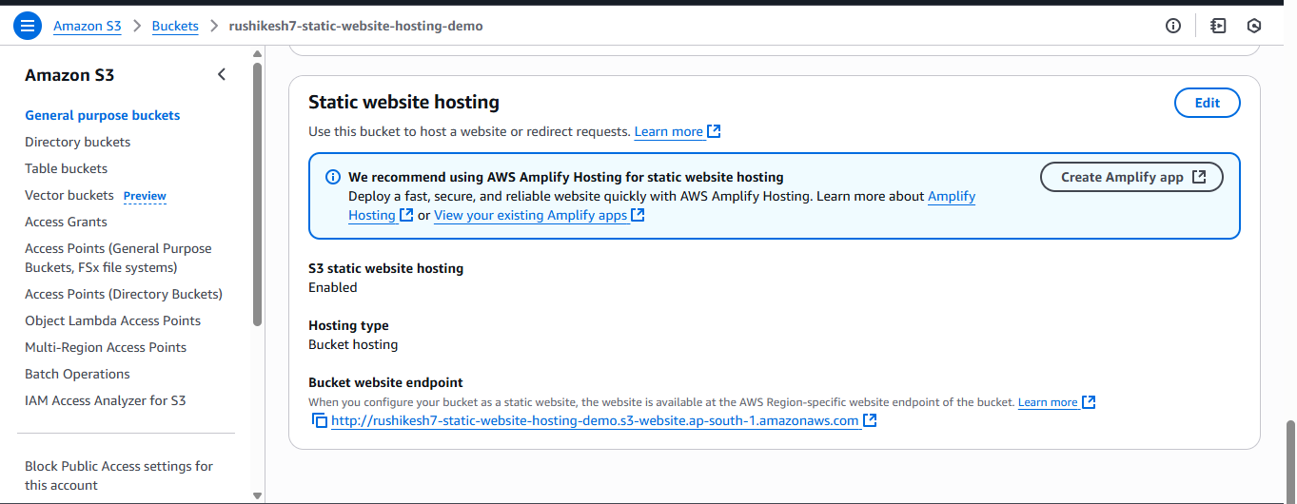

Just to cross verify, you can open that URL in new tab, you will see ‘403 Forbidden’ access denied message.

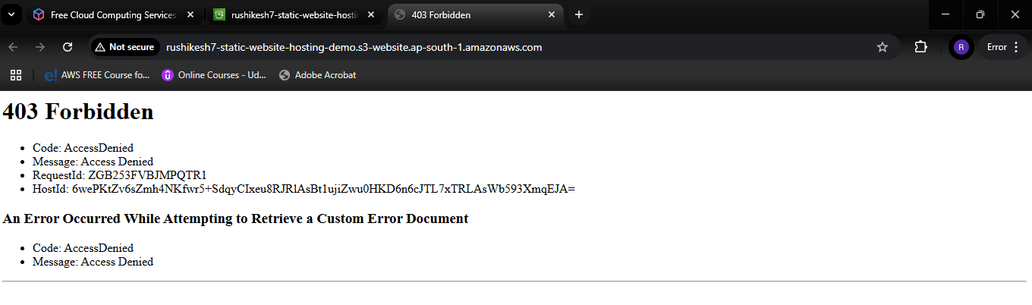

Step4: Make your S3 website public (Bucket Policy setup)

Buckets => Permissions => Bucket Policy => Edit

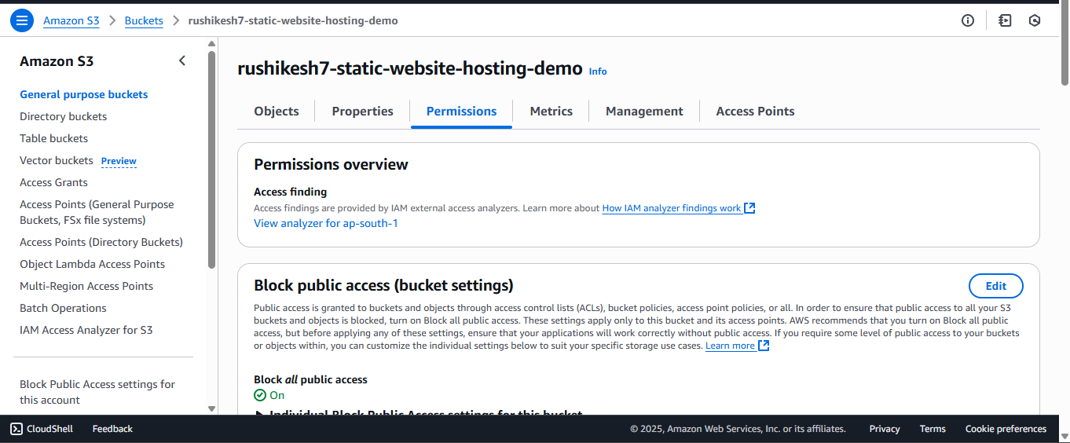

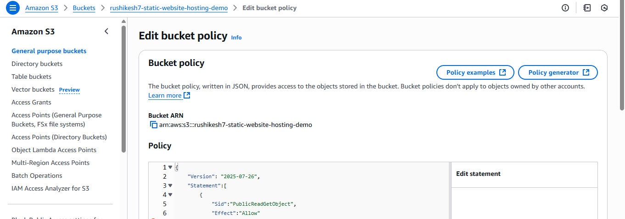

JSON code

{

"Version": "2012-10-17",

"Statement":[

{

"Sid":"PublicReadGetObject",

"Effect":"Allow",

"Principal":"*",

"Action":"s3:GetObject",

"Resource":"arn:aws:s3:::rushikesh7-static-website-hosting-demo/*"

}

]

}

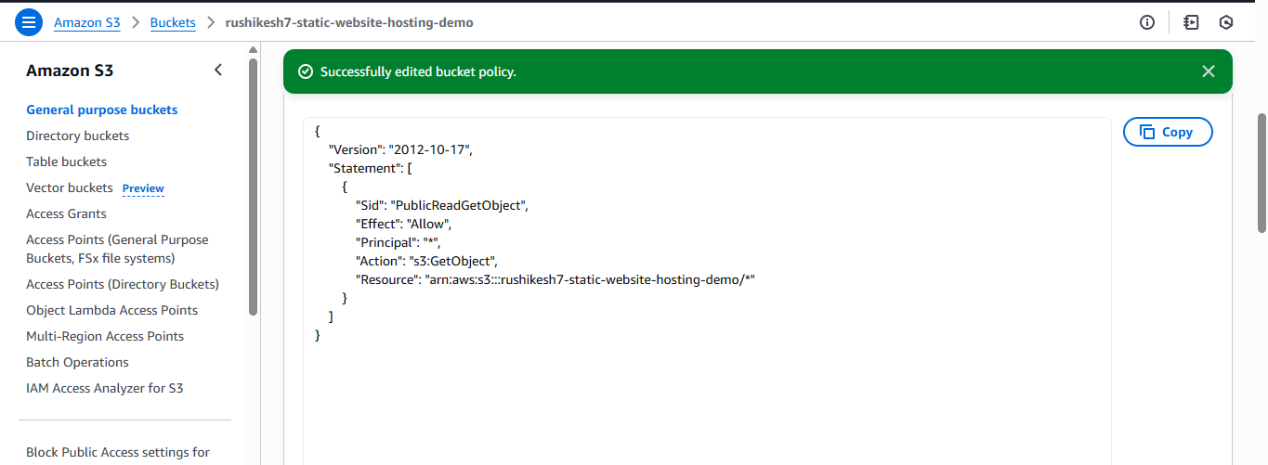

Now, we can try to open Endpoint URL

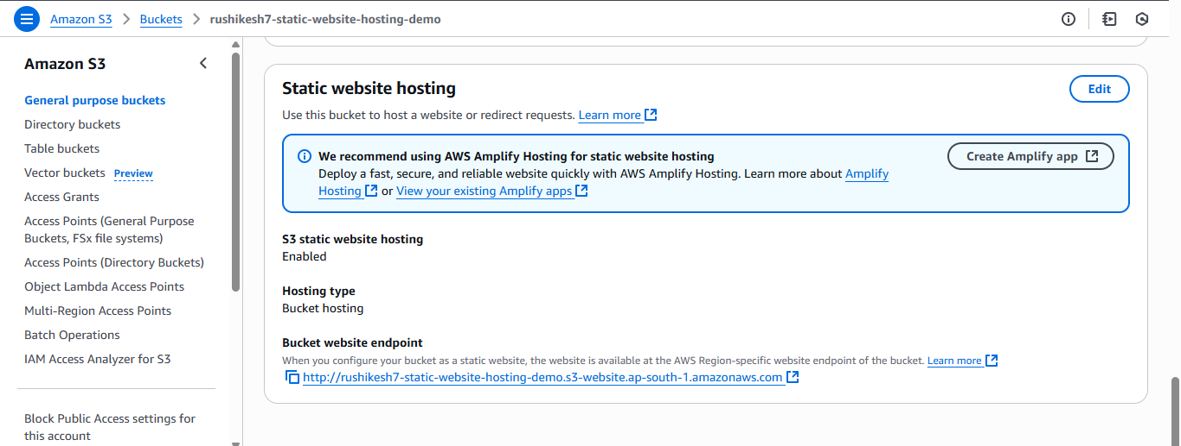

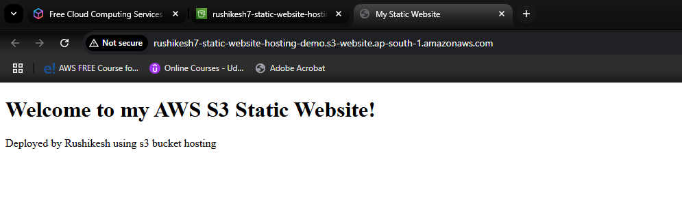

**Step 5A: Simulate a Downtime & Perform RCA**

Goal:

Break the website => investigate symptoms =>identify cause => resolve => document RCA

Steps:

First, rename or delete the object index.html, then hit/open the endpoint URL, it should show error page.

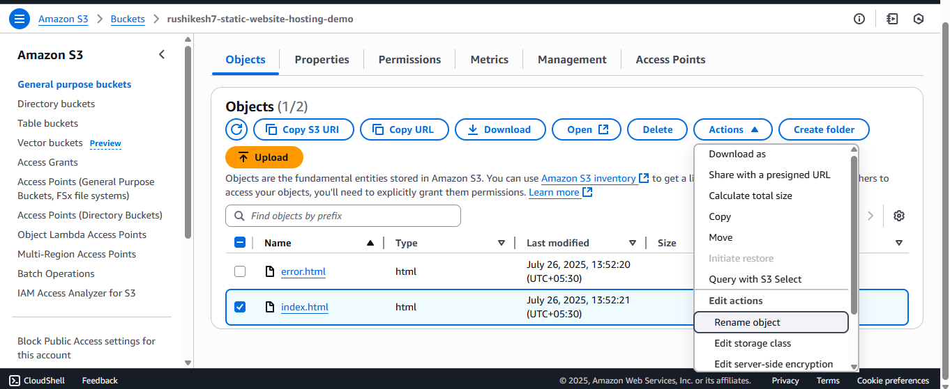

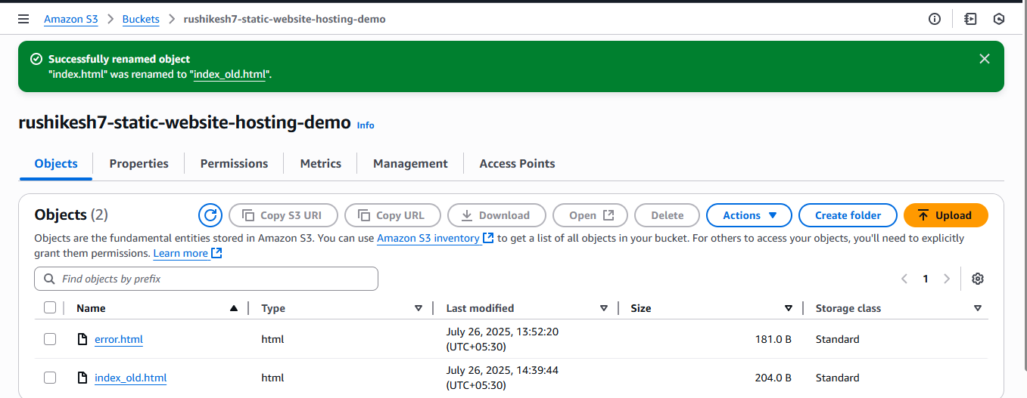

Now, let’s hit the same endpoint URL again for index page & see the result.

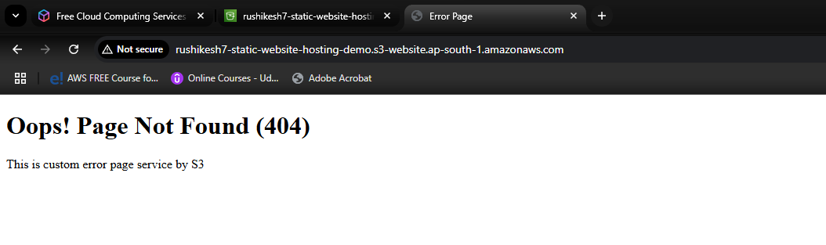

**Step 5B: Perform RCA**

Team receiving the complaint:

“Website is showing error page instead of homepage.”

Check 1: Is the S3 bucket accessible publicly?

Go to your bucket => Permissions => check bucket setting => Block all public access (On/Off) & bucket policy.

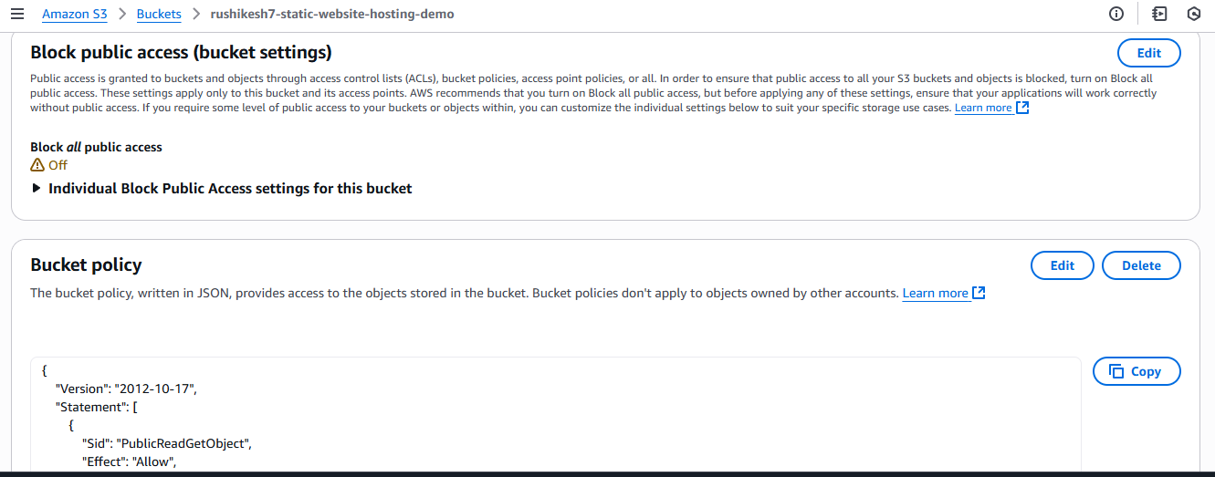

Ans: Yes, its accessible publicly.

Check 2: Are index and error docs correctly configured in static website setting?

Click on your bucket => Properties => Static Website Hosting => Edit => check the docs name correctly mentioned.

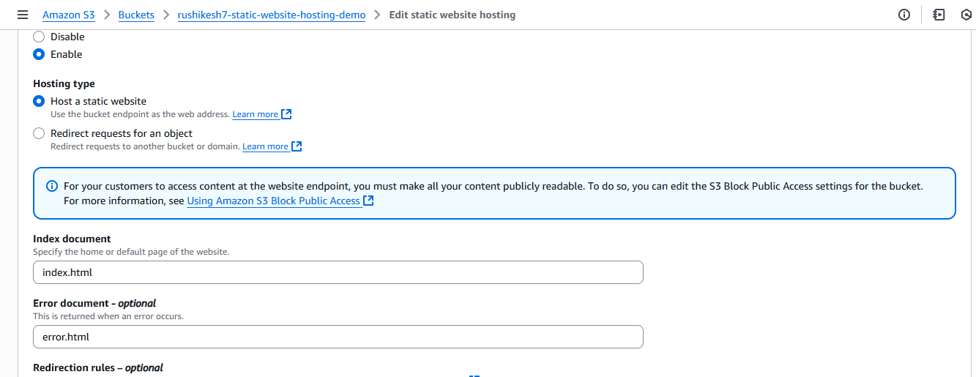

Yes, its configured correctly.

Check 3: Is index.html file still present in the bucket?

Go to the buckets => click your bucket => check the file is present or not

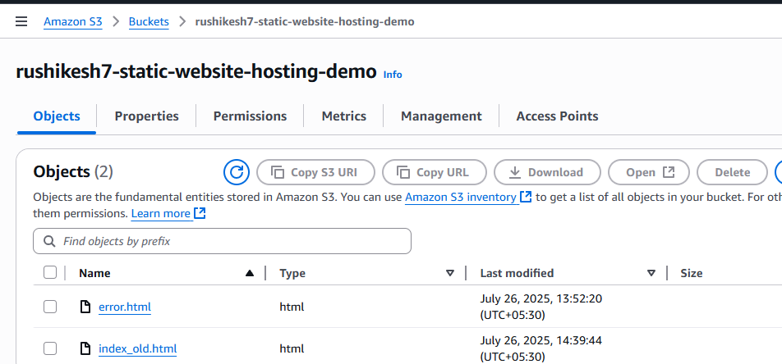

Here is the root cause of the issue, file is not present or file name is changed.

Last check 4: Any recent changes in the bucket that might have caused this issue?

**Step 5C: Resolve the issue**

Once we diagnosed that the index.html file is missing/renamed:

* **Re-upload or restore the file** to bring the website back online.
* Confirm the site works again

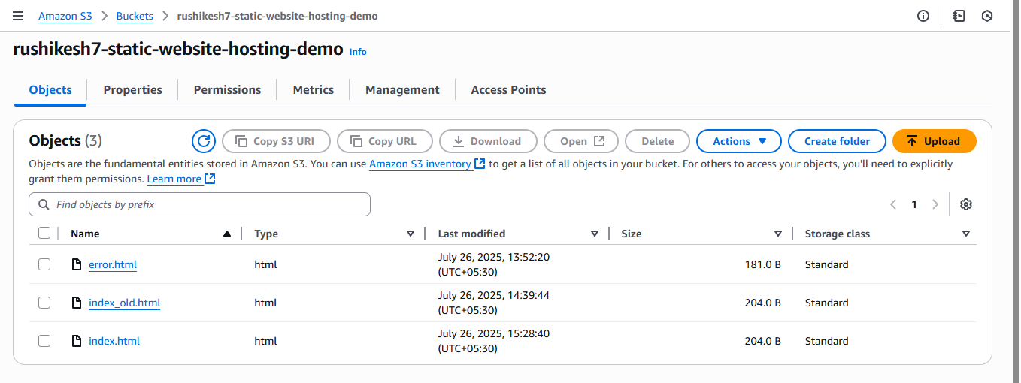

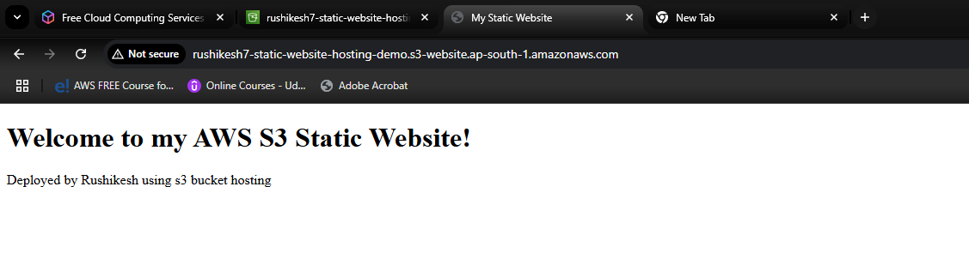

**Step 5D: RCA Report**

**Root Cause Analysis (RCA)**

**Issue:** Website showed error page instead of homepage

**Timeline:**

-10:00 AM: User reported the issue: website is showing error page

-10:05 AM: Investigation started

-10:08 AM: Found that index.html was missing from the S3 bucket

-10:10 AM: index.html re-uploaded, website restored

**Root Cause:**

-index.html was accidentally deleted or renamed.

**Resolution:**

-Restored index.html file

-Website returned to normal

**Prevention Action:**

* Enable versioning on the bucket to recover deleted objects
* Set up CloudWatch Event to alert on delete action