##### EXPERIMENT NO:-04

**Aim:** **Apply DML Commands for the specified system.**

**Theory:**

The structured query language (SQL) commands deal with the manipulation of data present in the database that belongs to the DML or Data Manipulation Language. This includes most of the SQL statements.

## Examples of DML

The examples of DML in the Database Management System (DBMS) are as follows −

* SELECT − Retrieve data from the database.
* INSERT − Insert data into a table.
* UPDATE − Update existing data within a table.
* DELETE − Delete records from a database table.

## Syntax for DML Commands

The syntax for the DML commands are as follows –

### INSERT

Insert command is used to insert data into a table.

The syntax for insert command is as follows −

**Syntax**

Insert into <table_name> (column list) values (column values);

For example, if we want to insert multiple rows to the Employee table, we can use the following command −

**Example**

Insert into Employee(Emp_id, Emp_name) values (001, “ bhanu”);

Insert into Employee(Emp_id, Emp_name) values (002, “ hari”);

Insert into Employee(Emp_id, Emp_name) values (003, “ bob”);

### SELECT

Select command is used to retrieve data from the database.

The syntax for the select command is as follows −

**Syntax**

SELECT * from <table_name>;

For example, if we want to select all rows from the Employee database, we can use the following command −

**Example**

SELECT * from Employee;

### DELETE

Delete command is used to delete records from a database table.

The syntax for the delete command is as follows -

**Syntax**

 Delete from <table_name>WHERE condition;

For example, if we want to delete an entire row of employee id 002, we can use the following command −

**Example**

DELETE from Employee WHERE Emp_id=002;

### UPDATE

Update command is used to update existing data within a table.

The syntax for the update command is as follows -

**Syntax**

UPDATE <table_name> SET column_number =value_number WHERE condition;

For example, if we want to update the name of the employee having the employee id 001, we can use the command given below −

**Example**

UPDATE Employee SET Emp_name= Ram WHERE Emp_id= 001;

**Application of DML commands on Specified Case study with Input & Output:**

**Command :-**  **INSERT :** to add a new record in a table.

**Sample Insert Example on patient table:**

insert into patient values(7770,'ROSHAN','A+',31,30,STR_TO_DATE('14-03-1990', '%d-%m-%Y'),'HIV',186);

insert into patient values(7771,'SALMAN','O+',27,40,STR_TO_DATE('14-07-1994', '%d-%m-%Y'),'NEMIA',186);

insert into patient values(7772,'AJAY','AB+',44,44,STR_TO_DATE('18-08-1997', '%d-%m-%Y'),'LEUKEMIA',987);

insert into patient values(7773,'UMESH','AB+',35,59,STR_TO_DATE('21-01-1985', '%d-%m-%Y'),'SICKEL-CELL',256);

insert into patient values(7774,'SARITA','B+',24,55,STR_TO_DATE('11-02-1997', '%d-%m-%Y'),'CANCER',369);

insert into patient values(7775,'TANVI','A-',19,41,STR_TO_DATE('01-01-2002', '%d-%m-%Y'),'LIVER',186);

insert into patient values(7776,'DEEPAK','O+',29,34,STR_TO_DATE('05-11-1992', '%d-%m-%Y'),'HEMOPHILIA',895);

**Sample Insert Example on p_mobile_no table:**

insert into p_mobile_no values(8564875621,7770);

insert into p_mobile_no values(9585875624,7770);

insert into p_mobile_no values(9264875622,7771);

insert into p_mobile_no values(8864875625,7773);

insert into p_mobile_no values(8964875623,7773);

insert into p_mobile_no values(7764875624,7774);

insert into p_mobile_no values(8664487623,7775);

insert into p_mobile_no values(8294875629,7776);

insert into p_mobile_no values(9562652620,7776);

insert into p_mobile_no values(9052175626,7776);

**Sample Insert Example on donor table:**

insert into donor values(369,'SUDHIR',23,40,'O+','NONE',STR_TO_DATE('20-06-1999', '%d-%m-%Y'));

insert into donor values(895,'ANANYA',42,45,'AB+','NONE',STR_TO_DATE('01-06-1980', '%d-%m-%Y'));

insert into donor values(256,'KABIR',24,35,'B+','NONE',STR_TO_DATE('12-12-1990', '%d-%m-%Y'));

insert into donor values(987,'SUBADHA',32,38,'O+','NONE',STR_TO_DATE('06-05-1990', '%d-%m-%Y'));

insert into donor values(186,'RAUNAK',43,50,'A-','NONE',STR_TO_DATE('15-02-1980', '%d-%m-%Y'));

**Sample Insert Example on d_mobile _no table:**

insert into d_mobile_no values(8564875620,369);

insert into d_mobile_no values(8064875621,369);

insert into d_mobile_no values(9564875628,895);

insert into d_mobile_no values(7774875623,256);

insert into d_mobile_no values(8802487522,987);

insert into d_mobile_no values(8560075621,987);

insert into d_mobile_no values(8025654620,186);

**Sample Insert Example on blood_bank table:**

insert into blood_bank values(474,'Ashirwad blood bank','dadar',7774,256);

insert into blood_bank values(514,'Holy hosp blood bank','bandra',7771,369);

insert into blood_bank values(429,'G.T.hosp blood bank','parel',7776,987);

insert into blood_bank values(298,'K.E. blood bank','dhule',7770,256);

insert into blood_bank values(915,'j.j.hosp. blood bank','byculla',7773,987);

insert into blood_bank values(310,'R.R.blood bank','thane',7775,186);

insert into blood_bank values(268,'s.t.blood bank','pune',7772,895);

**Sample Insert Example on bb_mobile_no table:**

insert into bb_mobile_no values(9564875624,474);

insert into bb_mobile_no values(9632417894,514);

insert into bb_mobile_no values(8963524176,514);

insert into bb_mobile_no values(7562146255,429);

insert into bb_mobile_no values(8126516264,298);

insert into bb_mobile_no values(9235452122,915);

insert into bb_mobile_no values(8928112478,310);

insert into bb_mobile_no values(9654658754,268);

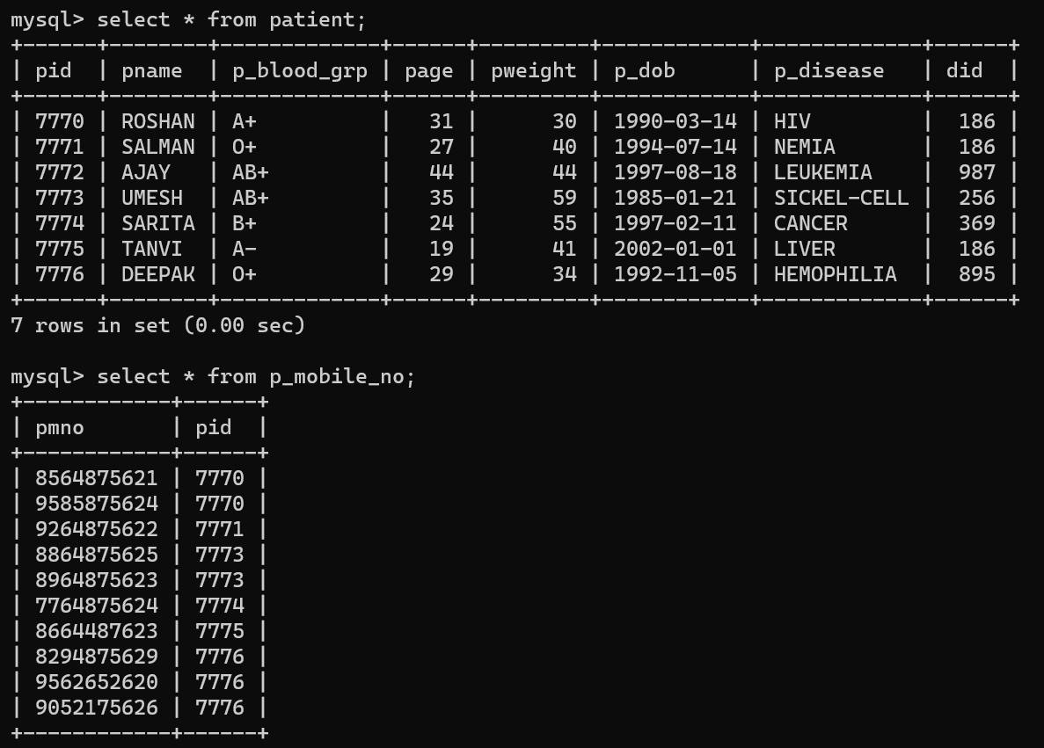

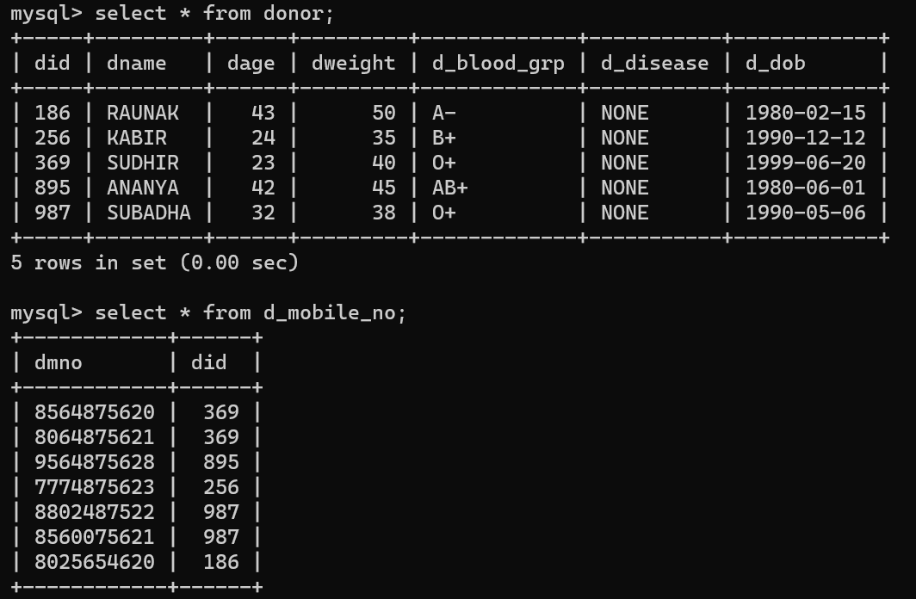

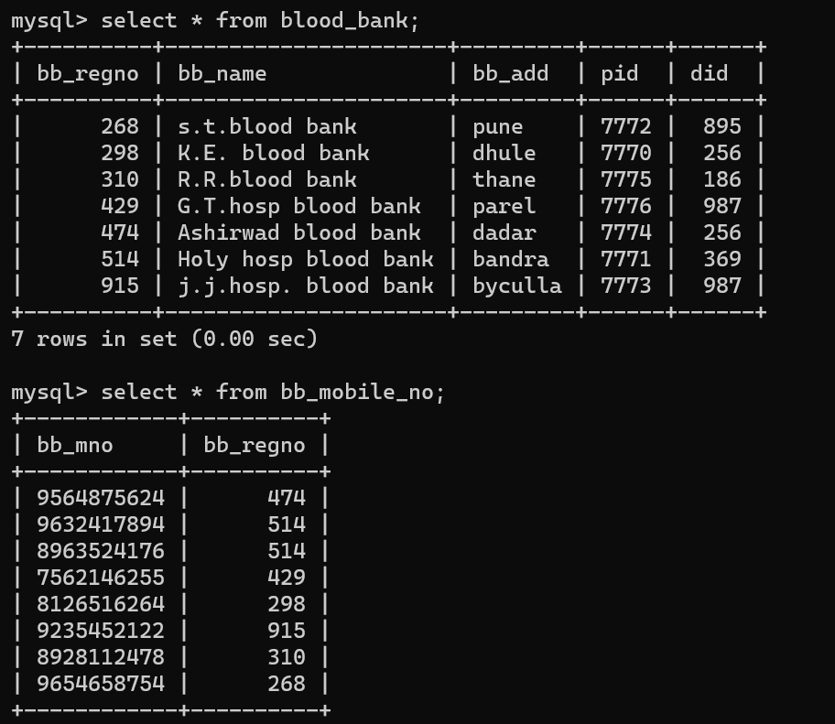

**Command :-**  **Update :** is to update the a column value of a table.

**Q1: SET all patient a weight of 50 .**

Ans : UPDATE patient SET pweight = 50;

**Q2: Increase everybody patient age by 10%.**

Ans : UPDATE SET page= page + (page *.1);

**Q3: Increase weight of patient id 7776 by 10%** .

Ans : UPDATE patient SET pweight= pweight + (pweight *.1) where pid = 7776;

**Q4: Increase weight of patient’s by 10% who has receive blood from did=514.**

Ans : UPDATE patient SET pweight= pweight + (pweight *.1) where did = 514;

**Command :-**  **Delete:** is use to delete row from table.

**Q5. Remove all patient of the blood bank.**

Ans : Delete from patient;

**Q6. Remove patient who has disease as ‘HIV’ from patient.**

Ans : Delete from patient where pdisease = ‘HIV’;

**Command :-**

**Select:**  is use to retrieve information(rows) from table.

Syntax :

SELECT <col-List> FROM <Table-name>

[WHERE <condition> ]

[GROUP BY <col-name>]

[HAVING <condition>]

[ORDER BY <expression>];

**Examples :**

**Q7: Display all patients’s details.**

Ans: select * from patient;

**Q8 : Display details of all Donor.**

Ans: select * from donor;

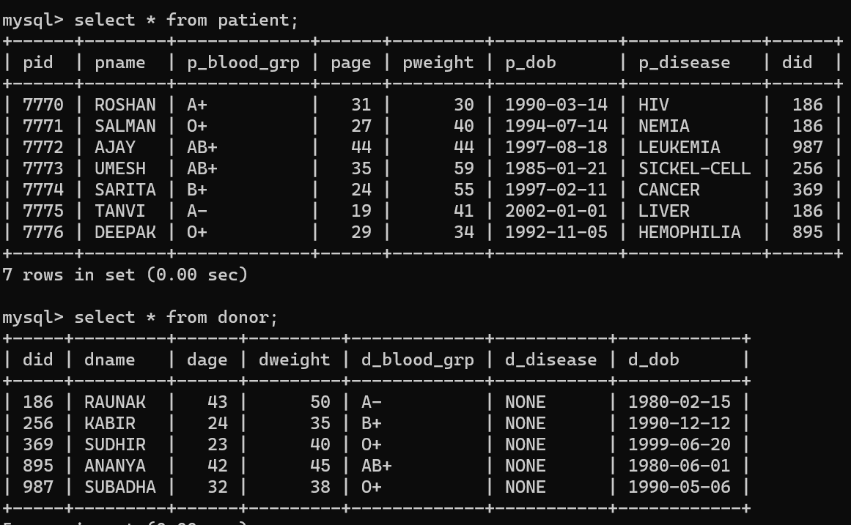

**Q9: Display only patient id and name of the patient of all patients’s .**

Ans: select pid, pname from patient;

**Q10: Display only patient Name and patient id of the patient of all patient’s .**

Ans: select pname, pid from patient;

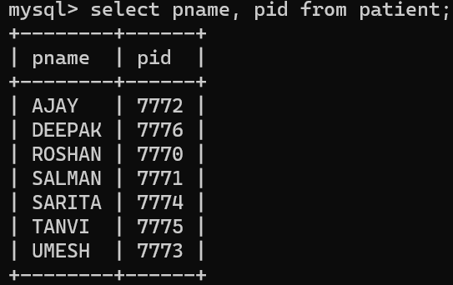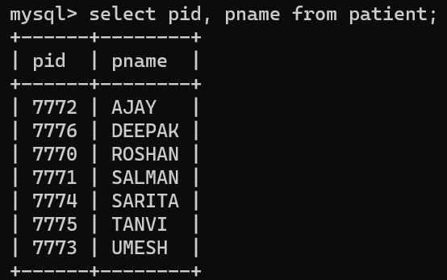

**Q11: List the patient details who has receive blood from did 186;**

Ans: select * from patient where did = 186;

**Q12: List the name and weight of the donors whose age is more than 40.**

Ans: select dname, dage from donor where dage > 40;

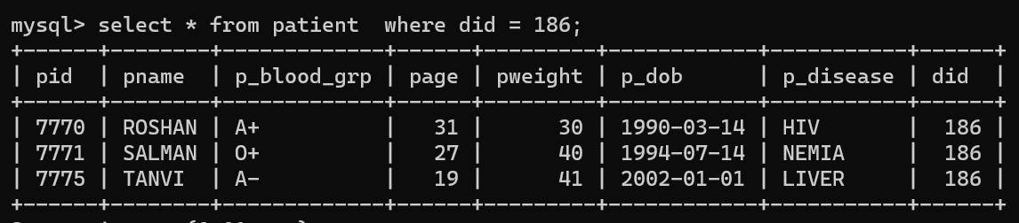

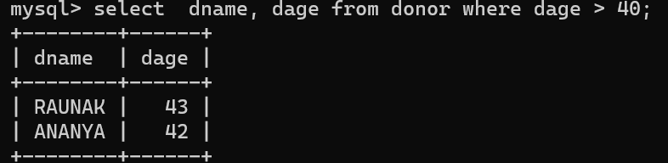

**Q13: List the pid and as blood group AB+.**

Ans: select pid, pname from patient where p_blood_grp = 'AB+';

**Q14: List the names patient has disease ‘LIVER’ in donor 186.**

Ans: select pname from patient where p_disease = ‘LIVER’ and pid = 7775;

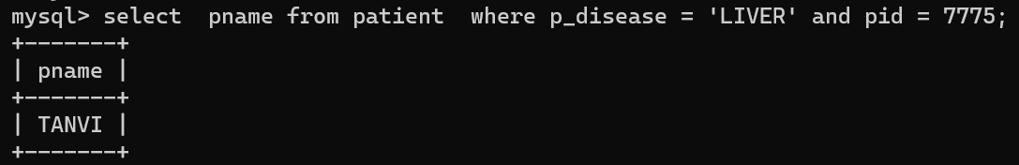 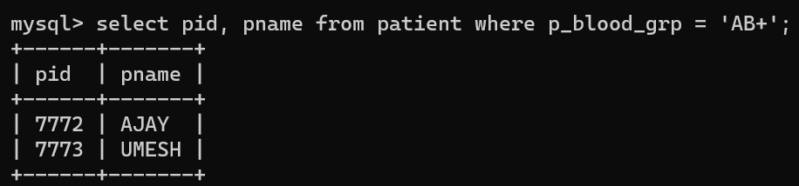

**Q15: List the names of donors has none disease and O+ blood group.**

Ans: select dname from donor where d_disease = ‘NONE’ or d_blood_grp = ‘O+’;

**Q16: List the details of the donors who has born before Sep. 99.**

Ans: select * from donor where d_dob <= ’1999-09-01’;

**Q17 : List the names of donor have not O+ blood group.**

Ans: select dname from donor where d_blood_grp <> ‘O+’;

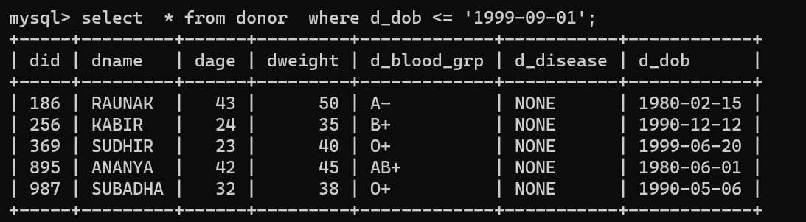

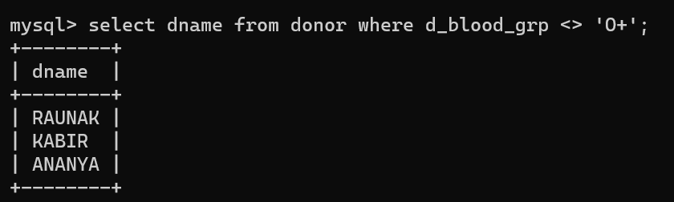

**Use of Special operator:**

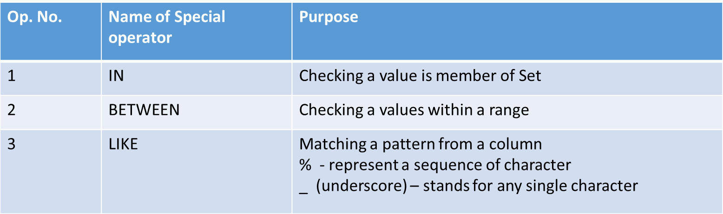

**Q18: List the names of the blood bank whose reg no are 514,298, 915,268:**

Ans: Select bb_name from blood_bank where bb_regno IN (514,298, 915,268);

**Q19: List the patient details not receive blood from donor did 256,186 and 895.**

Ans : Select * from patient where did NOT IN (256,186,895);

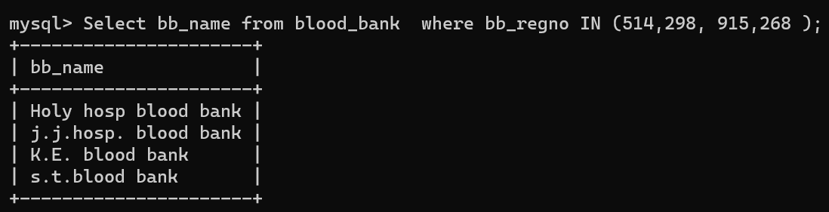

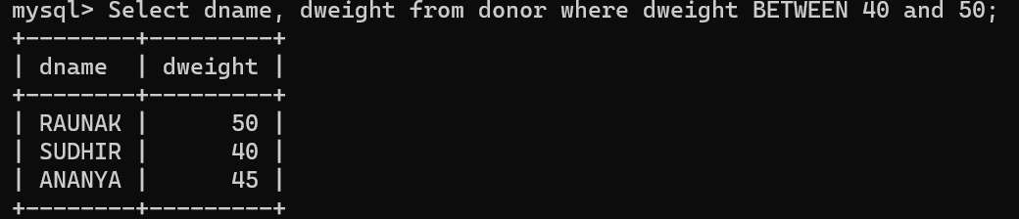

**Q20 : List the donor name and weight whose weight is in the of range of 40 and 50.**

Ans : Select dname, dweight from donor where dweight BETWEEN 40 and 50;



**Use of LIKE Special operator : (use of %)**

**Q21 : List the patient whose names start with “S” and (not “s”).**

Ans : select pname from patient where pname LIKE "S%";

**Q22 : List the patient names ending with an “N”.**

Ans: select pname from patient where pname LIKE "%N";

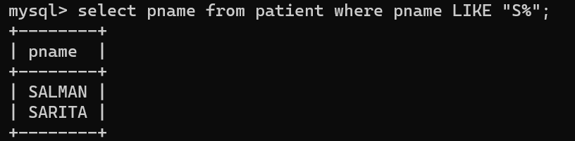

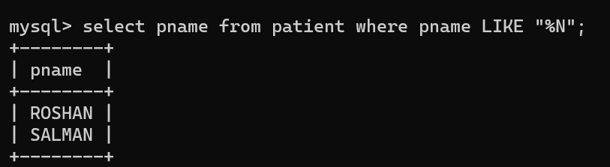

**Use of LIKE Special operator : (use of _)**

**Q23: List the names of donor whose names have exactly 6 characters.**

Ans: select dname from donor where dname LIKE "______";

**Q24: List the names of donor names having “U” as the second character.**

Ans: select dname from donor where dname LIKE "_U%";

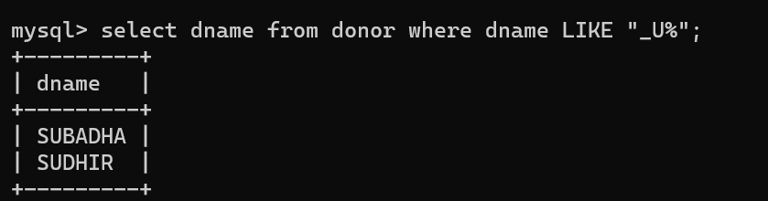

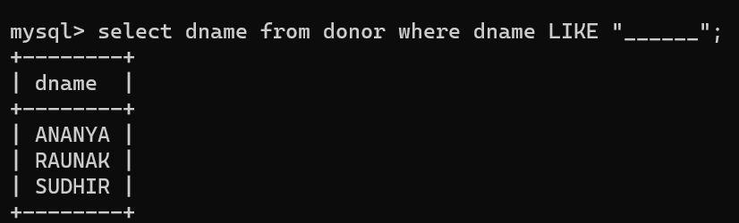

**Working with NULL values:**

**Q25: List the names of patient who has not any disease.**

Ans: select pname from patient where p_disease is NULL;

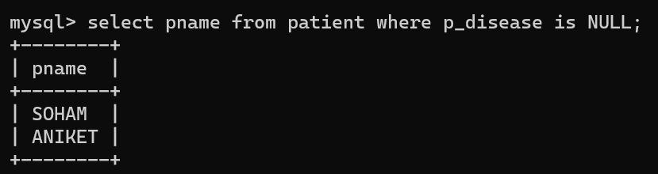

**Q26: List the names of donors and blood group of donor who has no disease**.

Ans: select dname, d_blood_grp from donor where d_disease is NONE;

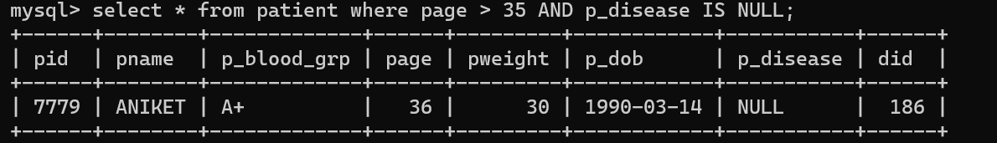

**Q27: List the patient who has disease.**

Ans: select pname from patient where p_disease is NOT NULL;

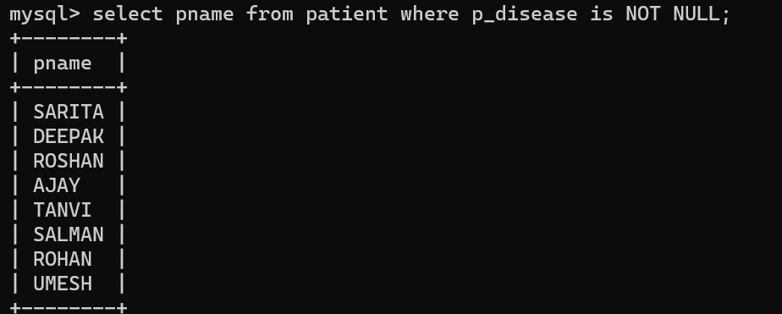

**Q28: List the details of patient whose age is greater than 35 and disease is NULL.**

Ans: select * from patient where page > 35 AND p_disease IS NULL;



**Working with Alias values : (Derived attribute )**

**Q29: List the dname ,weight and DW amount of all donors.(DW is 10% of d_weight)**

Ans: select dname, dweight, dweight*.1 from donor;

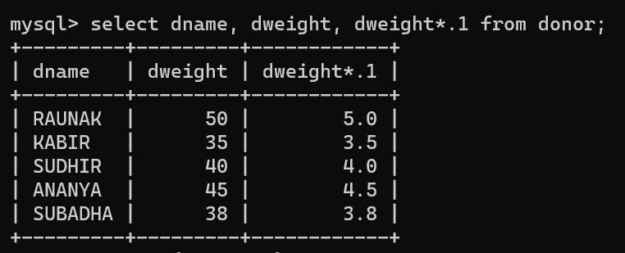

**Q30: write same above query using alias….**

Ans: select dname, dweight, dweight*.1 DW from donor;

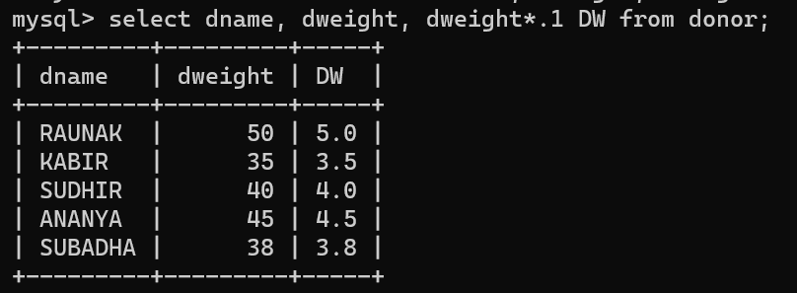

**Working with ORDER BY clause :**

**Q31: List the pid,pname ,weight in ascending order of age.**

Ans: select pid,pname, pweight from patient order by page;

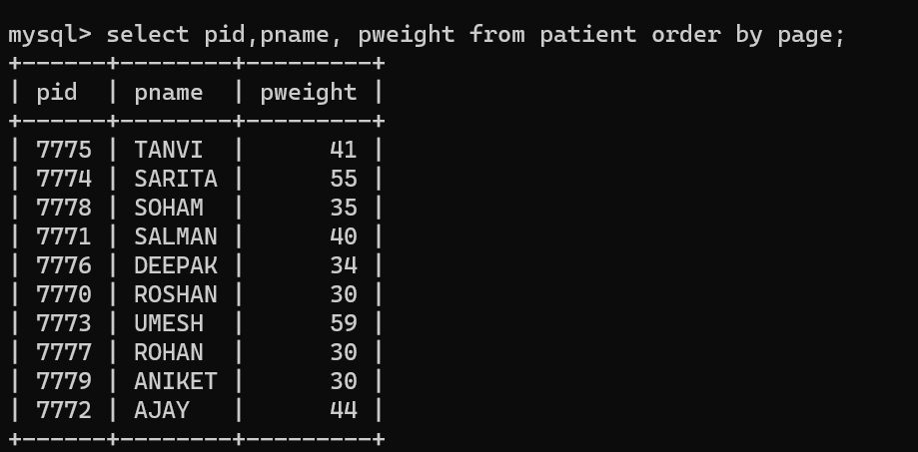

**Q32: List the did,dname ,age in descending order of weight.**

Ans: select did,dname, dage from donor order by dweight DESC;

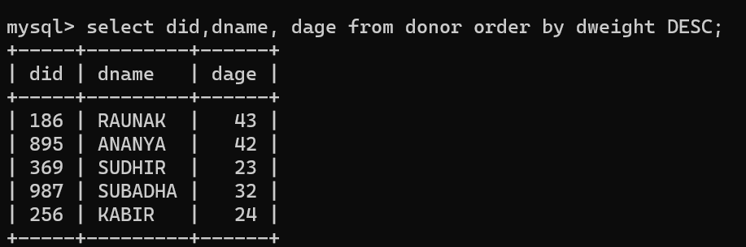

**Q33: List the did,age,dname ,weight in ascending order of did and then descending**

**order of weight.**

**Ans: select did,dage,dname, dweight from donor order by did, dweight DESC;**

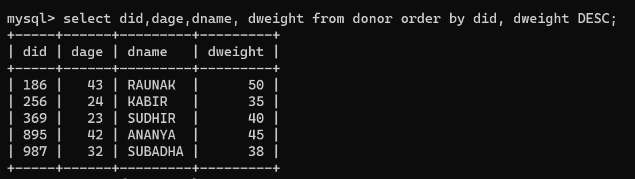

**Q34: List the , dname ,weight and DW (10% of weight ) in ascending order of DW.**

**Ans: select did,dname, dweight ,dweight * .1 DW from donor order by 4;**

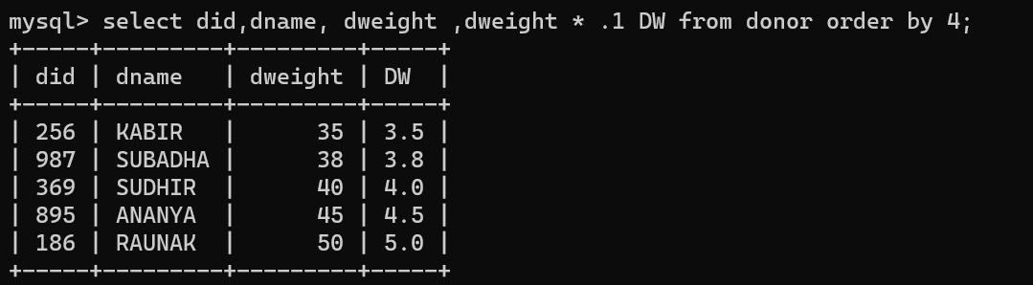

**Q35: List the did, dname ,weight and DW (10% of weight ) in ascending order of DW.**

Ans: select did,dname, dweight ,dweight * .1 DW from donor order by dweight*.1;

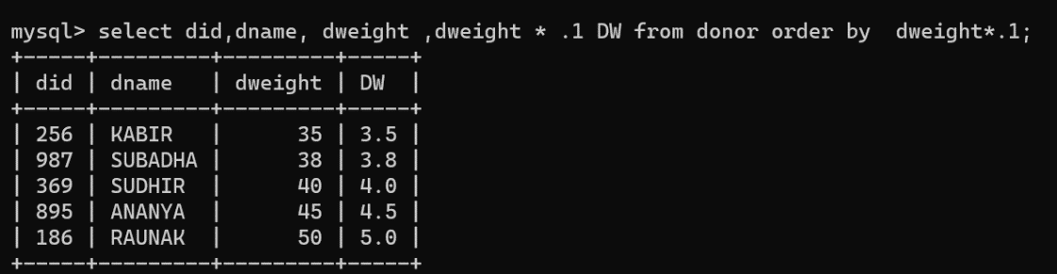

**Q36 : Or**

**Ans: select did,dname, dweight ,dweight * .1 DW from donor order by DW;**

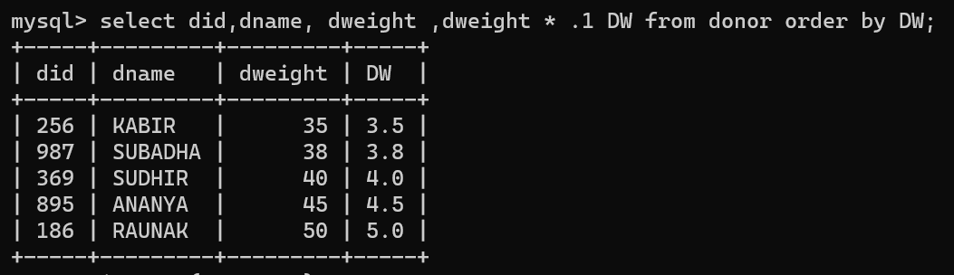

**Conclusion:**

|  |  |  |  |  |  |
| --- | --- | --- | --- | --- | --- |
| **R1** | **R2** | **R3** | **R4** | **Total** | **Sign with Date** |
| **(3)** | **(5)** | **(4)** | **(3)** | **(15)** |  |
|  |  |  |  |  |