##### EXPERIMENT NO:-06

**Aim: Implement various Join operations.**

**Theory:**

**Inner Join:** The INNER JOIN keyword selects records that have matching values in both tables.

SELECT *column-name(s)*  
FROM *table1*  
INNER JOIN *table2*ON *table1.column_name*=*table2.column_name*;

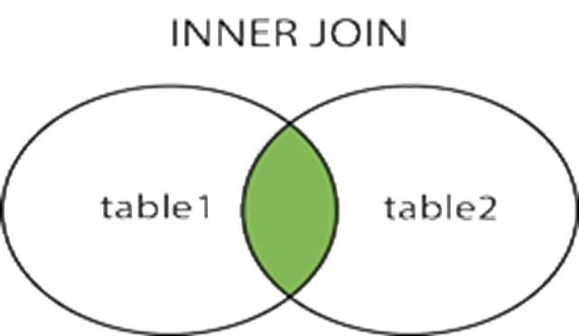

**Left Join:** The LEFT JOIN keyword returns all records from the left table (table1), and the matched records from the right table (table2). The result is NULL from the right side, if there is no match.

SELECT *column_name(s)*  
FROM *table1*  
LEFT JOIN *table2*ON *table1.column_name*=*table2.column_name*

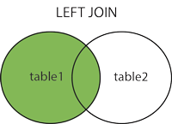

**Right Join:**

The RIGHT JOIN keyword returns all records from the right table (table2), and the matched

records from the left table (table1). The result is NULL from the left side, when there is no match.

SELECT *column_name(s)*  
FROM *table1*  
RIGHT JOIN *table2*ON *table1.column_name*=*table2.column_name*;

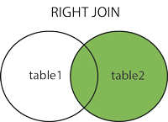

**FULL outer join:**

The FULL OUTER JOIN keyword returns all records when there is a match in left (table1) or right

(table2) table records.

SELECT *column_name(s)*  
FROM *table1*  
FULL OUTER JOIN *table2*ON *table1.column_name*=*table2.column_name;*

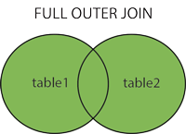

**Self Join :** When table is joined with itself.

Syntax: SELECT *column_name(s)*  
 FROM *table1 T1, table1 T2*  
 WHERE *condition*;

**Application of Join Operations on Specified Case study with Input & Output:**

**Inner Join:**

Q63 : List the pid , pname, did and dname of all patient.

Ans : select pid,pname,P.did,dname from patient P

INNER JOIN donor on P.did = donor.did;

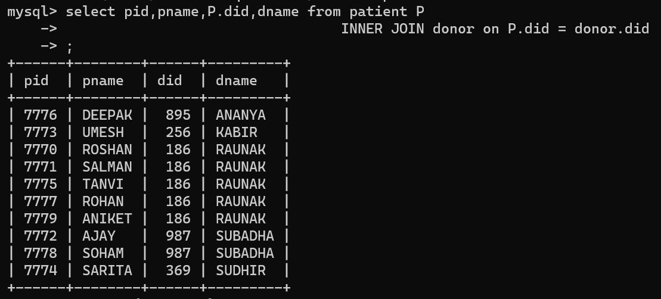

**Left Join:**

Q64 :Display the patient details like(pid, pname,did and dname)with no corresponding donor name and location.

Ans : SELECT pid, pname, P.did,dname FROM patient P  
LEFT JOIN donor  
ON patient.did = donor.did;

**Right Join:**

Q 65:Display the list of patients receive blood from each donor. Display the donors information even if no

patient belong to that donor

Ans : SELECT pid, pname, P.did,dname FROM patient P  
RIGHT JOIN donor  
ON patient.did = donor.did;

**FULL outer join:**

Q66 :Display all records all patient and blood_bank.

Ans : SELECT pid, pname, E.did,dname FROM patient P  
 FULL OUTER JOIN blood_bank  
ON patient.did = blood_bank.did;

**Self Join :** When table is joined with itself.

Syntax: SELECT *column_name(s)*  
 FROM *table1 T1, table1 T2*  
 WHERE *condition*;

Q 67: List out the pnames and their blood bank names.

|  |  |
| --- | --- |
| **Ename** | **Mangername** |
| **SMITH** | FORD |
| **ALLEN** | BLAKE |
| **WARD** | BLAKE |
| **JONES** | KING |
| **MARTIN** | BLAKE |
| **BLAKE** | KING |
| **CLARK** | KING |
| **SCOTT** | JONES |
| **TURNER** | BLAKE |
| **ADAMS** | SCOTT |
| **JAMES** | BLAKE |
| **FORD** | JONES |
| **MILLER** | CLARK |

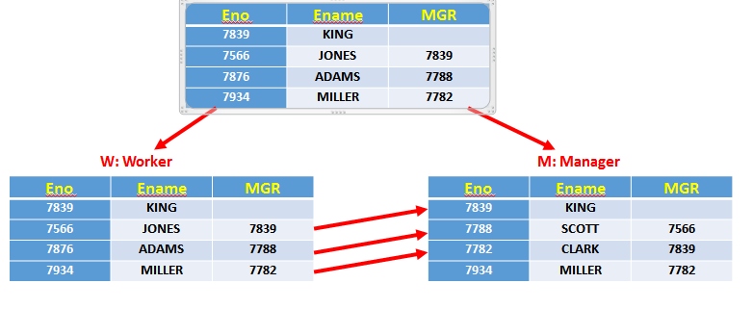

Ans :

**select P.pname, BB.bb_name from blood_bank BB, patient P where P.pid=BB.pid;**

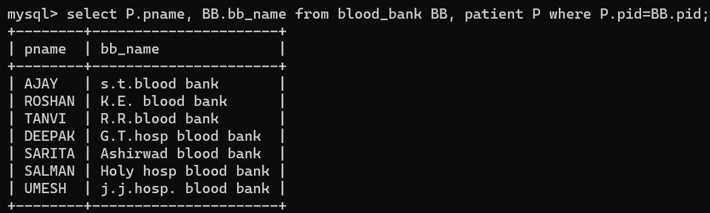

**Conclusion:**

|  |  |  |  |  |  |
| --- | --- | --- | --- | --- | --- |
| **R1** | **R2** | **R3** | **R4** | **Total** | **Sign with Date** |
| **(3)** | **(5)** | **(4)** | **(3)** | **(15)** |  |
|  |  |  |  |  |