BLAST 02 — UML & Design Documentation
Project: Cybersecurity Security Event and Command History Analyzer Using Stack in C++
Student: Rushikesh Pareshkumar Nayak
Instructor: Dr. Victor Govindaswamy

1. UML Class Diagram
This diagram shows the class used in my C++ program. The class stores security events in a fixed-size array. It has functions to add, remove, view, and display events.
SecurityEventStack
− events : string[5]
− top : int
+ SecurityEventStack()
+ isEmpty() : bool
+ isFull() : bool
+ push(event : string) : void
+ pop() : void
+ peek() : void
+ display() : void
+ checkStatus() : void
+ countEvents() : void
+ clearStack() : void

2. What the UML Symbols Mean
The minus sign (−) means private. Only the class can directly use these variables. The plus sign (+) means public. Other parts of the program can call these functions. “void” means the function does not return a value. “bool” means it returns true or false.

3. How the Class Works
- events is an array that holds up to five security-event messages.
- top keeps the position of the newest event. At the beginning, top is −1 because the Stack is empty.
- push adds a new event to the top. pop removes the newest event. peek shows the newest event without removing it.
- display prints events from newest to oldest. isEmpty and isFull check whether an operation is allowed.
- checkStatus shows whether the Stack is empty, full, or has free space. countEvents shows the number of saved events. clearStack resets the Stack to empty.

4. Program Flow (Simple Steps)
- Start the program and create a SecurityEventStack object.
- Show the menu with choices 1 through 8.
- Read the user’s choice. If the input is not a number, show an error and return to the menu.
- Run the chosen operation: add, peek, remove, display, check status, count, or clear events.
- After each operation, show the menu again.
- If the user selects 8, display a goodbye message and stop the program.

5. Important Design Notes
The Stack follows LIFO (Last In, First Out). The newest event is shown or removed first. If the Stack already has five events, the program shows “Stack Overflow.” If someone tries to remove an event from an empty Stack, the program shows “Stack Underflow.” This is a learning program, not a real security monitoring system. Events are not saved after the program closes.

5. Program Flowchart
This flowchart shows how the menu-based Security Event Analyzer runs. After an operation, the program returns to the menu. Choosing option 8 exits the program.
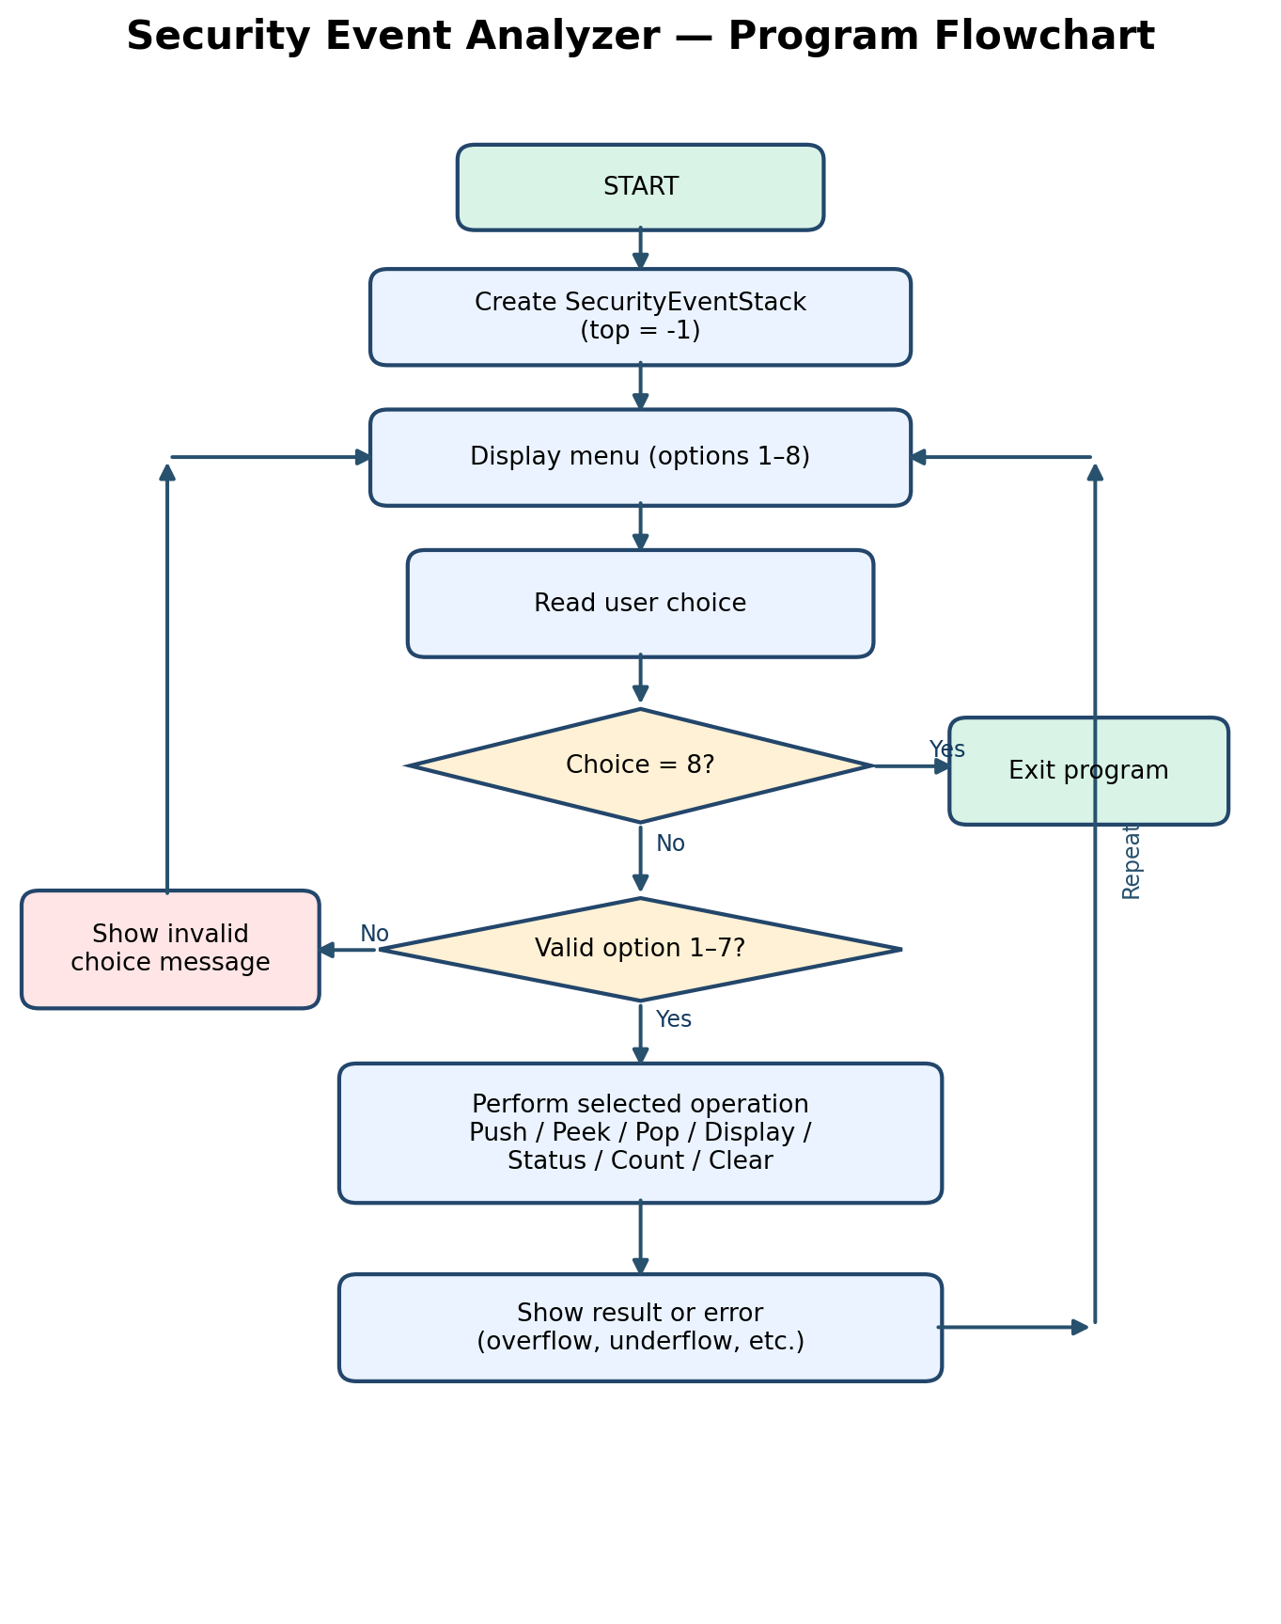
Figure: Main menu flow, input checking, stack operations, and exit.

Flowchart Explanation
- The program begins by creating an empty stack with top = -1.
- The menu displays eight options and asks the user to choose one.
- If the user selects 8, the program ends.
- If the choice is not a valid menu option, the program displays an error and returns to the menu.
- For options 1–7, the program performs the selected action. It reports errors such as stack overflow or underflow when necessary.
- After displaying the result, the program returns to the menu so the user can continue.

