**Unnamed PL/SQL code block: Use of Control structure and Exception handling is mandatory.**

**Suggested Problem statement:**

**Consider Tables:**

**1. Borrower(Roll_no, Name, DateofIssue, NameofBook, Status)**

**2. Fine(Roll_no,Date,Amt)**

use dbmspracticals;

drop table fine;

create table fine(rollno int,fdate date,amt int,foreign key (rollno) references borrower(rollin));

create table borrower(rollin int primary key,name varchar(30),dateOfIssue date,bname varchar(30),status char(1));

insert into borrower values(4,"Sanskruti","2020-10-02","UnChartered","I");

insert into borrower values(5,"Vaibhav","2020-09-12","Atomic Habits","I");

insert into borrower values(6,"Sakshi","2020-11-06","Reverb","I");

delimiter //

drop procedure fine_calculations;

create procedure fine_calculations(IN rno int, bname char(30))

begin

declare i_date date;

declare diff int;

declare fine_amt int;

declare exit handler for sqlexception select 'Table not found';

select dateofIssue into i_date from borrower where rollin = rno and bname = bname;

select datediff(curdate(),i_date) into diff;

if diff>15 and diff <= 30 then

set fine_amt = diff*5;

insert into fine values(rno,currdate(),fine_amt);

elseif diff>30 then

set fine_amt = 15*5 + (diff-30)*50;

insert into fine values(rno,sysdate(),fine_amt);

end if;

update borrower SET status = 'R' where rollin=rno and bname=name;

end //

call fine_calculations(3,"HellFire");

call fine_calculations(6,"Reverb");

select * from borrower;

select * from fine;

**Table before calling fine_calculations:**

**select * from borrower;**

**select * from fine;**

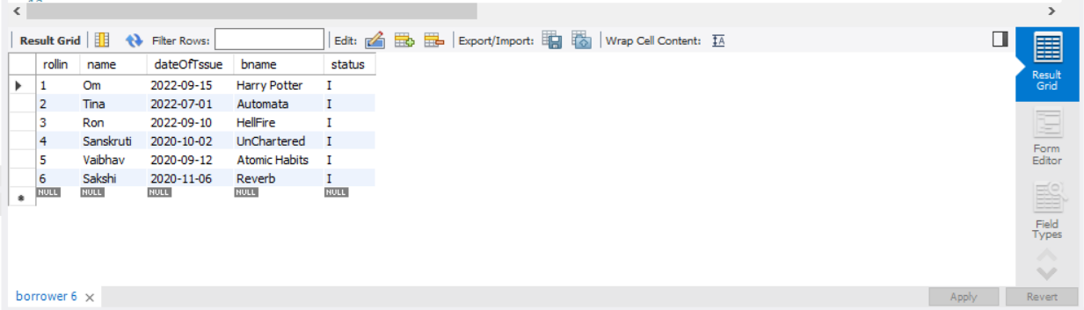

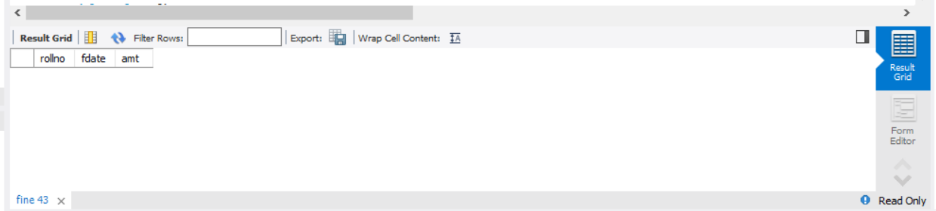

**Calling Procedure:**

call fine_calculations(3,"HellFire");

call fine_calculations(6,"Reverb");

call fine_calculations(1,"Harry Potter");

call fine_calculations(2,"Automata");

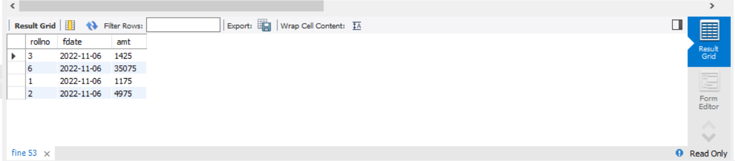

**Conclusion:**

Hence we have used implemented the control structure and exception handling using procedures.