**Assignment -8**

MongoDB Queries: Design and Develop MongoDB Queries using CRUD operations. (Use CRUD operations, SAVE method, logical operators etc.).

**Create Database, Collection, Insert operations**

**Prerequisite- create database**

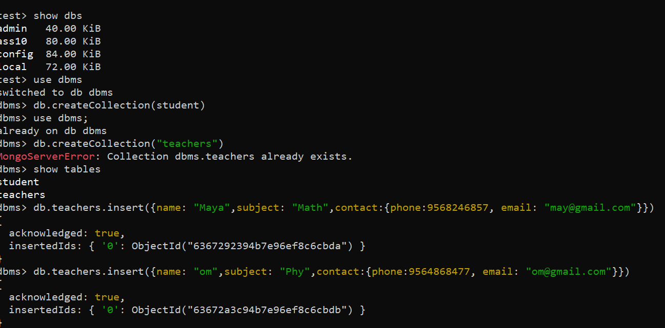

**Find Query:**

**(Similar to select in mysql):to get specified records**

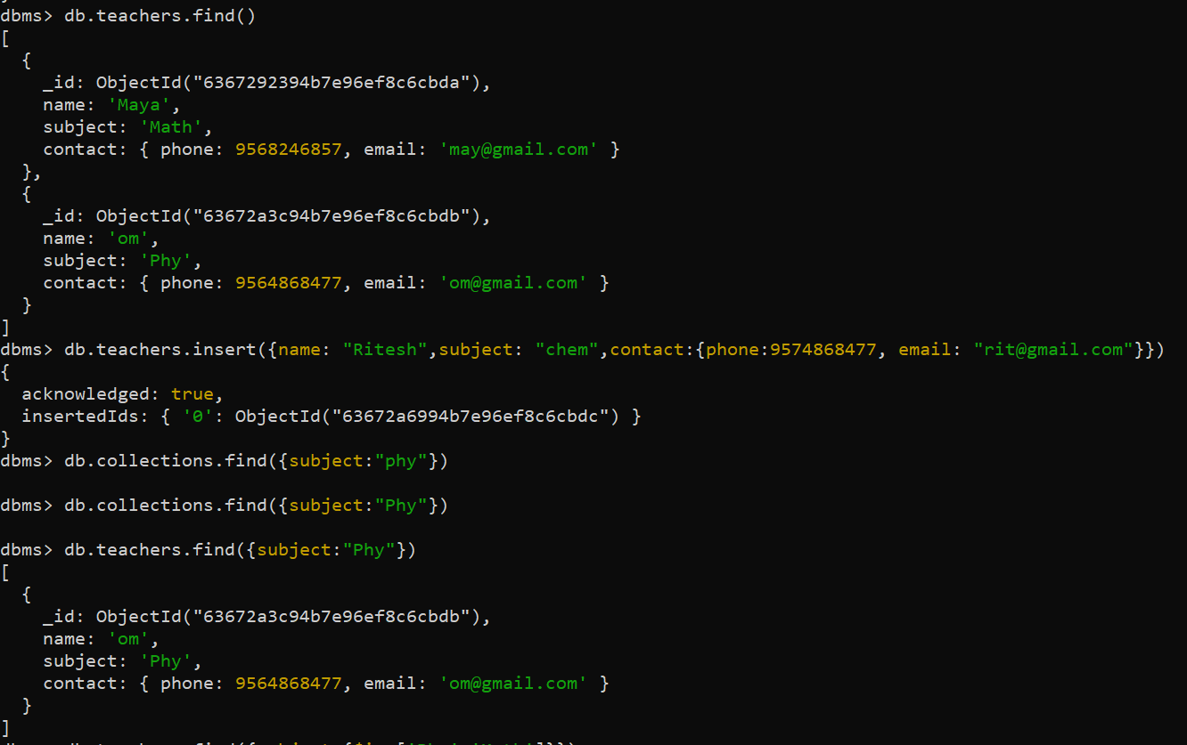

**Use of Logical operators (**using logical operators with find**)**

**$eq, $or, $and**

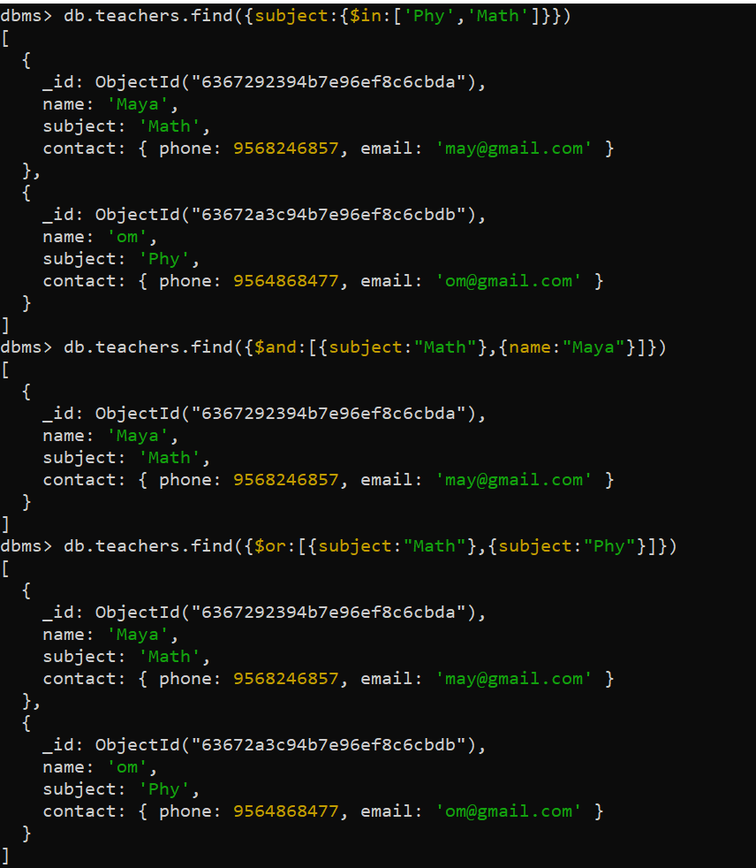

**Using Logical not: $not**

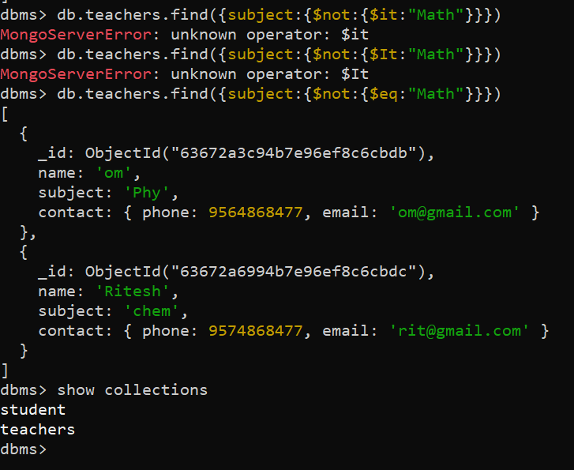

**Using Update:**

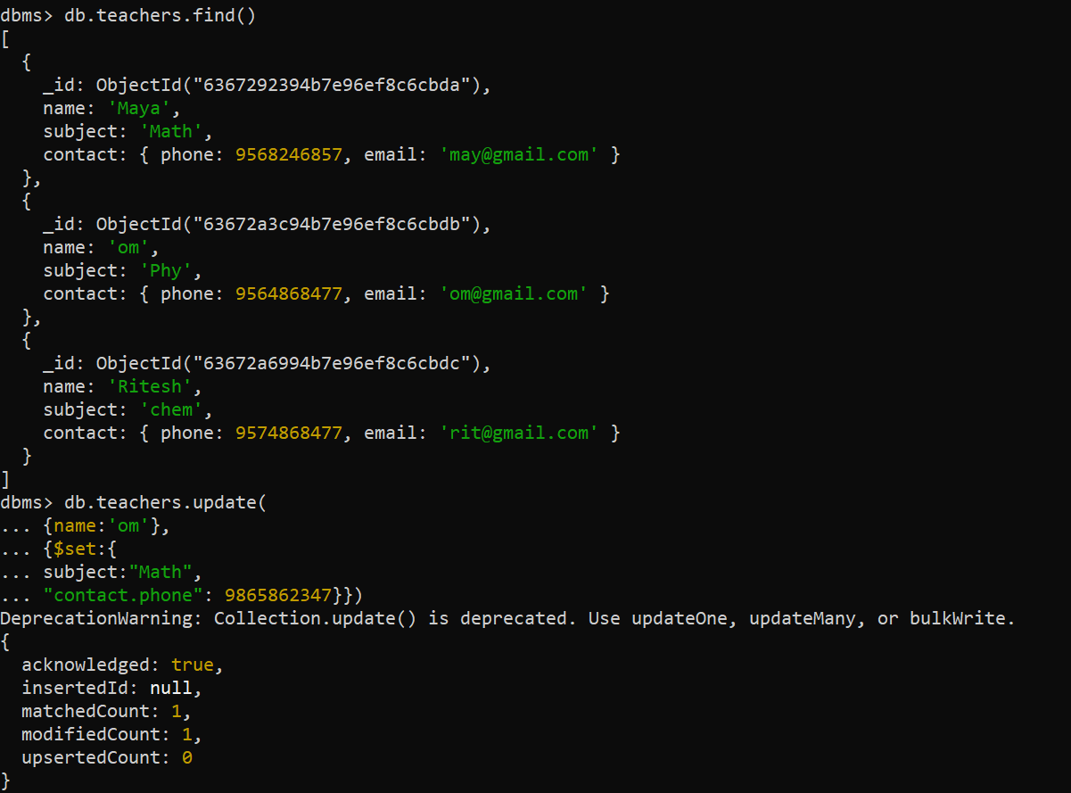

**After Update:**

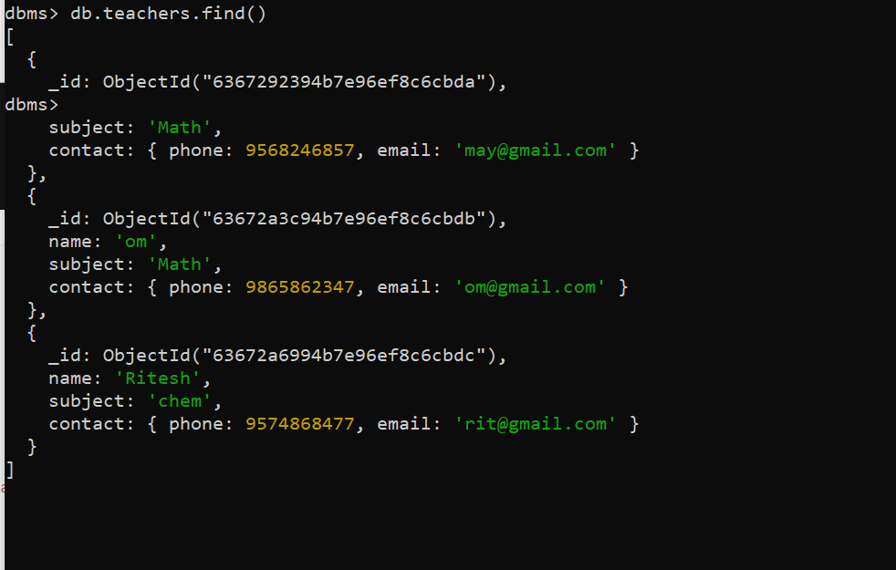

**Conclusion:**

**Hence we have performed CURD operations in Mongodb**