**Assignment -9**

MongoDB - Aggregation and Indexing: Design and Develop MongoDB Queries using aggregation and indexing with suitable example using MongoDB.

**Create Database, Collection, Insert operations**

**Create Indexes:**

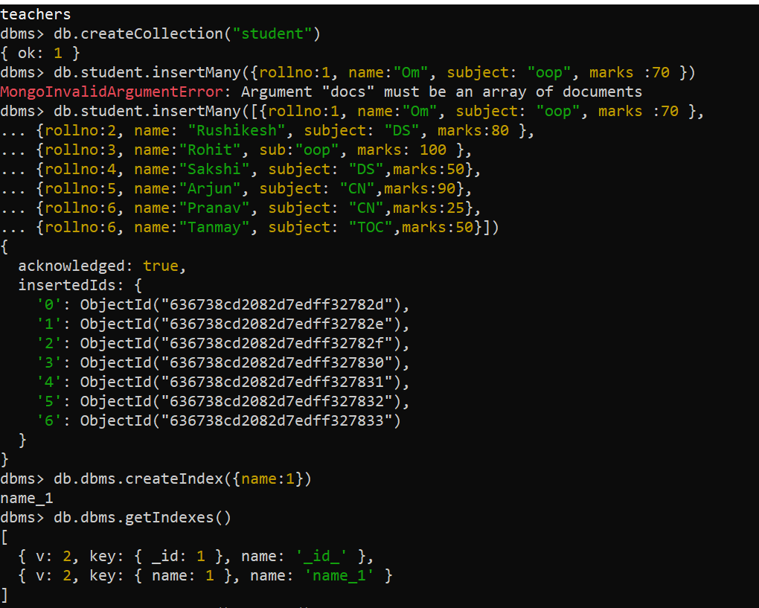

**Sort in ascending order using indexes:**

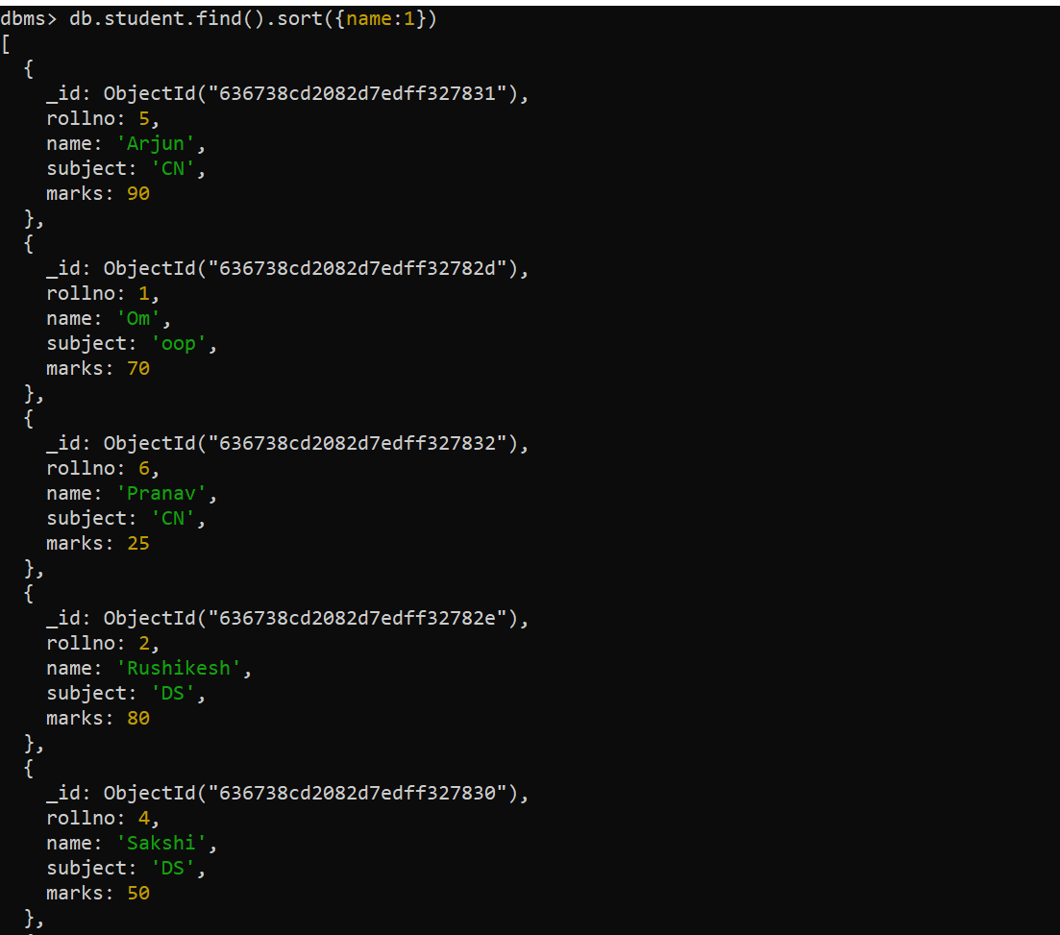

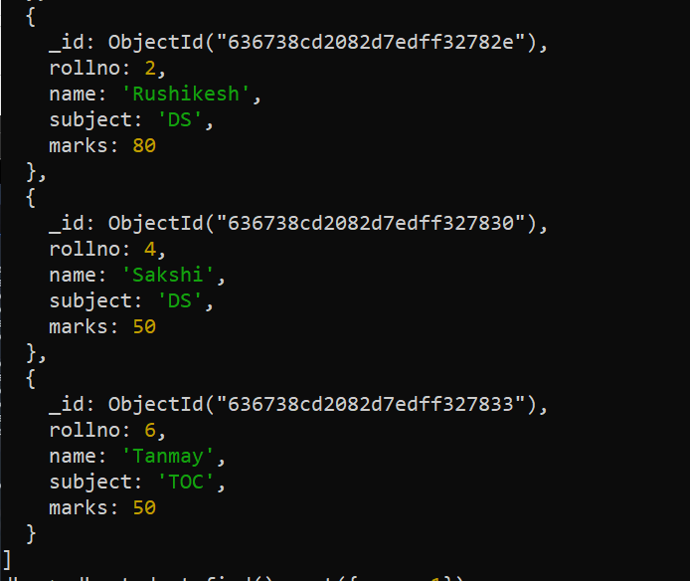

**Sort in descending order using indexes:**

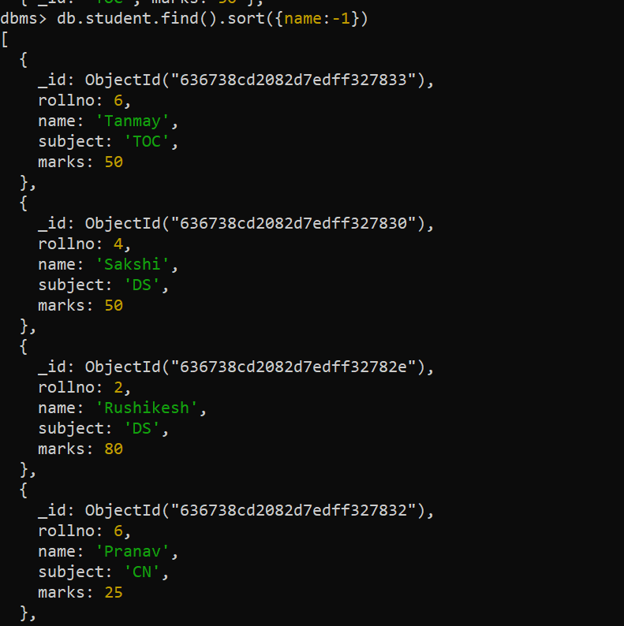

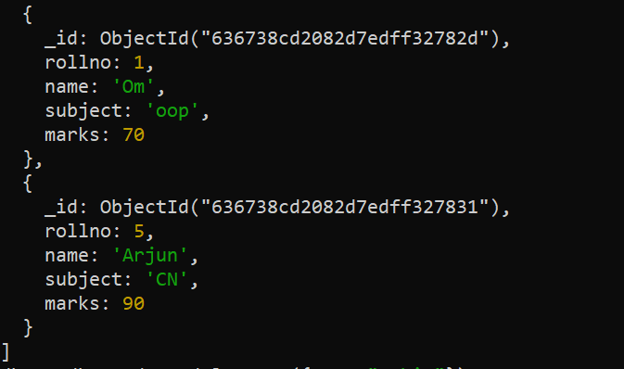

**Use Aggregate functions:**

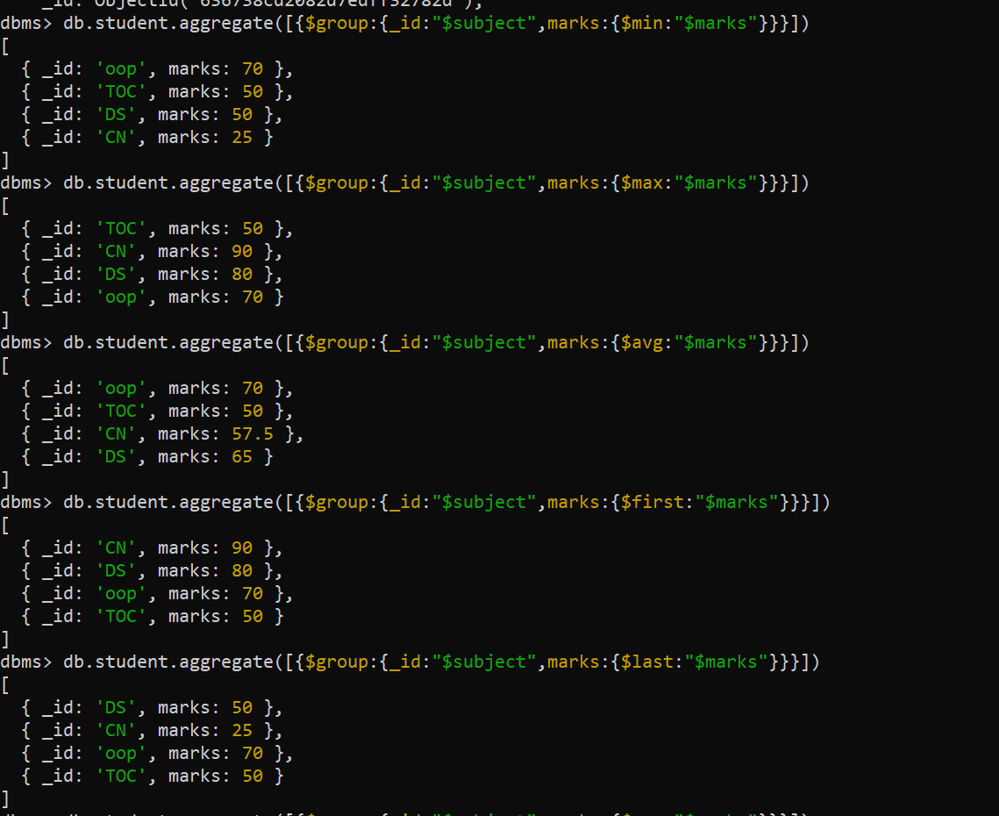

**Conclusion:**

**We have implemented aggregation and indexing using Mongodb.**