**WT Prac-1  
 Submission**

**21BCM055**

**Rushil Shah**

**Practical-1:**



A.

**Code:**

<!DOCTYPE html>

<html lang="en">

<head>

    <meta charset="UTF-8">

    <meta http-equiv="X-UA-Compatible" content="IE=edge">

    <meta name="viewport" content="width=device-width, initial-scale=1.0">

    <title>21BCM055 Practical-1(b)</title>

    <style>

    .myDiv {

**text-align**: **center**;

    }

    </style>

</head>

<body>

    <h1 style="color: blue; text-align: center; font-size:260%; font-family: 'Lucida Sans', 'Lucida Sans Regular', 'Lucida Grande', 'Lucida Sans Unicode', Geneva, Verdana, sans-serif;">Rushil Shah</h1>

    <div class="myDiv">

        <a style="text-align: center;" href="https://www.linkedin.com/in/rushil-shah-018425224/">LinkedIn Profile</a>

    </div>

    <h2 style="color:brown; text-align: center; font-size:190%; font-family: 'Lucida Sans', 'Lucida Sans Regular', 'Lucida Grande', 'Lucida Sans Unicode', Geneva, Verdana, sans-serif;">Machine learning Engineer</h2>

    <div class="myDiv">

        <img src="Rushil_image.png" alt="Rushil_Shah" style="width:250px;height:250px;">

    </div>

    <hr><hr>

    <br>

    <h2 style="color: crimson;">* Profile</h2>

    <h3 style="color:rgb(133, 48, 213)">

        <ul>

            <li> Avid and Curious Learner</li>

            <li> An exemplary teen entrepreneur with curiosity in the technical field</li>

            <li> An astonishing leadership quality of managing team and leading them towards excellence</li>

        </ul>

    </h3>

    <hr>

    <h2 style="color: crimson;">* Education</h2>

    <h3 style="color: rgb(133, 48, 213)">

        <ul>

            <li> INSTITUTE OF TECHNOLOGY NIRMA UNIVERSITY,</li>

            <li style="list-style-type:none;"> Ahmedabad — Integrated B.Tech(Computer Science)-MBA</li>

            <br>

            <ul >

                <li style="color:darkorange">Time Duration: present-2026</li>

                <li style="color:forestgreen"> Result (1st Year): 8.5 CGPA</li>

            </ul>

        </ul>

    </h3>

    <br>

    <h3 style="color: rgb(133, 48, 213)">

        <ul>

            <li> Maharaja Agrasen Vidyalaya, Ahmedabad, Higher Secondary</li>

            <ul>

                <li style="color:darkorange"> Year: 2021</li>

                <li style="color:forestgreen"> Result: 87%</li>

            </ul>

        </ul>

    </h3>

    <br>

    <h3 style="color: rgb(133, 48, 213)">

    <ul>

        <li> Amrita Vidyalayam, Ahmedabad, Junior Secondary</li>

        <ul>

            <li style="color:darkorange"> Year: 2019</li>

            <li style="color:forestgreen"> Result: 92%</li>

        </ul>

    </ul>

    </h3>

    <hr>

    <h2 style="color: crimson;">* Skills</h2>

    <h3 style="color: rgb(133, 48, 213)">

    <ol>

        <li> C/C++</li>

        <li> Java</li>

        <li> MYsql/Php</li>

        <li> Data Science</li>

        <li> Digital Marketing</li>

        <li> Python (AI/ML)</li>

    </ol>

    </h3>

    <hr>

    <h2 style="color: crimson;">* Interests</h2>

    <h3 style="color: rgb(133, 48, 213)">

        <ul>

            <li> Chess</li>

            <li> Competitive Programming</li>

            <li> Logic and Algorithm development</li>

            <li> Yoga and Gym</li>

            <li> Table Tennis</li>

        </ul>

    </h3>

    <hr>

    <h2 style="color: crimson;">* Languages</h2>

    <h3 style="color: rgb(133, 48, 213)">

        <ol>

            <li> English</li>

            <li> Hindi</li>

            <li> Gujarati</li>

        </ol>

    </h3>

</body>

</html>

* **Conclusion:**

**The page contains information about his name, LinkedIn profile, profession ("Machine Learning Engineer"), education, skills, interests, and languages. It also includes some styling using CSS for centring elements and setting various font styles and colours. The page has a structured layout using headings, paragraphs, lists, and images.**

**Output:**

**Rushil Shah**

[LinkedIn Profile](https://www.linkedin.com/in/rushil-shah-018425224/)

**Machine learning Engineer**



**\* Profile**

* **Avid and Curious Learner**
* **An exemplary teen entrepreneur with curiosity in the technical field**
* **An astonishing leadership quality of managing team and leading them towards excellence**

**\* Education**

* **INSTITUTE OF TECHNOLOGY NIRMA UNIVERSITY,**
* **Ahmedabad — Integrated B.Tech(Computer Science)-MBA**
  + **Time Duration: present-2026**
  + **Result (1st Year): 8.5 CGPA**

* **Maharaja Agrasen Vidyalaya, Ahmedabad, Higher Secondary**
  + **Year: 2021**
  + **Result: 87%**

* **Amrita Vidyalayam, Ahmedabad, Junior Secondary**
  + **Year: 2019**
  + **Result: 92%**

**\* Skills**

1. **C/C++**
2. **Java**
3. **MYsql/Php**
4. **Data Science**
5. **Digital Marketing**
6. **Python (AI/ML)**

**\* Interests**

* **Chess**
* **Competitive Programming**
* **Logic and Algorithm development**
* **Yoga and Gym**
* **Table Tennis**

**\* Languages**

1. **English**
2. **Hindi**
3. **Gujarati**

**B.**

**Code:**

<!DOCTYPE html>

<html lang="en">

<head>

    <meta charset="UTF-8">

    <meta name="viewport" content="width=device-width, initial-scale=1.0">

    <title>21BCM055 Practical-1(b)</title>

</head>

<body>

    <p>Preceding Text</p>

    <ol type="I">

        <li>List Item 1</li>

        <ol type="a">

            <li>Nested Item 1.1</li>

            <li>Nested Item 1.2</li>

        </ol>

        <li>List Item 2</li>

        <ol>

            <li>Nested Item 2.1</li>

            <li>Nested Item 2.2</li>

            <ul type="circle">

                <li>Nested Item 2.2.1</li>

                <li>Nested Item 2.2.2</li>

                <ul>

                    <li>Nested Item 2.2.2.1</li>

                    <li>Nested Item 2.2.2.2</li>

                </ul>

                <li>Nested Item 2.2.3</li>

            </ul>

            <li>Nested Item 2.3</li>

        </ol>

        <li>List Item 3</li>

        <ul type="disc">

            <li>Nested Item 3.1</li>

            <li>Nested Item 3.1</li>

            <li>Nested Item 3.1</li>

        </ul>

    </ol>

</body>

</html>

**Output:**

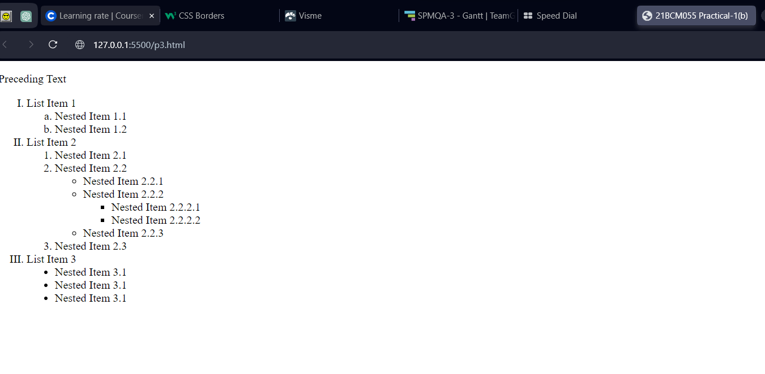

**Conclusion:**

**The content of the HTML code snippet is a structured list with different levels of nesting. The list includes ordered (numbered) and unordered (bulleted) list items. It demonstrates the use of various list types, including Roman numerals, lowercase letters, and nested lists.**