VISVESVARAYA TECHNOLOGICAL UNIVERSITY

“JnanaSangama”, Belgaum -590014, Karnataka.


LAB REPORT

on

Analysis and Design of Algorithms

Submitted by

RUSHIL MAGAZINE (1BM22CS225)

in partial fulfillment for the award of the degree of

BACHELOR OF ENGINEERING

in

COMPUTER SCIENCE AND ENGINEERING


B.M.S. COLLEGE OF ENGINEERING

(Autonomous Institution under VTU)

BENGALURU-560019

April-2024 to August-2024

B. M. S. College of Engineering,

Bull Temple Road, Bangalore 560019

(Affiliated to Visvesvaraya Technological University, Belgaum)

Department of Computer Science and Engineering


CERTIFICATE

This is to certify that the Lab work entitled “Analysis and Design of Algorithms” carried out by RUSHIL MAGAZINE (1BM22CS225), who is bonafide student of B.M.S. College of Engineering. It is in partial fulfillment for the award of Bachelor of Engineering in Computer Science and Engineering of the Visvesvaraya Technological University, Belgaum during the academic semester April-2024 to August-2024. The Lab report has been approved as it satisfies the academic requirements in respect of an Analysis and Design of Algorithms (23CS4PCADA) work prescribed for the said degree.

Madhavi R.P

Associate Professor

Department of CSE

BMSCE, Bengaluru

Dr. Jyothi S Nayak

Professor and Head

Department of CSE

BMSCE, Bengaluru

Lab

Program

No.

1

2

3

4

5

6

7

8

9
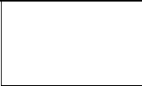

10

Index Sheet


Program Details

Leetcode-1 : Find Disappeared Numbers in the array

Leetcode-2: Zigzag Traversal of BST

Leetcode-3: Increasing Order Search Tree


Write program to obtain the Topological ordering of vertices in a given digraph using DFS

Write program to obtain the Topological ordering of vertices in a given digraph using Source Removal Method


Sort a given set of N integer elements using Merge Sort technique and compute its time taken. Run the program for different values of N and record the time taken to sort.


Sort a given set of N integer elements using Quick Sort technique and compute its time taken.


Implement Johnson Trotter algorithm to generate permutations. Write a C program for Pattern Matching

Leetcode-4: Find kth Largest Integer in the array

Sort a given set of N integer elements using Heap Sort technique and compute its time taken.

Implement All Pair Shortest paths problem using Floyd’s algorithm

Implement 0/1 Knapsack problem using dynamic programming. Find Minimum Cost Spanning Tree of a given undirected graph
using Prim’s algorithm.

From a given vertex in a weighted connected graph, find shortest paths to other vertices using Dijkstra’s algorithm.
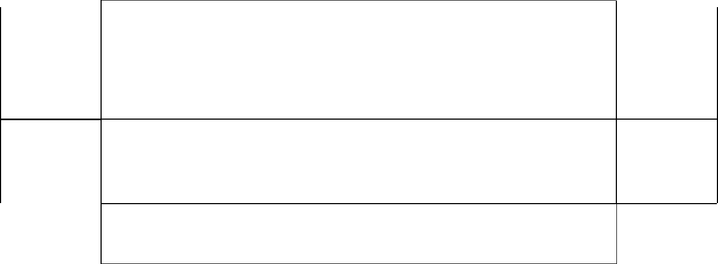

Page No.

1

2-3

3-4

5-9

9-14

14-18

19-25

25-32

32-38

39-50



Find Minimum Cost Spanning Tree of a given undirected graph using Kruskal’s algorithm.

Implement Fractional Knapsack using Greedy technique. Implement “N-Queens Problem” using Backtracking.

Course Outcome

CO1

CO2

CO3
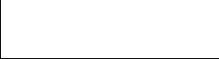

CO4

Analyze time complexity of Recursive and Non-recursive algorithms using asymptotic notations.

Apply various design techniques for the given problem.

Apply the knowledge of complexity classes P, NP, and NP-Complete and prove certain

problems are NP-Complete
Design efficient algorithms and conduct practical experiments to solve problems.

LAB-1 :

Leetcode-1 : Find Disappeared Numbers in the array

int* findDisappearedNumbers(int* nums, int numsSize, int* returnSize) { int temp = 0;

for (int index = 0; index < numsSize; ++index) {

temp = abs(nums[index]) - 1;

nums[temp] = abs(nums[temp]) * -1;

}

int insert_index = 0;

*returnSize = 0;

for (int index = 0; index < numsSize; ++index) {

if (nums[index] > 0) {

++*returnSize;

nums[insert_index++] = index + 1;

}

}

return nums;

}

Output:

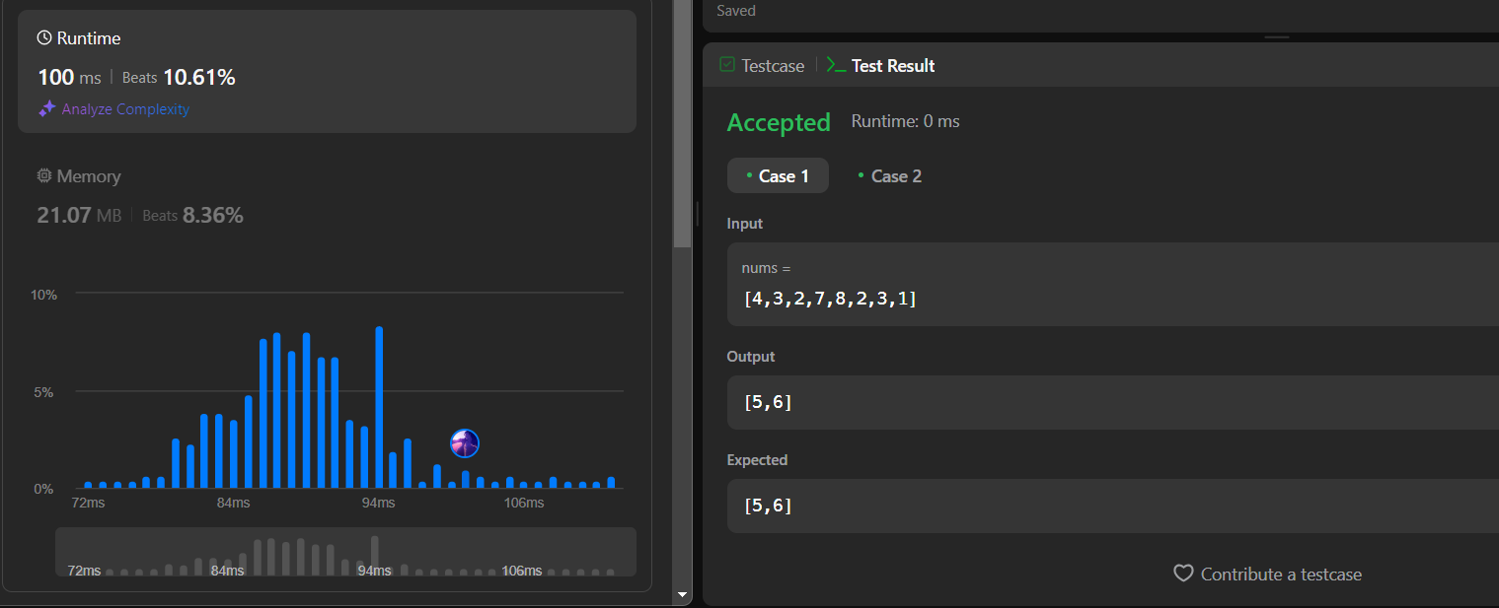
LAB-2 :

Leetcode-2: Zigzag Traversal of BST

int** zigzagLevelOrder(struct TreeNode* root, int* returnSize, int** returnColumnSizes) { int **ans = malloc(2000*sizeof(int*));

*returnColumnSizes = malloc(2000*sizeof(int)); *returnSize = 0;

struct TreeNode *tmp[2000] ={0};

int top = -1, start = 0;

tmp[++top] = root;

while(tmp[start])

{

int tmp_top = top;

ans[(*returnSize)] = malloc((top-start+1)*sizeof(int)); (*returnColumnSizes)[(*returnSize)] = (top-start+1); int idx = (*returnSize)%2 ? (top-start+1)-1:0; int step = (*returnSize)%2 ? -1:1;
while(start <= tmp_top)

{

ans[(*returnSize)][idx] = tmp[start]->val;

if(tmp[start]->left)

tmp[++top] =tmp[start]->left;

if(tmp[start]->right)

tmp[++top] =tmp[start]->right;

start++;

idx += step;

}

(*returnSize)++;

2

}

return ans;

}

Output:

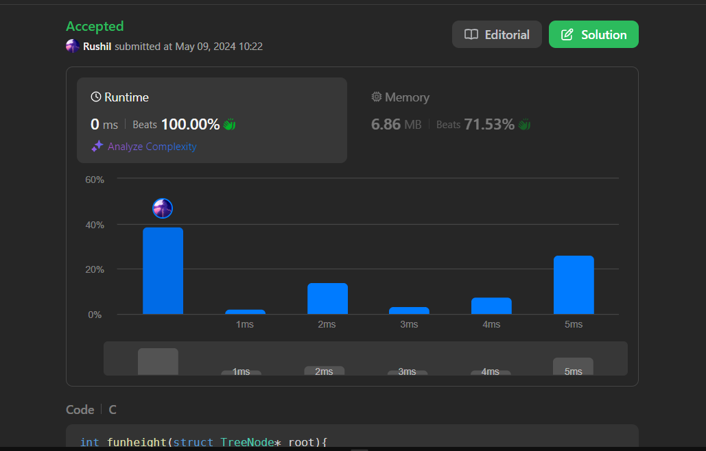

LAB-3 :

Leetcode-3: Increasing Order Search Tree

struct TreeNode* increasingBST(struct TreeNode* root) { if (root == NULL)

return NULL;

struct TreeNode* newRoot = NULL;

struct TreeNode* prev = NULL;

struct TreeNode* curr = root;

struct TreeNode* stack[2000];

int top = -1;

while (curr != NULL || top != -1) {

while (curr != NULL) {

3

stack[++top] = curr;

curr = curr->left;

}

curr = stack[top--];

if (newRoot == NULL) {

newRoot = curr;

} else {

prev->right = curr;

}

prev = curr;

curr->left = NULL;

curr = curr->right;

}

return newRoot;

}

Output:
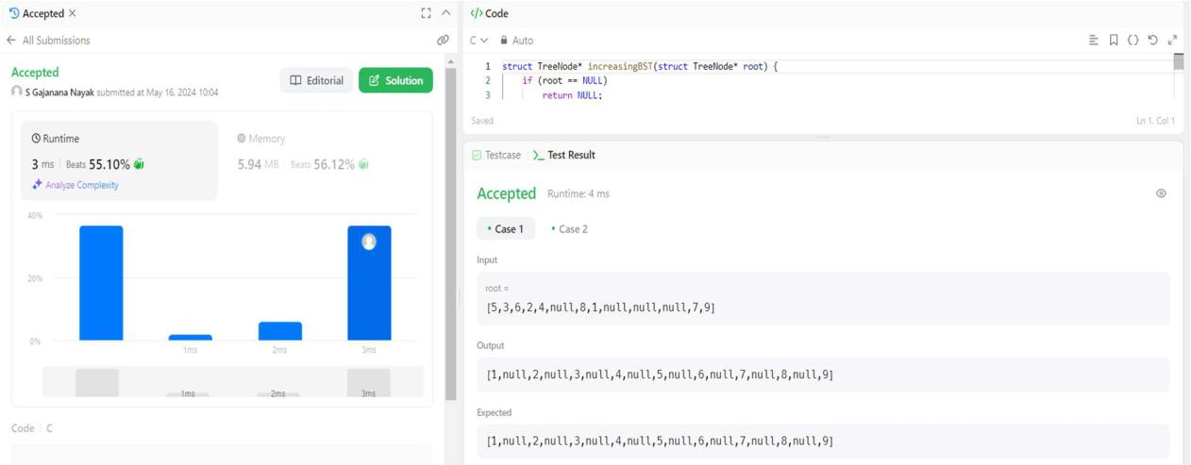

4

LAB-4 :

Topological ordering using DFS

#include <stdio.h>

#include <stdlib.h>

#define MAX_VERTICES 100

int s[MAX_VERTICES] = {0};

int res[MAX_VERTICES];

int j = 0;

void DFS(int u, int n, int a[MAX_VERTICES][MAX_VERTICES]) { s[u] = 1;

for (int v = 0; v < n; v++) {

if (a[u][v] == 1 && s[v] == 0) {

DFS(v, n, a);

}

}

res[j++] = u;

}

int main() {

int n;

printf("Enter the number of vertices: ");

scanf("%d", &n);

int a[MAX_VERTICES][MAX_VERTICES];

printf("Enter the adjacency matrix:\n");

for (int i = 0; i < n; i++) {

for (int j = 0; j < n; j++) {

scanf("%d", &a[i][j]);

}

}

5

for (int u = 0; u < n; u++) {

if (s[u] == 0) {

DFS(u, n, a);

}

}

printf("Topological order: ");

for (int i = j - 1; i >= 0; i--) {

printf("%d ", res[i]);

}

printf("\n");

return 0;

}

Output:
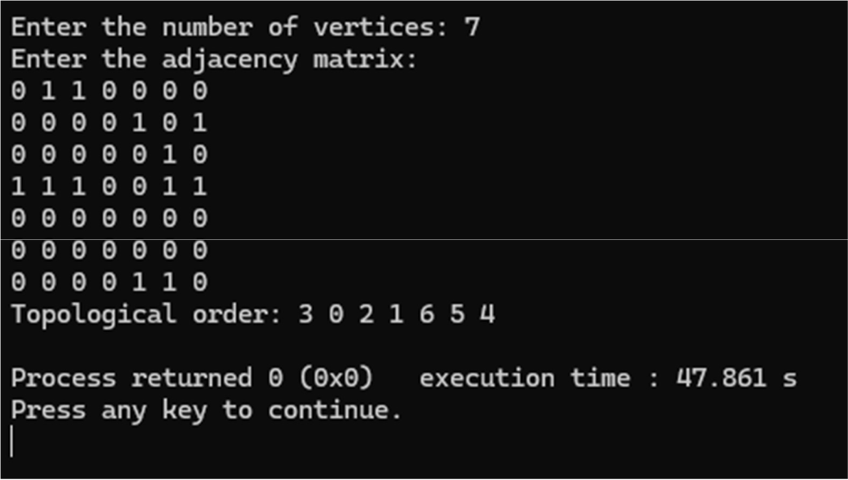

6

Topological sorting using Source Removal Method

#include <stdio.h>

#include <stdlib.h>

int st[100];

int top = -1;

void degree(int adj[][20], int n) {

int indegree[20];

int sum = 0;

for (int j = 0; j < n; j++) {

sum = 0;

for (int i = 0; i < n; i++) {

sum = sum + adj[i][j];

}

indegree[j] = sum;

}

for (int i = 0; i < n; i++) {

if (indegree[i] == 0) {

top++;

st[top] = i;

}

}

while (top != -1) {

int u = st[top];

top--;

printf("%d ", u);

for (int v = 0; v < n; v++) {

7

if (adj[u][v] == 1) {

indegree[v]--;

if (indegree[v] == 0) {

top++;

st[top] = v;

}

}

}

}

}

int main() {

int n;

printf("Enter the number of nodes: ");

scanf("%d", &n);

int adj[20][20];

printf("Enter the adjacency matrix:\n");

for (int i = 0; i < n; i++) {

for (int j = 0; j < n; j++) {

scanf("%d", &adj[i][j]);

}

}

printf("Topological order of nodes: ");

degree(adj, n);

return 0;

}

8

Output:
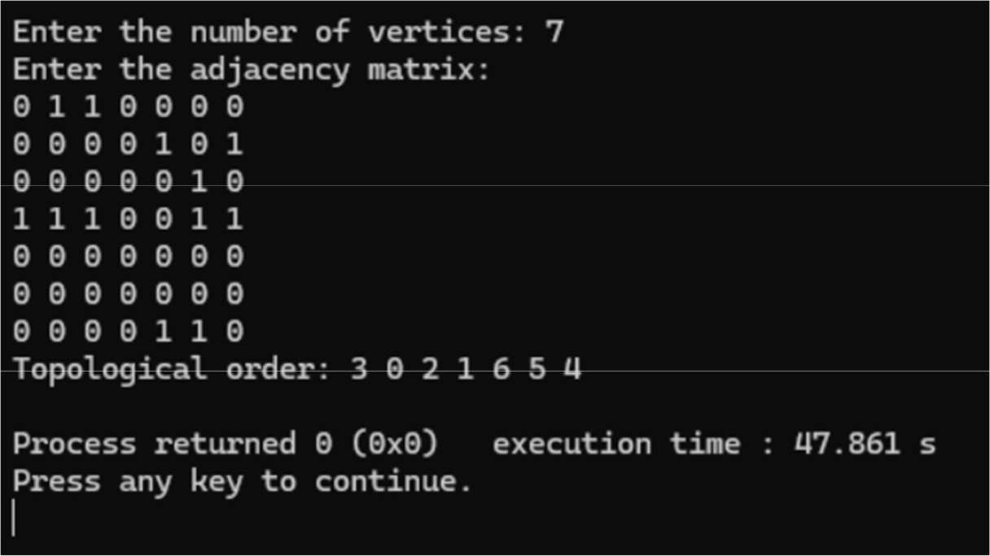

LAB-5 :

Merge Sort

#include<stdio.h>

#include<time.h>

#include<stdlib.h>

void split(int[],int,int);

void combine(int[],int,int,int);

void main()

{

int a[15000],n, i,j,ch, temp;

clock_t start,end;

while(1)

{

printf("\n1:For manual entry of N value and array elements");

printf("\n2:To display time taken for sorting number of elements N in the range 500 to 14500");

9

printf("\n3:To exit");

printf("\nEnter your choice:");

scanf("%d", &ch);

switch(ch)

{

case 1: printf("\nEnter the number of elements: "); scanf("%d",&n);

printf("\nEnter array elements: ");

for(i=0;i<n;i++)

{

scanf("%d",&a[i]);

}

start=clock();

split(a,0,n-1);

end=clock();

printf("\nSorted array is: ");

for(i=0;i<n;i++)

printf("%d\t",a[i]);

printf("\n Time taken to sort %d numbers is %f Secs",n, (((double)(end-start))/CLOCKS_PER_SEC));

break;

case 2:

n=500;

while(n<=14500) {

for(i=0;i<n;i++)

{

//a[i]=random(1000);

a[i]=n-i;

}

start=clock();

10

split(a,0,n-1);

//Dummy loop to create delay

for(j=0;j<90000000;j++){ temp=38/600;}

end=clock();

printf("\n Time taken to sort %d numbers is %f Secs",n, (((double)(end-start))/CLOCKS_PER_SEC));

n=n+1000;

}

break;

case 3: exit(0);

}

getchar();

}

}

void split(int a[],int low,int high)

{

int mid;

if(low<high)

{

mid=(low+high)/2;

split(a,low,mid);

split(a,mid+1,high);

combine(a,low,mid,high);

}

}

void combine(int a[],int low,int mid,int high)

{

int c[15000],i,j,k;

i=k=low;

11

j=mid+1;

while(i<=mid&&j<=high)

{

if(a[i]<a[j])

{

c[k]=a[i];

++k;

++i;

}

else

{

c[k]=a[j];

++k;

++j;

}

}

if(i>mid)

{

while(j<=high)

{

c[k]=a[j];

++k;

++j;

}

}

if(j>high)

{

while(i<=mid)

{

c[k]=a[i];

12

++k;

++i;

}

}

for(i=low;i<=high;i++)

{

a[i]=c[i];

}

}

Output:
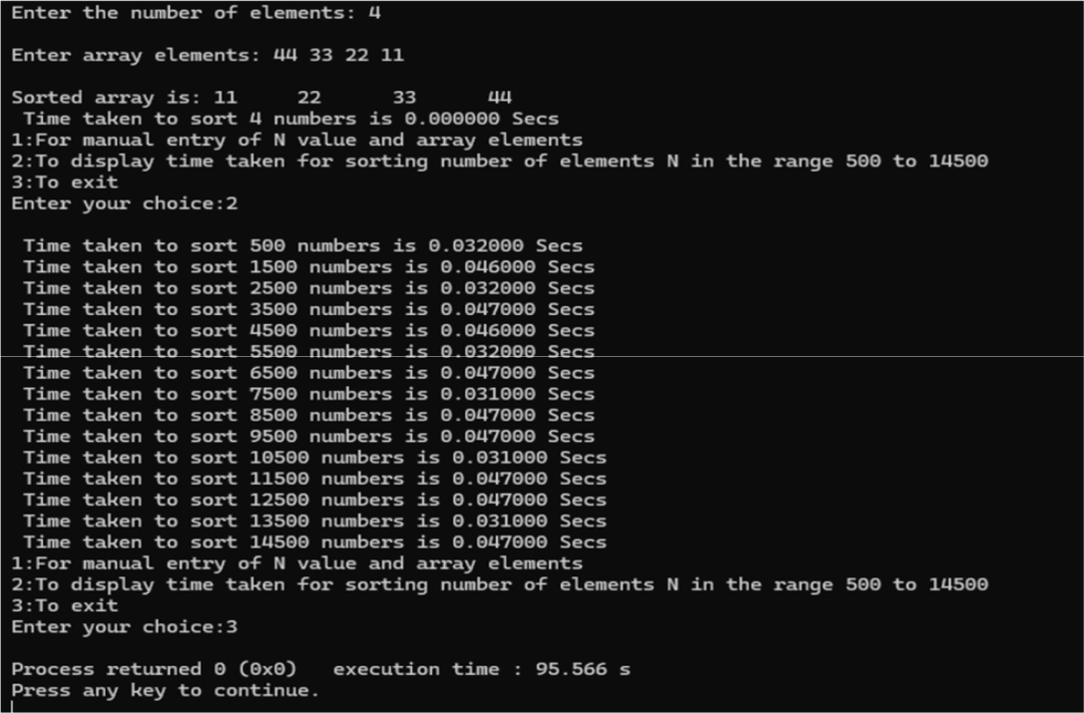

Graph:

13

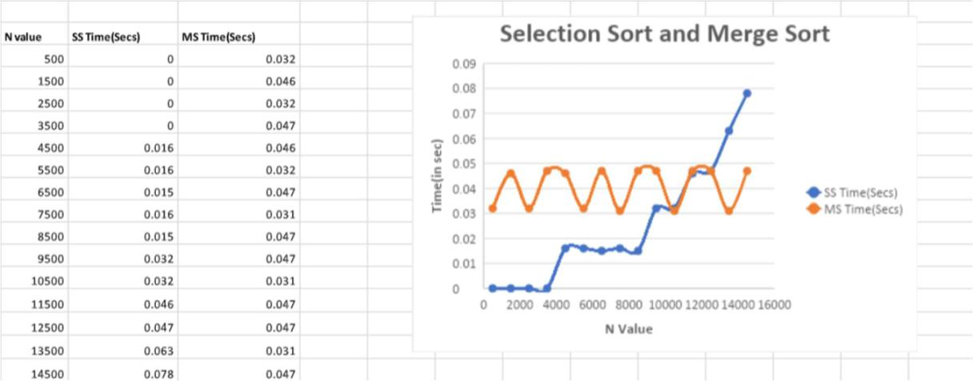

LAB 6:

Quick Sort:

#include<stdio.h>

#include<stdlib.h>

#include<stdbool.h>

#include<time.h>

void swap(int *a, int *b){

int temp = *a;

*a = *b;

*b = temp;

}

int partition(int a[], int low, int high){

int pivot = a[low];

int i = low + 1;

int j = high;

while (i <= j) {

while (i <= j && a[i] <= pivot)

14

i++;

while (i <= j && a[j] > pivot)

j--;

if (i < j)

swap(&a[i], &a[j]);

}

swap(&a[low], &a[j]);

return j;

}

void quicksort(int a[],int low,int high){

int point;

if(low<high){

point=partition(a,low,high);

quicksort(a,low,point-1);

quicksort(a,point+1,high);

}

}

void main(){

int a[15000], n, i, j, ch, temp;

clock_t start, end;

while (1) {

printf("\n 1:For manual entry of N value and array elements");

printf("\n 2:To display time taken for sorting number of elements N in the range 500 to 14500");

printf("\n 3:To exit");

15

printf("\nEnter your choice:");

scanf("%d", &ch);

switch (ch) {

case 1:

printf("\nEnter the number of elements: ");

scanf("%d", &n);

printf("Enter array elements: ");

for (i = 0; i < n; i++) {

scanf("%d", &a[i]);

}

start = clock();

quicksort(a,0,n-1);

end = clock();

printf("\nSorted array is: ");

for (i = 0; i < n; i++) {

printf("%d\t", a[i]);

}

printf("\nTime taken to sort %d numbers is %f Secs", n, (((double)(end - start)) / CLOCKS_PER_SEC));

break;

case 2:

n = 500;

while (n <= 14500) {

for (i = 0; i < n; i++) {

a[i] = n - i;

}

start = clock();

quicksort(a, 0, n - 1);

16

for (j = 0; j < 500000; j++) {

temp = 38 / 600;

}

end = clock();

printf("\nTime taken to sort %d numbers is %f Secs", n, (((double)(end - start)) / CLOCKS_PER_SEC));

n = n + 1000;

}

break;

case 3:

exit(0);

}

getchar();

}

}

Output:

17

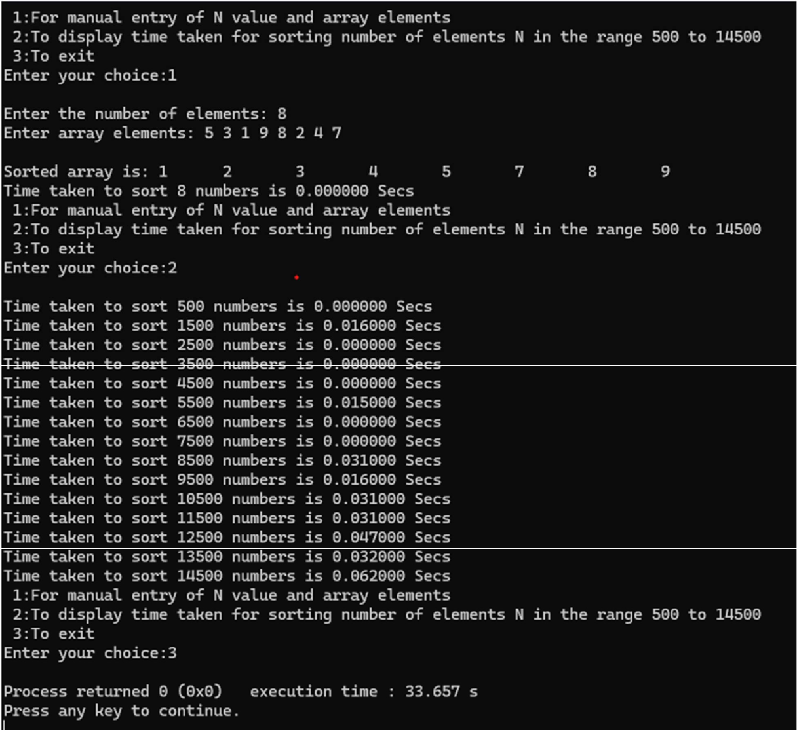

Graph:
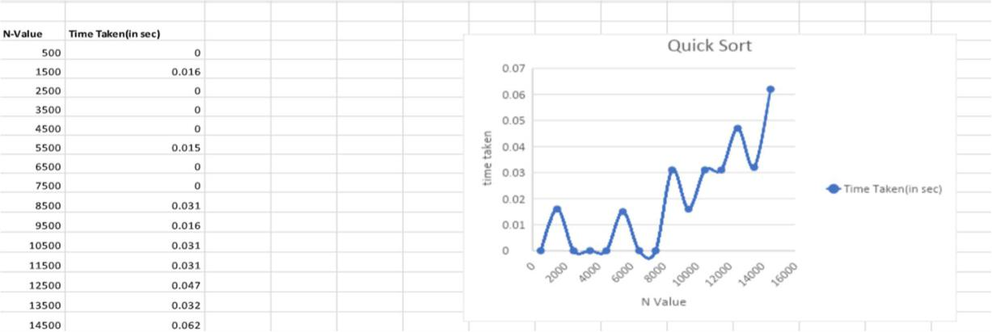

18

LAB 7:

Johnson Trotter Algorithm:

#include <stdio.h>

#include <stdlib.h>

int flag = 0;

int swap(int *a,int *b)

{

int t =*a;

*a = *b;

*b = t;

}

int search(int arr[],int num,int mobile)

{

int g;

for(g=0; g<num; g++) {

if(arr[g] == mobile)

return g+1;

else {

flag++;

}

}

return -1;

}

int find_Moblie(int arr[],int d[],int num)

{

int mobile = 0;

int mobile_p =0;

int i;

for(i=0; i<num; i++) {

19

if((d[arr[i]-1] == 0) && i != 0) {

if(arr[i]>arr[i-1] && arr[i]>mobile_p) {

mobile = arr[i];

mobile_p = mobile;

} else {

flag++;

}

} else if((d[arr[i]-1] == 1) & i != num-1) { if(arr[i]>arr[i+1] && arr[i]>mobile_p) {
mobile = arr[i];

mobile_p = mobile;

} else {

flag++;

}

}else { flag++;

}

}

if((mobile_p == 0) && (mobile == 0))

else return mobile;

return 0;

}

void permutations(int arr[],int d[],int num)

{

int i;

int mobile = find_Moblie(arr,d,num);

int pos = search(arr,num,mobile);

if(d[arr[pos-1]-1]==0) swap(&arr[pos-1],&arr[pos-2]); else

swap(&arr[pos-1],&arr[pos]);

20

for(int i=0; i<num; i++) {

if(arr[i] > mobile) {

if(d[arr[i]-1]==0) d[arr[i]-1] = 1;

else d[arr[i]-1] = 0;

}

}

for(i=0; i<num; i++) {

printf(" %d ",arr[i]);

}

}

int factorial(int k)

{

int f = 1;

int i = 0;

for(i=1; i<k+1; i++) {

f = f*i;

}

return f;

}

int main()

{

int num =0;

int i;

int j;

int z =0;

printf("Johnson trotter algorithm to find all permutations of given numbers \n");

printf("Enter the number\n");

scanf("%d",&num);

int arr[num],d[num];

21

z = factorial(num);

printf("total permutations = %d",z);

printf("\nAll possible permutations are: \n");

for(i=0; i<num; i++) {

d[i] = 0;

arr[i] = i+1;

printf(" %d ",arr[i]);

}

printf("\n");

for(j=1; j<z; j++) {

permutations(arr,d,num);

printf("\n");

}

return 0;

}

Output:
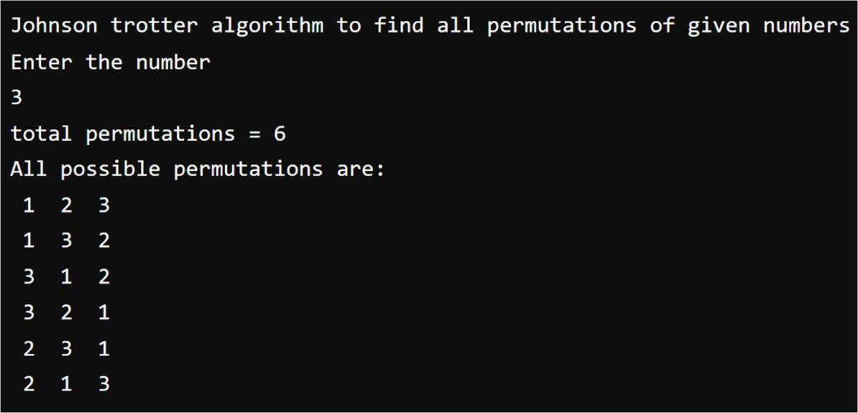

22

Pattern Matching Program:

#include<stdio.h>

#include<string.h>

void main()

{

char a[50], b[50];

printf("Enter two strings a and b\n");

scanf("%s",a);

scanf("%s",b);

int n = strlen(a);

int m = strlen(b);

int j, flag = 0;

for(int i = 0; i <= n-m; i++)

{

j = 0;

while(j < m && a[i+j] == b[j])

j = j + 1;

if(j == m)

{

printf("%d\n",j);

flag = 1;

printf("%d",i);

break;

}

}

if(flag == 0)

printf("String not matched");

23

}

Output:
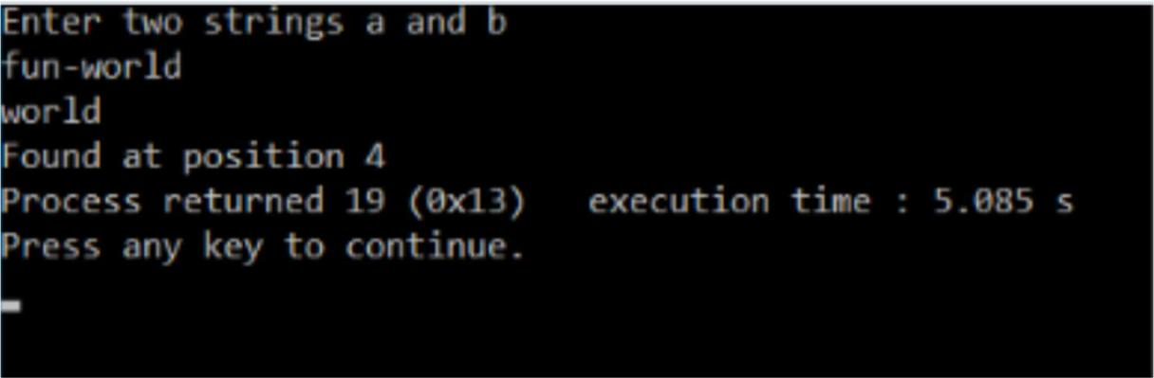

Leetcode-4: Find kth Largest Integer in the array:

int cmp(const void*a,const void*b) {

const char* str1 = *(const char**)a;

const char* str2 = *(const char**)b;

if (strlen(str1) == strlen(str2)) {

return strcmp(str1, str2);

}

return strlen(str1) - strlen(str2);

}

char * kthLargestNumber(char ** nums, int numsSize, int k){ qsort(nums,numsSize,sizeof(char*),cmp); return nums[numsSize-k];
}

Output:

24

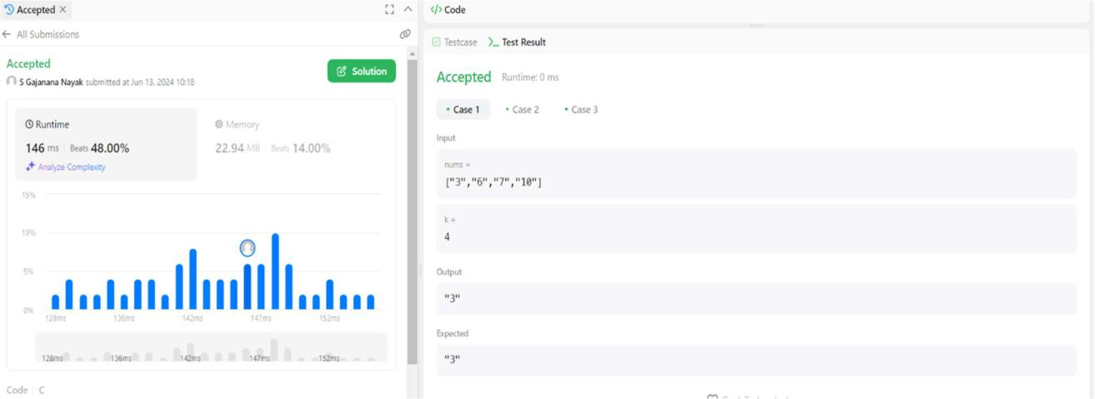

LAB 8:

Heap Sort:

#include<stdio.h>

#include<stdlib.h>

#include<time.h>

void bottom_up_heapify(int n, int a[]);

void swap(int *a, int *b);

void heap_sort(int n, int a[]);

void bottom_up_heapify(int n, int a[]) {

int p, item, c;

for (p = (n-1)/2; p >= 0; p--) {

item = a[p];

c = 2 * p + 1;

while (c <= n - 1) {

if (c + 1 <= n - 1 && a[c] < a[c + 1]) {

c++;

}

25

if (item >= a[c]) {

break;

}

a[p] = a[c];

p = c;

c = 2 * p + 1;

}

a[p] = item;

}

}

void swap(int *a, int *b) {

int temp = *a;

*a = *b;

*b = temp;

}

void heap_sort(int n, int a[]) {

int i;

bottom_up_heapify(n, a);

for (i = n - 1; i >= 0; i--) {

swap(&a[0], &a[i]);

bottom_up_heapify(i, a);

}

}

int main() {

int a[15000], n, i, j, ch, temp;

clock_t start, end;

while (1) {

26

printf("\n1: For manual entry of N value and array elements");

printf("\n2: To display time taken for sorting number of elements N in the range 500 to 14500");

printf("\n3: To exit");

printf("\nEnter your choice: ");

scanf("%d", &ch);

switch (ch) {

case 1:

printf("\nEnter the number of elements: ");

scanf("%d", &n);

printf("\nEnter array elements: ");

for (i = 0; i < n; i++) {

scanf("%d", &a[i]);

}

start = clock();

heap_sort(n, a);

end = clock();

printf("\nSorted array is: ");

for (i = 0; i < n; i++)

printf("%d\t", a[i]);

printf("\nTime taken to sort %d numbers is %f Secs", n, (((double)(end - start)) / CLOCKS_PER_SEC));

break;

case 2:

n = 500;

while (n <= 14500) {

for (i = 0; i < n; i++) {

//a[i] = rand() % 1000;

a[i] = n - i;

27

}

start = clock();

heap_sort(n, a);

//Dummy loop to create delay

for (j = 0; j < 500000; j++) {

temp = 38 / 600;

}

end = clock();

printf("\nTime taken to sort %d numbers is %f Secs", n, (((double)(end - start)) / CLOCKS_PER_SEC));

n = n + 1000;

}

break;

case 3:

exit(0);

}

getchar();

}

return 0;

}

Output:

28

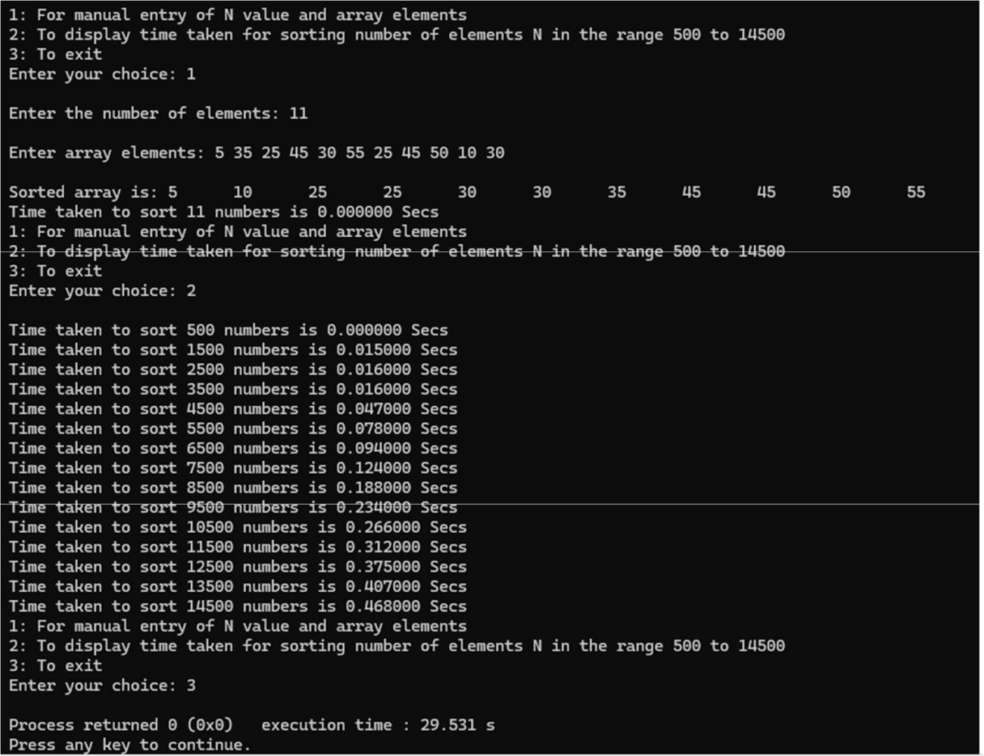

Graph:
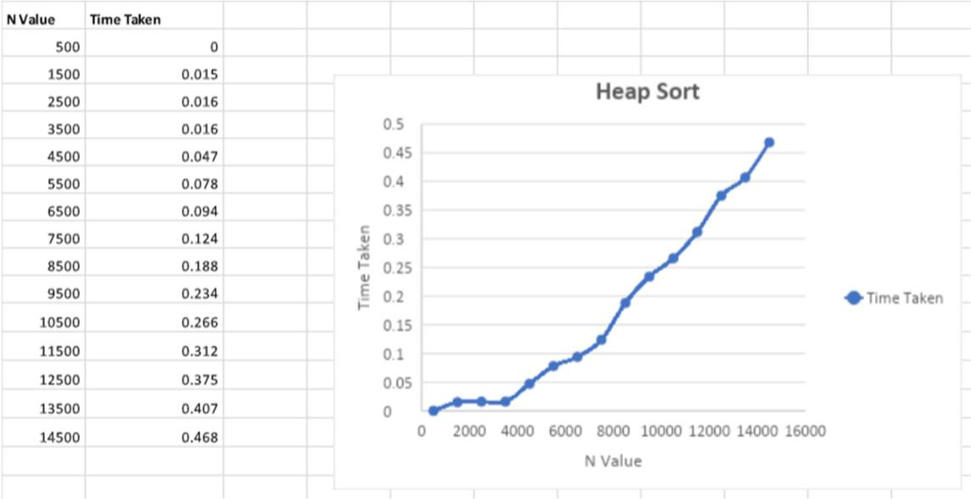

29

Floyd’s Algorithm:

#include <stdio.h>

#define V 5

#define INF 99999

void printSolution(int dist[][V]);

void floydWarshall(int dist[][V])

{

int i, j, k;

/* Add all vertices one by one to

the set of intermediate vertices.

---> Before start of an iteration, we

have shortest distances between all

pairs of vertices such that the shortest

distances consider only the

vertices in set {0, 1, 2, .. k-1} as

intermediate vertices.

----> After the end of an iteration,

vertex no. k is added to the set of

intermediate vertices and the set

becomes {0, 1, 2, .. k} */

for (k = 0; k < V; k++) {

- Pick all vertices as source one by one for (i = 0; i < V; i++) {

  - Pick all vertices as destination for the

  - above picked source

for (j = 0; j < V; j++) {

// If vertex k is on the shortest path from

30

- i to j, then update the value of

- dist[i][j]

if (dist[i][k] + dist[k][j] < dist[i][j])

dist[i][j] = dist[i][k] + dist[k][j];

}

}

}

printSolution(dist);

}

void printSolution(int dist[][V])

{

printf(

"The following matrix shows the shortest distances"

- between every pair of vertices \n"); for (int i = 0; i < V; i++) {

for (int j = 0; j < V; j++) { if (dist[i][j] == INF)

printf("%7s", "INF"); else

printf("%7d", dist[i][j]);

}

printf("\n");

}

}

int main()

{

int graph[V][V] = { { 0, 4, INF, 5,INF },

{ INF, 0, 1, INF,6 }, { 2,INF, 0, 3,INF },

31

{ INF, INF, 1, 0,2 } , {1,INF,INF,4,0}};
floydWarshall(graph);

return 0;

}

Output:
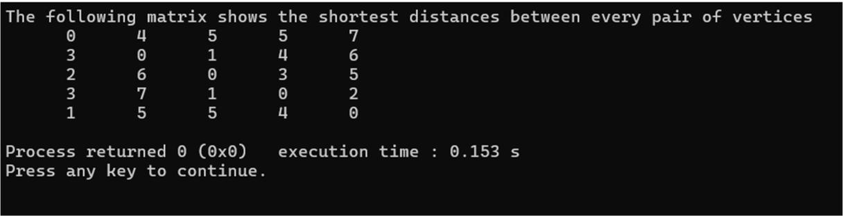

LAB 9:

Knapsack using Dynamic Programming:

#include <stdio.h>

#define N 4

#define CAPACITY 7

int max(int a, int b) {

if(a>b){

return a;

}

return b;

}

void knapsack(int weights[], int profits[]) {

32

int i, w;

int dp[N + 1][CAPACITY + 1];

for (i = 0; i <= N; i++) {

for (w = 0; w <= CAPACITY; w++) {

if (i == 0 || w == 0)

dp[i][w] = 0;

else if (weights[i - 1] <= w)

dp[i][w] = max(profits[i - 1] + dp[i - 1][w - weights[i - 1]], dp[i - 1][w]); else

dp[i][w] = dp[i - 1][w];

}

}

int maxProfit = dp[N][CAPACITY];

printf("Maximum profit: %d\n", maxProfit);

int selectedObjects[N];

int k = N, c = CAPACITY;

while (k > 0 && c > 0) {

if (dp[k][c] != dp[k - 1][c]) {

selectedObjects[k - 1] = 1;

  - =c- weights[k - 1]; } else {

selectedObjects[k - 1] = 0;

}

k--;

}

printf("\nTable Values (DP Table):\n");

33

for (i = 0; i <= N; i++) {

for (w = 0; w <= CAPACITY; w++) {

printf("%d\t", dp[i][w]);

}

printf("\n");

}

printf("\nObjects selected in the knapsack:\n");

for (i = 0; i < N; i++) {

if (selectedObjects[i] == 1)

printf("Object %d (Weight: %d, Profit: %d)\n", i + 1, weights[i], profits[i]);

}

}

int main() {

int weights[N];

int profits[N];

printf("Enter the weights:\n");

for(int i=0;i<N;i++){

scanf("%d",&weights[i]);

}

printf("Enter the profits:\n");

for(int i=0;i<N;i++){

scanf("%d",&profits[i]);

}

printf("Knapsack Capacity: %d\n", CAPACITY); printf("Objects:\n");

34

for (int i = 0; i < N; i++) {

printf("Object %d - Weight: %d, Profit: %d\n", i + 1, weights[i], profits[i]);

}

knapsack(weights, profits);

return 0;

}

Output:
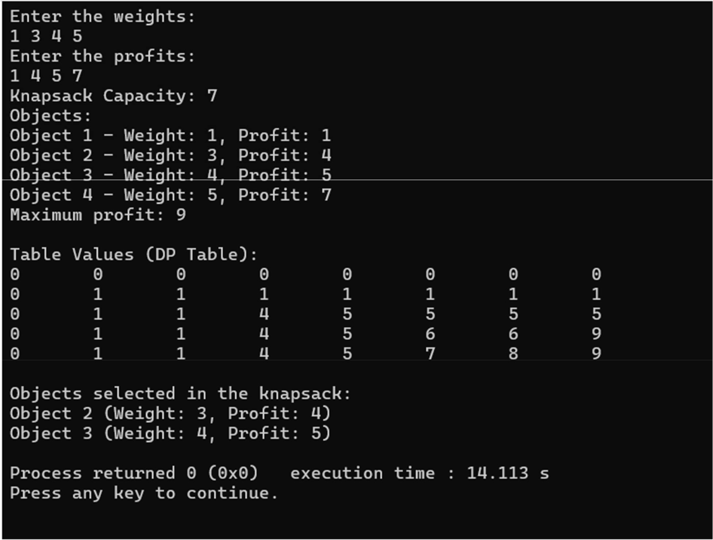

35

Prims Algorithm:

#include <stdio.h>

#include <limits.h>

#define MAX 100

void prims(int n, int cost[MAX][MAX], int INF) { int S[MAX], d[MAX], p[MAX], T[MAX][2]; int i, j, min, source, sum = 0, k = 0, u; min = INF;

source = 0;

for (i = 0; i < n; i++) {

for (j = 0; j < n; j++) {

if (cost[i][j] != 0 && cost[i][j] < min) {

min = cost[i][j];

source = i;

}

}

}

for (i = 0; i < n; i++) {

S[i] = 0;

d[i] = cost[source][i];

p[i] = source;

}

S[source] = 1;

for (i = 1; i < n; i++) {

min = INF;

u = -1;

for (j = 0; j < n; j++) {

if (S[j] == 0 && d[j] <= min) {

min = d[j];

36

u = j;

}

}

T[k][0] = u;

T[k][1] = p[u];

k++;

sum += cost[u][p[u]];

S[u] = 1;

for (j = 0; j < n; j++) {

if (S[j] == 0 && cost[u][j] < d[j]) {

d[j] = cost[u][j];

p[j] = u;

}

}

}

if (sum >= INF) {

printf("Spanning tree does not exist.\n");

} else {

printf("Spanning tree exists and MST is:\n");

for (i = 0; i < n - 1; i++) {

printf("%d -> %d\n", T[i][1], T[i][0]);

}

printf("The cost of Spanning tree is MST is %d\n", sum);

}

}

int main() {

int n, cost[MAX][MAX], i, j;

int INF = INT_MAX;

37

printf("Enter the number of vertices: ");

scanf("%d", &n);

printf("Enter the cost adjacency matrix:\n");

for (i = 0; i < n; i++) {

for (j = 0; j < n; j++) {

scanf("%d", &cost[i][j]);

if (cost[i][j] == 9999 ) {

cost[i][j] = INF;

}

}

}

prims(n, cost, INF);

return 0;

}

Output:
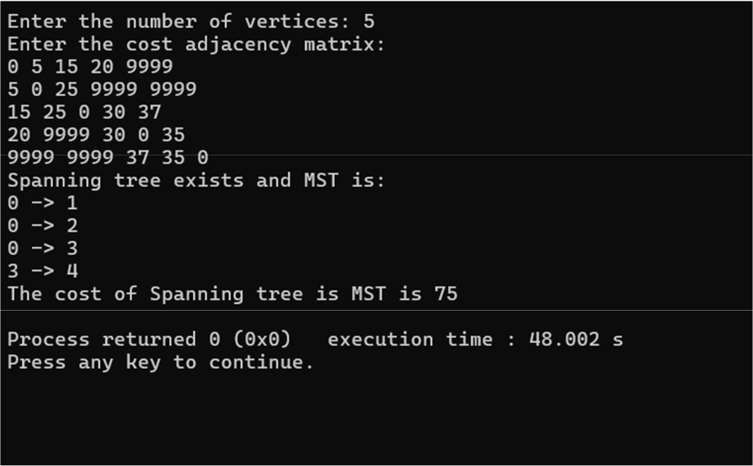

38

LAB 10:

Dijkstra’s Algorithm:

#include <limits.h>

#include <stdbool.h>

#include <stdio.h>

#define V 6

int minDistance(int dist[], bool sptSet[])

{

int min = INT_MAX, min_index;

for (int v = 0; v < V; v++)

if (!sptSet[v] && dist[v] <= min) {

min = dist[v];

min_index = v;

}

return min_index;

void printSolution(int dist[])

{

printf("Vertex \t\t Distance from Source\n");

for (int i = 0; i < V; i++)

printf("%d \t\t\t %d\n", i, dist[i]);

}

void dijkstra(int graph[V][V], int src)

{

int dist[V];

bool sptSet[V];

39

for (int i = 0; i < V; i++)

dist[i] = INT_MAX, sptSet[i] = false;

dist[src] = 0;

for (int count = 0; count < V - 1; count++) {

int u = minDistance(dist, sptSet);

sptSet[u] = true;

for (int v = 0; v < V; v++)

if (!sptSet[v] && graph[u][v]

- dist[u] != INT_MAX

- dist[u] + graph[u][v] < dist[v]) dist[v] = dist[u] + graph[u][v];
}

printSolution(dist);

}

int main()

{

int graph[V][V];

printf("Enter the values of adjacency matrix:\n"); for (int i = 0; i < V; i++) {

for (int j = 0; j < V; j++) {

scanf("%d", &graph[i][j]);

}

}

dijkstra(graph, 0);

return 0;

40

}

Output:
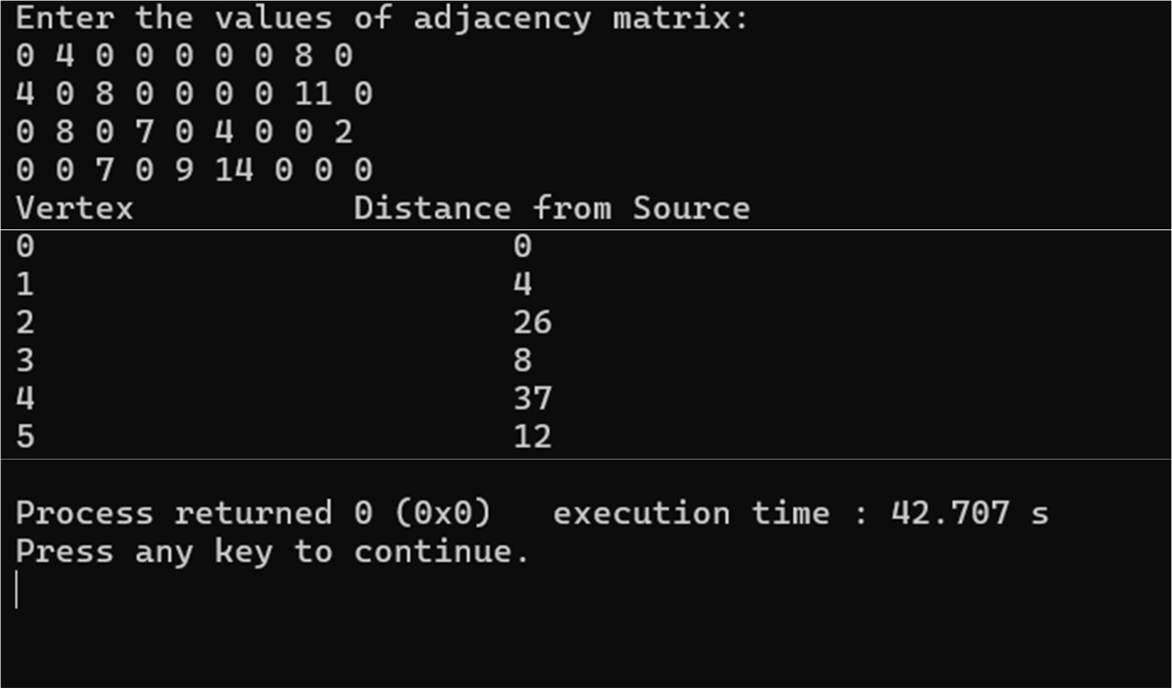

Kruskal’s Algorithm:

#include <stdio.h>

#include <stdlib.h>

int comparator(const void* p1, const void* p2)

{

const int(*x)[3] = p1;

const int(*y)[3] = p2;

return (*x)[2] - (*y)[2];

}

void makeSet(int parent[], int rank[], int n)

{

41

for (int i = 0; i < n; i++) {

parent[i] = i;

rank[i] = 0;

}

}

int findParent(int parent[], int component)

{

if (parent[component] != component) {

parent[component] = findParent(parent, parent[component]);

}

return parent[component];

}

void unionSet(int u, int v, int parent[], int rank[])

{

u = findParent(parent, u);

v = findParent(parent, v);

if (rank[u] < rank[v]) {

parent[u] = v;

} else if (rank[u] > rank[v]) { parent[v] = u;
} else {

parent[v] = u;

rank[u]++;

}

}

void kruskalAlgo(int n, int edges[][3], int e)

{

qsort(edges, e, sizeof(edges[0]), comparator);

int parent[n];

42

int rank[n];

makeSet(parent, rank, n);

int minCost = 0;

printf("Following are the edges in the constructed MST\n"); for (int i = 0; i < e; i++) {

int u = edges[i][0];

int v = edges[i][1];

int wt = edges[i][2];

int parent_u = findParent(parent, u);

int parent_v = findParent(parent, v);

if (parent_u != parent_v) {

unionSet(parent_u, parent_v, parent, rank);

minCost += wt;

printf("%d -- %d == %d\n", u, v, wt);

}

}

printf("Minimum Cost Spanning Tree: %d\n", minCost);

}

int main()

{

int n, e;

printf("Enter the number of vertices: ");

scanf("%d", &n);

printf("Enter the number of edges: ");

scanf("%d", &e);

int edges[e][3];

printf("Enter the edges (u v wt):\n");

for (int i = 0; i < e; i++) {

scanf("%d %d %d", &edges[i][0], &edges[i][1], &edges[i][2]);

43

}

kruskalAlgo(n, edges, e);

return 0;

}

Output:
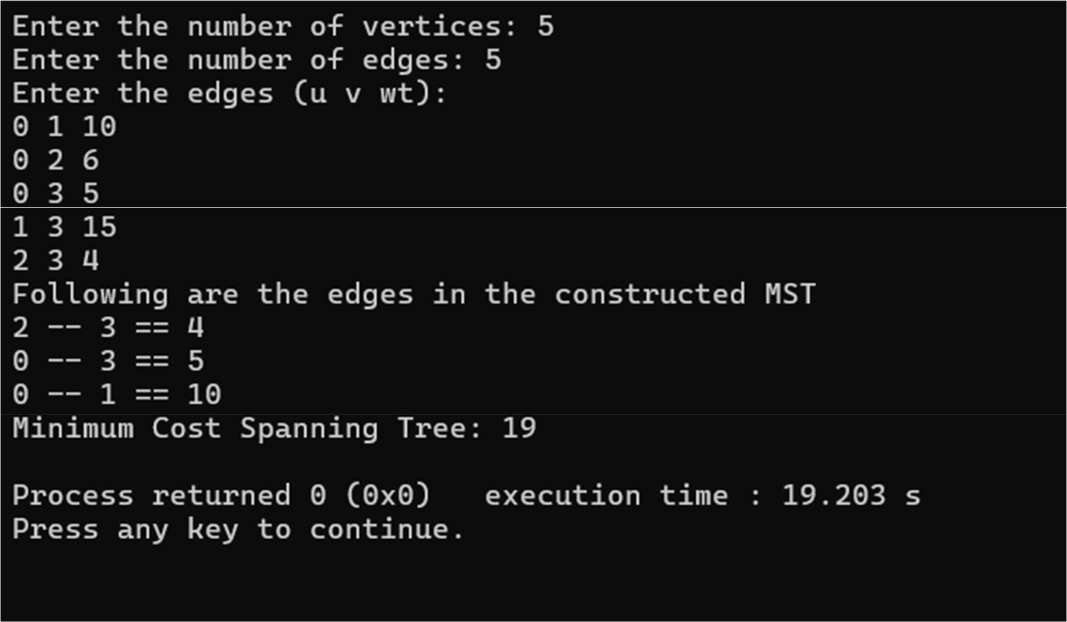

Greedy knapsack Problem:

#include <stdio.h>

void main() {

int n;

float m;

printf("Enter the capacity\n");

scanf("%f", &m);

printf("Enter the number of objects\n");

scanf("%d", &n);

printf("Enter the elements of Profit/ Weight of %d objects\n", n);

44

float w[n], p[n], x[n];

float ratio[n];

for (int i = 0; i < n; i++) {

scanf("%f %f", &p[i], &w[i]);

x[i] = 0;

ratio[i] = p[i] / w[i];

}

for (int i = 0; i < n - 1; i++) {

for (int j = 0; j < n - i - 1; j++) {

if (ratio[j] < ratio[j + 1]) {

- Swap profits float tp = p[j + 1]; p[j + 1] = p[j]; p[j] = tp;

- Swap weights float tw = w[j + 1]; w[j + 1] = w[j]; w[j] = tw;

- Swap ratios

float tr = ratio[j + 1];

ratio[j + 1] = ratio[j];

ratio[j] = tr;

}

}

}

float rc = m;

float mp = 0;

for (int i = 0; i < n; i++) {

// If weight is less than remaining capacity

45

if (w[i] <= rc) {

- make it visited x[i] = 1;

- Subtract weight from remaining capacity rc -= w[i];

- Add to total Profit

mp += p[i];

}

- If weight is greater than capacity else {

  - Take portion of remaining capacity x[i] = rc / w[i];

  - add to profit

mp += x[i] * p[i];

break; // No more capacity left

}

}

printf("The Selected objects are:\n");

for (int i = 0; i < n; i++) {

if (x[i]) {

printf("Object %d (fraction: %.2f)\n", i + 1, x[i]);

}

}

printf("The Maximum Profit is: %.2f\n", mp);

}

Output:

46

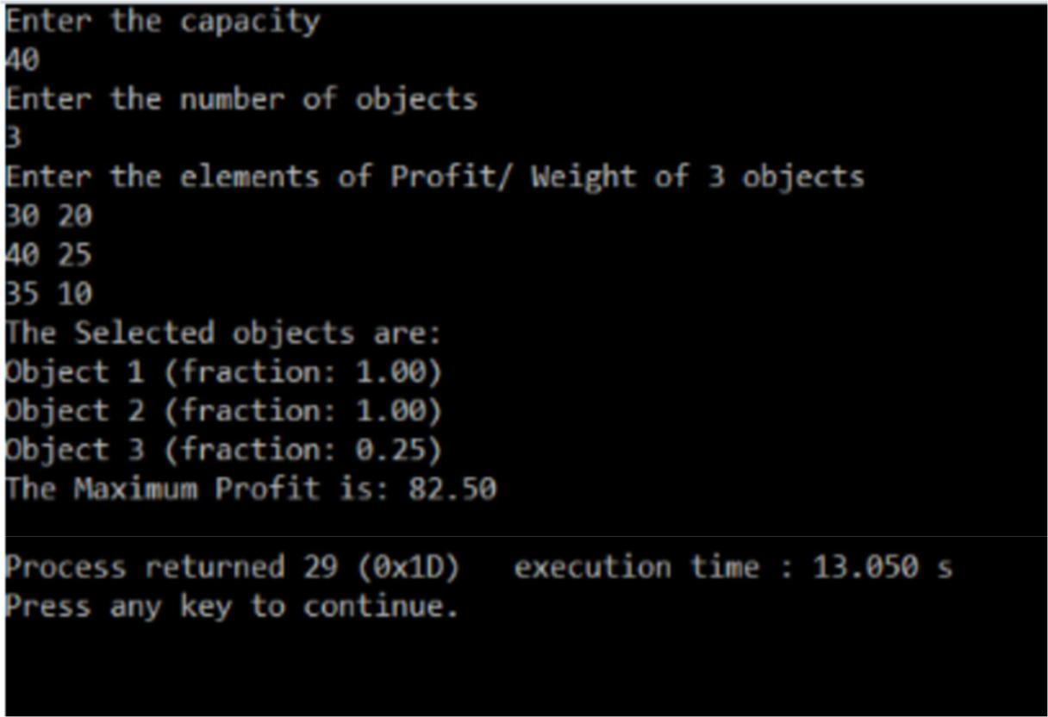

N Queens Problem:

#include <stdio.h>

#include <stdbool.h>

#define N 8 // You can change N to any number to solve for different board size void printSolution(int board[N][N]) {

for (int i = 0; i < N; i++) {

for (int j = 0; j < N; j++) {

printf("%2d ", board[i][j]);

}

printf("\n");

}

}

47

bool isSafe(int board[N][N], int row, int col) {

int i, j;

- Check this row on the left side for (i = 0; i < col; i++)

if (board[row][i]) return false;

- Check upper diagonal on the left side

for (i = row, j = col; i >= 0 && j >= 0; i--, j--)

if (board[i][j])

return false;

// Check lower diagonal on the left side

for (i = row, j = col; j >= 0 && i < N; i++, j--)

if (board[i][j])

return false;

return true;

}

bool solveNQUtil(int board[N][N], int col) {

- If all queens are placed if (col >= N)

return true;

- Consider this column and try placing this queen in all rows one by one for (int i = 0; i < N; i++) {

  - Check if the queen can be placed on board[i][col]

if (isSafe(board, i, col)) {

48

- Place this queen in board[i][col] board[i][col] = 1;

- Recur to place the rest of the queens if (solveNQUtil(board, col + 1))
return true;

- If placing queen in board[i][col] doesn't lead to a solution

- then backtrack

board[i][col] = 0; // Remove queen from board[i][col]

}

}

- If the queen cannot be placed in any row in this column, return false return false;

bool solveNQ() {

int board[N][N] = {0};

if (!solveNQUtil(board, 0)) {

printf("Solution does not exist");

return false;

}

printSolution(board);

return true;

}

int main() {

solveNQ();

return 0;

}

49

Output:
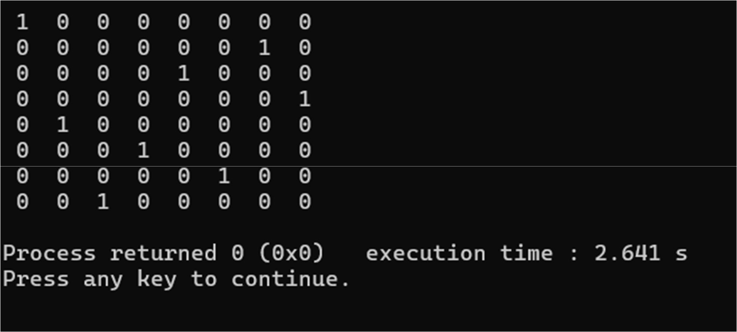

50

