# Demand Forecasting and Waste Optimization Strategies for Doon Bites Restaurant

**Final report for the BDM Capstone Project**

Submitted by

**Name**: Rushil Gupta

**Roll number**: 21f1006728

**Email ID**: [21f1006728@ds.study.iitm.ac.in](mailto:21f1006728@ds.study.iitm.ac.in)



IITM Online BS Degree Program,

Indian Institute of Technology, Madras, Chennai Tamil Nadu, India, 600

**Contents**

1. Executive Summary 3

2. Detailed Explanation of Analysis Process/Method 4

3. Results and Findings 10

4. Interpretation of Results and Recommendations 17

5. Conclusion 19

# Executive Summary

Doon Bites is a small vegetarian food outlet in Lucknow which serves fast food, particularly Chinese, to its customers every evening. Like any other typical small fast-food business, it faces the problem of raw material wastage, lack of proper awareness about customer’s demands and preferences, and low profits and heavy competition. A thorough data-based analysis of their business and operations can open the door to improved sales and healthier profits by revealing hidden patterns and existing trends in the sales and purchase data. Graphical representation of cleaned and processed data gives a better visual idea about this, which can then be examined to find out the root cause behind certain spikes or anomalies or recurring patterns, and then make strategic decisions accordingly.

In the previous report, 4 such interesting trends/patterns were observed, namely – certain categories having more sales than others, the business performing poorly online as compared to in person, veggies contributing to a major part of the waste being generated and the sales showing a repetitive but consistent trend, except for one major dip.

This report shall dive further into those findings and examine their root cause, as well as probe into other aspects such as customer preferences, days when sales peak, which dishes are in hot demand etc. Subsequently these cases shall be interpreted and recommendations will be given on how to boost sales growth online, how to reduce waste without affecting profits, which dishes’ should be anticipated more than others and which dates are likely to witness more sales than others.

# Detailed Explanation of Analysis Process/Method

1. **Data Collection and Cleaning/Preprocessing**

The data of Doon Bites restaurant’s sales and purchases was not available digitally. The owner Mr. Rautela had stored sales data manually in a register on a day to day basis. Orders from Zomato and Swiggy were shown on the orders history section. Menu list and raw materials list too was in a paper format.

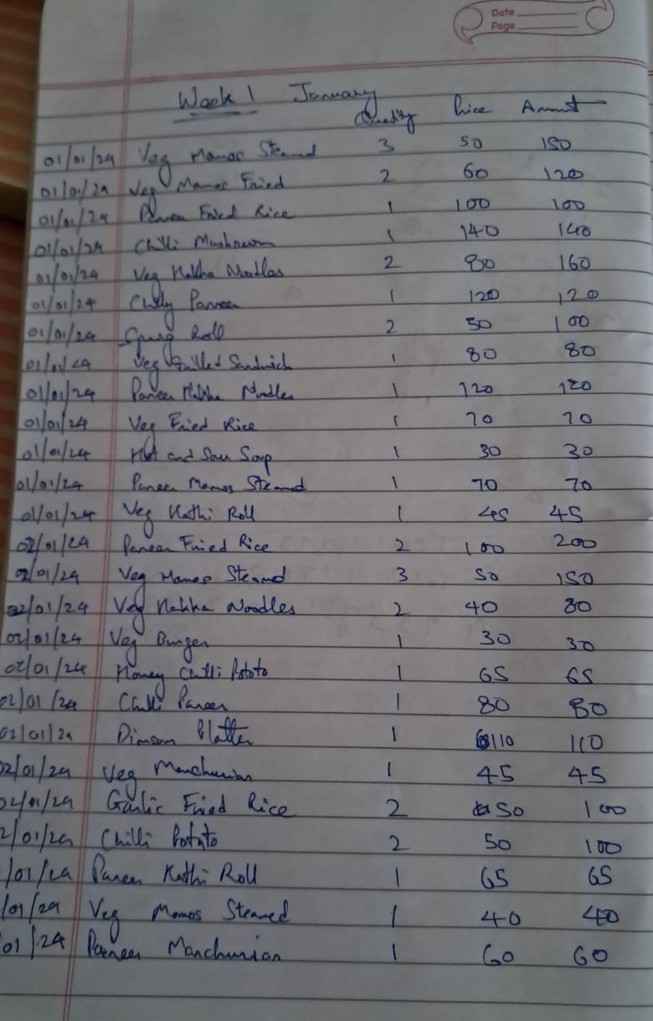

*Image of the sales data stored manually in a register*

All this data was captured by tools such as google lens and scanner, text was extracted from it and then stored in an excel sheet. Then basic data cleaning steps such as imputation, sorting, checking for duplicates and inconsistencies was taken care of.

The final data stored in excel comprised of 4 sheets which store different kinds of data – Dishes Data, Raw Material Data, Sales Data and Purchase Data.

**Dishes Data** contains the cost and selling price of each dish being served by the restaurant, along with its quantity (half/full). It also captures the profit earned by Doon Bites on each quantity of each dish. The dishes are segregated into a broader category based on their type, such as Soup, Noodles, Momos etc.

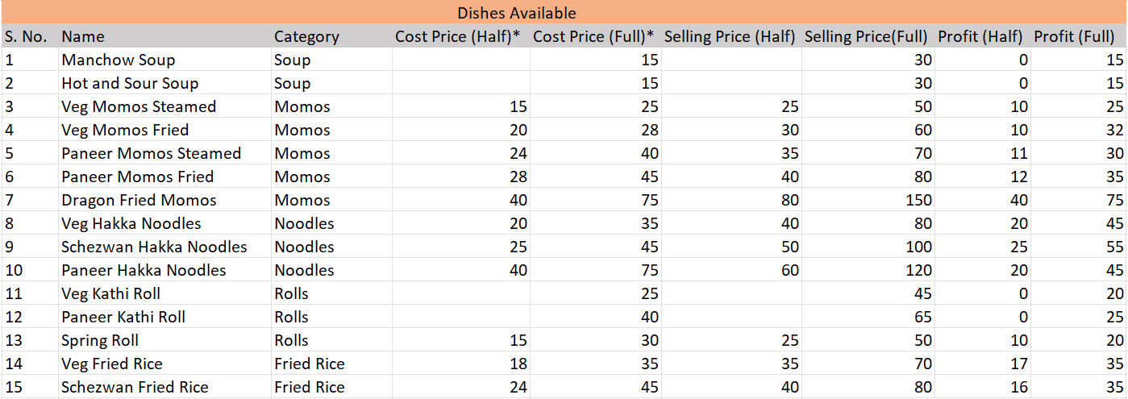

*Dishes Datasheet*

**Raw Material Data** contains the list of raw materials along with their cost price and the quantity which is being consumed per day basis. Raw material too is categorized into broader terms such as Veggies, Sauce, Breads etc.

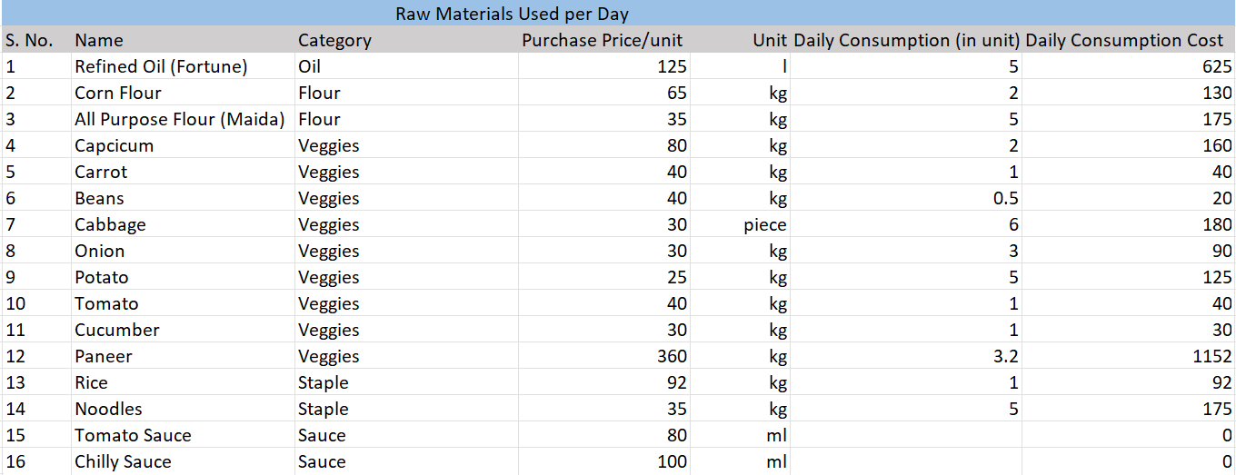

*Raw Material Datasheet*

**Sales data** stores the sales of the dishes on a daily basis, along with the quantity sold and the medium through which it was sold. It also calculates the total amount of the dish, which is price * quantity.

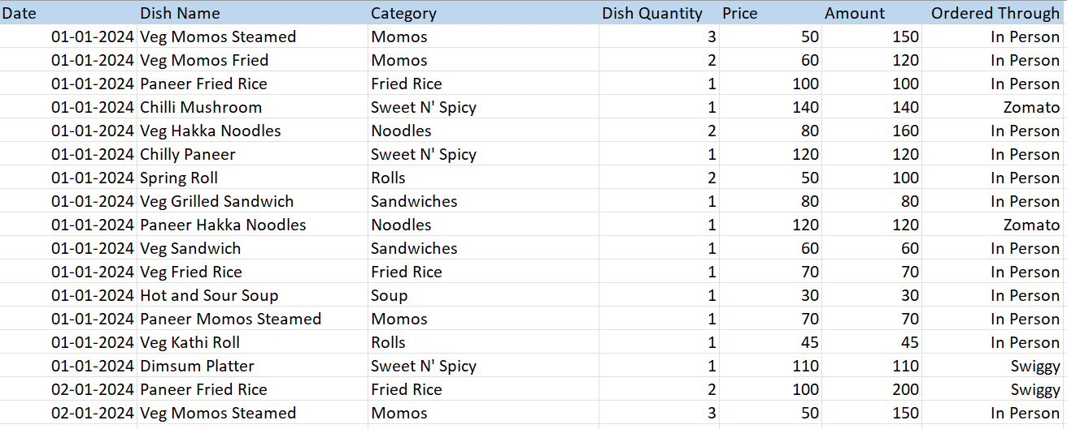

*Sales Datasheet*

**Purchase Data** stores the purchases of the raw materials made by the business in order to fulfil customers’ demands. It captures the purchase price, unit and quantity purchased on a given date, as well as calculates the total amount a particular raw material costed.

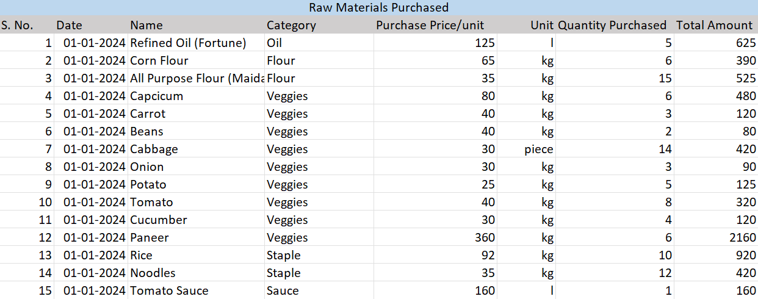

*Purchase Datasheet*

Having the data stored in a proper tabular format in Excel made it easy to find out descriptive

statistics of the data such as average, mode, sum and daily and weekly performance of a certain category or dish or raw material.

1. **Calculating Profits and Demand**

Profits earned by the business were calculated using the below formula:

*Profit calculated per day = Total amount of dishes sold per day – Total amount of raw materials used per day – total amount of raw materials wasted per day.*

Total amount of raw materials used per day is approximately the same as the total cost price of the dishes ordered in a day.

Example: If an order is of 1 full plate dragon fried momos, the cost of raw materials used in its preparation would be equal to Rs. 80 (refer to dishes data).

Total amount of raw materials wasted per day is the approximate cost of raw materials which are discarded at the end of the day, as they are unfit to be used for the next day. This is calculated by checking the date of purchase of the raw material and its shelf life and the quantity of raw material left after its shelf life is over.

Example. If paneer is purchased worth 6kgs, costing Rs. 2160 (360 Rs/kg, refer to raw material data) and after its shelf life of approximately 3 days, paneer worth 2 kgs is still left, then the total waste amount would be 2*360 = Rs. 720.

Having used the above formula and logic, the total sales calculated for the period of 45 days was **Rs.** **78,860** and the total raw material amount used was **Rs. 23580** and the total raw material amount wasted was **Rs. 15,470**.

This meant that the business was earning a profit of 78860 – 23580 – 15470 = **Rs. 39800** over the span of 45 days.

This would translate to a monthly profit of 39800 / 1.5 = **Rs. 26,536**.

The above calculation shows that the business is not earning as well as it should, and approximately **10,000 Rs.** Of their purchase is going to waste every month.

Similarly, sales data indicates that **1373 orders** were made during this time period, or 1373 / 45 = **30 orders** were made on an average day, or 30 / 5 = **6 orders** were made per hour on average. (The business is only operational for 5 hours a day).

This would indicate **low demand** for a business which is in the fast-food industry, but suggests that the orders should have been handled efficiently due to lower traffic.

Moreover, the **Ordered Through** column in sales data has frequency of ‘In Person’ values as **975,** which indicates that majority of orders came from people who physically went to the outlet. Therefore, in the online market, there is low demand for this business.

1. **Visualizing the Data**

Now that the problem of the business was both verified and quantified through statistical data

analysis, it was time to dive further into the findings by graphing them appropriately. Here are the

few graphs used along with their justifications: -

1. Sales Data’s dish categories were graphed using a **bar chart** based on the number of orders

each category received. This was done to find out the performance of a particular category with

respect to the number of orders it received, and to compare it with the performance of other

categories.

1. A **line chart** was used to show the sales of the business on a weekly basis. It helped

understand how the business was faring on a weekly basis in terms of sales, and to discover any

trends or patterns available.

1. **Pie Charts** were used to show the composition of various topics such as, percentage of

waste being generated by a certain category of raw material, percentage of customers ordering

online through a food delivery platform etc. It was instrumental in understanding just how much a

category or variable is contributing to an overall percentage of the topic.

Graphs and charts helped discover new patterns and trends in the data and gave a better description of

the challenges faced and the key areas to be inspected and worked upon.

4. **Understanding the Causes of the Findings**

The findings from the visual representation of data then paved way for investigation as to why certain

patterns emerged and upon discussion with the owner and looking at non numerical (non data related)

factors, certain conclusions were arrived at.

Example: Was the sale high due to weekend factor? Are people buying more from one category than

most other categories combined? Etc.

After a thorough understanding of the controllable and non-controllable factors leading to these

findings, certain measures were discussed and recommended to the owner which would help him

control the controllables and find optimal solutions to increase his profit while not compromising on

the service being provided.

Example: Reducing the purchase of X to reduce significant wastage, increasing the production of Y to

maximize profit etc.

These 4 steps explain in detail from scratch how the data was collected, cleaned, processed, visualized,

and the findings discussed with the stakeholders in order to help their business perform better in the market.

The actual results and findings and the corresponding recommendations made are mentioned in detail next.

# Result And Findings

## Top Selling Categories and Dishes:

As mentioned above, categories of dishes were plotted on a bar chart to compare the number of orders they received during this time period. The following chart was the result.

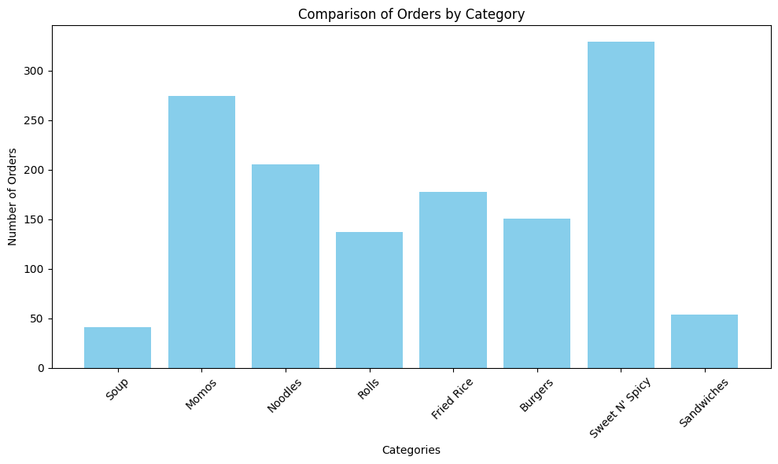

*Categories compared by the number of orders they received*

The chart here indicates that Doon Bites’ best selling categories are **Sweet N’ Spicy** and **Momos.**

If we compare the findings into percentage, we find that Sweet N’ Spicy accounts for **24%** of the total

orders made and Momos accounts for **20%** of the total orders made.

In contrast, categories such as Sandwiches and Soup only account for **4%** and **3%** of the total orders.

Now that the top selling categories are discovered, the dishes within those categories which perform

the best need to be discovered.

A bar chart for the dishes within Sweet N’ Sour and Momos categories were also plotted to understand

the proportion of orders each dish in a category received.

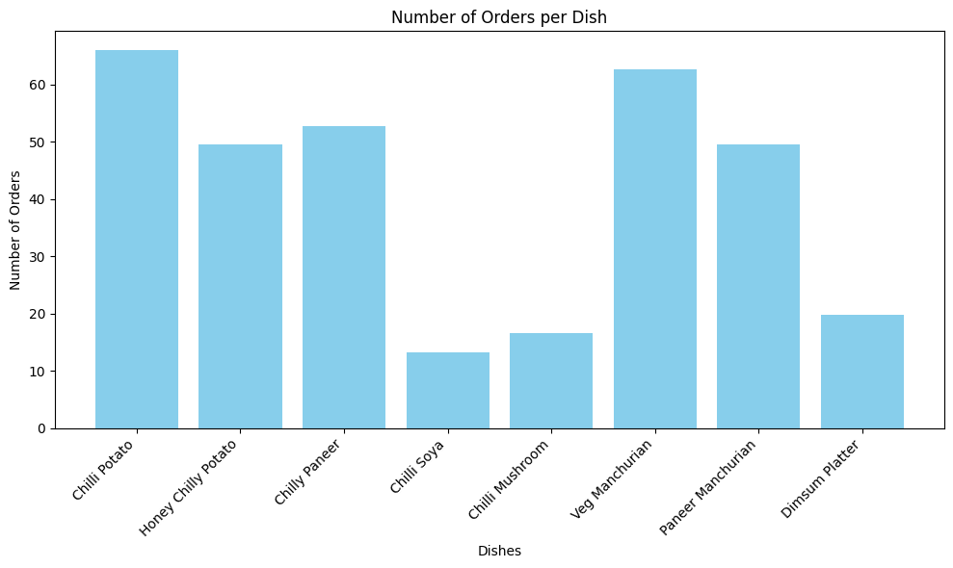

*Dishes within the Sweet N’ Sour category based on the number of orders they received*

From the chart above, it can be seen that common fast food items such as **Chilly Potato** and **Veg**

**Manchurian** are the most in demand, followed by **Honey Chilli Potato** and **Paneer Manchurian**. Dishes

like **Chilli Soya** and **Chilli Mushroom** and **Dimsum Platter** were the least in demand.

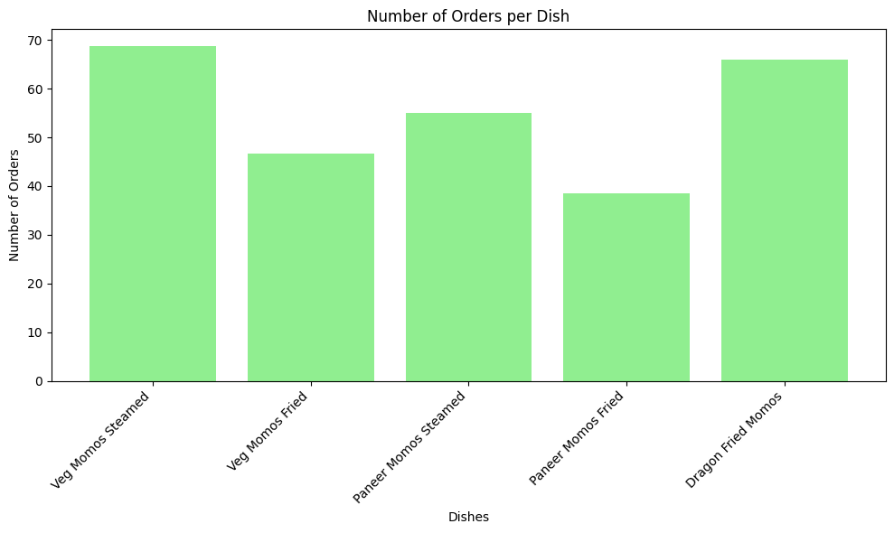

*Dishes within the Momos category based on the number of orders they received*

Similary it can be seen from the Momos chart that **Veg Momos Steamed** and **Dragon Fried Momos** have received the maximum number of orders whereas the fried varients of momos are not as much in demand.

From the above two charts, an interesting observation can be made that the common fast food items readily available in the market are also the ones which are being ordered the most in Doon Bites’, such as Chilli Potato and Manchurian, with the only exception being **Dragon Fried Momos.**

## Sales Trend

In order to determine the sales pattern of the business, a line chart was plotted.

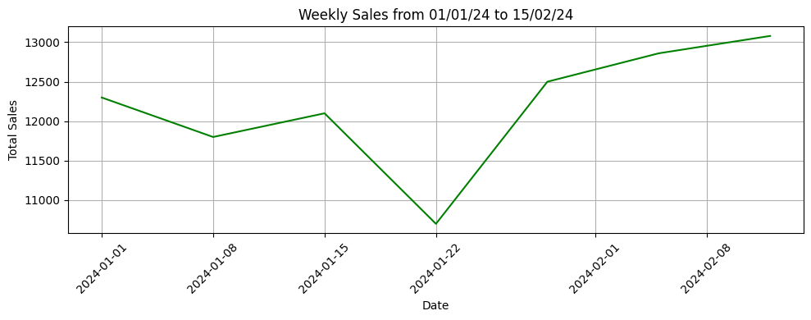

*Weekly sales chart*

The business more or less seems to be growing steadily as the weeks progress. However certain dips in sales are noted, especially in the 2nd week ( 08-01-24) and more noticeably in the 4th week (22-01-24).

In order to inspect why the sales declined significantly, sales of each date were plotted in a line chart.

This was the result.

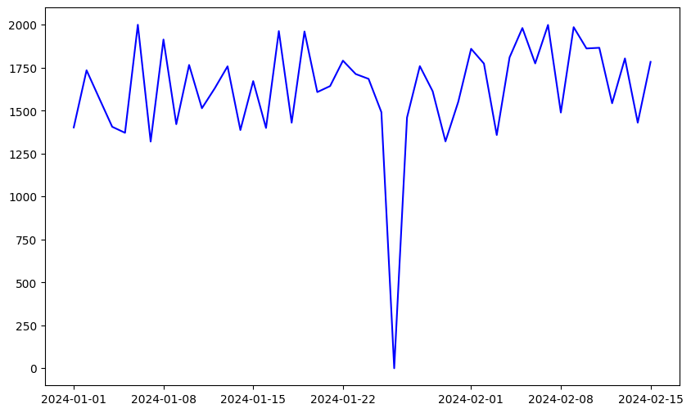

*Daily Sales Chart*

It can be seen from this chart that the sales dropped to 0 for a day in the 4th Week of January, which lead to the overall decline of sales for that particular week. On inspecting the sales data, it is found that the business did not operate on 26th of January, thus leading to no sales happening on that date.

## Waste Analysis

## To understand the categories which contribute the most towards waste generation, a pie chart was drawn, as shown below.

## 

## *% of Waste being generated by different categories*

## It can be seen that Veggies contribute the most towards waste generation, followed by Breads. To understand which veggies account for the most waste, a bar chart is plotted.

## 

## *Comparison of Veggies by the waste they generate*

## It can be seen that Mushroom and Paneer contribute to the most waste generated by veggies, accounting to almost 52% of the total veggies waste. Now it needs to be determined just how much of waste amount in Rupees is being contributed by these two veggies. This can be determined by the graph below:

## 

## *Waste comparison by Amount (in Rupees)*

## From the above graph, it is evident that Paneer and Mushroom by themselves contribute to a lot of waste that is generated by Doon Bites. Paneer accounts for ~ Rs. 3300 worth of waste generated while mushroom accounts for ~ Rs. 2250 of the waste generated. Breads (including buns and bread flour) account for ~ Rs. 3000 worth of waste in this period of 45 days.

## Customer Order Preference Analysis

## Previously calculated statistics indicated that the customers widely preferred to order in person as compared to online. This when plotted on a pie chart (shown below) gave the exact number of orders and where they came from.

## 

*Comparison of the source of orders made*

**71%** of the total orders in the 45 day period came when a customer ordered at the outlet. Food ordering and delivery platforms such as Zomato and Swiggy only accounted for **27%** of the total orders in this time period. Examining the orders made online further we get the following chart –

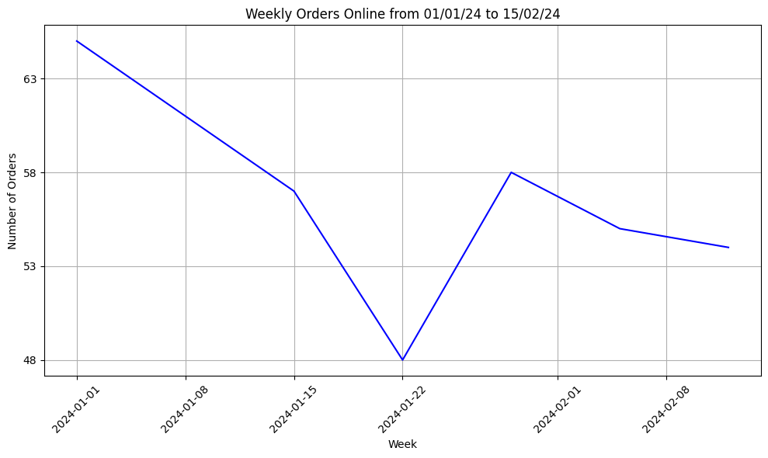

*Line Chart showing the number of orders made online in a week*

It can be seen that the orders made online are slowly reducing as the week progresses. (4th week does not count due to the business being shut on 26th January as understood previously). Examining the orders made online further by comparing them with regular orders in terms of sales, we get –

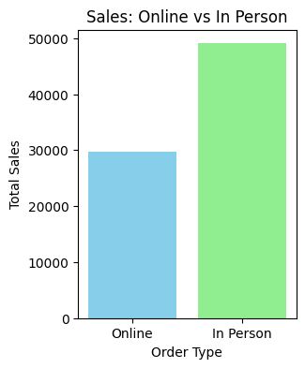

*Comparison of In Person and Online Orders by the amount of sales*

It is evident from the above graph that **29%** of the orders made online have resulted in **~ 37%** of the

total sales observed in this time period. This means that the 398 orders made online had an average cost of **Rs. 74** per order as compared to the 975 orders in person having an average cost of **Rs. 50** per order.

This signifies that an average online order is approximately **1.5** times bigger than an average in person order. This indicates that customers typically prefer online orders only if they are relatively bigger.

# Interpretation of Results and Recommendations

The above findings and results have provided a better, data driven idea about the customer preferences, top selling categories and dishes and the typical trend. Accounting these with the non data driven factors such as weather, public holiday, working hours of customers, competition in the segment etc, some key recommendations can be made which are guranteed to benefit the business in the long term.

1. **Focusing on main dishes:** As the findings suggest, Doon Bites is famous for its Chinese food, especially **Momos** and **Chilly Potatoes** and **Manchurian**. These dishes should be prioritized over the others, and raw materials required for them should be sufficiently stocked. **Dragon Fried Momos** seems like an USP of this outlet, as it has witnessed almost as many orders as regular momos, despite it being 3x costlier. Therefore, the business should promote that dish on its outlet and online in order to attract more customers.
2. **Removing certain Dishes from Menu:** The business could benefit from removing dishes like Sandwiches from its menu, as it is not only less profit yielding, but it also goes against the reputation of the business being Chinese food centric. Removing it would also eliminate the wastage of regular bread, saving the business **~ Rs.600** per month. The business can also consider dropping Chilli Soya from their menu as it has shown poor demand and is not very profitable, due to the nature of its preparation (10/25 rupees profit on half/full order of 1).
3. **Reducing Purhase of Certain Raw Materials: Mushrooms** are one of the key contributors in the waste that is generated, and they find their use in very few dishes (namely Chilly Mushroom and Soups). Reducing the purchase of mushrooms by **1/3rd** would save ~ **Rs. 1400** per month from being wasted.

Similarly Paneer too is a heavy contributor in waste, and buying 50% less Paneer may seem risky on some days due to its involvement in lots of dishes, but in the long term, it would save **~ Rs. 1800** per month from being wasted. For other wastes, it is generally a good idea to restock the inventory 2 times a week instead of daily or on alternate days, as it gives a much better idea of when to refill certain materials and by how much. Veggies and flour and sauces involved in momos, and Sweet N’ Spicy should not be reduced, as the waste they generate is not more than the potential profit their availability can bring.

Items like oil, flour, sauce, raw noodles which do not go to waste for long periods of time can be negotiated and bought in bulk, suppose once in two/three months, saving the business at least **Rs. 500** per month.

1. **Predicting the Demand:** Sales has witnessed a **slow but steady rise** as the weeks have progressed. This can likely be attributed to the change in weather from being extremely chilly to the onset of spring, making people step out of their houses more often. This trend is likely to continue in the upcoming weeks, and the business should make the most of it by preparing its inventory and manpower to accommodate more customers. Orders are likely to come in for its key categories such as Momos and Sweet N’ Spicy and steps should be taken to fulfil them.Winter dishes such as soups might witness a fall in demand, it already has seen low demand in these 45 days, therefore, the business can opt to pay less attention to them now.
2. Attracting Customers Online: As witnessed earlier, online customers tend to order more than in person customers, which can be a good thing for the business, provided it manages to retain them. The observed trend is that the business is losing its online customers, also likely due to the fact that people do not wish to order from the comforts of their home, now that the weather has started to improve. Doon Bites can try luring customers online by giving offers, promoting their specialities, and giving loyalty benefits to existing customers. This is likely to attract more customers online, especially those who live nearby, and is likely to make customers place larger orders in the hopes of getting a good deal, which would lead to benefit of both the business and the customers.

# Conclusion

This Business Data Management Project has combined extensive research, open and proper interaction with the key stakeholders of the Business and has been built upon thorough processing and analysis of the data available to predict the demand of the dishes, the preferences of the customers and the key areas where the business seems to be lacking.

Based upon the findings, proper, feasible steps have been brainstormed which can help this business grow further in terms of the profit being generated, and the recommendations given above are likely to increase the business’ profit by 20%, at least in the long run.

However, a lot of variables are at play when evaluating the performance of a business, and some of which are non-quantifiable. Therefore, market research is a continuous process and the business should regularly keep evaluating itself as well as the market and understand its customers’ preferences through surveys and patterns in the sales in order to continue excelling in their line of work.