**Demand Forecasting and Waste Optimization Strategies for Doon Bites Restaurant**

**A Proposal report for the BDM capstone Project**

Submitted by

Name: Rushil Gupta

Roll number:21f1006728



IITM Online BS Degree Program,

Indian Institute of Technology, Madras, Chennai

Tamil Nadu, India, 600036

**Contents**

1. Executive Summary and Title 3

2. Organization Background 3

3. Problem Statement 3

4. Background of the Problem 4

5. Problem Solving Approach 4

6. Expected Timeline 5

7. Expected Outcome 6

**Declaration Statement**

I am working on a Project titled ‘**Demand Forecasting and Waste Optimization Strategies for Doon Bites Restaurant**’. I extend my appreciation to **Doon Bites Restaurant** for providing the necessary resources that enabled me to conduct my project.

I hereby assert that the data presented and assessed in this project report is genuine and precise to the utmost extent of my knowledge and capabilities. The data has been gathered from primary sources and carefully analyzed to assure its reliability.

Additionally, I affirm that all procedures employed for the purpose of data collection and analysis have been duly explained in this report. The outcomes and inferences derived from the data are an accurate depiction of the findings acquired through thorough analytical procedures.

I am dedicated to adhering to the principles of academic honesty and integrity, and I am receptive to any additional examination or validation of the data contained in this project report.

I understand that the execution of this project is intended for individual completion and is not to be undertaken collectively. I thus affirm that I am not engaged in any form of collaboration with other individuals, and that all the work undertaken has been solely conducted by me. In the event that plagiarism is detected in the report at any stage of the project's completion, I am fully aware and prepared to accept disciplinary measures imposed by the relevant authority.

I understand that all recommendations made in this project report are within the context of the academic project taken up towards course fulfillment in the BS Degree Program offered by IIT Madras. The institution does not endorse any of the claims or comments.

Signature of Candidate:



Name: Rushil Gupta

Date: 4th April 2024.

# Executive Summary and Title

The project centers around **Doon Bites**, a small food outlet situated in Krishna Nagar, Lucknow, Uttar Pradesh, India. This business is B2C and serves vegetarian fast-food dishes.

The major problem this business faces is of food and raw material mismanagement resulting in overstocking which can lead to wastage, thus resulting in lesser profits.

This issue will be addressed by analyzing the data using various analytical approaches to pinpoint the key areas which can be worked upon in order to increase the profit.

The expected outcome would help the organization predict the demand of food products, which would help reduce food wastage and increase the profitability of the organization.

# Organization Background

**Owner**: Mukul Rautela

[**Address**](https://www.google.com/search?sca_esv=575429130&q=nanhe+namkeen+bhandar+address&ludocid=16057920507284547121&sa=X&ved=2ahUKEwi03Pjo-IaCAxW3S2wGHdIHC6MQ6BN6BAhDEAI): 01, Vinay Nagar, Krishna Nagar, Chowk, Lucknow, Uttar Pradesh. 226023

The business that I am working with is Doon Bites, a small food outlet located in Lucknow which opened in 2021. It specializes in fast food, particularly Chinese and serves both customers and other businesses. It operates in the evenings of all days of the week, during the hours of 5 pm to 10 pm.

The business also has its presence in online food ordering and delivery platforms such as Zomato and Swiggy, as well as its own Instagram handle for better visibility.

# Problem Statement

The following problems were identified upon interaction with the business owner.

1. **Inadequate Demand Forecasting:** Inability to accurately predict the demand of certain dishes.
2. **Poor Waste Optimization:** Lack of data-based insight into how much raw material is needed leads to waste generation.
3. **Low Profits:** Low footfall of customers has resulted in lesser profits.

# Background of the Problem

Doon Bites faces problems which are typical of a small business in the food industry. The core challenges stem from inaccurate demand forecasting, which leads to some hours of some days witnessing a peak in orders and customers, which in turn results in food shortage and increased response and delivery time.

On the other hand, the business witnesses most days with low sales, which leads to wastage of food and raw materials, subsequently reducing the overall profit.

This problem is furthered by the lack of proper sales and purchase records which could give the business owner an insight into customer preferences and raw material requirements which would help him adapt to the needs and requirements of the customers and optimize his resources accordingly.

# Problem Solving Approach

Details about the methods used with Justification

* Except for orders made through platforms such as Swiggy or Zomato, there is no proper digital record of the sales data of the business, or of the purchase data of the raw materials.
* The business relies solely on manual records and does not utilize any software for storing its historical data.
* The first step would involve retrieving sales data from both online delivery partners and data from the paper records.
* The next step would be transferring all this data into a spreadsheet and cleaning the data.
* To condense the data effectively, a wide range of tools in Excel would be used, particularly pivot tables.
* The data would also be plotted in charts and graphs for better visualization and easy understanding.
* Utilizing the information extracted from these tables, charts and graphs, business areas with the most significant profit potential would be highlighted.

Details about the intended data collection with Justification

* The data collected over the past two months encompasses a wide range of dishes categorized into segments like soups, noodles, burgers, sandwiches, rolls, fried rice, and others.
* Within these categories, numerous dishes with specific details have been recorded, including their names, unit prices, quantities sold, and total price.
* The dataset also considers the cost analysis of the expenses incurred in terms of raw materials, logistics, packaging, and other overheads.

Details about the analysis tools with Justification

* To analyze and gain insights from this extensive dataset, Excel's powerful tools are used, particularly pivot tables.
* Various Excel functions, such as VLOOKUP for quick reference, SUMIF for aggregating data, and statistical functions are employed to perform data analysis.
* Intuitive graphs and plots, such as bar charts, pie charts, line graphs, and scatter plots, are created to represent findings, enabling better comprehension and decision-making.

This detailed data analysis process would assist in gaining insights into food dishes’ performance in the market and would enable informed decision-making regarding waste management, pricing strategies, and cost optimization.

# Expected Timeline

The expected timeline of this project is approximately 3 weeks. Following are the WBS and Gantt Chart for the expected timeline:

## Work Breakdown Structure:

## Gantt chart

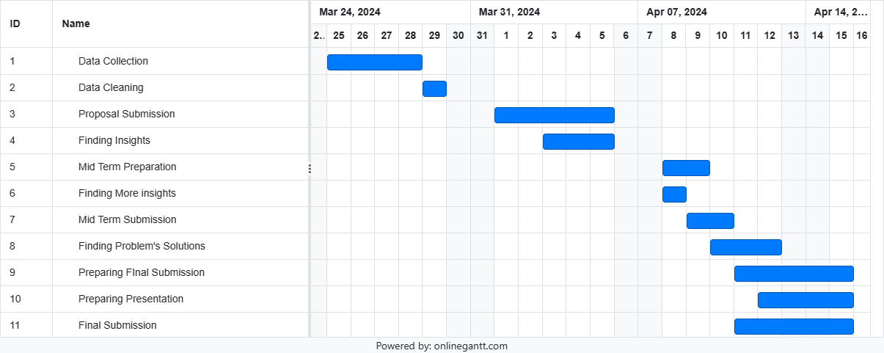

# Expected Outcome

1. Identifying areas for improvement and recognizing growth opportunities.
2. A data driven insight into customers’ footfall and their preferences.
3. Better waste management and better understanding of dishes and their sales.