1. Which command can be used to monitor real-time network traffic on a system?

a) netstat

b) iftop

c) ss

d) iptraf

Answer Key:

1.

b) iftop

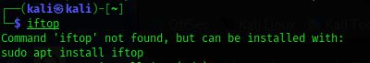

2. Which command would you use to track and trace system calls and signals?

a) traceroute

b) strace

c) lsof

d) dstat

Answer Key:

2.

b) strace



3. Which command can you use to create a bootable USB from an ISO image in Linux?

a) dd

b) iso2usb

c) mkusb

d) cpiso

Answer Key:

3.

a) dd

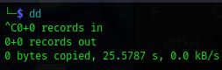

4. Which command will allow you to find all open files and processes associated with them?

a) ps

b) lsof

c) fstat

d) top

Answer Key:

4.

b) lsof

5. Which command would you use to display real-time system performance metrics (CPU, memory, disk, etc.)?

a) htop

b) nmon

c) uptime

d) dstat

Answer Key:

5.

a) htop

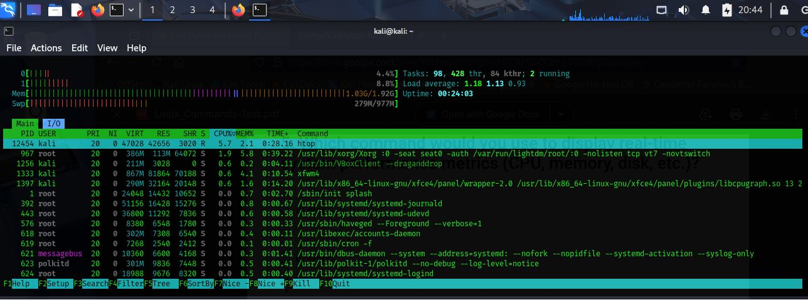

6. Which command will let you change the priority of a running process in Linux?

a) nice

b) renice

c) prio

d) priority

Answer Key:

6.

b) renice



7. Which command can be used to create a compressed archive of files, preserving file permissions and directory structure?

a) tar

b) zip

c) rar

d) gzip

Answer Key:

7.

a) tar

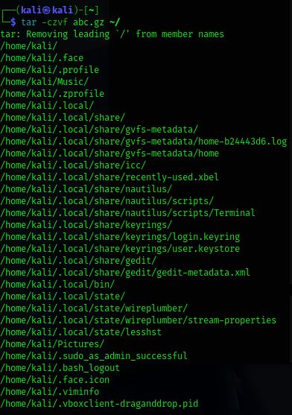

8. Which command would you use to securely transfer files between hosts over SSH?

a) scp

b) rsync

c) sftp

d) ftp

Answer Key:

8.

a) scp



9. Which command can you use to manage and display Docker containers and images in Linux?

a) dockerctl

b) dockermgr

c) docker

d) docker-compose

Answer Key:

9.

c) docker



10. Which command would you use to search through logs for specific entries (especially useful for troubleshooting)?

a) grep

b) logsearch

c) journalctl

d) searchlogs

Answer Key:

10.

c) journalctl



11. Which command is used to view and manipulate iptables (firewall) rules?

a) iptables

b) ufw

c) firewalld

d) ipfw

Answer Key:

11.

a) iptables



12. Which command allows you to mount a remote filesystem using SSH?

a) sshfs

b) mount

c) nfs

d) scpfs

Answer Key:

12.

a) sshfs



13. Which command can you use to monitor a log file in real-time as new entries are added?

a) cat

b) tail -f

c) logwatch

d) watch

Answer Key:

13.

b) tail -f



14. Which command would you use to check the disk usage of directories and files, and display it in a human readable format?

a) df

b) du

c) lsblk

d) diskusage

Answer Key:

14.

b) du

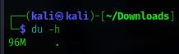

15. Which command can you use to check the status of your system’s hardware and see detailed information about it?

a) dmesg

b) lshw

c) lscpu

d) hwinfo

Answer Key:

15.

b) lshw

