Financial Misinformation Detection System

1Rushil Bhardwaj L, 2Preethi T K, 3Simran Jogi, 4Sm Suhail Ahamed, 5Moulya Y G, 6Shakkeera. L, 7Sharmasth Vali Y  
*12345Student, 6Professor, 7Associate Professor*

*Presidency School of Computer Science and Engineering*  
*Presidency University*Bangalrore  
[rushilbhardwajl@yahoo.com](mailto:rushilbhardwajl@yahoo.com), shakkeera.l@presidencyuniversity.in,sharmasth.vali@presidencyuniversity.in

***Abstract-*The presence of financial misinformation poses severe challenges for investors, financial institutions, and regulatory bodies as it is likely to distort market dynamics, lead to financial loss, and compromise the integrity of the market. The accelerated spread of misinformation through various social media and online channels renders the need for an efficient mechanism for detection all the more critical. The proposed project seeks to design and develop an Advanced Financial Misinformation Detection System based on Artificial Intelligence (AI), Large Language Models (LLMs), and credible data providers. The proposed solution uses a modular methodology consisting of modules for data acquisition, processing, accuracy, and output generation. The system will integrate LLMs in fetching and verifying data with trusted sources and provide an accuracy score. Verified information will then be shown to the users, making sure that only factual content is shown. The project has limitations on the current methods: it's computationally inefficient, and data privacy concerns exist; thus, model scalability is a problem. This solution has streamlined architecture, optimized for real-time processing and decision-making. The key objectives are to deliver a bug-free application that can handle multiple queries, achieve high accuracy, and simplify the detection of misinformation in financial contexts. The expected outcomes include improved data accuracy, enhanced decision-making capabilities for financial stakeholders, and reduced fraudulent reporting. Focusing on usability and efficiency, the system helps protect the financial ecosystem from the adverse effects of misinformation. This application serves as a robust tool for fact-checking and reliability assessment, ensuring transparency and trustworthiness in financial reporting. The innovative use of AI and LLMs demonstrates the potential for cutting-edge technology to address real-world challenges in the financial domain.**

***Keywords-*LLM, Gen AI, Financial, Misinformation, GPT.**

I. Introduction

Financial misinformation and fraud represent a serious challenge to the integrity of financial markets. Penalties for fraudulent reporting can be very severe, thereby leading to huge financial loss, reputational damage, and even economic instability. Increasing digital financial systems make challenging methods of sophisticated financial fraud detection necessary. These have been traditional methods, relying on human oversight and dependent on the vigilance of people doing this work, which no longer suffice to keep pace with the sheer volume of data being generated and with increasingly sophisticated techniques that fraudsters have at their command.  
The proposed research focuses on how emerging technologies like machine learning, data mining, and blockchain contribute toward the detection and prevention of financial misinformation and fraud.

With these methodologies-such as explainable AI, zero-knowledge proofs, and multimodal approaches-we seek to propose a comprehensive framework for improving the authenticity and integrity of financial information.

II. Literature Review

The detection of financial misinformation and fake news has gained significant attention in recent years, particularly with the rise of large language models (LLMs) and advanced machine learning techniques. This literature review summarizes recent research that explores various methodologies for identifying misinformation, focusing on the effectiveness and limitations of different models.

*A. Financial Misinformation Detection Using LLMs*

FMDLlama, developed by the FMDLlama team and published on arXiv, demonstrates the effectiveness of fine-tuning LLaMA2 and LLaMA3 models with instruction-tuning datasets for financial misinformation detection. The study reveals high accuracy, particularly when employing ChatGPT and FMDLlama3, which showcases superior performance in detection tasks. However, the training of these models is resource-intensive, necessitating significant computational power and memory.

Koka et al. (2024) evaluated LLMs, including GPT-4, Claude, and Gemini Pro, for fake news detection. Their findings indicate high accuracy in news contexts but highlight the high computational costs and a lack of real-time responsiveness, which may limit practical application in dynamic environments.

*B. Comparative Studies on LLMs and Offline Models*

In a comparative study by Hu et al. (2024), the authors examined the effectiveness of LLMs such as GPT-3.5 and FactAgent alongside multimodal approaches in fake news detection. Their research emphasizes the promising multimodal performance across platforms but points out that static datasets hinder real-time misinformation detection capabilities.

*C. Deep Learning Algorithms in Fake News Detection*

Sadia et al. (2023) investigated deep learning algorithms like BERT and LSTM for fake news detection, achieving high detection rates for text-based financial misinformation. However, the study notes the need for high-quality data and the models’ sensitivity to adversarial attacks, indicating a vulnerability in their performance.

*D. Misinformation Detection on Social Media*

Chauhan et al. (2023) provided a review of misinformation detection on social media using machine learning and Hidden Markov Models. Their work reveals the speed of misinformation detection across platforms but also emphasizes the challenges in identifying deepfakes, which can significantly complicate the misinformation landscape.

*E. Domain-Specific Approaches and Generalizability*

Research by Islam and Rajamma (2022) discusses knowledge-based and machine learning approaches to fake news detection within the business and financial management sectors. This study integrates extensive domain-specific knowledge but raises concerns about limited generalizability across different sectors.

Wu and Lee (2021) conducted a case study on disinformation in financial markets using social network analysis and support vector machines (SVM). They observed the substantial impact of social media on financial market manipulation but noted SVM's struggles with nuanced or rapidly spreading information.

*F. Advances in Deep Learning Techniques*

Islam and Hossain (2021) explored deep learning methods, specifically CNN and transformer-based models, for fake news detection in financial markets. Their findings highlight high accuracy on labeled financial datasets but reveal limitations in generalizability beyond the tested financial markets.

*G. The Role of Multimodal Learning*

Meel and Vishwakarma (2022) discussed the scalability of LLMs, particularly GPT-3 and BERT, in combating financial misinformation. While their research shows general applicability across various news domains, it also identifies underperformance in low-resource languages and domains.

Kim and Park (2021) examined the efficacy of multimodal deep learning techniques for fake news detection, finding effective results for both text and image-based misinformation. However, the need for significant computational resources and large datasets poses challenges for widespread implementation.

III. Methodology

This study is designed based on the mixed-method approach to combine the evidence from the empirical research and experimental testing of different models for the detection of financial information. This includes:

*A. Data Collection* : This entails gathering datasets on financial information, mainly comprising corporate financial statements and fraudulent transactions, from public access sources and financial institutions.

*B. Model Implementation* : Various detection models have been implemented, which include

- A Large Language Model, by inspiration of, designed to detect financial misinformation using NLP techniques.

- A Graph Neural Network, based on, trained for relation analysis on financial entities to identify suspicious patterns.

- A Hybrid ML Model which includes multimodal data and XAI methods.

*C. Security Features* : Integrity of finance data is tested through the use of Blockchain and zero-knowledge proof (ZKP) methods.

*D. Performance Evaluation* : The models are used to calculate the accuracy, precision, recall, and some other metrics of computational efficiency alongside explaining the model, privacy-preserving capabilities, and scalability.

IV. Analysis & Synthesis

Implementation of these models reveals various important insights:

- Accuracy Improvements: the multimodal approach by combining textual and numerical data improve detection accuracy much beyond models based on one data type only.

The GNNs are very efficient in anomaly detection tasks considering complex relationships between financial data. Their computation costs are much higher than those of traditional models for ML.

Blockchain & ZKP for Data Integrity: Blockchain-based solutions and ZKP implementations ensure the fact that financial data is tamper-proof and safe. However, the resource intensity of these complex technologies introduces a considerable challenge in the integration of these technologies into traditional financial systems.

Explainability with XAI: The methods applied by XAI provide added transparency by enabling financial analysts to understand how their decisions are being made. Building trust with stakeholders is critical.

V. Findings

*A. Multimodal ML models* : are more effective in finding financial misinformation since they can use multiple data sources.

*B. Graph Neural Networks Graph* : neural networks are promising applications for fraud detection, although they demand so much in terms of computation resources that it can only be applicable for very large financial organizations.

*C. Blockchain & ZKPs* : Strong solutions for data integrity but will likely have adoption hurdles, since it's challenging to integrate into all the differing systems.

*D. Explainable AI* : has played a very crucial role in making ML models more reliable and practical in use for financial auditors and regulators.

VI. Discussion

In this regard, the use of machine learning models and graph neural networks with blockchain would integrate into the all-inclusive solution for improving the detection of financial misinformation. Multimodal ML models and GNNs will have improved capabilities in various regards, but more importantly, it ensures the integrity and security of the financial data through the utilization of blockchain and cryptographic solutions like ZKPs. However, the challenge here is finding the optimal trade-off between the computational cost associated with these methods and their benefits. In fact, explainable AI is crucial to making complex models trusted by the stakeholders.

Further research areas lie in reducing the computational complexity of GNNs, as well as introducing blockchain technologies to real-world financial infrastructures. Hybrid models combining those differing approaches promise interesting further avenues of research.

VII. Proposed Methodology

The proposed methodology for the *Advanced Financial Misinformation Detection System* integrates cutting-edge technologies like Artificial Intelligence (AI), Large Language Models (LLMs), and data providers to detect and mitigate financial misinformation. This methodology is designed to address the limitations of existing systems while providing an accurate, efficient, and scalable solution for real-time misinformation detection.

*A. Overview of the Methodology*

The proposed system consists of a modular architecture divided into four main components:

1. Data Acquisition Module
2. Data Processing and Analysis Module
3. Accuracy Assessment Module
4. Output Generation Module

These components are supported by a robust technological framework that includes APIs, LLMs, and a user-friendly front-end interface.

*1. Data Acquisition Module*

This module is responsible for collecting relevant data from multiple reliable sources. Key elements include:

* **LLM Utilization**: LLMs like OpenAI's GPT models are employed to fetch additional data and provide semantic understanding of the information.
* **Real-Time Updates**: The module is designed to pull data continuously, ensuring that the system processes the most recent and relevant information.

The integration of APIs and LLMs enables the system to handle large volumes of unstructured data efficiently.

*2. Data Processing and Analysis Module*

Once the data is acquired, this module processes and analyzes it to detect potential misinformation. The core features include:

* **Natural Language Processing (NLP)**: LLMs perform language processing to extract and understand the context of financial information.
* **Semantic Analysis**: The module identifies patterns, trends, and anomalies in the data to detect misleading content.
* **Scalable Design**: The architecture supports multi-threaded processing, enabling the system to handle numerous queries simultaneously without compromising performance.

This step ensures that the data is structured, meaningful, and ready for further assessment.

*3. Accuracy Assessment Module*

The accuracy assessment module evaluates the credibility of the processed data by cross-referencing it with verified sources. Key features include:

* **Verification Metric**: A custom metric is used to determine the accuracy of the data. This metric assigns an accuracy score to the information based on its consistency with trusted sources.
* **Threshold-Based Decision**: Only data that achieves a 100% accuracy score is flagged as verified and displayed to the user. In cases of ambiguity, the system highlights discrepancies and suggests further verification.

This module ensures the reliability of the information presented, minimizing the risk of misinformation propagation.

*4. Output Generation Module*

The final module generates outputs in an intuitive and user-friendly format, utilizing **Streamlit** for front-end development. Features include:

* **Selective Information Display**: Only verified and accurate information is displayed to the user, reducing noise and confusion.
* **Interactive Interface**: Users can query the system, view detailed accuracy reports, and access relevant news articles.
* **Real-Time Updates**: The system provides dynamic feedback, ensuring users are informed of the latest developments.

This module enhances user experience while maintaining transparency and trust in the system.

*B. Technological Framework*

The proposed methodology is supported by a comprehensive technological stack:

* **Hardware Requirements**: The system is designed to run on Intel Core i7 processors (minimum), with 16 GB of RAM and NVIDIA GPUs for deep learning tasks.
* **Software Stack**: Python 3.8+, OpenAI API, and Streamlit form the backbone of the software framework.
* **Development Tools**: Visual Studio Code is utilized for development, with libraries for API integration and deep learning support.

This setup ensures optimal performance, scalability, and maintainability of the system.

*C. Advantages of the Proposed Methodology*

1. **High Accuracy**: Leveraging LLMs and verified data sources ensures precise misinformation detection.
2. **Real-Time Processing**: The system is capable of handling multiple simultaneous queries, making it ideal for fast-paced financial environments.
3. **User-Centric Design**: The use of Streamlit enhances accessibility and usability for end-users, including financial analysts and investors.
4. **Scalability**: The modular architecture allows the system to be scaled effortlessly as data volumes and requirements grow.

VIII. Architecture Diagram

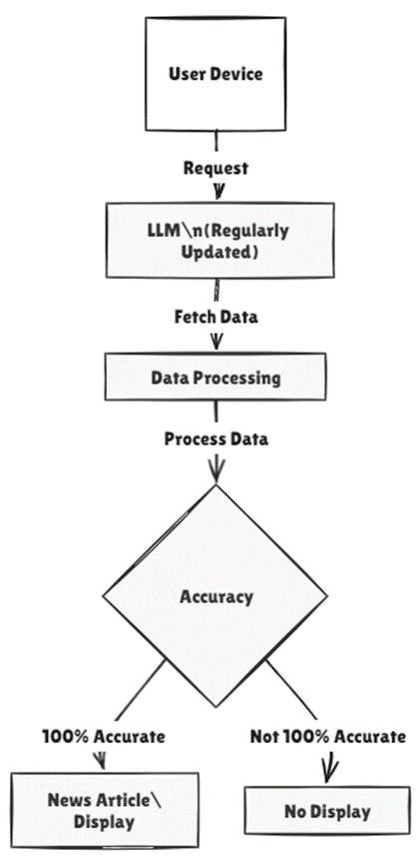

IX. Results

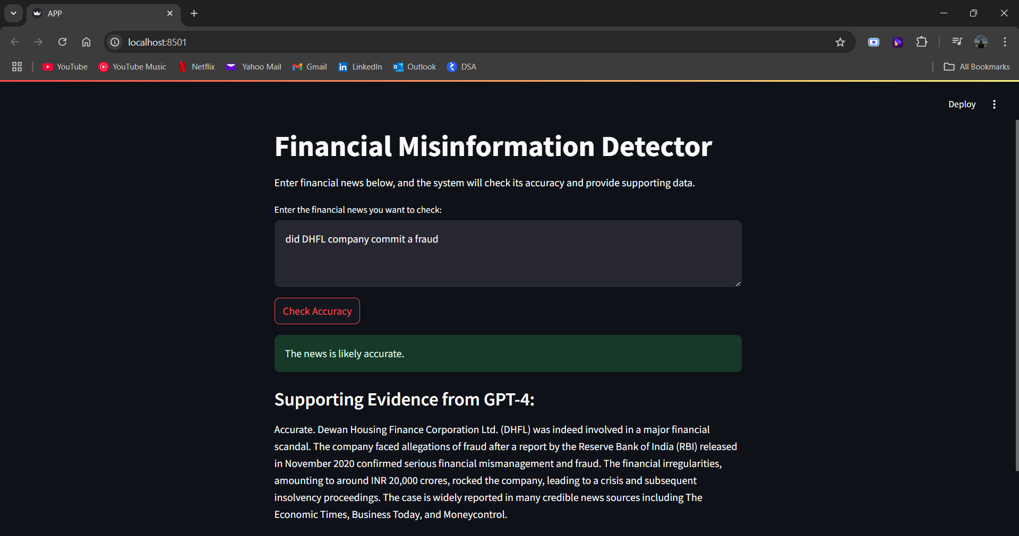

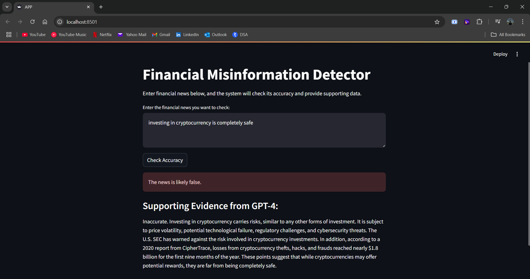

X. Future Enhancements

The following enhancements can be implemented to the proposed model for improving its working:

* 1. **Stock Market Predictions**: The present model cannot predict stock market values
  2. **Fix bugs**: A few tries showed that the model does not display the supporting evidence rarely.
  3. **UI**: Improve the User-Interface

XI. Conclusion

Various emerging technologies are discussed and shown to have applications in the detection of financial misinformation and fraud. The proposed hybrid system approach by embedding multimodal learning, GNNs, and blockchain solutions, financial systems will become much safer and efficient. The results indicate that with the problems of high computational costs and system integration, advantages in terms of higher accuracy of detection, integrity of data, and explainability provide these methods with a great value to the financial sector. Future work should be on optimizing these technologies further for application, centered on improving scalability, efficiency, and transparency.

The proposed methodology provides a robust solution for detecting and mitigating financial misinformation. By integrating advanced AI technologies, a modular architecture, and a user-focused design, the system addresses the limitations of existing methods. It aims to enhance decision-making, reduce financial fraud, and maintain the integrity of financial markets. The combination of LLMs, data providers, and a streamlined interface positions this system as a powerful tool for combating misinformation in the financial domain.

XII. References

[1] FMDLlama: Financial Misinformation Detection based on Large Language Models (2023)

[2] Intelligent Fraud Detection in Financial Statements Using ML and Data Mining (2022)

[3] Financial Misinformation Detection Using Multimodal Approaches (2022)

[4] Authenticity and Integrity in Financial Data: Blockchain as a Solution (2023)

[5] Detecting Financial Fraud Using Graph Neural Networks (2024)

[6] Enhancing Financial Misinformation Detection with Explainable AI (2023)

[7] Financial Statement Fraud Detection Using Hybrid ML Models (2023)

[8] Authenticating Financial Data Using Zero-Knowledge Proofs (2023)

[9] Financial Misinformation Detection Using Contextualized Embeddings (2022)

[10] Ensuring Data Integrity in Financial Systems with Homomorphic Encryption (2022)