

CHAROTAR UNIVERSITY OF SCIENCE AND TECHNOLOGY

FACULTY OF TECHNOLOGY AND ENGINEERING

B. TECH (IT/CE/CSE/AIML)

Subject: Advanced Web Development Frameworks (ITUE301) | Semester: 5th

Practical Statement: Practical 7: Authentication and Middleware Pipeline
Student Name: Hit Parsaniya
Student ID: 24IT059
GitHub Repository: https://github.com/Hit-Parsaniya/WEB-FRAMWORKS-PR6
Tech Stack: JavaScript (ES6+), Express JS, Node.js, Compass, MongoDB Atlas

PROBLEM STATEMENT:
• Add user registration and login functionality to the Task Management
application.
• Hash passwords using bcrypt before saving the User document to
MongoDB.
• Implement JWT token generation on successful login, with a
reasonable expiry (e.g., 1 hour).
• Protect all task routes using an authentication middleware that verifies
the JWT.
• Add server-side input validation that rejects malformed requests (e.g.,
missing title) before they reach the database.

Screenshots:
Auth.js
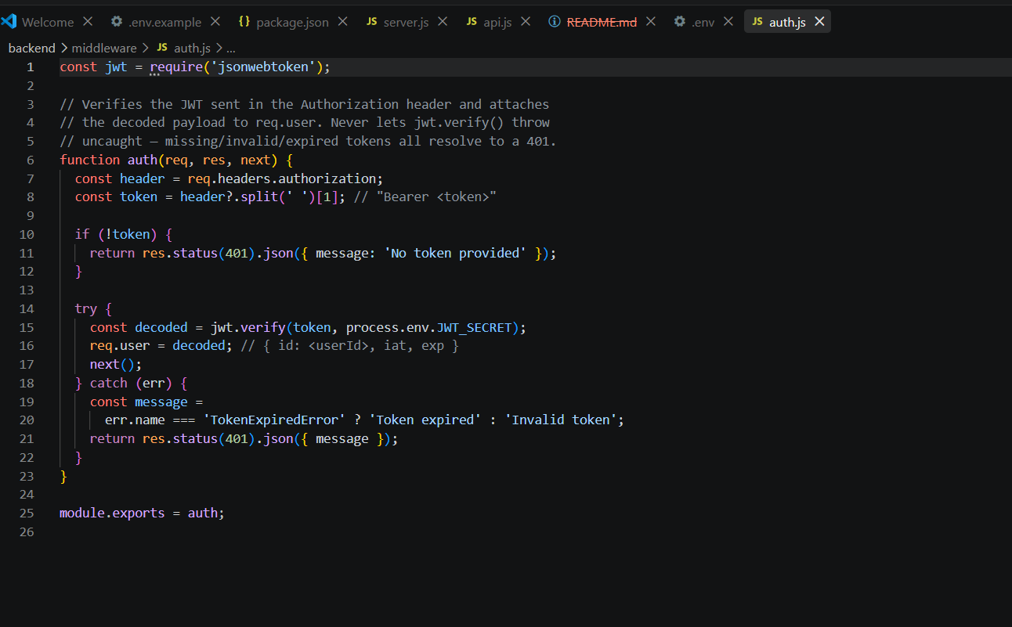
Validate.js
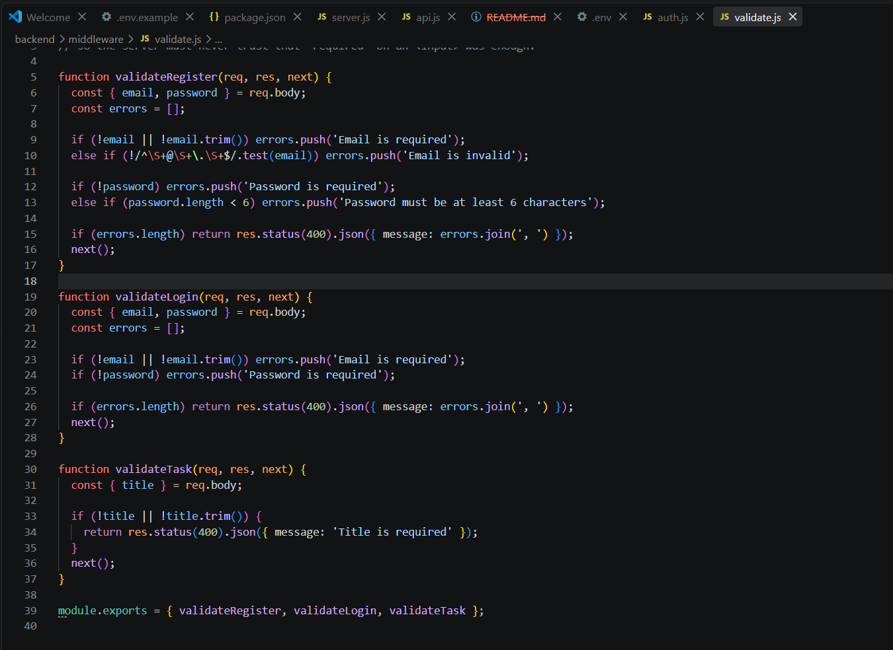

User.js
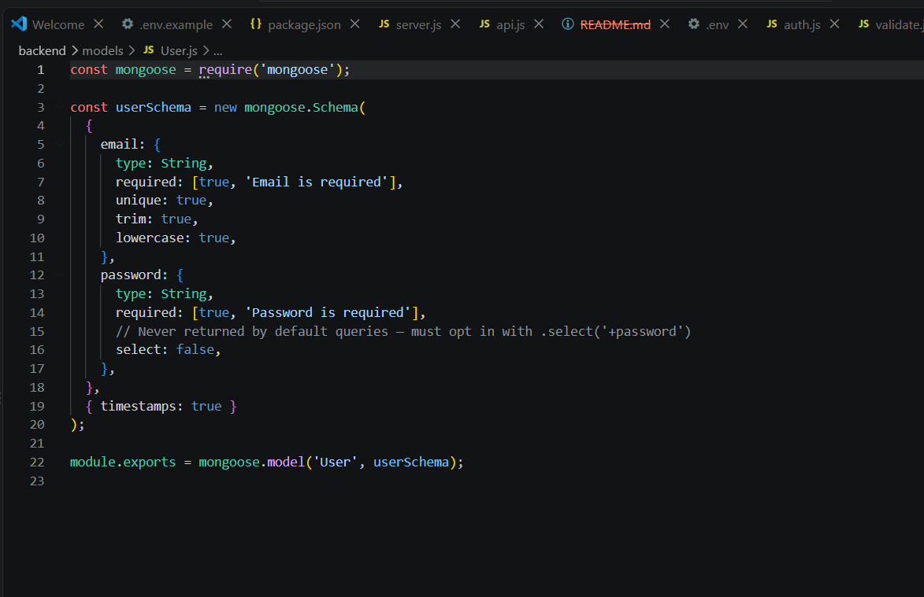

Auth.js

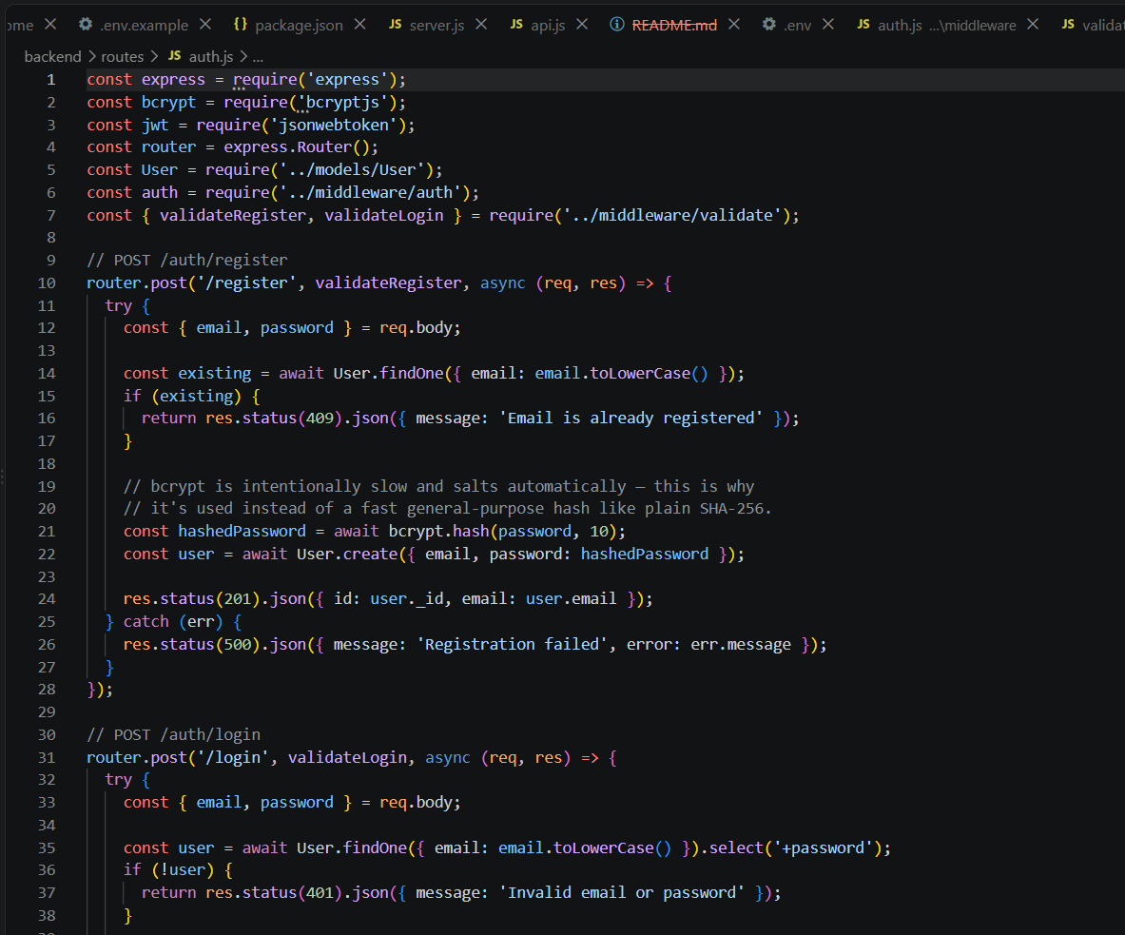

AuthContext.js
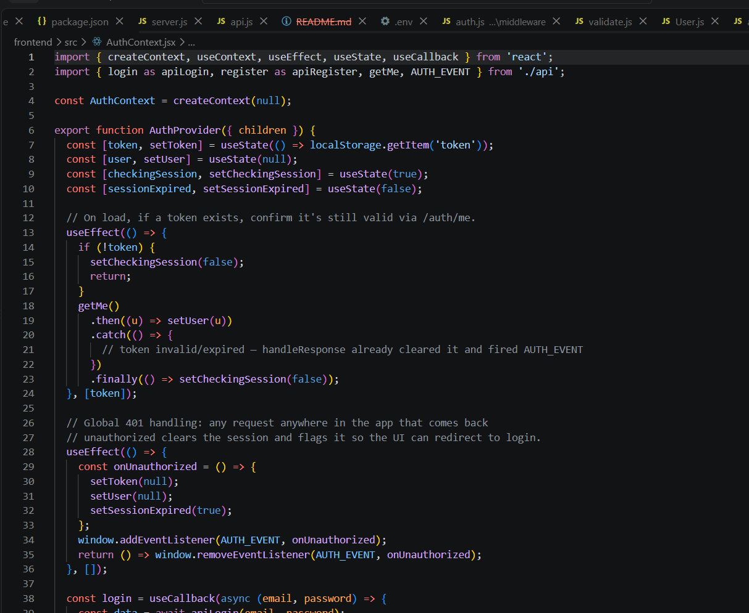

TaskManager.js

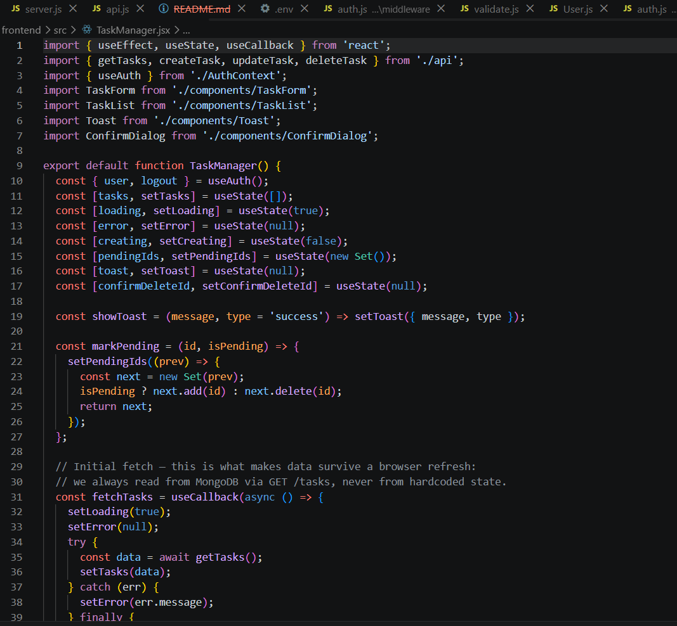

AuthForm.jsx
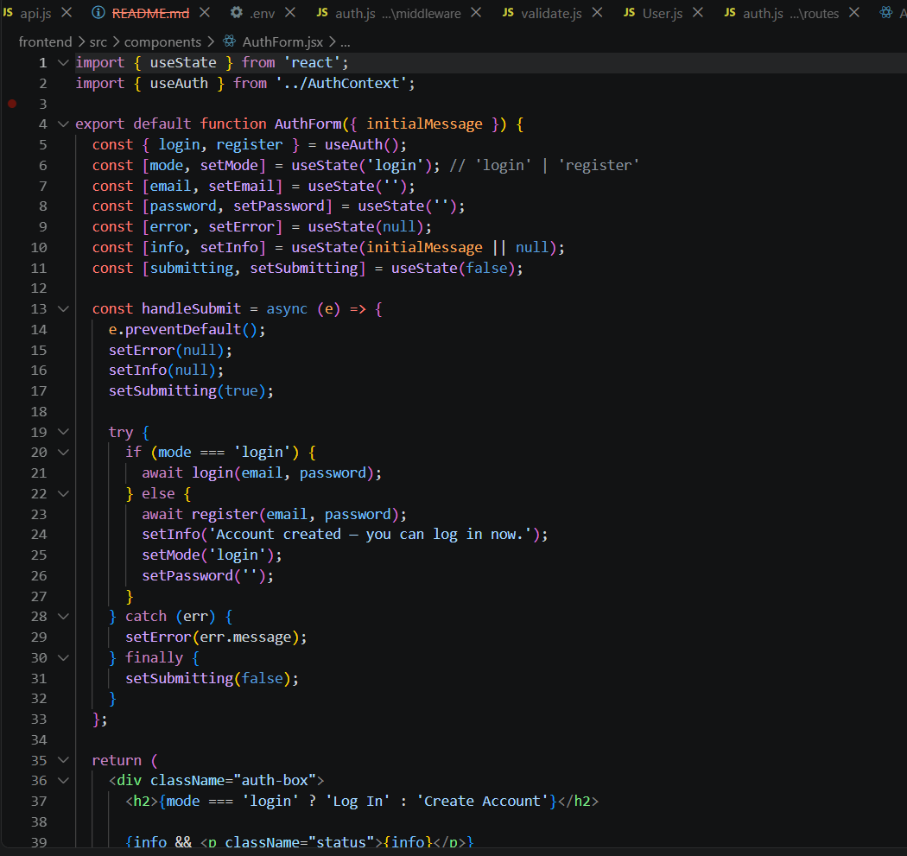

OUTPUT:
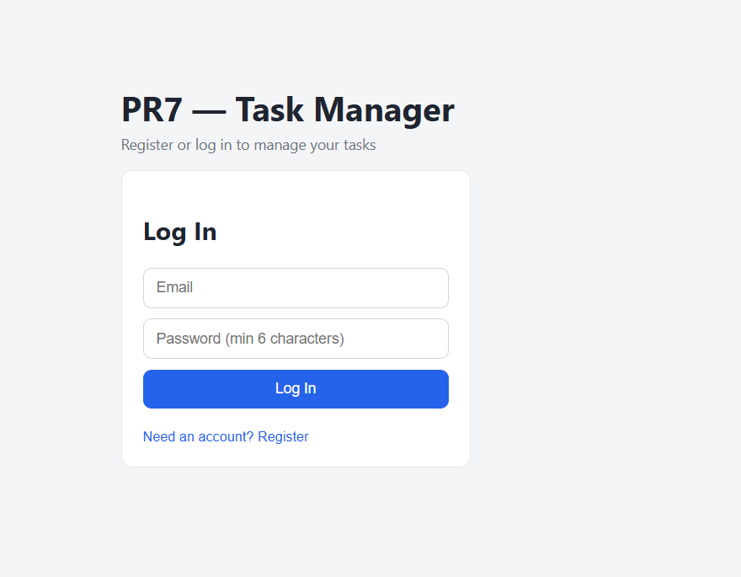

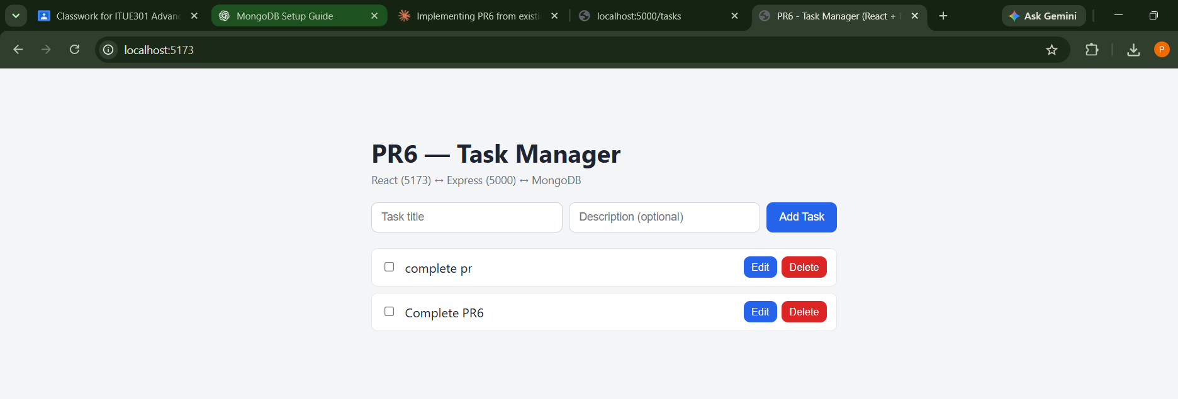

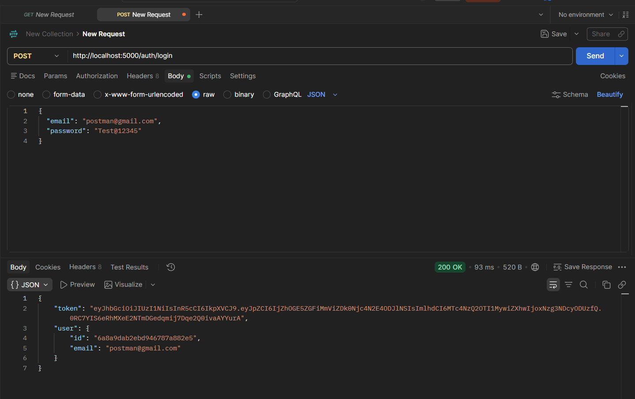

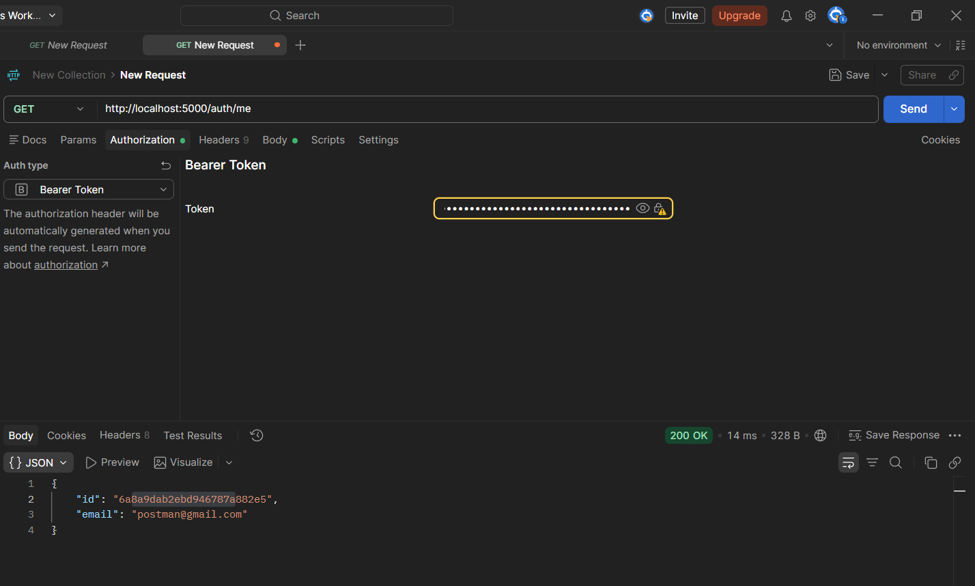

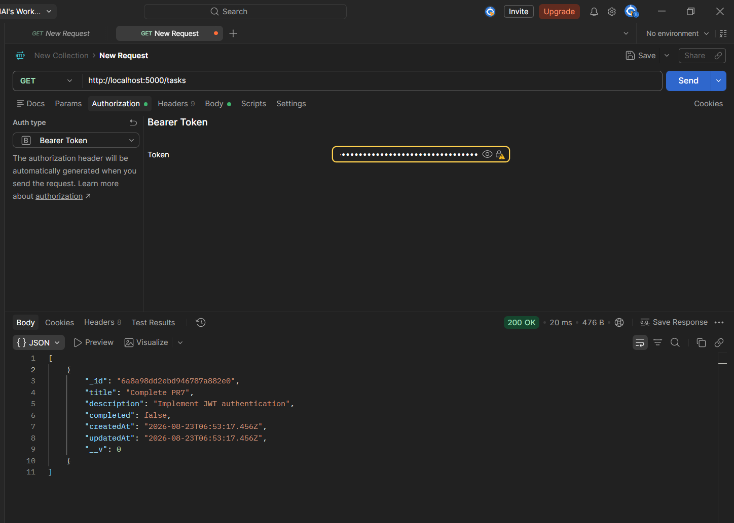
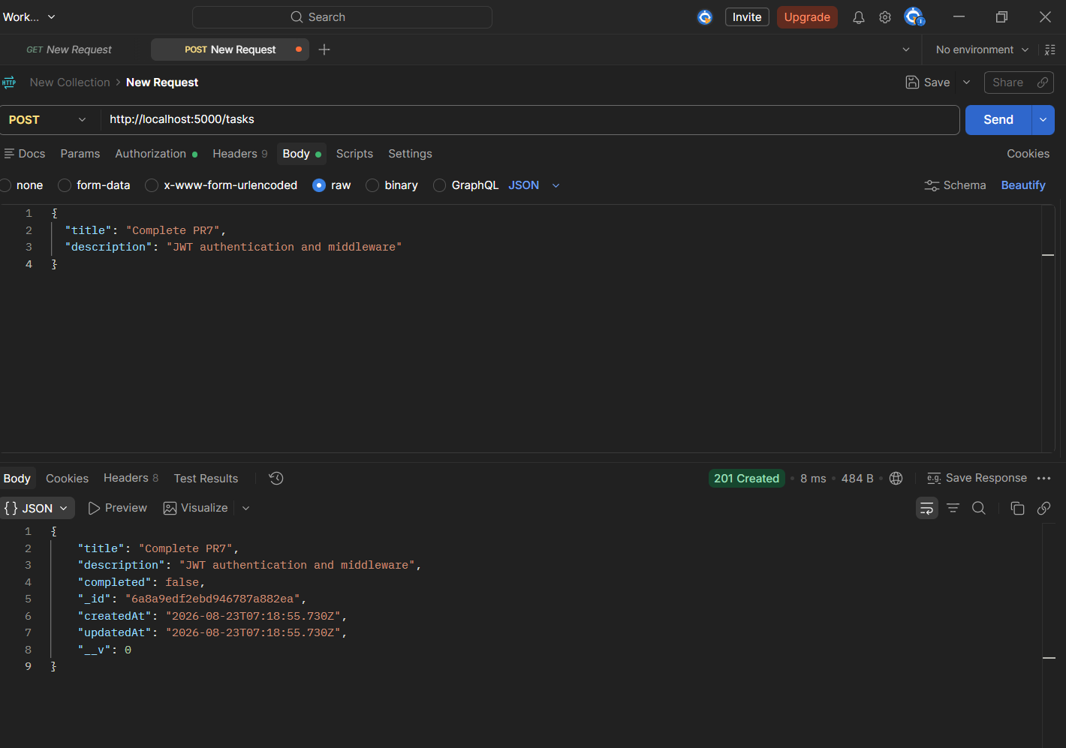

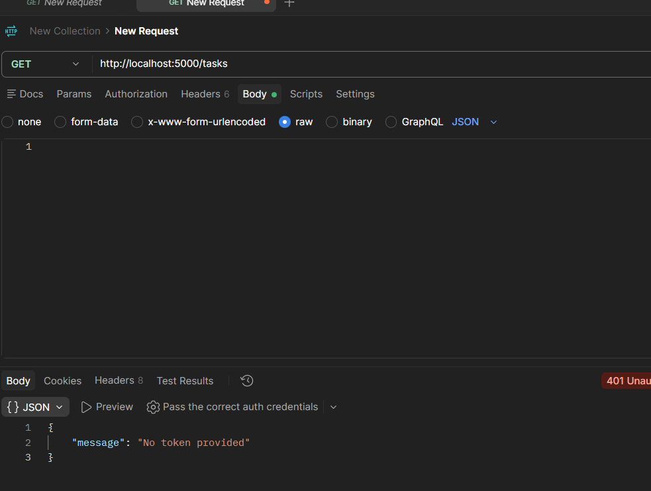

GitHub Repository: https://github.com/Hit-Parsaniya/WEB-FRAMWORKS-PR6

