Name : Rushil Patel  
ID : 22000270

1)

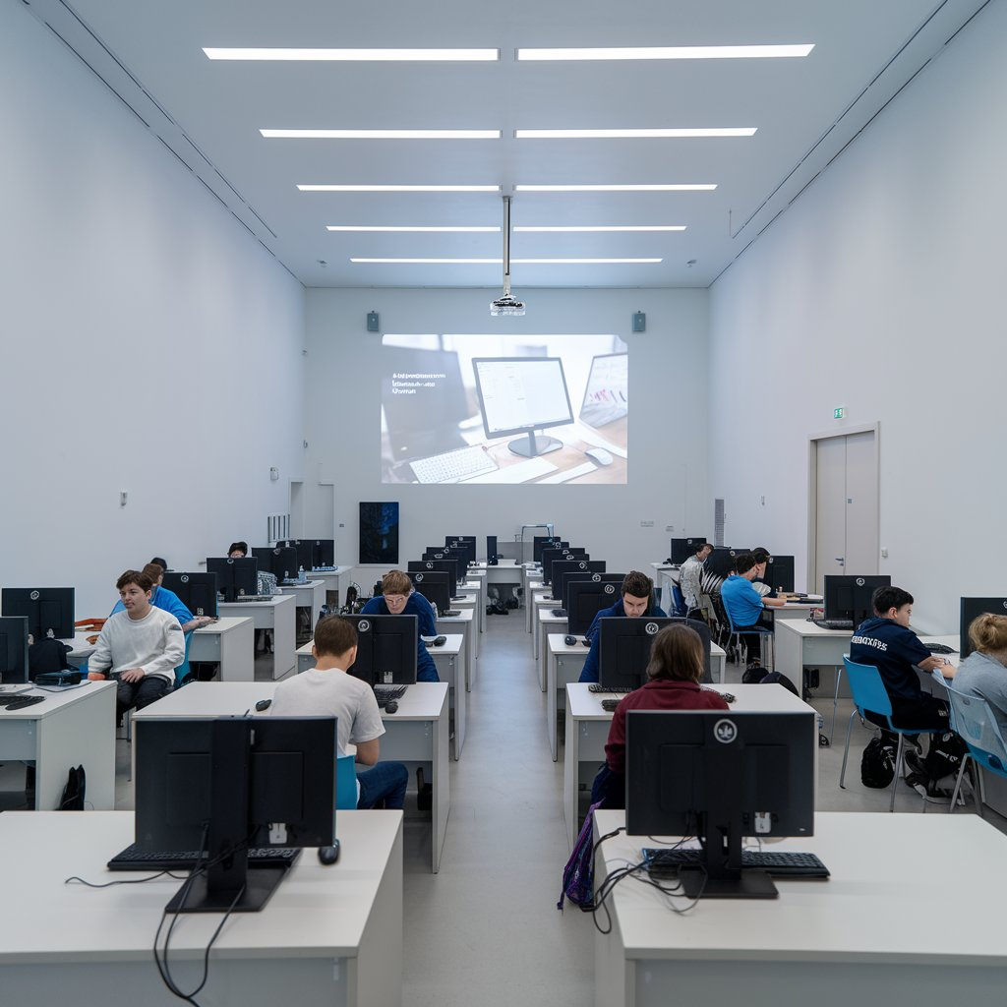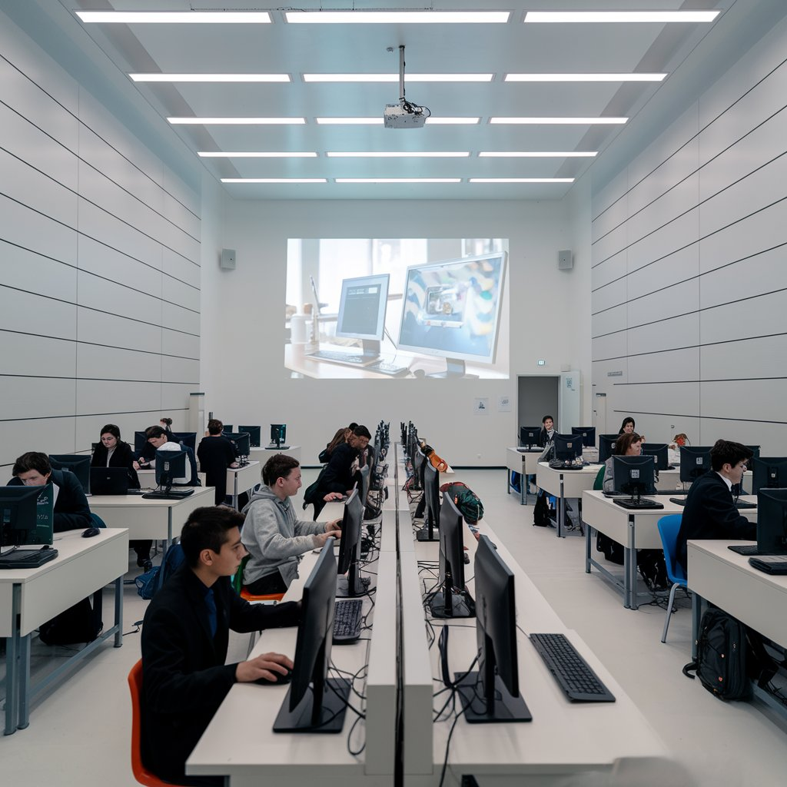

Prompt

Create an image of a modern classroom with white walls. The room features three columns of desks, each equipped with computers. Students are seated at the desks, actively using the computers. On the right-hand wall, there is a door. Opposite the viewpoint, a large image is projected onto the wall by a ceiling-mounted projector, showcasing a computer-related display. The atmosphere is studious and professional, with evenly spaced desks and bright, even lighting.

2)

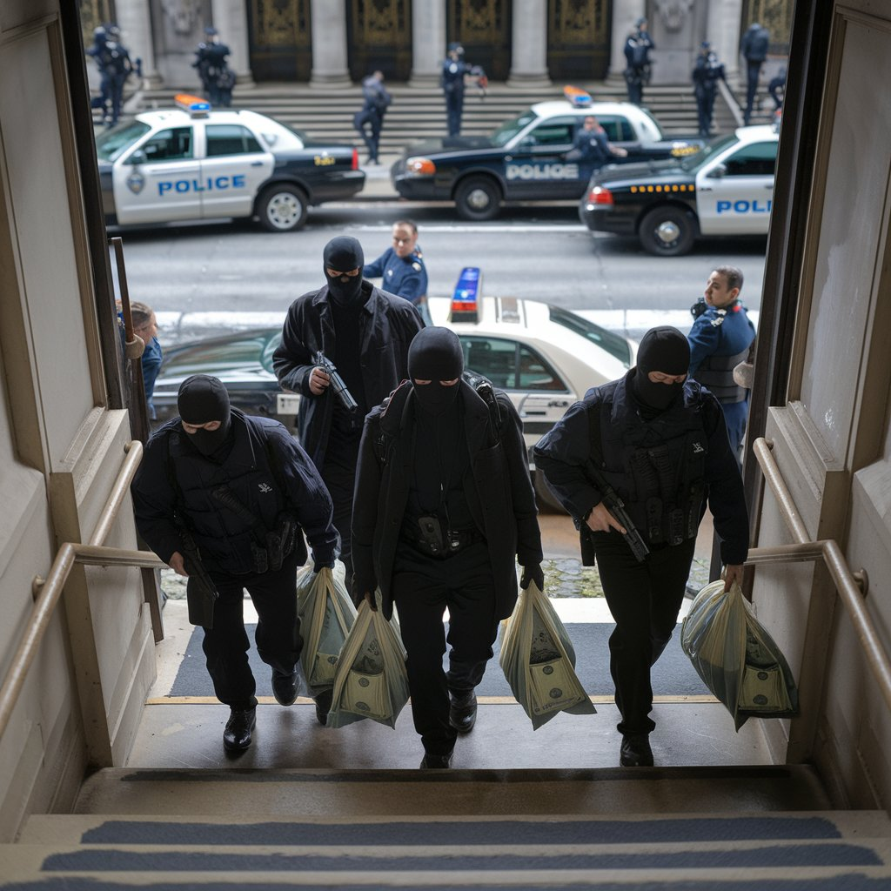

Prompt

Create a realistic poster image depicting a dramatic bank robbery scene. The upper half of the image shows a grand bank building with robbers exiting through the main doors, carrying large bags of money. They are armed and holding weapons, looking tense and ready to escape. The lower half seamlessly transitions to a street scene where police cars with flashing lights are surrounding the bank, officers positioned to apprehend the robbers. The entire scene is cohesive, with no dividing lines, showcasing the bank, robbers, and police in one continuous, intense visual narrative.