CASCADING STYLE SHEETS

BASIC SYNTAX FOR ALMOST EVERY CSS

Selector {

Property: value;

}

In selector, USE the NAME of the tag that is used in HTML like for changing the color of text of a button, you would write:

button{

Color: red;

}

61. Color and background color properties

Color already described above.

Background color used to change the bg color of the text, button or whatever.

* Background is different than background color. Later is only specific to color whereas background can be used to put much more for ex even a image in the background.

RGB COLOR SCHEME

Colors specified as a combination of red, green and blue.

button{

Color: rgb(12,45,255);

}

Number values range from 0 to 255.

HEXADECIMAL COLOR SCHEME

Colors specified through a hexadecimal code

# _ _ _ _ _ _

First two 🡪 Red channel

Middle two 🡪Green channel

Last two 🡪 Blue channel

The values can be from 0 to 9 and A to F.

**COMMON-TEXT PROPERTIES**

1. **Text align**

P{

Text-align: center/right/left;

}

1. **Font weight**

Used to change the boldness of the font.

Value ranges from 100 to 900

400 is normal

900 is bold.

P{

Font-weight: 400;

}

P{

Font-weight: 900;

}

1. **Text decoration**

Used to put lines on text.

Like underline, overline, line-through.

H1{

Text-decoration: blue underline;

}

Much more to it than just putting lines.

Can increase height of text lines

<https://developer.mozilla.org/en-US/docs/Web/CSS/text-decoration>

1. **Letter spaces**

**FONT-FAMILY**

P{

Font-family: sans-serif;

}

P{

Font-family: segou UI, Arial, serif;

}

In the second code fragment, there are multiple fonts and font families. This is done as a backup. For ex MAC does not support Segou UI so the browser will go with Arial. If that wasn’t supported either, it would’ve gone with serif font family(would’ve chosen one of the fonts from the entire family.)

SECTION-7

THE WORLD OF CSS SELECTORS

UNIVERSAL AND ELEMENT SELECTORS

Universal:

*{

Color: black;

}

Element:

Img{

Width: 100px;

Height: 200px;

}

You can even put ‘,’ to apply changes to different elements like

H1,h2{

Color: white;

}

**THE ID SELECTOR**

The id that you give to a particular button or any other element in HTML file, you can modify that specific element in css by:

#id{

…

}

**THE CLASS SELECTOR (IMP)**

When you want to be more specific with modifying elements, you can create a class and write it in html file to each element so as to group them together(hence the name).

.tag{

Color: black;

}

This will apply changes to all elements having a class= “tag”.

**THE DESCENCANT SELECTOR**

This is used to modify elements that are nested in a particular class or anything really.

Like:

Span a{

Color: red;

}

Here, anchor tags that are nested in a will have color red but not all anchor tags.

Can use with class, id selector.

**ADJACENT SELECTOR (+)**

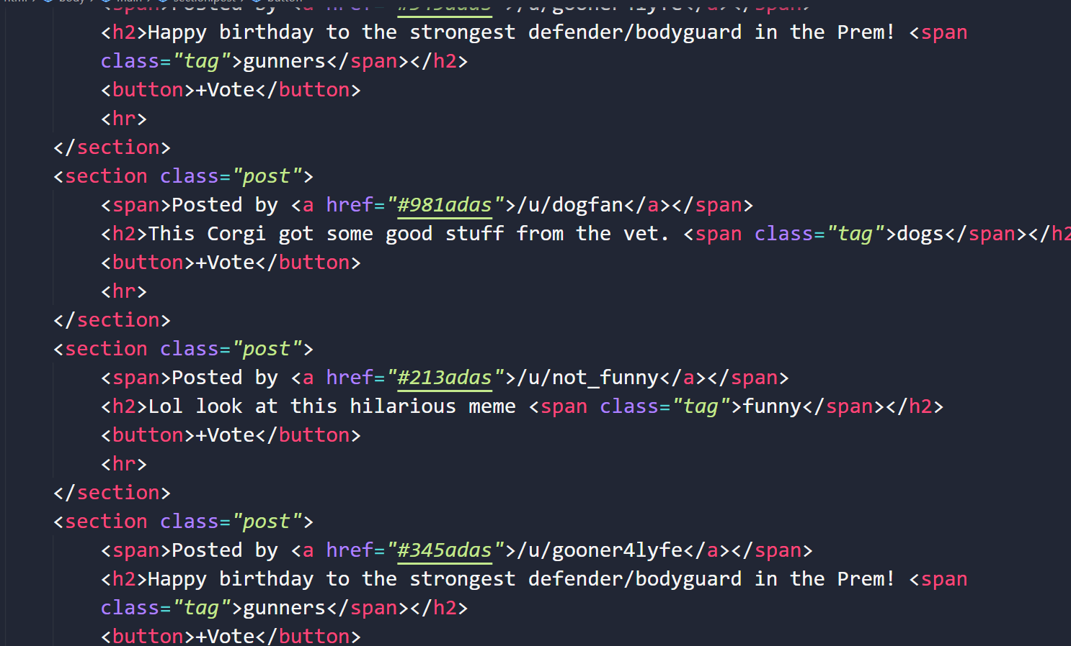

Here, <button> comes after every <h2> so you can use adjacent selector to modify those particular buttons that come after h2.

**DIRECT-DESCENDANT SELECTOR**

So in this, we select the direct descendant of a particular element like shown in figure.

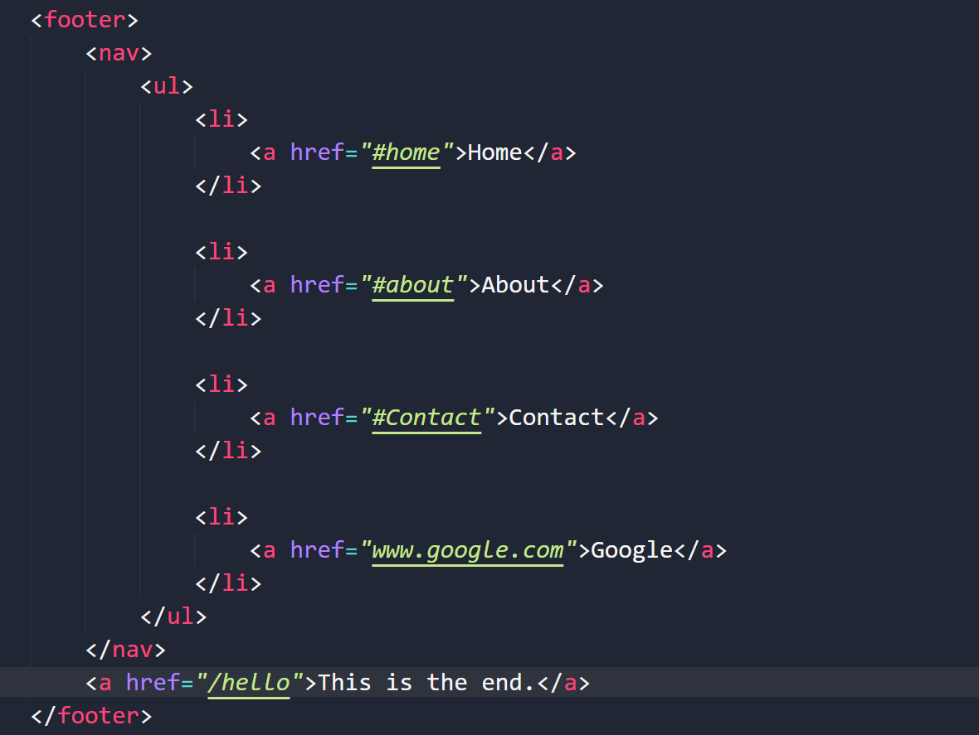

Here as u can see, the anchor tag (/hello) is a direct descendant of footer. Therefore if we want only that and not the other anchor tags to be modified such as those in list items, we use this.

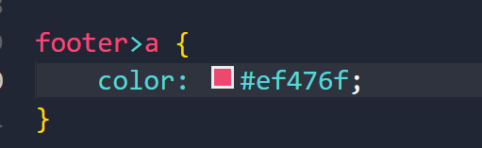

**THE ATTRIBUTE SELECTOR**

<https://developer.mozilla.org/en-US/docs/Web/CSS/Attribute_selectors>

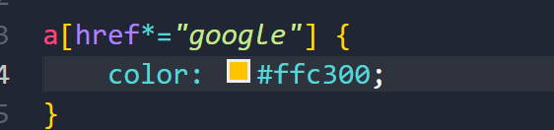

**PSEUDO CLASSES**

A [CSS](https://developer.mozilla.org/en-US/docs/Web/CSS) **pseudo-class** is a keyword added to a selector that specifies a special state of the selected element(s). For example, [:hover](https://developer.mozilla.org/en-US/docs/Web/CSS/:hover) can be used to change a button's color when the user's pointer hovers over it.

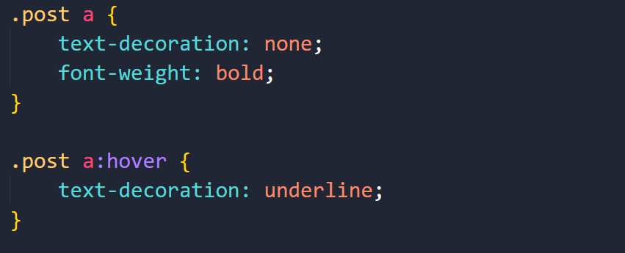

This wisll underline the text when you hover your mouse over it.

<https://developer.mozilla.org/en-US/docs/Web/CSS/Pseudo-classes>

**Pseudo elements**

Denoted by two colons, ::

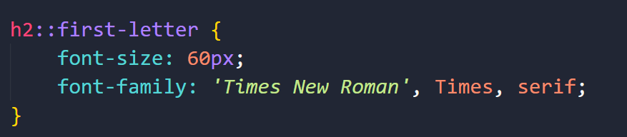

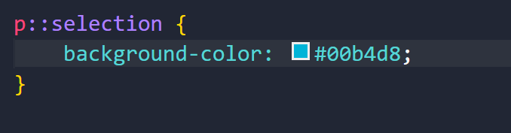

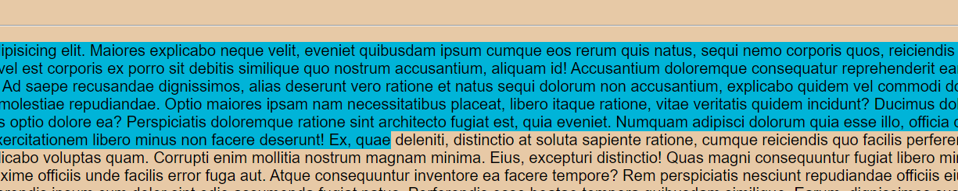

Selection

**SPECIFICITY**

**Priority order:**

**ID> Classes> Elements**

**Inline elements> IDs**

**Inline elements:**

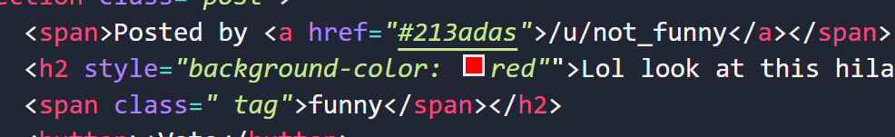

**When you specify css in html itself. Not preferred practice.**

**Important tool**

When you want to override everything. Using this will have THE highest priority over anything. Bad Practice.

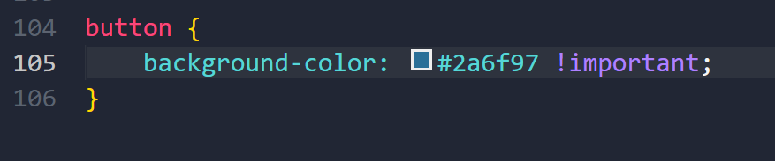

This will make changes to each and every button that’s present cuz it has important so not inline not id will be preferred.

**THE CSS BOX MODEL**

1. Width and Height

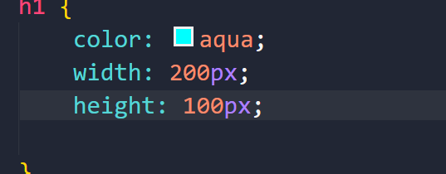

1. Border and Border-Radius

Border width, style and color.

If you want to edit the border, u can do so in one line itself like this.

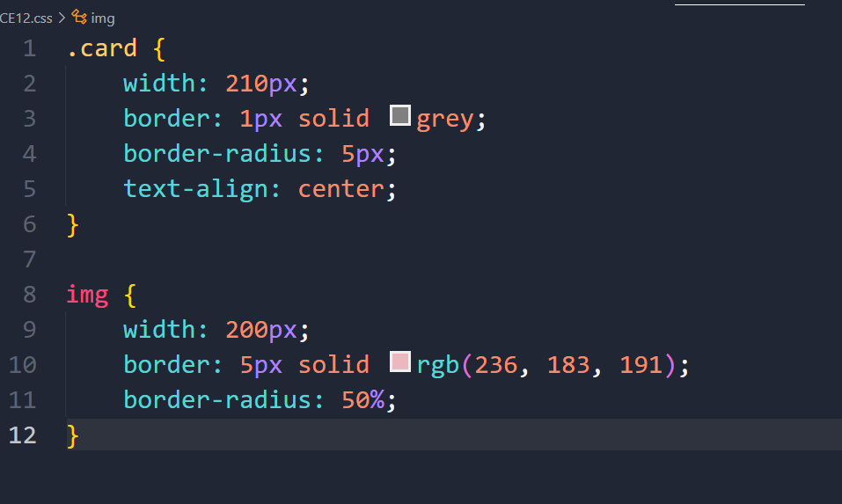

**#Blue shade is the content area**

**#Green shade is the padding**

**#Yellow is the border**

**#Orange is the margin**

**PADDING**

**You already know the meaning**

Syntax:

1. Apply to all four sides

Padding: 10px;

1. Vertical | Horizontal

Padding: 5px 10px;

1. Top | Horizontal | Bottom

Padding: 1px 2px 3px;

1. Top | right | bottom | left

Padding: 1px 2px 3px 4px;

* **MARGIN**

Space between outside of the element and the other elements.

#Orange in dev tools

* **CSS UNITS**

**Percentage:**

A relative unit which can help you when you want to have scale things up or down like you’re setting the width and height as 50% of the parent height.

**EM**s:

Relative unit.

See, consider an example where the font size of the parent element is 20px. Now that equals 1em. 2em equals 40px, 3em equals 60px and so on so it’s relative.

Problem with EMs

The problem arises when you have nested elements so if you’re using ems as units, it’ll multiply with each nest like

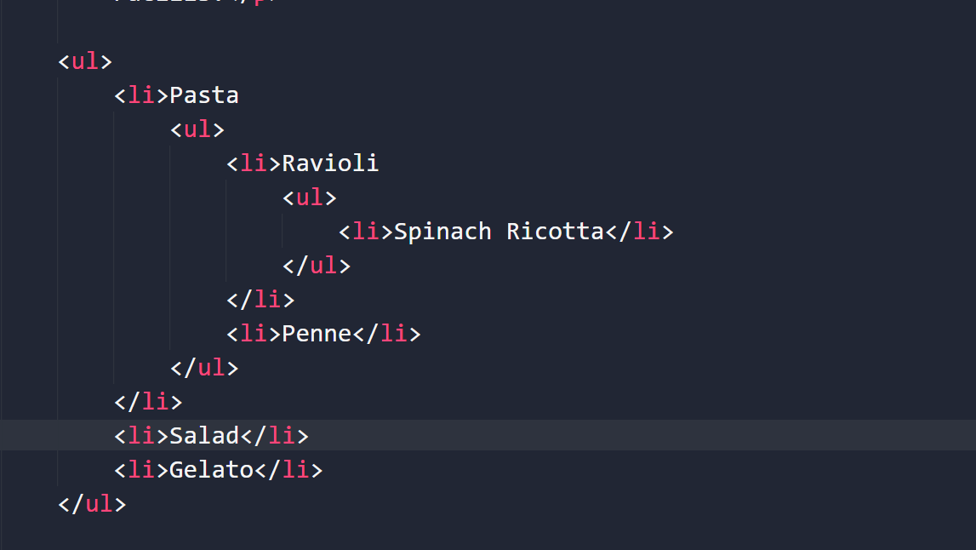

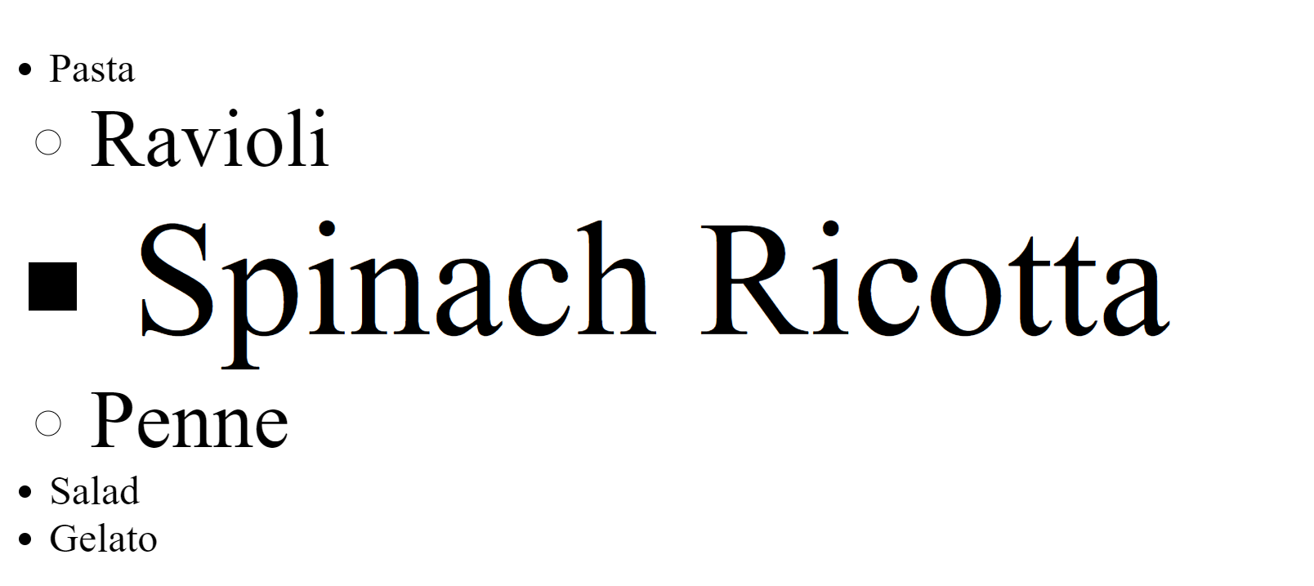

See how the font-size increments with each nest.

With rems, it takes the reference to not the parent element but the root html element so that value will always be fixed no matter where you use.

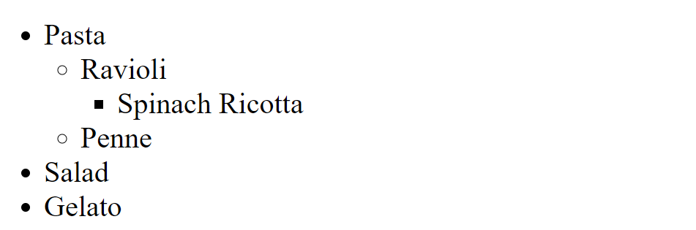

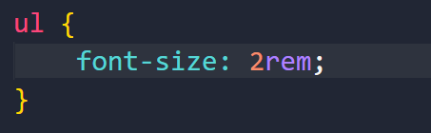

**ALPHA:**

<https://developer.mozilla.org/en-US/docs/Web/CSS/alpha-value>

**Opacity:**

<https://developer.mozilla.org/en-US/docs/Web/CSS/opacity>

With opacity, the entire thing is changed. So if you’re changing say the background color even the text color will be changed. (Watch video)

Position Properties:

<https://developer.mozilla.org/en-US/docs/Web/CSS/position>

MUST READ. Very helpful

**BUTTON SHADOW**

**Syntax:**

box-shadow: 2px 3px 12px red;

The box-shadow property enables you to cast a drop shadow from the frame of almost any element. If a [border-radius](https://developer.mozilla.org/en-US/docs/Web/CSS/border-radius) is specified on the element with a box shadow, the box shadow takes on the same rounded corners. The z-ordering of multiple box shadows is the same as multiple [text shadows](https://developer.mozilla.org/en-US/docs/Web/CSS/text-shadow) (the first specified shadow is on top).

/* offset-x | offset-y | blur-radius | color */Meaning of syntax below

box-shadow: 10px 5px 5px black;