From Bedroom to Battlefield: Examining Sex, Flirting, and Fighting in Relationships: Why Did She Leave Me?

Rushil Umaretiya (730677144), Cameron Wheeler (730697160), Ebeneezer Amaare (730647981), John Liu (730667893), Jason Fajerman (730700752)

Department of Interdisciplinary Studies, University of North Carolina at Chapel Hill

IDST 125L: Data Literacy Lab

May 1, 2024

# 

# Introduction

“Why did she leave me?” This is the question that every member of this research group has found themselves asking at different points throughout their lives. Whether it be short-term flings or long-lived engagements, the question of what keeps individuals together (or apart) has plagued the human species for centuries. The onset of modern technology altering how we communicate with one another, has made this query increasingly more pertinent. While we do not claim to have found an answer forthrightly, we hope to illuminate some of the way forward utilizing contemporary survey data and statistical analysis.

This study will examine the impact of sexual frequency, flirting behaviors, and conflict frequency on relationship longevity, analyzing whether couples who engage in these behaviors differently are more likely to stay together or break up after three and five years. Specifically, the research investigates the hypothesis that a lower frequency of sex, a lower frequency of flirting with each other, and more frequent fighting are significant predictors of relationship dissolution. We ask, “How do the frequency of sex, flirting behaviors, and frequency of fighting correlate with the likelihood of relationship breakup among couples after three and five years, and are these factors significant predictors of whether a relationship will endure or end?”

Our analysis is based on a five-year survey spanning from 2017 to 2022 published in 2023 by Stanford University titled *How Couples Meet and Stay Together* featuring a set of 3,510 survey respondents separated into 3 waves, with 2,107 subjects being followed up in wave two after 3 years and 1,722 subjects followed up in wave three after 5 years. Fortunately, all data has been completely anonymized and respondents are only represented by random numerical identifiers. This minimizes any ethical risks involving sensitive relationship data privacy. While LGBTQ+ respondents have been oversampled in the original survey, we made no differentiation between sexual orientation during our analysis which may be a possible point of contention and should be addressed in future studies.

# Methods

# This dataset was originally acquired through Stanford Libraries’ Social Science Data Collection on April 20th, 2023, and processed in RStudio using the originally provided RData file. For analysis, we examined the following categorical and numerical variables from the dataset:

| **Variable** | **Description/Options** | **Type** |
| --- | --- | --- |
| w1_section | Survey section in wave 1: 1) partnered adults  2) previously partnered adults  3) never partnered adults | Categorical |
| w2_section | Survey section in wave 2:  1) Still married  2) Marriage ended  3) Still in relationship (unmarried at  last wave)  4) Relationship (unmarried at last  wave) ended  5) Was unpartnered, now partnered  6) Was unpartnered still unpartnered | Categorical |
| w3_section | Survey section in wave 3:  1) Still married  2) Marriage ended  3) Still in relationship (unmarried at  last wave)  4) Relationship (unmarried at last  wave) ended  5) Was unpartnered now partnered  6) Was unpartnered still unpartnered | Categorical |
| w2_weekly_sex_frequency | Weekly sex frequency calculated from categorical variable *w2_sex_frequency* | Numerical, Discrete |
| w3_weekly_sex_frequency | Weekly sex frequency calculated from categorical variable *w3_sex_frequency* | Numerical, Discrete |
| w2_flirt | How often respondent flirts with partner online during wave 2:   1. Every day 2. A few times a week 3. Once a week 4. 1-3 times a month 5. Less than once a month 6. Never | Categorical |
| w3_flirt | How often respondent flirts with partner online during wave 3:   1. Every day 2. A few times a week 3. Once a week 4. 1-3 times a month 5. Less than once a month 6. Never | Categorical |
| w2_fight | In the previous 7 days, how often the respondent had fought with partner during wave 2:   1. once 2. twice 3. three times 4. four times 5. five times 6. six times 7. seven times or more | Categorical |
| w3_fight | In the previous 7 days, how often the respondent had fought with partner during wave 3:   1. once 2. twice 3. three times 4. four times 5. five times 6. six times 7. seven times or more | Categorical |

# 

# *“w1_” refers to the 2017 data, “w2_” refers to the 2020 data,*

# *and “w3_” refers to the 2023 data*

# 

The first step taken was to remove all respondents who were unpartnered/previously partnered at the beginning of the survey in wave one using **w1_section** to filter down responses to 2,862 observations. This was done as we wanted to track relationships that lasted or ended rather than new relationships forming.

### survey[survey$w1_section == "section 1: partnered adults"]

Then, we recoded **w2_section** and **w3_section** into a binary variable called **w2_stilltogether** and **w3_stilltogether** respectively. This new binary variable tracked whether or not couples that were originally married/partnered in wave 1 continued to be married/partnered in waves 2 and 3. For respondents that had exited a relationship in wave 2, they were given a value of *NA* for **w3_stilltogether**.

### survey$w2_stilltogether <- ifelse(survey$w2_section == "A, still married to 2017 spouse" | survey$w2_section == "C, still partnered w 2017 unmarried partner", 1, 0)

### survey$w3_stilltogether <- ifelse(survey$w3_section == "A, still married" | survey$w3_section == "C, still partnered (unmarried at last contact)", 1, ifelse(survey$w3_section == "B, was married broke up" | survey$w3_section == "D, was partnered (and unmarried at last contact), broke up", 0, NA))

Finally, we recoded and split our data by each of our frequency factors (sex, flirting, and fighting) according to the following methods (code shown was conducted for both waves):

## Sex Frequency

Since weekly sex frequency was already a numerical discrete variable we did not need to recode it at all. Rather, we split the data by partners who were having sex fewer than once a week and at least once a week which allowed us to determine if frequent sex was an indicator of longevity in a relationship.

### w2_less_than_once_a_week <- survey$w2_stilltogether[survey$w2_weekly_sex_frequency < 1]

### w2_at_least_once_a_week <- survey$w2_stilltogether[survey$w2_weekly_sex_frequency >= 1]

## Flirting

After using the “table” function to analyze the distribution of data, we found that in wave 2, 906 respondents had never flirted with their partners online and 745 had between less than once a month and daily. With a similar split for wave 3 (627 flirted, 652 never), we decided that we would split data by those who did and did not use online platforms to flirt with their partners by first recoding the data into flirted or not.

### survey$w2_flirted = ifelse(survey$w2_flirt == "Never", 0, 1)

The data was split by this flirted variable:

### w2_noflirt = survey$w2_stilltogether[survey$w2_flirted == 0]

### w2_flirt = survey$w2_stilltogether[survey$w2_flirted == 1]

## Fighting Frequency

Finally, we noticed a similar, near-half split in partners who had fought zero times in the past week and those who had fought at least once in the past week (934 hadn’t/632 had in wave 2 and 739 hadn’t/526 had in wave 3). This led us to conduct a similar recoding and split the data like we had for flirting frequency.

### survey$w2_fought <- ifelse(survey$w2_fight_cat == "0 times (no arguments or fights)", 0, 1)

### w2_fight <- survey$w2_stilltogether[survey$w2_fought == 1]

### w2_nofight <- survey$w2_stilltogether[survey$w2_fought == 0]

# Results & Discussion

We conducted three two-sided t-tests for a difference in means for each of our frequency factors in RStudio. Due to the nature of the datasets, we assumed that there were unequal variances for all factors. Statistical tests were conducted using the following commands (repeated for wave 3):

### t.test(w2_less_than_once_a_week, w2_at_least_once_a_week, alternative="two.sided", var.equal=FALSE)

### t.test(w2_flirt, w2_noflirt, alternative="two.sided", var.equal=FALSE)

### t.test(w2_fight, w2_nofight, alternative="two.sided", var.equal=FALSE)

Here are the results for the three factors:

## Significance of Sex

The following is a stacked bar chart comparing the proportions of partners still together to those who aren’t between partners who had sex at least once a week or less than once a week:

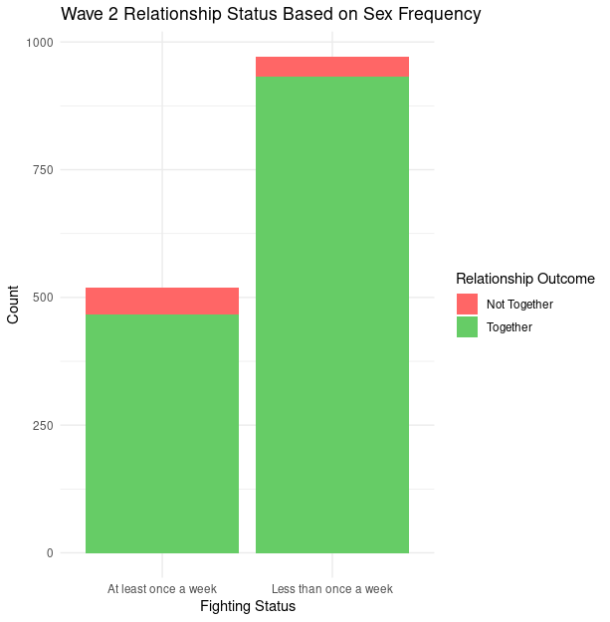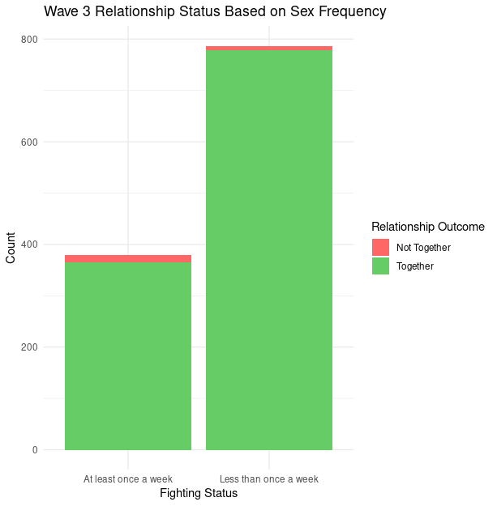

Here are the results of our t-test for a difference in means:

| Group | Mean of <1/wk | M of >= 1/wk | t | df | p |
| --- | --- | --- | --- | --- | --- |
| Wave 2 | 0.9588477 | 0.8998073 | 4.0295 | 765.86 | **6.147e-05** |
| Wave 3 | 0.9885642 | 0.9605263 | 2.6211 | 490.92 | **0.009036** |

Both tests, from the second and third waves of the survey, indicate statistically significant differences between couples who have sex less than once a week compared to those who engage in sexual activities more frequently. More specifically, in both cases, couples who had sex less than once a week reported marginally higher relationship stability. This counterintuitive result may indicate that factors other than sexual frequency play more critical roles in the maintenance of long-term relationships, such as the quality of interactions, emotional connection, and other aspects of intimacy. Further research should explore these dimensions to fully understand the dynamics at play. Moreover, the slight decrease in the strength of the association over time (from Wave 2 to Wave 3) suggests that the impact of sexual frequency on relationship stability may diminish as relationships mature or as other factors come to bear on relationship outcomes.

## Significance of Flirting

The following is a stacked bar chart comparing the proportions of partners still together to those who aren’t between partners who had flirted online or not:

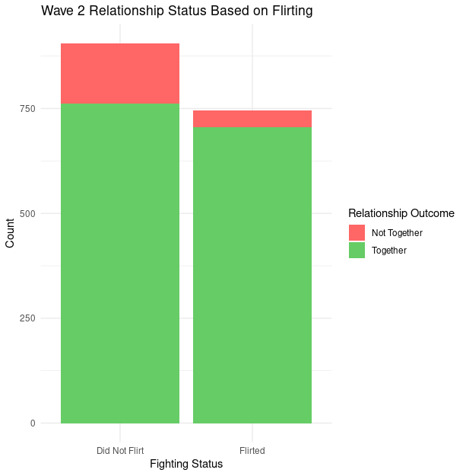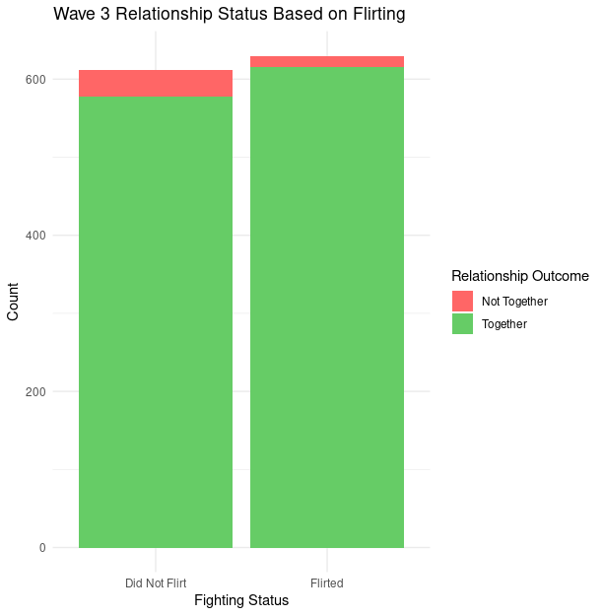Here are the results of our t-test for a difference in means:

| Group | M of Flirted | M of No Flirt | t | df | p |
| --- | --- | --- | --- | --- | --- |
| Wave 2 | 0.9463087 | 0.8399558 | 7.2225 | 1534 | **8.007e-13** |
| Wave 3 | 0.9761905 | 0.9444444 | 2.8645 | 1059.4 | **0.00426** |

Similar to the previous factor, a statistically significant difference was found in both cases (Wave 2 and Wave 3) between couples who engaged in online flirting with each other and those who did not along with the continuation of the decrease in statistical strength of our results from Wave 2 to Wave 3. These findings across both survey waves suggest that engaging in flirting within a relationship context is associated with higher relationship stability. This may imply that flirting, perhaps as an expression of playfulness or continued attraction, could contribute positively to the dynamics of a long-term relationship. It’s important to note the robustness of the previous two factor’s results as the p-values are so low.

## Significance of Fighting

The following is a stacked bar chart comparing the proportions of partners still together to those who aren’t between partners who had fought within the past week or not:

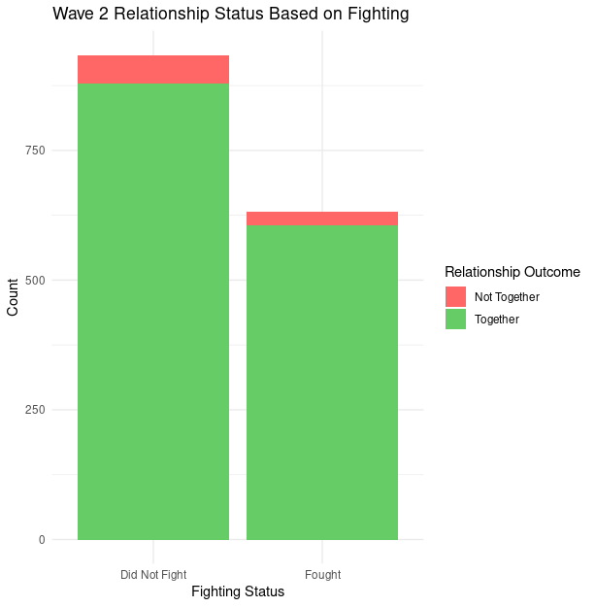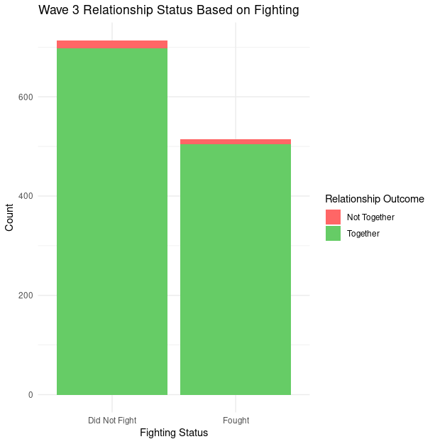

Here are the results of our t-test for a difference in means:

| Group | M of Fought | M of No Fight | t | df | p |
| --- | --- | --- | --- | --- | --- |
| Wave 2 | 0.9572785 | 0.9400428 | 1.5402 | 1483.7 | 0.1237 |
| Wave 3 | 0.9824903 | 0.9761905 | 0.7747 | 1187.7 | 0.4387 |

Our inquiry into the statistical significance of fighting on relationship longevity yields less conclusive evidence than the previous two factors. Our high p-values indicate that any apparent difference in relationship stability due to fighting might be due to chance. From these findings, it can not be concluded that frequent fighting significantly impacts relationship stability across the observed waves. This contrasts with more commonly held beliefs that frequent conflicts are detrimental to relationship health. The context, nature, and resolution of fights may play a more critical role in determining their impact on relationship outcomes than mere frequency. The results suggest that simply measuring the frequency of fights without considering these factors may not adequately capture the complexities involved in how conflicts affect relationships.

# Conclusion

This study explored the interplay between sexual frequency, flirting, fighting, and relationship stability using data from the *How Couples Meet and Stay Together* survey. Our findings reveal a more nuanced landscape of relationships than originally hypothesized, highlighting that less frequent sexual activity and more frequent flirting are indicators of more successful relationships, while the impact of fighting is statistically insignificant. These counterintuitive results suggest that the specific quality and context of these interactions may be more elucidative of relationship longevity than their frequency alone. Moving forward, future research ought to delve into the qualitative aspects of these interactions to understand their impacts on relationships more deeply. Additionally, exploring other potential influences such as emotional intimacy, sexual orientation, communication style, and external stressors could provide a more comprehensive view of what helps couples stay together. Until then, we will continue wondering: “Why did she leave me?”

# References

Rosenfeld, Michael J., Reuben J. Thomas, and Sonia Hausen. 2023. How Couples Meet and Stay Together 2017-2020-2022 combined dataset. [Computer files]. Stanford, CA: Stanford University Libraries. <https://data.stanford.edu/hcmst2017>