Homework 5
5.
i)
I | dam
You (sg) | di
we | dim
You (pl) | did
they | dand
not | na
was/were+-ing | mi
ii)

They were buying. | mixaridand
You (sg) did not buy. | namixaridi
You (sg) were buying. | mixaridi
1. (circle = bold)

These are all complex:

f) reuse
g) triumphed
q) optionality
2)

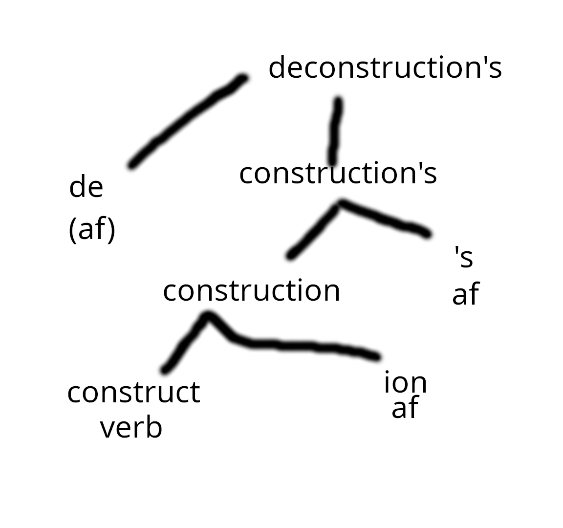

1) de- + V = V with reversed or negated meaning
2) V + -ion = N
3) N + -’s = possessive N

