Rushil Umaretiya
LING 101-6003
16 October 2023
Homework 6: Morphology / Syntax
Q1: 4.17) derivational inflectional
e) The strongest rower continued.
f) The pitbull has bitten the cyclist.
Q2: 9.9)
a) fishes. Children would apply the rule N + -s = N (plural) and change it to fishes.
b) goed. Regular past tense in English involves adding ‘-ed,’ the child may not know the irregular past tense form of “went.”
c) mouses. Regular plural form again involves adding ‘-es,’ so the child may use the regular form instead of the irregular ‘mice.’
d) eated. Like with “went,” the child might apply the regular ‘-ed’ past tense rule.
e) haves. The third person singular form usually takes -s in the present tense, like "runs" or "plays,” but in this case ‘have’ has the irregular form ‘has’ instead of ‘haves.’
f) gooses. Same justification as a) and c).
g) bringed. The child might use the regular -ed past tense rule instead of the irregular “brought.”
h) hitted. Children may not recognize that hit can be both past and present tense, and so may add on an extra ‘-ed’ regular past tense ending.
i) him. Instead of saying the entire reflexive form of “himself” which refers back to the subject, children may just restrict their speech to saying “him.” For example, “He hurt him,” instead of “He hurt himself.”
j) womans. Same justification as a) or c).
Q3:
a) Draw two tree structures for the word unrepaintable.
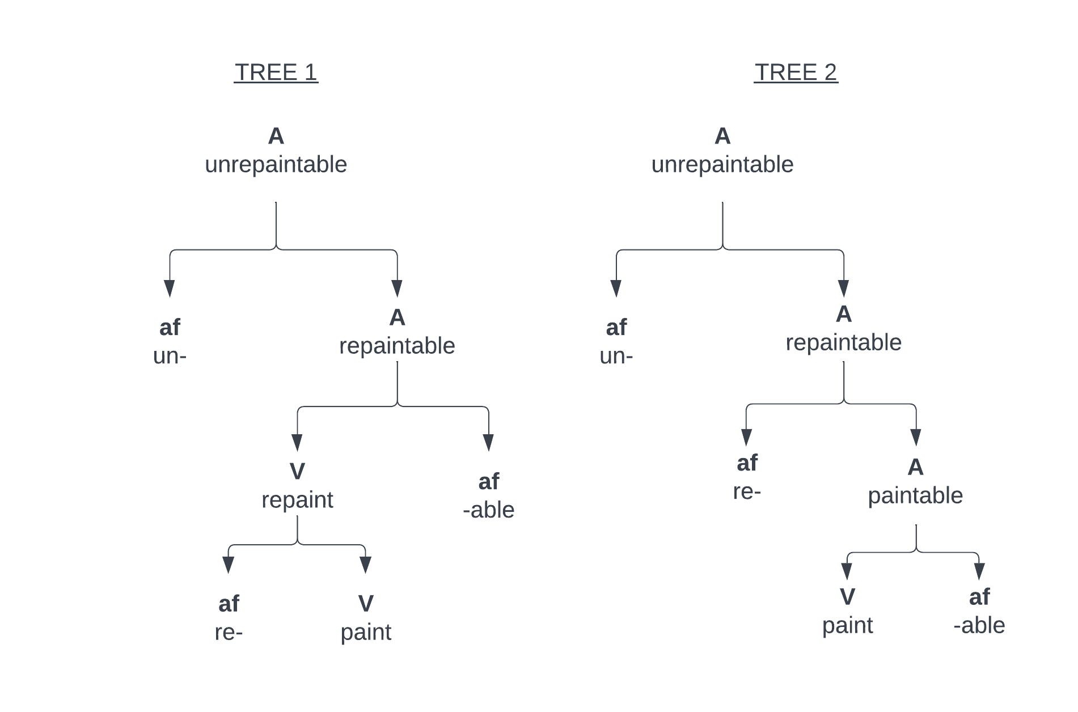

b) For every distinct affix that appears in your trees, write a word-formation rule.
re-
re- + V → V, do to the V again.
-able
V + -able → A, the potential or capacity for V
un-
un- + A → A, negation or opposite of A

c) Do the two tree structures correspond to the same meaning for unrepaintable?
No, tree 1 signifies the lack of repaintability or “something that cannot be painted again” since “repaint” was formed before “repaintable.” Tree 2, signifies “something that was once paintable but now is not” as paintable was formed first.

Q4: Apply the three constituency tests to the following sentences and make a case for which group of words is a constituent:
a) Jane went [to the store] with her cousin.
b) Steve looked [up the number] in the book.
(bold = passes test)
Test | Sentence a) | Sentence b)
Substitution | Jane went [there] with her cousin. | Steve looked [it] in the book.
Coordination | Jane went [to the store] and [there] with her cousin. | Steve looked [up the number] and [it] in the book.
Movement | [To the store], Jane went with her cousin. | [Up the number], Steve looked in the book.

Considering that [to the store] in sentence a) passed all three constituency tests, while sentence b) fails at most of them, we can assert that the word grouping in sentence a) is a constituent while in sentence b) it is not. To go into more depth, we can see that in the substitution and coordination tests for sentence b), [it] does not work with the verb ‘looked’ and you cannot move [up the number] to the front of the sentence without the entire sentence sounding awkward. In sentence a), however, we can see clearly that replacing [to the store] with [there] creates no grammatical issues with the sentence.

