Rushil Umaretiya
Dr. Jen Smith
LING 101-6003
30 October 2023
Homework 8: Syntax
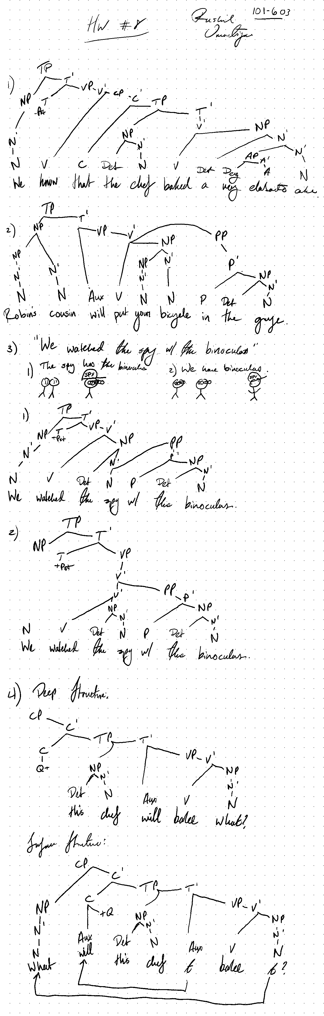
(the two meanings are displayed at the top and then the trees are drawn out in order)

