Rushil Umaretiya
Prof. Leve
RELI 67
16 October, 2023
Interviewee Proposal
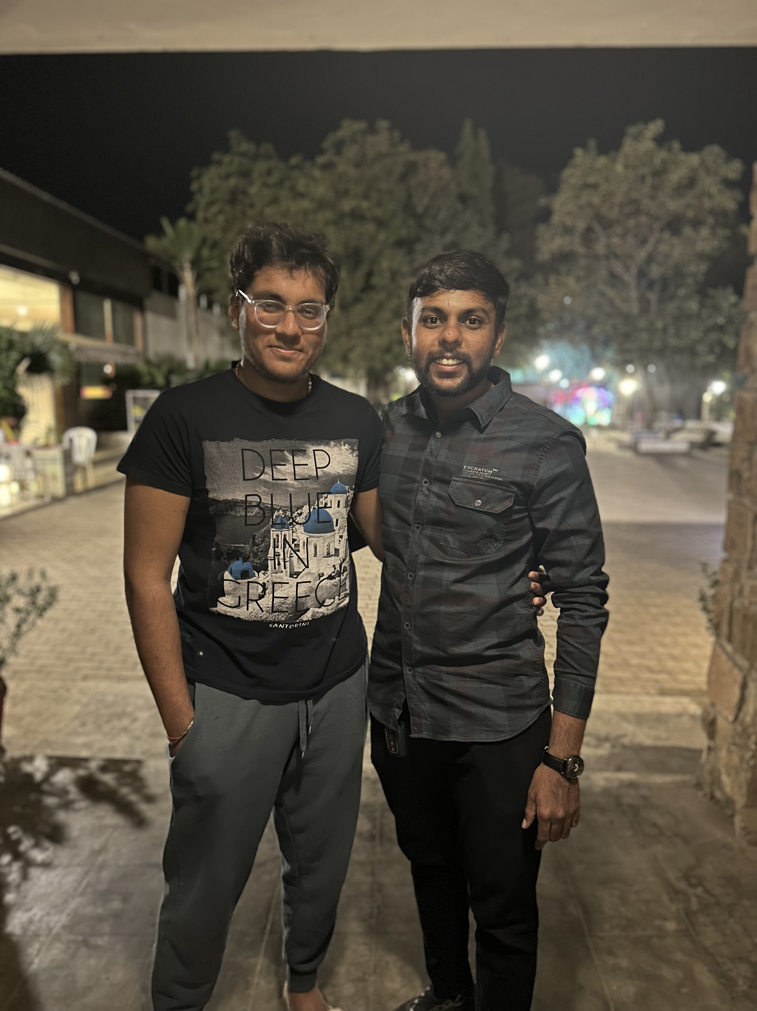
1) Name of interviewee

Jenishbhai Umaretiya (pictured on right)

2) How do you know this person, or know of this person? If you haven't identified an individual yet, how do you propose to find someone who fits your suggested profile?
This is my first cousin, namely the oldest son of my Dad’s older brother who lives in India. He’s just completed his masters and is currently running his fathers’ manufacturing business. Last year, when the above photo was taken, I was visiting my home city of Rajkot, Gujarat and he had just gotten engaged to his fiancee, Princy.

3) If you already know your proposed interviewee, how well do you know them? (i.e., how did you meet? for how long have you known one another? how often do you see each other? what is the tone of your relationship?)
So, the thing is, I was pretty young when I was growing up in India, but after I left it was really hard to keep in touch other than the “Happy Birthdays” and big occasions. We’ve been back a total of four times since we moved, and so we don’t interact more than several times a year. They have a lot more knowledge about my life than I do theirs. The relationship is familial and loving, it’s just the case that I don’t know a ton about him.
4) Why do you think this person is likely to be a good person to interview given the goals of the final project? (i.e., why do you think it's worth trying to analyze how this person's understanding of self and personhood is reflected in the ways they are living/have lived their lives?)
I think that he’s at a core turning point in his life that he may not even realize himself as it is just a rite of passage for a lot of Indians, but Jenish is about to fully enter into an arranged marriage with Princy. They seem to be quite happy, but the culture of marriage arrangement is still alive and thriving in India and I’d like to talk to him about his experience with love and marriage throughout school and how that falls on him as his wedding approaches in November. I’d like to talk about where he sees his life, any regrets that may have fallen on him at this point, and what the future holds in his mind.

5) Have you already made contact with this person? If so, have they agreed to participate in the project? If you haven't asked them yet, when do you plan to do so? And what do you plan to say? If you did already speak to them, how did you describe the class and the project?
No, but he’ll probably say yes to a call. I’m still a little unclear on the project timeline and talked to Prof. Leve about my trip to India and how we might schedule a Zoom call for the full interview before his marriage. I plan to tell him about how we’re talking about South Asian ideological systems in class and how I’d like to talk to him about how he feels about the choices and steps that have led up to his marriage.

