**Project Title: - WiseCare**

**Project Team: - Fall Team. 14**

**Team Members: -**

[Pranjal Jain](https://github.com/jpranjal) [Rushin Naik](https://github.com/Rushin95) [Sucheta Mandal](https://github.com/suchetamandal) [Surendra R Yadav](https://github.com/surendrary)

**Problem Statement:-**

Rising healthcare cost is always been a problem for American citizens over the years. To increase healthcare quality and affordability among all levels of people, Patient Protection and Affordable Care Act (also known as Obamacare) is introduced. It is introduced as a collaborative mechanism of mandate health insurance, subsidies and insurance exchange. This campaign was started with a great hopes and but suddenly it started to fail. There has been reports of more than 500 million loss from 2014.There were many plans executed to reduce the loss before the situation got worse. Various insurers left the obamacare because they didn't want to bear the loss for the long time. Even individuals are also considering obamacare as a burden for future terms, as a result day by day this Act campaign is losing its interest in public.

**Proposed Solution:-**

We will gather different form of policy data, user reviews and premium statistics to analyze the data driven impact of obamacare on Americans life. Our project will give graphical insights to Insurance Company, obamacare officials and citizens to decide this act’s good and bad concerns. It will also help them to track down the actual cause of loss, if any. On the other hand, obamacare officials also can argue over how this act can be made more affordable for general public. Overall, everyone can take a data driven, logical decision on this health act.

**Technologies to be used:**

Apache Spark, Python, Bootstarp.

**Architectural Flow Diagram:-** 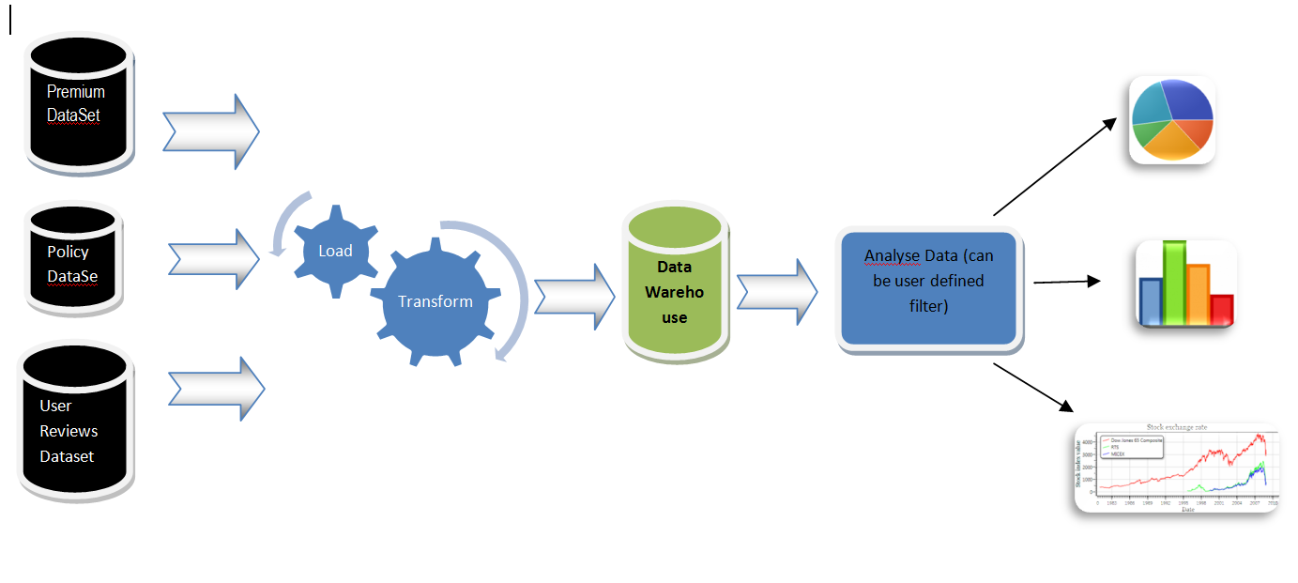

**List of Personas:-**

**Persona 1:- General American Citizen.**

**How to use this system:-** Enter age, Enter State, Policy Type, Premium range, System will present a graphical view of that specific data and user can then decide its impact on his economy and health care status,

**Persona 2:- Professional who works for betterment of obamacare.**

**How to use this system: -** Enter Year (From and Two), Enter State. System will present a graphical view of that specific data and user can also choose different formats of graph.

**Persona 1:- Insurance Policy Professional**

**How to use this system: -** Enter Year (From and Two), Enter State, Enter Policy type etc. System will present a graphical view of that specific data and user can also conclude what is going wrong and what can be down to nullify if any business loss found.