

Tugas 2

Algoritma dan Struktur Data
Teknik Informatika Kelas C

Nama:
Zhafran Rama Azmi (215150207111025)
Gibran Hakim (215150200111020)

Dosen:
Putra Pandu Adikara, S.Kom., M.Kom.



Program Studi Teknik Informatika
Jurusan Teknik Informatika
Universitas Brawijaya

2022
1. Kode
import java.util.Scanner;

// Zhafran Rama Azmi (215150207111025)
// Gibran Hakim (215150200111020)

public class Main {
public static void main(String[] args) {
Scanner in = new Scanner (System.in);
Tree dirTree = new Tree();
while(in.hasNext()){
String input = in.next();
if (input.equals("TAMBAH")) {
in.next();
String name = in.next();
long data = in.nextLong();
System.out.println("TAMBAH " + name + " PADA " + dirTree.add(name, data));
} else if (input.equals("HITUNG")) {
String path = in.next();
TreeNode node = dirTree.findWithPath(path);
if (node == null) {
System.out.println("PATH " + path + " tidak ditemukan");
} else {
System.out.println("UKURAN " + path + " = " + dirTree.countValue(node));
}
} else if (input.equals("CETAK")) {
String path = in.next();
TreeNode node = dirTree.findWithPath(path);
if (node == null) {
System.out.println("PATH " + path + " tidak ditemukan");
} else {
dirTree.print(node, 0);
System.out.println();
}
} else if (input.equals("HAPUS")) {
String path = in.next();
TreeNode node = dirTree.findWithPath(path);
if (node == null) {
System.out.println("PATH " + path + " tidak ditemukan untuk dihapus");
} else {
dirTree.delete(node);
System.out.println("PATH " + path + " berhasil dihapus");
}
}
}
}
}

class TreeNode {
TreeNode parent;
LinkedList child;
long size;
String name;

TreeNode() {
this.parent=null;
this.child = new LinkedList();
this.size = -1;
this.name = "";
}

TreeNode(TreeNode parent, long size, String name) {
this.parent = parent;
this.child = new LinkedList();
this.size = size;
this.name = name;
}
}

class Tree {
TreeNode root;
int height;

Tree() {
this.root = new TreeNode(null, -1, "data");
this.height = 0;
}

String add (String name, long data, TreeNode curNode, int posY) {
String path = "/" + root.name;
ListNode p = curNode.child.head;
while (p!=null) {
if (name.length() >= p.node.name.length()) {
if (p.node.name.equals(name.substring(0, p.node.name.length()))) {
path += "/" + p.node.name;
curNode = p.node;
p = curNode.child.head;
posY++;
continue;
}
}
p = p.next;
}
curNode.child.add(name, data, curNode);
if (this.height <= posY) {
this.height = posY;
}
return path;
}

String add(String name, long data) {
return this.add(name, data, root, 0);
}

TreeNode findWithPath(String path) {
String[] nodeName = path.split("/");
int posY = 1;
TreeNode p = root;

if (p.name.equals(nodeName[posY]) && posY == nodeName.length - 1) {
return p;
}

ListNode pList = p.child.head;

while (pList != null) {
if (pList.node.name.equals(nodeName[posY + 1])) {
if (posY + 1 == nodeName.length - 1) {
return pList.node;
} else {
p = pList.node;
pList = p.child.head;
posY++;
continue;
}
}
pList = pList.next;
}
return null;
}

void print(TreeNode node, int posY) {
if (node == root) {
System.out.println(root.name);
} else {
String indent = "";
for (int i = 0; i < posY; i++) {
indent += "--";
}
if (indent.length() > 0) {
System.out.printf("%s %s (%d)\n" , indent , node.name , node.size);
} else {
System.out.printf("%s%s (%d)\n" , indent , node.name , node.size);
}
}
ListNode p = node.child.head;
while (p != null) {
print(p.node, posY + 1);
p = p.next;
}
}

void print() {
print(root, -1);
}

long countValue(TreeNode cur) {
long tmp = 0;
if (cur.size > -1) {
tmp = cur.size;
}
ListNode p = cur.child.head;
while (p != null) {
tmp += countValue(p.node);
p = p.next;
}
return tmp;
}

void delete(TreeNode node) {
node.parent.child.remove(node.name);
node.parent = null;
}
}

class ListNode {
ListNode next, prev;
TreeNode node;

ListNode() {
this.next = this.prev = null;
this.node = null;
}

ListNode(TreeNode node) {
this.node = node;
}

ListNode(TreeNode node, ListNode next, ListNode prev) {
this.node = node;
this.next = next;
this.prev = prev;
}
}

class LinkedList {
ListNode head, tail;
int size;

LinkedList(){
this.size = 0;
}

boolean isEmpty() {
return size == 0;
}

void removeFirst(){
if(isEmpty()){
System.out.println("Data is empty !");
} else{
ListNode temp = head;
if(head == tail){
head = tail = null;
} else{
head.next.prev = null;
head = temp.next;
}
size--;
}
}

void removeLast(){
if(this.isEmpty()){
System.out.println("Data is empty !");
} else{
ListNode temp = tail;
if(head == tail){
head = tail = null;
} else {
tail.prev.next = null;
tail = temp.prev;
}
size--;
}
}

void remove(String name){
ListNode temp = head;
if(this.isEmpty()){
System.out.println("Data is empty !");
} else{
while(temp != null){
if(temp.node.name.equals(name)){
if(temp == head){
this.removeFirst();
} else if(temp == tail){
this.removeLast();
} else{
temp.prev.next = temp.next;
temp.next.prev = temp.prev;
size--;
}
break;
}
temp = temp.next;
}
}
}

void add(String name, long val, TreeNode parent){
ListNode curr = new ListNode(new TreeNode(parent, val, name));
if(this.isEmpty()){
head = tail = curr;
} else{
tail.next = curr;
curr.prev = tail;
tail = curr;
}
size++;
}
}

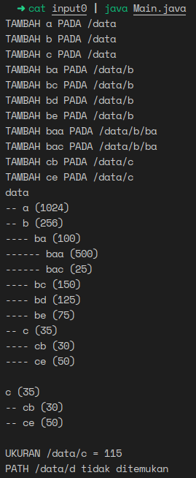
2. Output
TAMBAH a PADA /data
TAMBAH b PADA /data
TAMBAH c PADA /data
TAMBAH ba PADA /data/b
TAMBAH bc PADA /data/b
TAMBAH bd PADA /data/b
TAMBAH be PADA /data/b
TAMBAH baa PADA /data/b/ba
TAMBAH bac PADA /data/b/ba
TAMBAH cb PADA /data/c
TAMBAH ce PADA /data/c
data
-- a (1024)
-- b (256)
---- ba (100)
------ baa (500)
------ bac (25)
---- bc (150)
---- bd (125)
---- be (75)
-- c (35)
---- cb (30)
---- ce (50)

c (35)
-- cb (30)
-- ce (50)

UKURAN /data/c = 115
PATH /data/d tidak ditemukan

TAMBAH aab PADA /data
TAMBAH a PADA /data
TAMBAH aab PADA /data/aab
TAMBAH aabc PADA /data/aab/aab
data
-- aab (100)
---- aab (300)
------ aabc (300)
-- a (200)

a (200)

UKURAN /data/a = 200
PATH /data/a/ab tidak ditemukan
UKURAN /data/aab = 700
UKURAN /data/aab/aab = 600

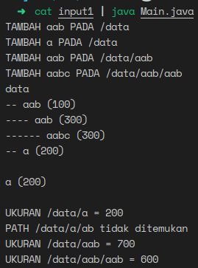
Refleksi Diri:
Yang paling sulit saya dan teman kelompok saya hadapi adalah dalam cara berpikir secara rekursif.

