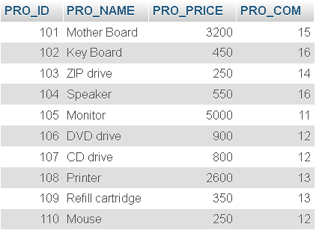

**TABLE NUMBER 1**

create table product(PRO_ID int(30),PRO_NAME varchar(100),PRO_PRICE int(30),PRO_COM int(20));

INSERT INTO product VALUES(101,'MOTHER BOARD',3200.00,15),(102,'KEY BOARD',450.00,16),(104,'ZIP drive',450.00,16),(105,'Monitor',5000.00,11),(106,'DVD drive',900.00,12),(107,'CD drive',800.00,12),(108,'Printer',2600.00,13),(109,'Refill catridge',350.00,13),(110,'Mouse',250.00,12);