MVC

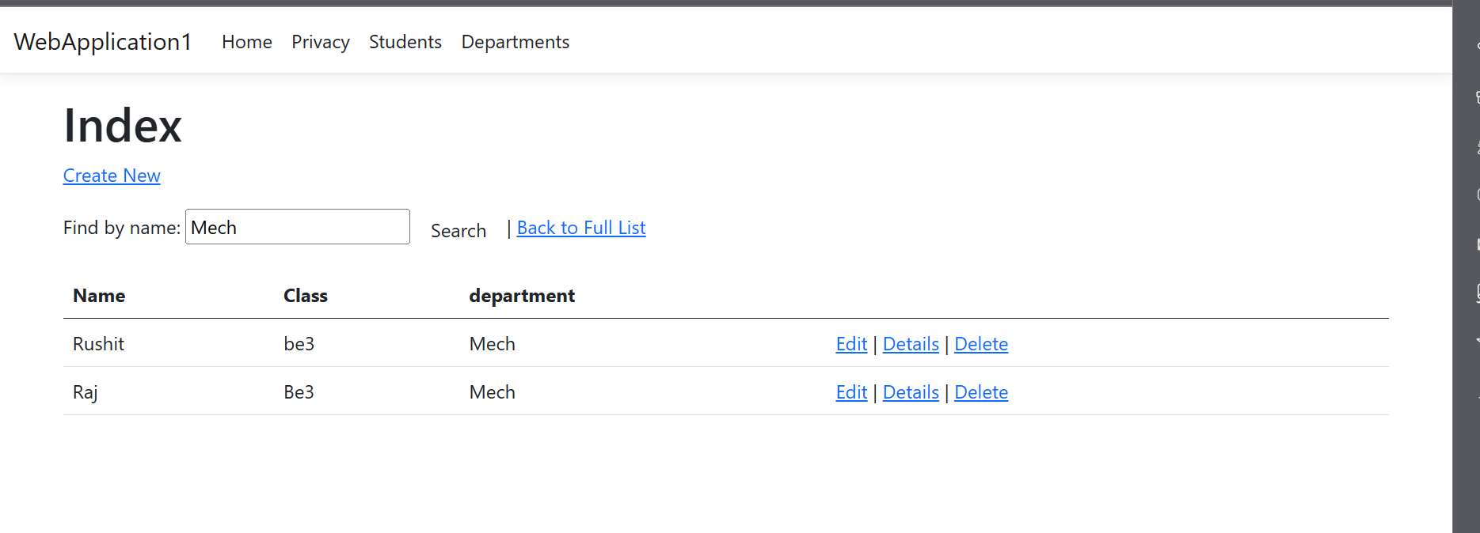

WebApi



