ML LAB WEEK 10 – SUPPORT VECTOR MACHINE (SVM)
NAME : D R Rushmitha
SRN : PES1UG24AM910
SECTION : E

1. Objective
The objective of this lab is to understand and implement Support Vector Machine (SVM) classifiers using Linear, Radial Basis Function (RBF), and Polynomial kernels.The models are trained on the Moons and Banknote datasets and evaluated using classification metrics and decision boundary visualizations.

2. Analysis Questions

A. Moons Dataset
1. What can you infer about the Linear Kernel's performance?
The Linear kernel performs reasonably well,but it cannot completely capture the curved shape of the two moons data set.Since a linear SVM creates a straight-line decision boundary,some points near the curved regions are classified incorrectly.Therefore, the linear model is less suitable for this non-linear data set.
2. Compare the RBF and Polynomial kernel decision boundaries.
The RBF kernel produces a flexible non-linear decision boundary that follows the curved shape of the two-moons data closely.The Polynomial kernel also produces a curved boundary, but its shape depends on the polynomial transformation and may not match the data set as closely as the RBF boundary.In this experiment, the RBF model gives a better separation of the two classes.

B. Banknote Dataset
3. Which kernel was most effective for the Banknote data set?
The most effective kernel should be identified from the classification reports generated by the notebook by comparing accuracy, precision, recall, and F1-score.The kernel with the strongest overall test performance is the most effective for this data set.
4. Why might the Polynomial kernel have under performed here?
The Polynomial kernel introduces a polynomial decision function.If the degree and other parameters do not match the structure of the Banknote data, the resulting boundary may be unnecessarily complex or may not represent the class separation effectively.This can lead to lower test performance compared with a Linear or RBF kernel.

C. Hard vs. Soft Margin
5. Which margin (soft or hard) is wider?
The soft-margin SVM uses C = 0.1, while the hard-margin SVM uses C = 100. A smaller C allows more training errors in exchange for a wider margin.Therefore, the soft-margin model generally has the wider margin.
6. Why does the soft-margin model allow 'mistakes'?
A soft-margin SVM allows some training samples to be inside the margin or even misclassified.This is controlled by the smaller C value.Allowing these violations helps the model avoid focusing too strongly on individual training points and can produce a decision boundary that generalizes better.
7. Which model is more likely to be overfitting and why?
The hard-margin model with C = 100 is more likely to overfit because it strongly penalizes classification errors and attempts to classify the training data with very little tolerance for mistakes. This can make the decision boundary more sensitive to individual training samples.
8. Which model would you trust more for new data and why?
For unseen data,the soft-margin model can generally be preferred when the data may contain noise or overlapping samples because it allows a controlled number of training violations and focuses more on a robust separating margin.The final choice should be confirmed using test set performance.

3. Moons Dataset Results
This notebook compares Linear, RBF, and Polynomial SVM kernels on the Moons data set.The generated classification reports are as follows :
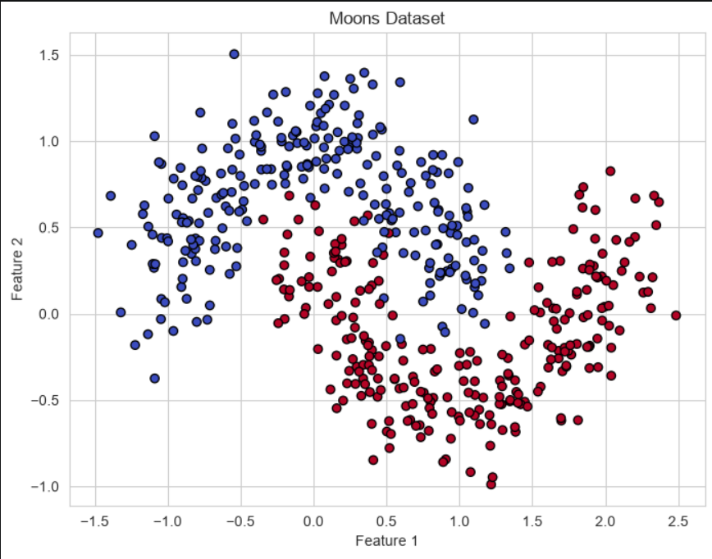

CLASSIFICATION REPORTS :
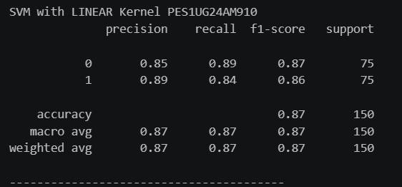
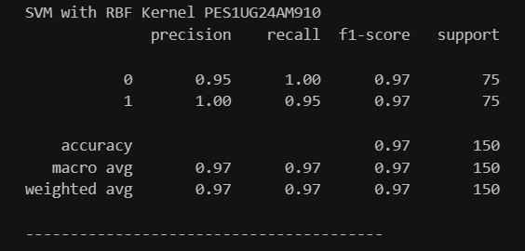
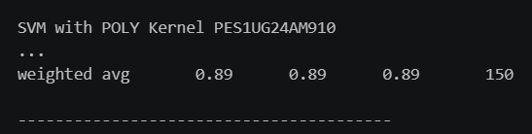
SVM KERNELS (Moons Dataset) :
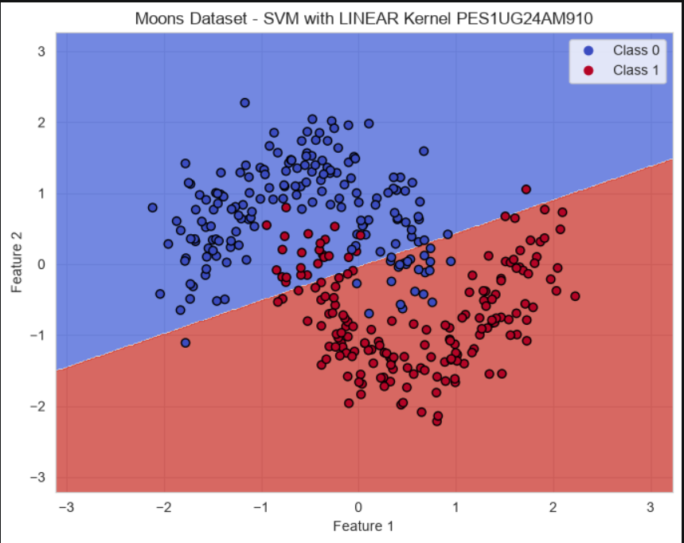

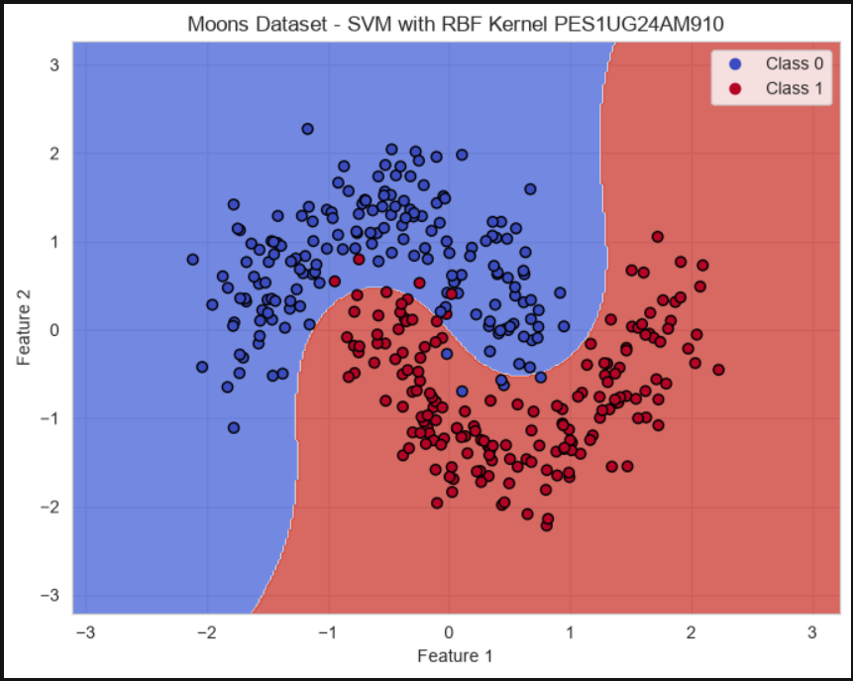
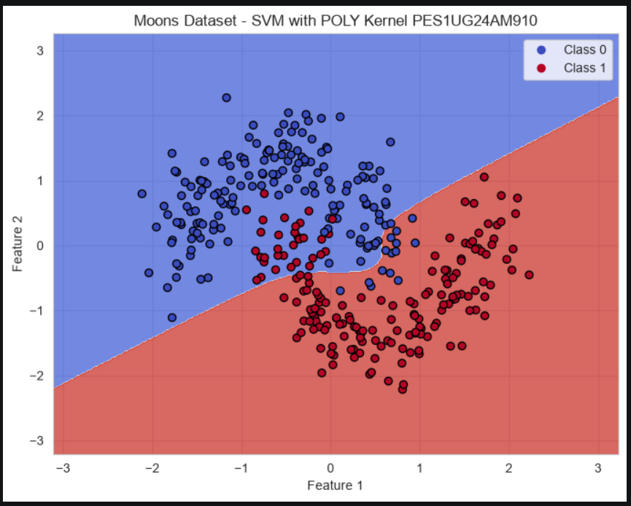

4. Banknote Dataset Results
This notebook compares Linear, RBF, and Polynomial SVM kernels on the Banknote data set.The Classification reports are as follows :
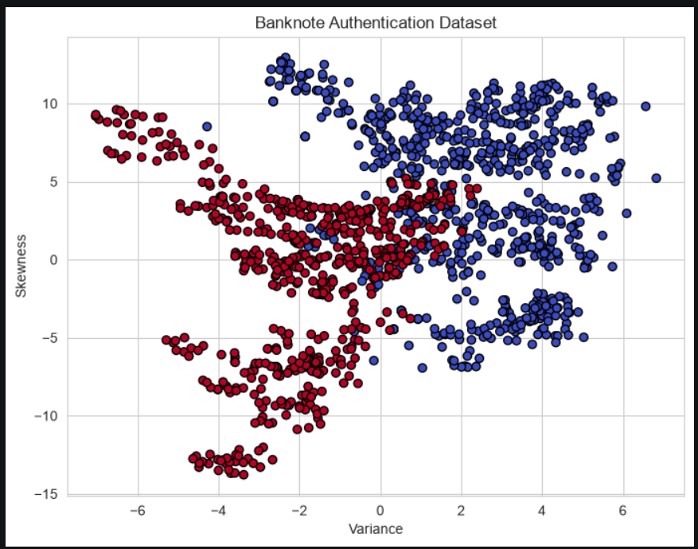
CLASSIFICATION REPORTS :
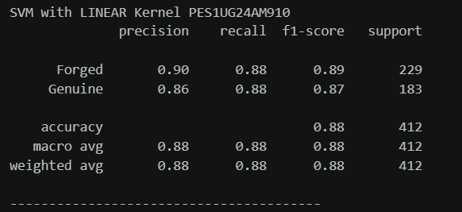
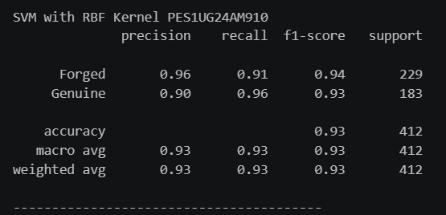
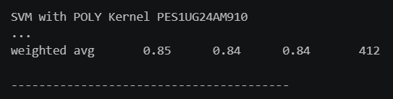
SVM KERNELS (Banknote Dataset) :
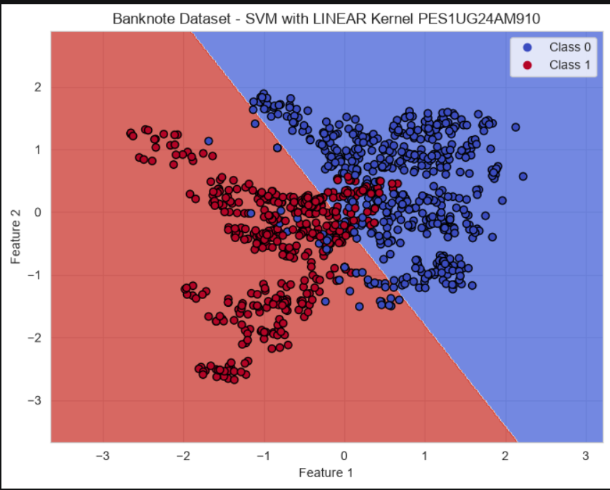
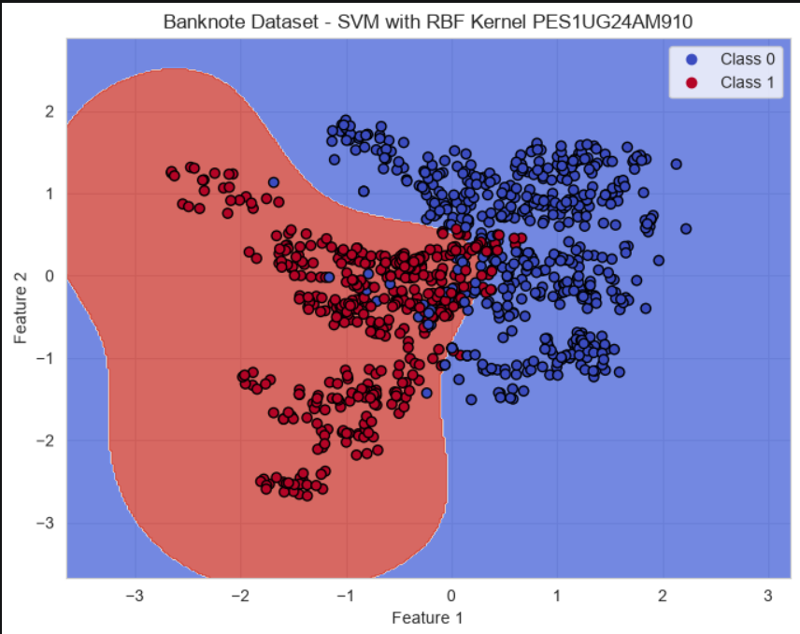
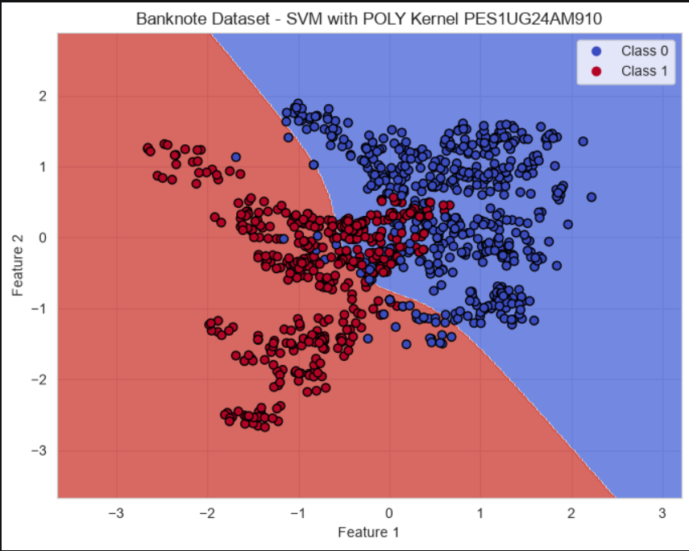

5. Margin Analysis
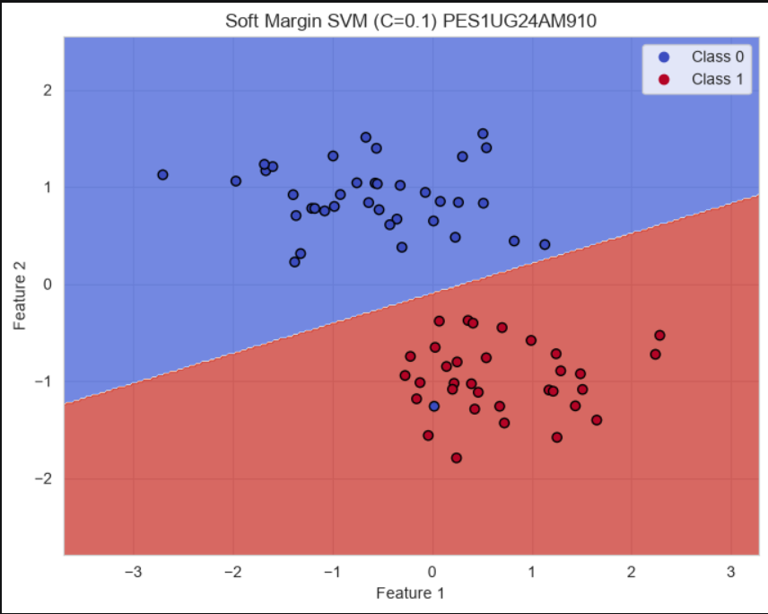
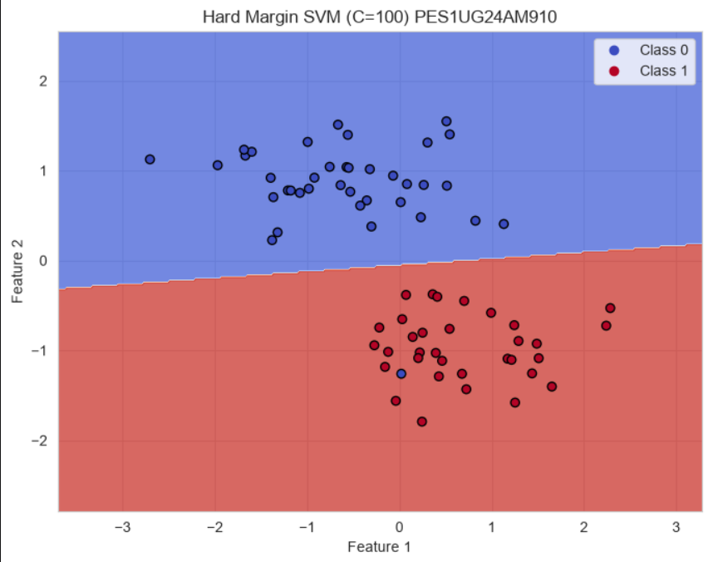

6. Conclusion
This lab demonstrates how different SVM kernels affect classification and decision boundaries.The Linear kernel is suitable when the classes can be separated approximately by a straight boundary, whereas RBF and Polynomial kernels can model non linear relationships.The comparison between soft and hard margins also shows how the C parameter controls the trade-off between a wide margin and training errors.

