Software Engineering LAB1
NAME : D R Rushmitha
SRN : PES1UG24AM910
SECTION : E
1.Requirements Table :
ID | Type | Description | Priority | Acceptance Criteria | Rationale
FR-001 | Functional | System shall compute triage severity scores from intake vitals and dynamically order the ER bed allocation waitlist. | High | Pass: Higher-acuity patient automatically moves ahead of lower-acuity patient. Fail: FIFO queue ignores critical emergency. | Ensures critical patients are treated first, reducing preventable harm from delayed care.
FR-002 | Functional | System shall check ER bed availability and auto-allocate the highest-priority waitlisted patient when a bed opens, or retain patient in prioritized waitlist if unavailable. | High | Pass: Bed assigned to top-of-queue patient within seconds of becoming free. Fail: Bed remains unassigned or goes to a lower-priority patient. | Prevents manual bed-tracking errors and speeds up patient placement.
FR-003 | Functional | System shall flag whether a patient requires ICU care and, if yes, check real-time ICU bed availability. | High | Pass: ICU-flagged patient triggers an availability check automatically. Fail: ICU need is recorded but no availability check occurs. | Ensures no delay between clinical decision and bed-search action.
FR-004 | Functional | If no ICU bed is available, system shall initiate and track an inter-facility ambulance transfer workflow until status is resolved. | Medium | Pass: Transfer request auto-generated with live status updates (Requested → En Route → Arrived). Fail: Transfer initiated with no status tracking. | Prevents patients being "lost" between hospitals during ICU overflow.
FR-005 | Functional | System shall update bed status (ER, ICU, waitlist) and refresh the shared dashboard in real time for both Triage Nurse and Hospital Administrator roles. | High | Pass: Any status change is visible to all logged-in users within the defined latency. Fail: Dashboard shows stale data after a bed-state change. | Keeps all stakeholders synchronized for coordinated decision-making.
NFR-006 | Performance & Security  (Non-Functional) | Bed status transitions (Occupied, Cleaning, Available) must propagate to all connected ER dashboard clients in under 1 second via Web Sockets, over an encrypted (TLS) connection. | High | Pass: Load testing confirms <1s propagation and TLS-secured channels under simulated peak load. Fail: Latency exceeds threshold or data transmitted unencrypted. | Real-time accuracy is safety-critical in ER triage; encryption protects patient data in transit (HIPAA-aligned).
NFR-007 | Availability & Reliability  (Non-Functional) | The dashboard and allocation engine must maintain 99.9% uptime, with automatic failover ensuring no single point of failure disrupts triage/ICU workflows. | High | Pass: System recovers from a simulated node failure within 5 seconds with no data loss. Fail: Downtime exceeds SLA or triggers data/state loss. | ER systems cannot tolerate downtime; a crash during an emergency could directly endanger patient lives.

2. UML Use-Case Diagram:
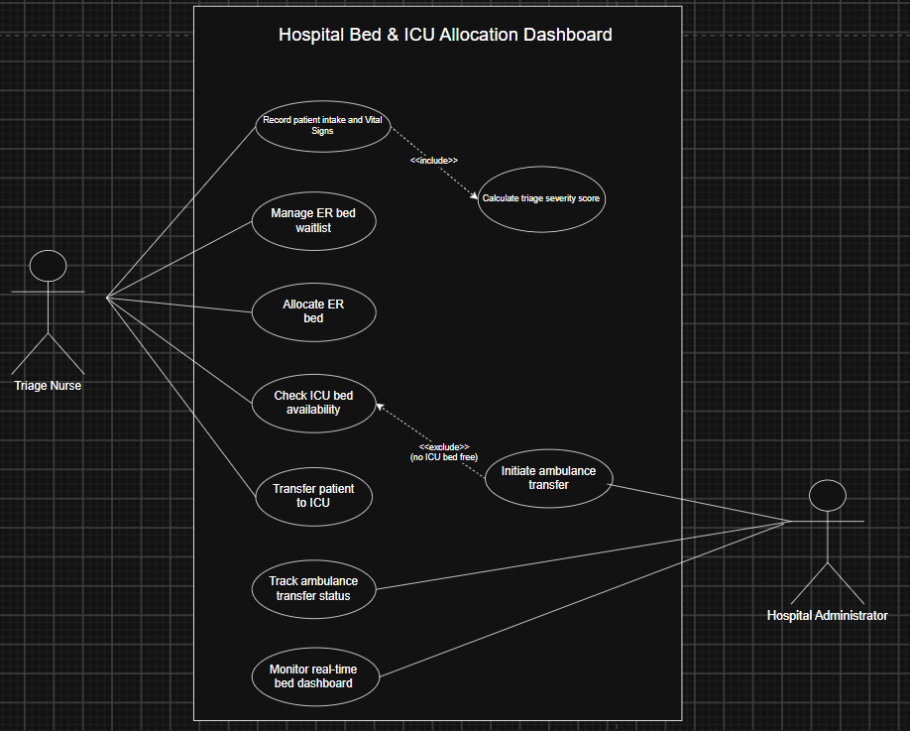

3.Use-Case Flow Specification:
Use Case ID | UC-003
Use Case Name | Allocate ER Bed to Highest-Priority Patient
Primary Actor | Triage Nurse
Secondary Actor(s) | Hospital Administrator (dashboard visibility), System (auto-scoring)
Trigger | A patient's intake vitals have been recorded and a triage severity score has been calculated.
Related FR(s) | FR-001, FR-002, FR-003, FR-004

Preconditions :
- Patient has been registered and intake vitals recorded in the system (FR-001 dependency).
- Triage severity score has been successfully calculated for the patient.
- Triage Nurse is authenticated and has an active session on the ER dashboard.
- ER bed inventory data (Occupied / Cleaning / Available) is current in the system.

Postconditions :
- Success: Patient is either assigned an ER bed or placed in the prioritized waitlist at the correct rank.
- Bed status and waitlist position are updated in real time on all connected dashboards (NFR-001).
- An audit log entry is created recording the allocation decision and timestamp.
Main Success Scenario :
1. Triage Nurse records patient intake details and vital signs into the system.
2. System calculates the triage severity score from the recorded vitals.
3. System inserts the patient into the ER bed allocation waitlist, ordered by descending severity score.
4. System checks current ER bed availability.
5. System determines an ER bed is available and identifies the highest-priority eligible patient.
6. System allocates the available ER bed to that patient and updates the patient's status to “Admitted – ER Bed.”
7. System updates bed status and the real-time dashboard for all connected Triage Nurse and Hospital Administrator clients.
8. Use case ends successfully.

Alternate Flow A1 – No ER Bed Available
1. System confirms zero eligible ER beds are free.
2. System retains the patient in the prioritized waitlist at their severity-ranked position rather than allocating a bed.
3. System continues monitoring bed status; when a bed transitions to “Available,” the flow resumes at Main Success Scenario Step 5 for the highest-priority waitlisted patient.
4. System updates the real-time dashboard to reflect the patient's waitlist status

