SOFTWARE ENGINEERING
LAB2
JIRA
NAME : D R Rushmitha
SRN : PES1UG24AM910
SECTION : E
EPICS
1.Hospital Bed Management
Story | Points
View Available Hospital Beds | 2
Update Hospital Bed Status | 3
View Hospital Bed Occupancy | 2

2.ICU Bed Management
Story | Points
View Available ICU Beds | 3
Allocate an ICU Bed to a Patient | 5
Update ICU Bed Status | 3

3.Patient Bed Allocation
Story | Points
Add Patient Admission Details | 3
Allocate a Hospital Bed to a Patient | 5
View Patient Bed Allocation Details | 3

SCREENSHOTS:
1.All EPICS
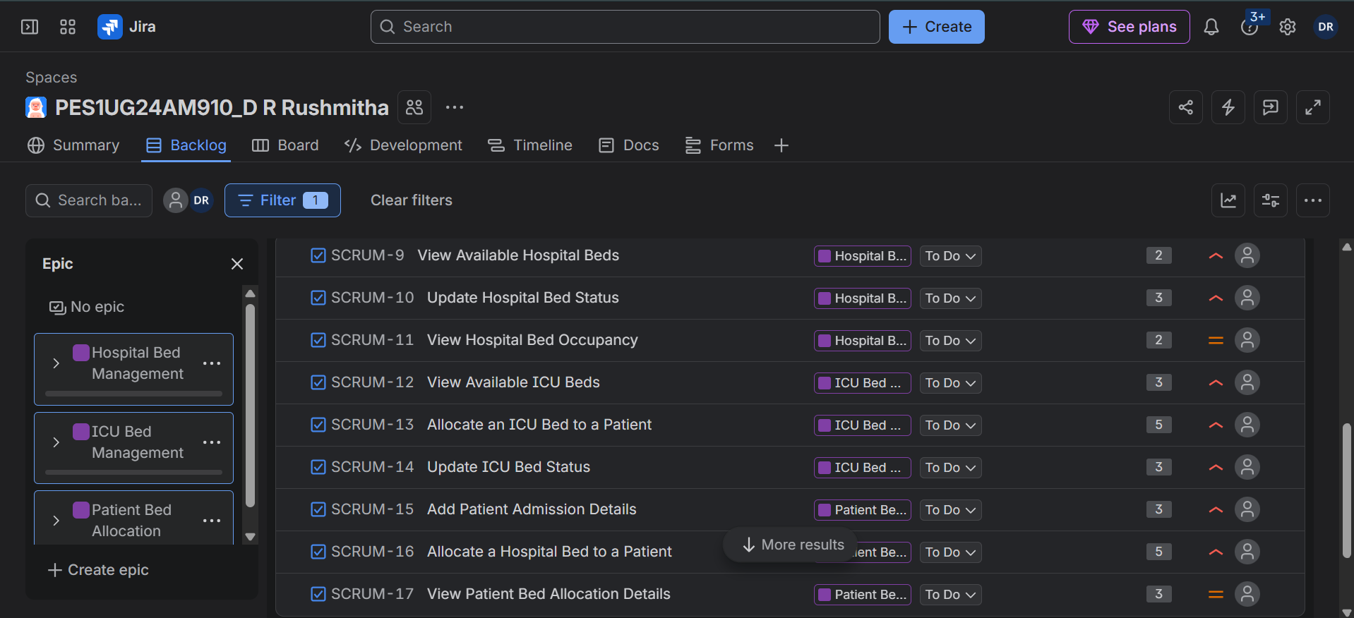
2.Hospital Bed Management
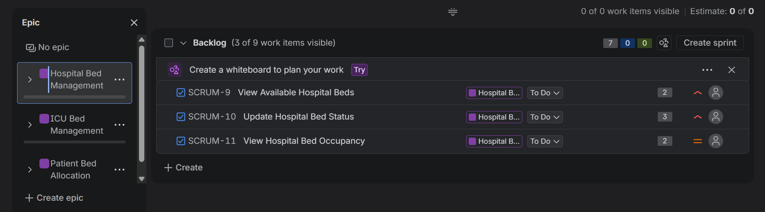
3.ICU Bed Management
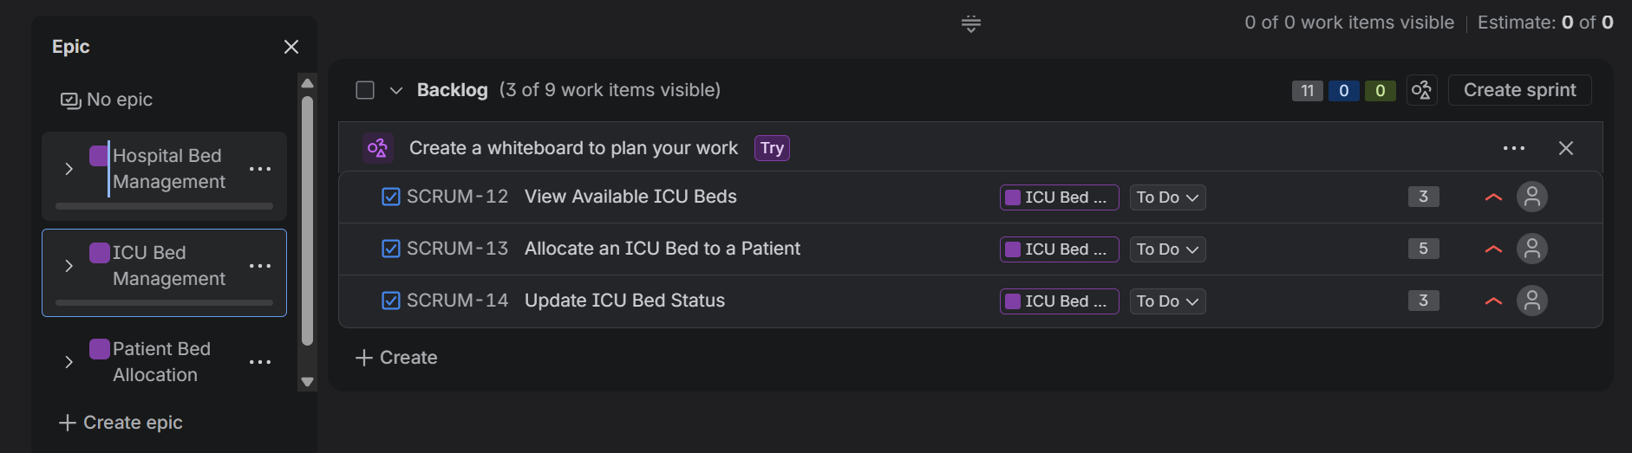
4.Patient Bed Allocation
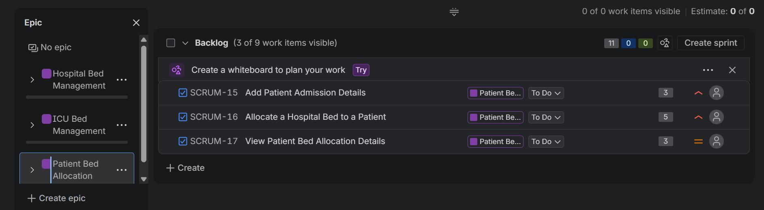
5.Sprint
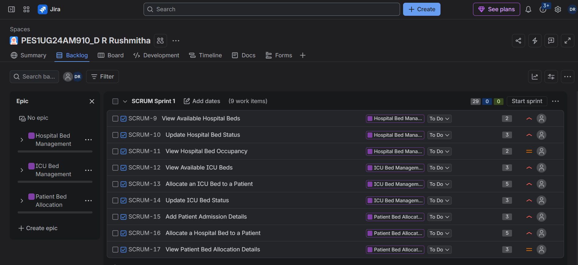
6.To Do
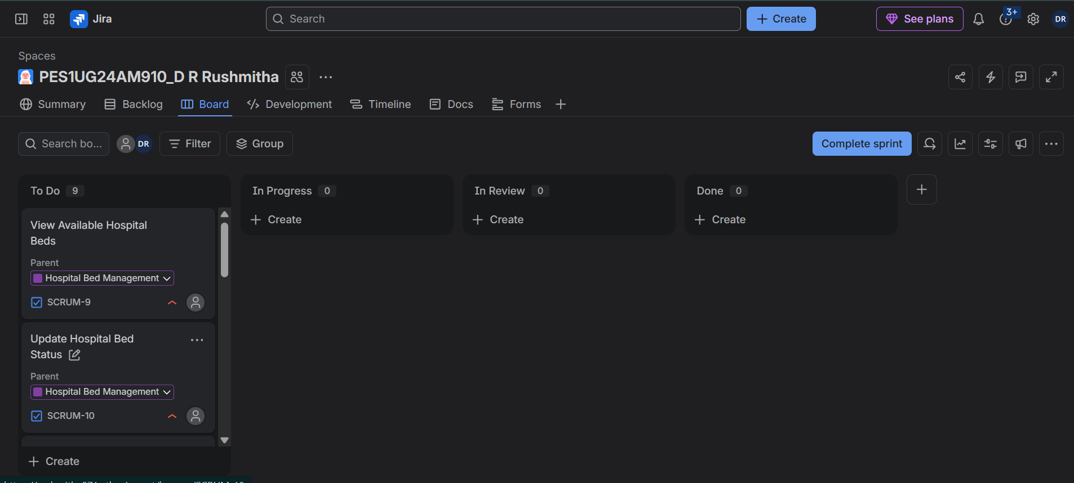
7.To Do -> In Progress -> Done
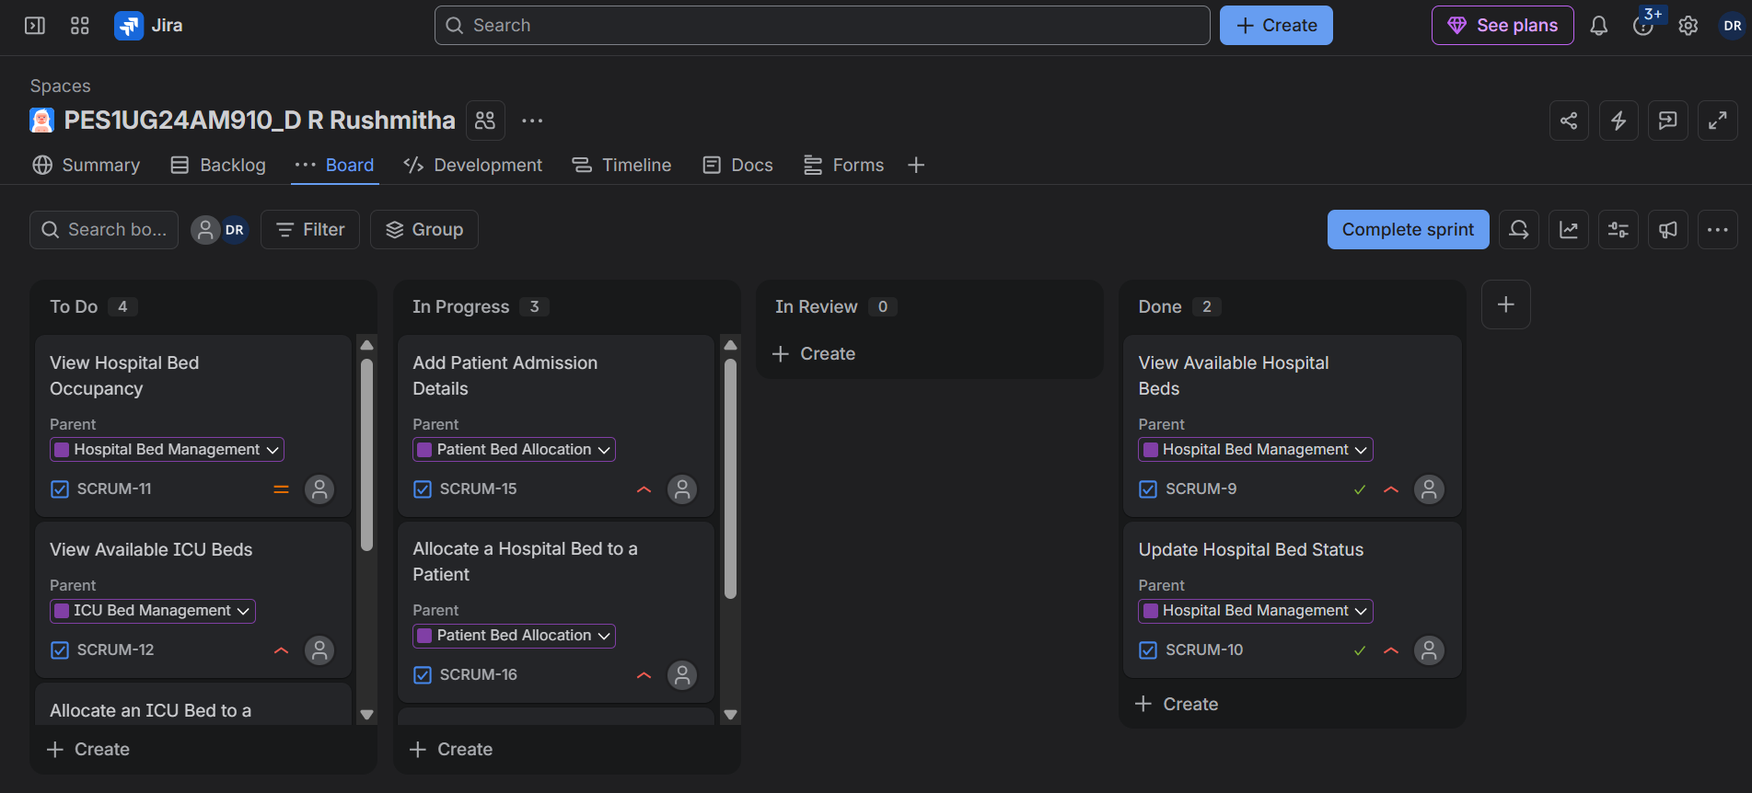

8.All Tasks Completed
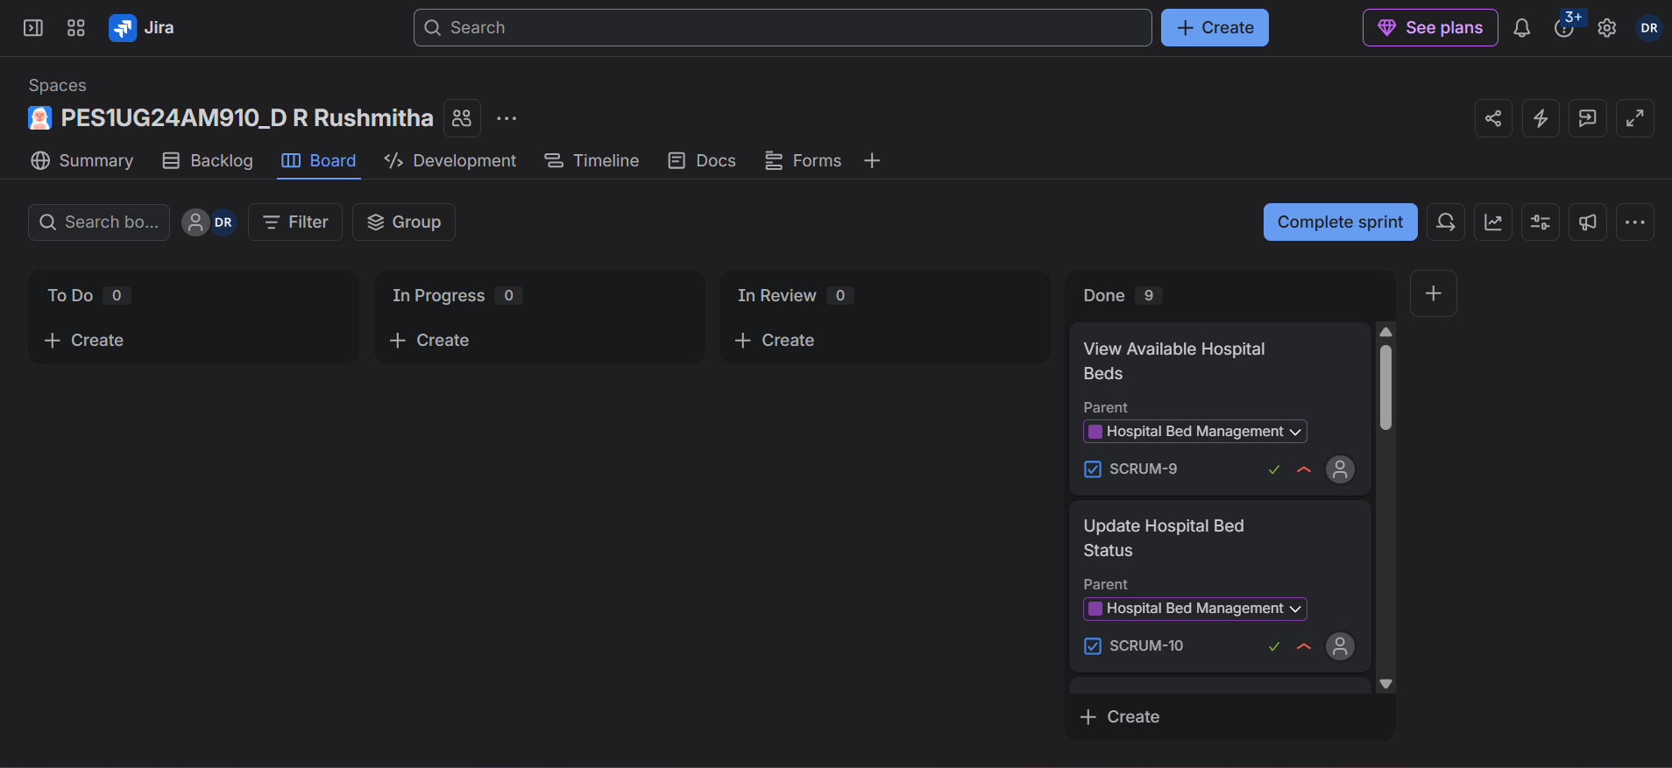
9.Summary
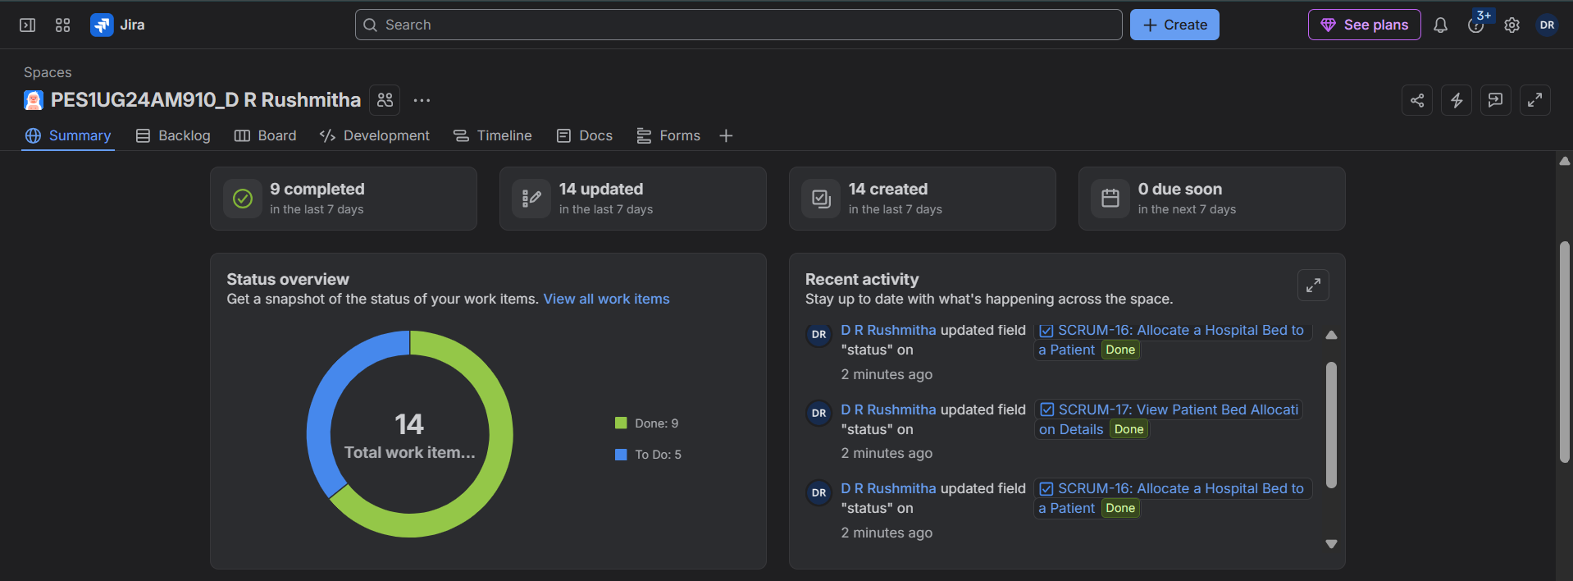
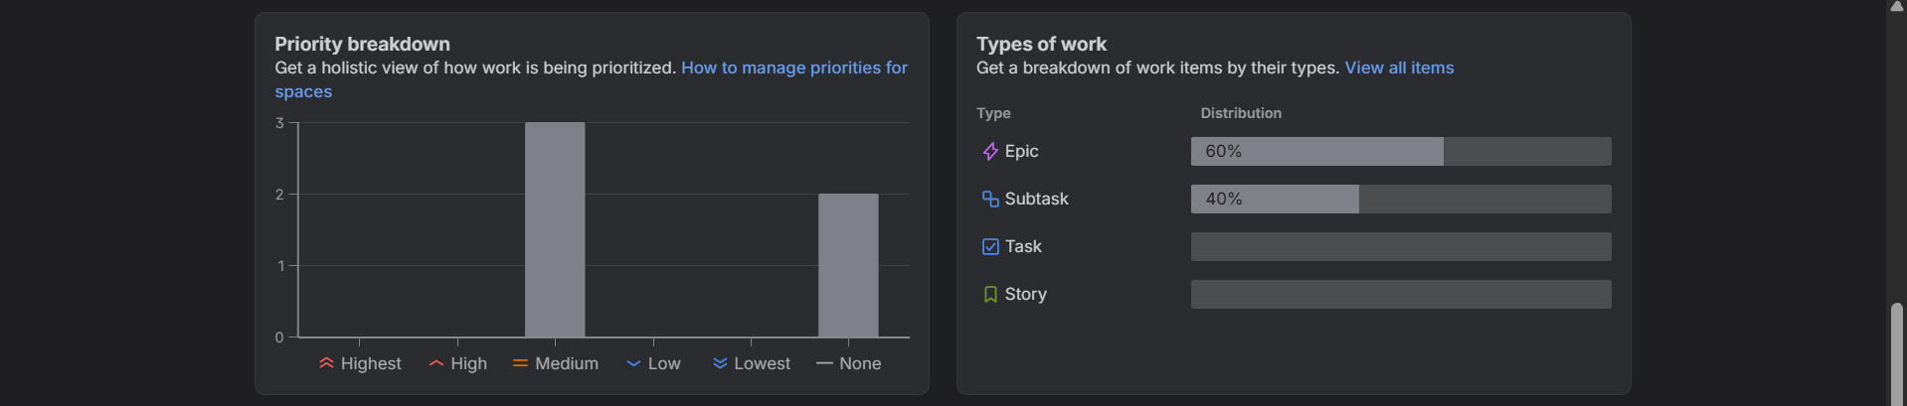
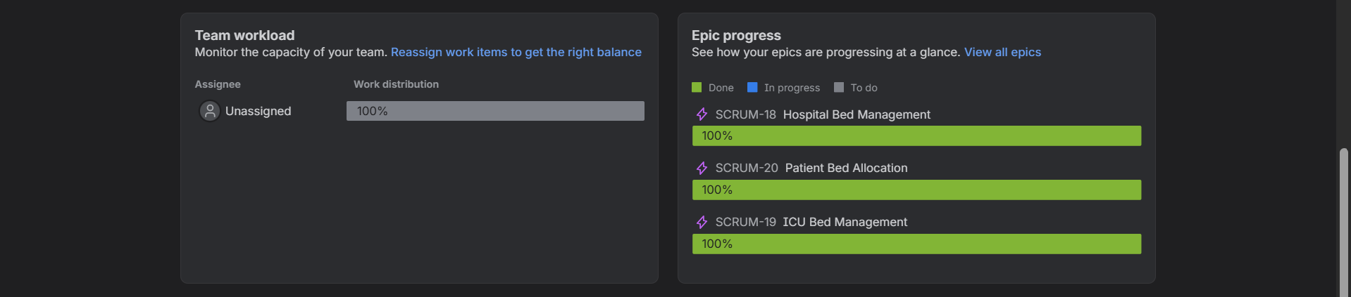

10.Burndown Chart
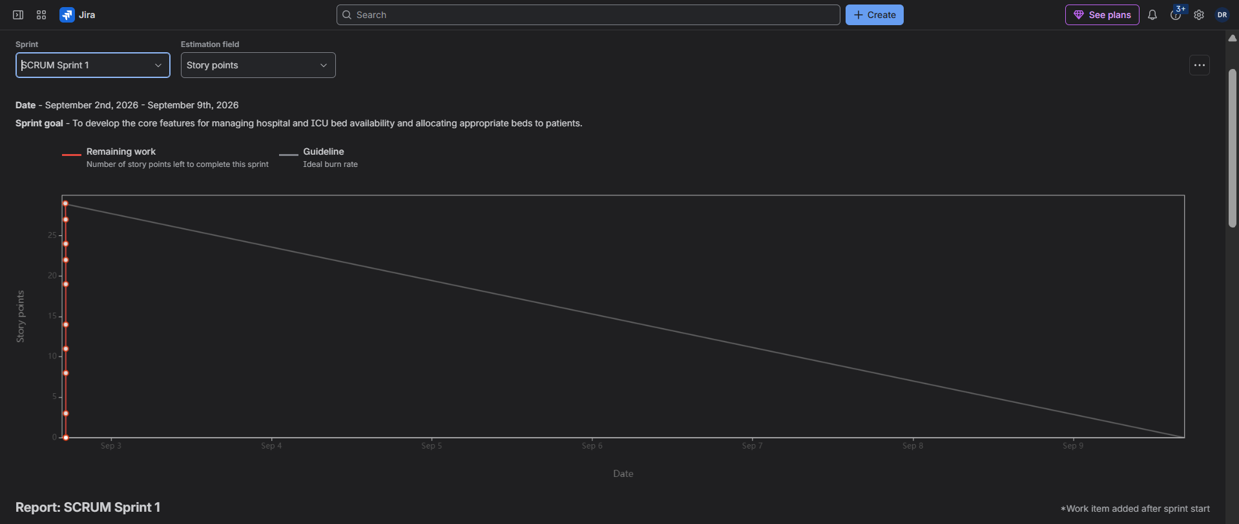

Reflection Questions:
- Did your estimations reflect the actual effort?
Yes, the story point estimations reasonably reflected the relative effort required for each User Story. Simple tasks, such as viewing available beds, were given lower story points because they were less complex. More complex tasks, such as allocating a hospital or ICU bed to a patient, were given higher story points because they involved more processing and decision-making. Since the sprint was simulated, the estimations were mainly used to represent the expected relative effort.

- Was your backlog well-prioritized?
Yes, the backlog was well-prioritized. The core features, such as viewing available hospital and ICU beds, updating bed status, and allocating beds to patients, were given High priority because they are essential for the main functionality of the system. Supporting features, such as viewing occupancy and allocation details, were given Medium priority. This helped ensure that the most important functionality was completed first.

- How did your simulated sprint align with your plan?
The simulated sprint aligned well with the original plan. All nine User Stories were included in Sprint 1 and were gradually moved from To Do to In Progress and finally to Done. This followed the planned workflow and demonstrated how work progresses during a sprint. The sprint goal was also achieved because the simulated work covered hospital bed management, ICU bed management, and patient bed allocation.

- What insights did the burndown chart give about your team's capacity?
The burndown chart showed how the remaining work decreased as User Stories were completed during the sprint. It helped demonstrate the team's capacity by showing whether the planned Story Points could be completed within the sprint period. Since the tasks were completed gradually in the simulation, the chart showed a general reduction in remaining work. This indicates that the planned workload was manageable for the sprint capacity.

