**PETPALS, PYTHON CODING CHALLENGE-**

**P221 RUSHMITHA SREEJA KALUVAKOLANU (OUTPUTS)**

**PetAdoptionDB**

select * from Donations;

select * from Pets;

select * from AdoptionEvents;

OUTPUT:

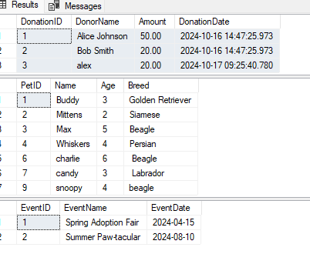

**OUTPUT from Python Terminal:**

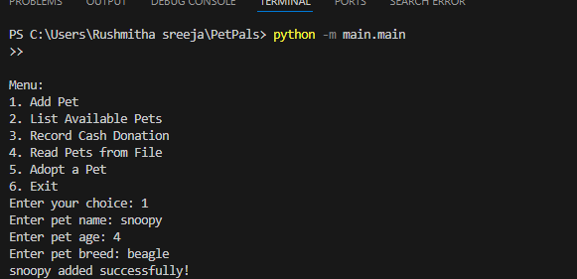

**Output2:**

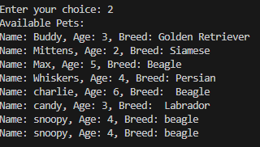

**Output3,4:**

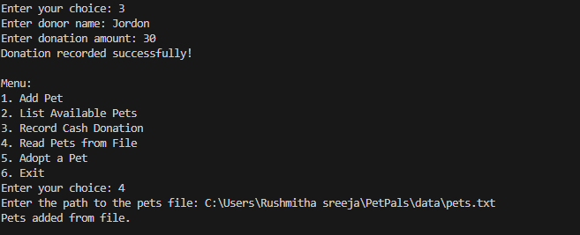

**Output5,6:**

