**ELBRITS**

**Performance Analysis Reports for Zonal Senior Manager (ZSM)**

1. **Revenue / Visits Count Report:**

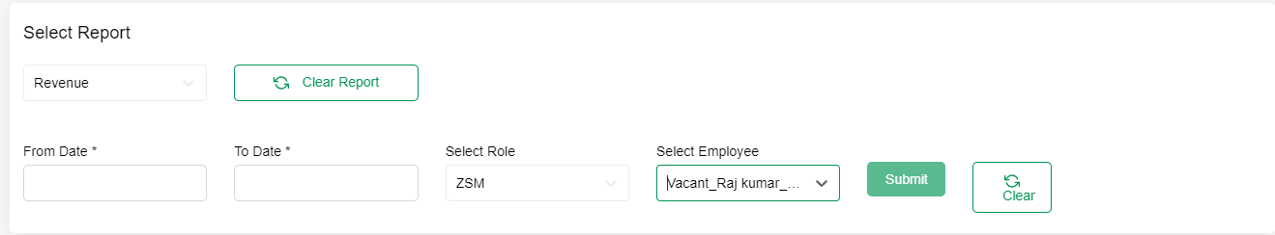

|  |  |  |  |
| --- | --- | --- | --- |
| **Filter** | **Drop Down Values** | **Details** | **Grid Result** |
| Select Report (*Required) | Revenue, Count |  |  |
| From Date  (*Required) |  | If From Date only selected and To date is Null then the Results should for the particular date only based on following selected parameters | Zone Name |
| To Date |  | To Date should not be less the From Date | Employee Name |
| Roles: Drop Down  (*Required) | ALL ADMIN,SM,ZSM, RBM,ABM, BE | By Default, ALL should be selected | Doctor Name |
| Employee Drop Down | All, Employee Names should to loaded according Roles Selection. If all selected then results for the whole zone should be displayed. | By Default, ALL should be selected | Visit Count |
| Search | Should find any value in the Grid |  | Amount |

1. **Name:** GetValuesForReportType

**Summary:**

This will be called when user open the report page it will get Report Type Master Data for Filter Drop down Values.

**URL:**

**Inputs: N/A**

**Output:**

Report Type ID and Report Type Name

**Stored Procedure**:

SP_GetValuesForReportType

1. **Name:** GetRoles

**Summary:**

This will be called when user open the report page it will get Role Master Data for Filter Drop down Values.

**URL:**

**Inputs:**

User ID(GUID)

**Output:**

Role Name and Role ID

**Stored Procedure**:

SP_GetRoles

1. **Name:** GetEployeeValuesForReportFilters

**Summary:**

This will be called when user open the report page it will get Employee Data for Filter Drop down Values.

**URL:**

**Inputs:**

User ID(GUID)

**Output:**

Name, User ID, Employee Code

**Stored Procedure**:

SP_GetEployeeValuesForReportFilters

1. **Name:** GetReportFilteredData

**Summary:**

This will be called when user selected the filters value and click Get Report Button

**URL:**

**Inputs:**

Report Type(Revnue/Visit)

From Date(dd-mm-yyyy)

To Date(dd-mm-yyyy)

User ID(GUID)

**Output:**

Division, Doctor Code, Doctor Name, Employe Name, Total Revenue/Visit Date.

**Stored Procedure**:

SP_GetReportFilteredData