**ELBRITS**

**Performance Analysis for a Month of July -2022**

**Sample Graphs for Month wise using given excel sheets.**

1. MSL_Complete_637957673176059402
2. MSL_Detail_637957673663986859
3. **Customer (Doctor) vs Revenue (By Employee)**

**Ex: Varun.R(E00514)**

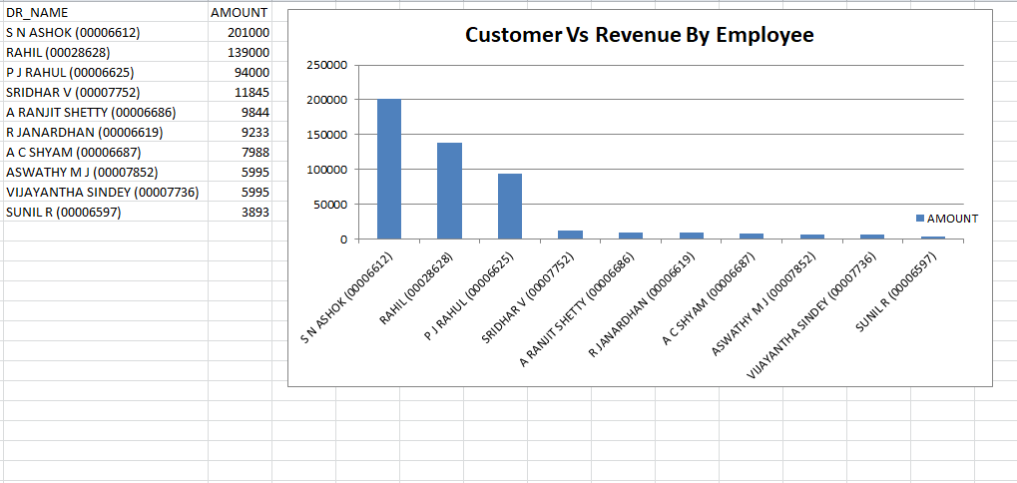

1. **Customer (Doctor) vs Visit Count (By Employee)**

**Ex: Guruprasad NS (E00162)**

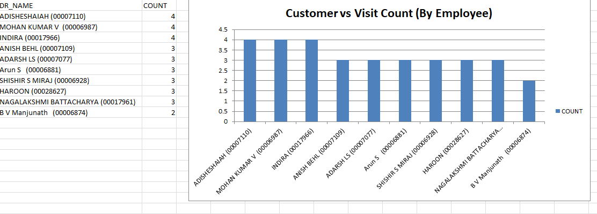

1. **Employee Revenue – Top 10**

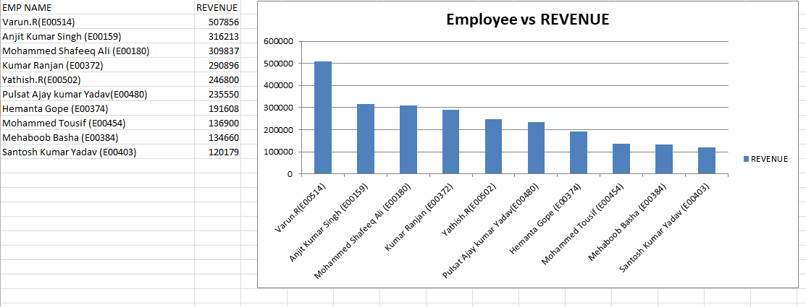

1. **Employee Visits – Top 10**

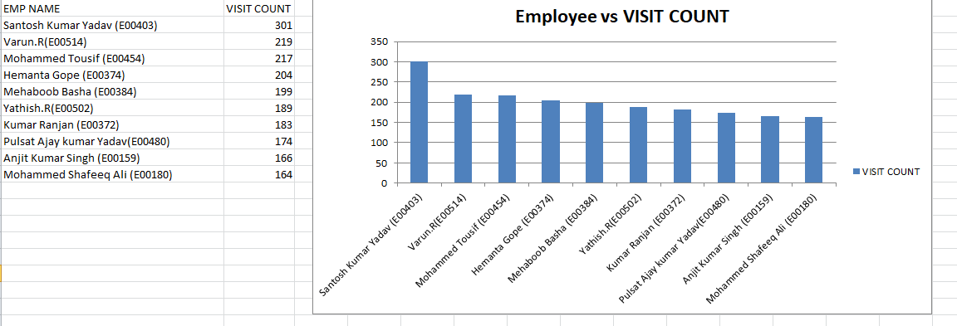

1. **Customer (Doctor) Revenue – Top 10**

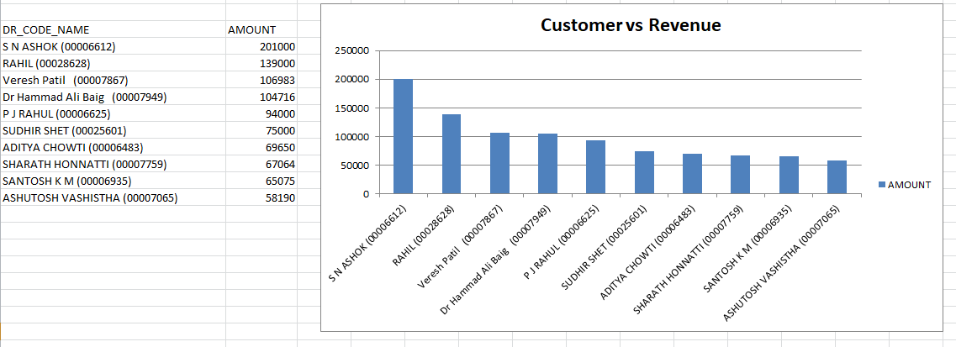

1. **ABM Revenue**

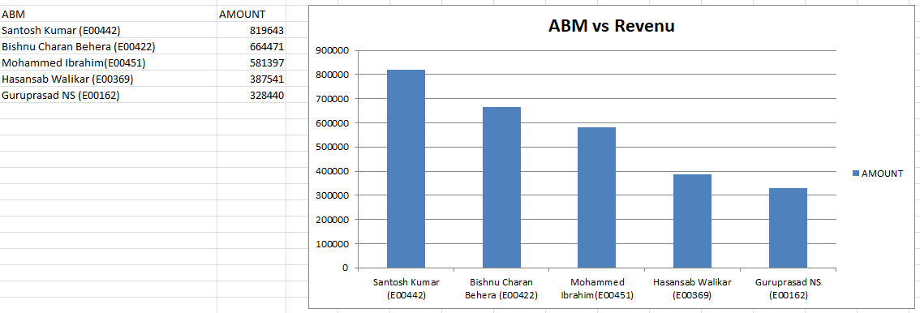

1. **ABM BE’s Visits**

