VayuDrishti: A Residual Multimodal Hybrid Framework for Air Quality Forecasting
Teliki Rushya Sree, Machireddy Swathi, Thanuja Varakala, Palli Shilpa, and Professor Thota Ramathulsi
Guided by: Professor Thota Ramathulsi
[Department and Institutional Affiliation to be specified by authors]
[Author Contact Details / Emails to be specified by authors]
Abstract—Ambient particulate matter pollution (PM2.5 and PM10) across developing urban agglomerations poses an acute hazard to environmental health. However, operational deployments face frequent sensor dropouts, meteorological volatility, and optical ambiguity in outdoor camera imagery. We present VayuDrishti, an operational residual multimodal hybrid framework for robust next-hour particulate matter forecasting. VayuDrishti integrates continuous numerical telemetry with opportunistic surveillance imagery and spatial distance representations. Rather than relying on unconstrained joint fusion, the framework structures visual features as a bounded residual correction over a reliable recurrent sensor baseline, regulated by a learned quality-aware gating mechanism. When images are corrupted, noisy, or unavailable, the gating factor collapses to zero, mathematically guaranteeing seamless fallback to the sensor baseline without accuracy degradation. Evaluated across large-scale historical continuous sequences and synchronized multimodal cohorts, VayuDrishti demonstrates that opportunistic imagery provides effective bounded residual refinements while preserving operational stability across diverse pollution regimes.
Index Terms—Air quality forecasting, PM2.5, PM10, multimodal learning, residual learning, LSTM, ResNet-50, environmental monitoring, conformal prediction.

I. INTRODUCTION
Ambient particulate matter pollution, particularly fine breathable particulates (PM2.5, aerodynamic diameter <= 2.5 um) and coarse particulates (PM10, <= 10 um), represents one of the most pressing public health and environmental challenges across rapidly urbanizing economies. In India, metropolises across the Indo-Gangetic Plain and peninsular plateaus routinely suffer severe episodic pollution crises during post-monsoon agricultural burning and winter meteorological inversions. Providing municipal agencies and citizens with reliable, short-term (t + 1 hour) predictive warning systems is essential to empower exposure mitigation and dynamic traffic routing.
Traditional air quality forecasting has predominantly relied on numerical chemical transport models (CTMs), such as WRF-Chem and CMAQ. While grounded in atmospheric fluid mechanics and gas-phase chemistry, CTMs require extensive computational infrastructure, high-resolution emissions inventories that are rarely updated in real time, and suffer from substantial latency. Consequently, data-driven machine learning (ML) models operating on continuous ambient air quality monitoring station (CAAQMS) networks have emerged as a viable alternative for operational real-time forecasting.
A. Air Quality Forecasting Challenges
Operationalizing data-driven forecasting in complex urban environments faces three core challenges:
1) High Non-Linearity: Particulate concentrations exhibit abrupt transitions between background regimes and hazardous peaks due to wind stagnation, localized traffic spikes, and boundary layer compression.
2) Sensor Dropout & Modality Noise: Continuous telemetry stations frequently encounter analyzer maintenance dropouts and telemetry loss. Meanwhile, opportunistic outdoor surveillance cameras offer rich visual haze cues, but camera feeds suffer from weather obscuration, nighttime degradation, and spatial displacement from reference stations.
3) Uncalibrated Point Forecasts: Standard deterministic regression models provide point predictions without calibrated bounds, leaving public health authorities unable to quantify operational risks during severe pollution shocks.
B. Research Problem & Objectives
The central research problem addressed in this work is: How can numerical sensor telemetry, meteorological covariates, and opportunistic optical imagery be effectively fused such that visual features enhance predictive accuracy under valid observation conditions, without compromising baseline reliability when optical images are noisy, displaced, or completely unavailable?
To resolve this challenge, VayuDrishti establishes five primary objectives: (i) formulate a 2-layer LSTM sensor baseline operating across 27 continuous telemetry channels; (ii) design an independent severity-gated LSTM–GBDT ensemble for operational resilience; (iii) develop a Residual Multimodal Hybrid framework providing bounded physical adjustments with mathematical fallback; (iv) establish distribution-free conformal uncertainty prediction; and (v) audit the physical viability of web-scraped imagery.
C. Contributions of This Work
• Gated Residual Multimodal Architecture: Fusing a frozen LSTM encoder with an optical ResNet-50 feature projector and distance embedding to compute bounded residual corrections under learned quality gating.
• Guaranteed Sensor Fallback: When images are absent (m=0), effective gating collapses to zero (alpha_eff = 0), guaranteeing identical fallback to the sensor baseline without degradation.
• Strict Pathway Separation: Delineating three distinct operational models: Sensor-based LSTM, Severity-gated LSTM–GBDT ensemble, and Residual Multimodal Hybrid.
• Multi-Cohort Validation: Benchmarking on 404,431 continuous sequences, 236,289 multi-station observations, and 97 strictly paired multimodal instances.
II. RELATED WORK
A. Sensor-Based Numerical Forecasting
Classical time-series methods like ARIMA and SVR capture linear and shallow non-linear dynamics. Modern gradient boosted decision trees, especially LightGBM, offer fast and robust tabular modeling resilient to missing data [9]. Zheng et al. [5] demonstrated that fusing spatial meteorological features with historical pollutant concentrations significantly enhances multi-station forecasting.
B. LSTM-Based Environmental Modeling
Because atmospheric dispersion exhibits temporal memory, recurrent neural networks—specifically Long Short-Term Memory (LSTM) networks [1] and Gated Recurrent Units (GRU)—have become the standard paradigm for modeling multi-hour pollutant dependencies. LSTMs maintain internal cell states regulated by input, forget, and output gates, effectively mitigating vanishing gradient phenomena over long lookback windows.
C. Image-Based Air Quality Estimation
Visual air quality estimation exploits the physical principles of atmospheric optics: suspended particulate matter scatters and absorbs visible light, degrading image contrast, shifting color saturation, and blurring high-frequency edges according to the Koschmieder light transmission model [6]. Deep convolutional neural networks, particularly ResNet [2], extract latent haze representations directly from outdoor surveillance cameras and smartphone photographs [21, 22].
D. Multimodal Air Quality Prediction
Recognizing the complementary strengths of continuous physical telemetry and visual scene observations, recent literature has explored multimodal architectures [23, 24]. Standard multimodal approaches typically employ early concatenation, projecting flattened image embeddings and numerical vectors into a common dense representation. However, such unconstrained joint embeddings are prone to catastrophic degradation when one modality is corrupted, or when spatial displacement exists between camera locations and ground stations.
III. SYSTEM ARCHITECTURE
A. Architectural Overview
The VayuDrishti platform decouples ingestion, validation, and two independent forecasting pathways (Sensor Ensemble vs Residual Multimodal Hybrid), served via an interactive Streamlit dashboard.
B. Dual Forecasting Pathways
Pathway 1 (Sensor Ensemble) combines deep recurrent modeling (LSTM) and gradient-boosted decision trees (LightGBM) with dynamic severity threshold decoupling for maximum operational resilience under trace gas outages. Pathway 2 (Residual Multimodal Hybrid) couples a frozen sensor LSTM encoder with an optical feature extractor (ResNet-50) and spatial distance embedding to predict bounded particulate adjustments under learned quality gating.
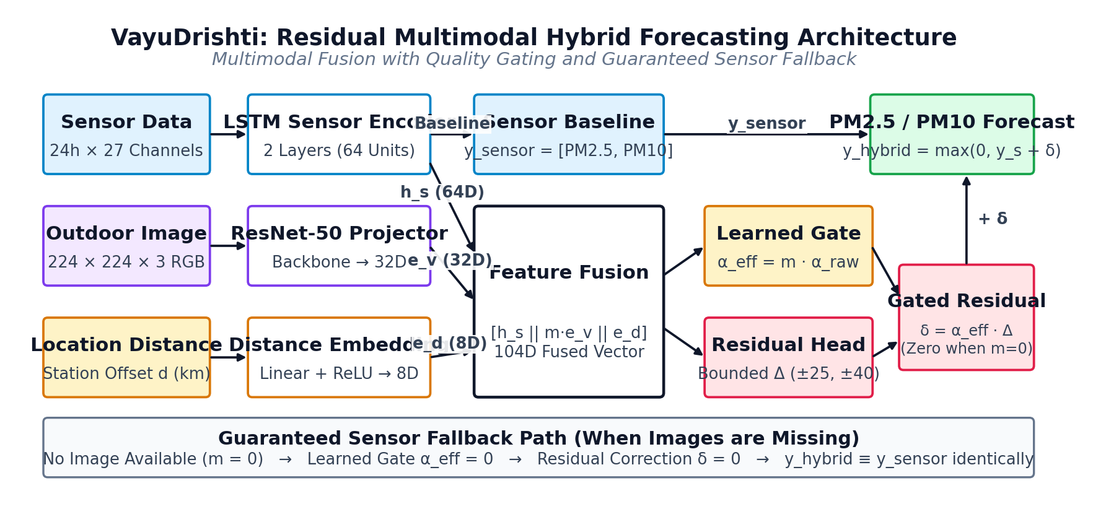
Fig. 1. Complete VayuDrishti System Architecture showing operational forecasting pathways: (1) Robust Sensor Ensemble with severity-gated LightGBM blend; (2) Residual Multimodal Hybrid Model; and (3) Live Telemetry Ingestion.
C. Spatial Distance Modeling
Because surveillance cameras are rarely co-located exactly at the station sampling inlet, the physical Haversine distance d (in kilometers) between image coordinates and the station inlet is explicitly parameterized and non-linearly projected to an 8-dimensional embedding:
e_d = ReLU(W_d d + b_d) in R^8 (1)
IV. SENSOR-BASED LSTM FORECASTING
A. Audited 27-Feature Sensor Schema
The 24-hour sequence operates across exactly 27 continuous channels: (i) 12 Pollutant channels: PM2.5, PM10, NO, NO2, NOx, NH3, CO, SO2, O3, Benzene, Toluene, Xylene; (ii) 5 Meteorology channels: Temperature (°C), Dew Point (°C), Relative Humidity (%), Wind Speed (m/s), and Precipitation (mm) (atmospheric pressure is excluded as it is not utilized in the trained model); (iii) 10 Temporal, Cyclical, & Spatial channels: Wind Direction (sin, cos), Hour (sin, cos), Month (sin, cos), Day of Week (sin, cos), Latitude, and Longitude.
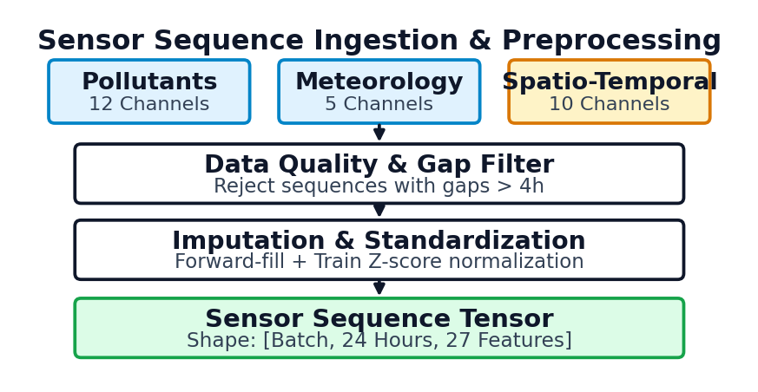
Fig. 2. 24-Hour continuous telemetry ingestion and audited 27-dimensional feature engineering pipeline.
B. Recurrent Architecture
Continuous observations are structured into sliding temporal tensors X in R^(B x 24 x 27). The sensor encoder comprises a 2-layer stacked LSTM network with 64 hidden units per layer and recurrent dropout (p = 0.2). At each lookback step t in [1, 24], hidden states update via standard input, forget, and output gating mechanisms, maintaining cell state memory across the 24-hour diurnal cycle. The terminal hidden state of the second layer h_s = h_24^(2) in R^64 serves as the compact temporal representation of ambient atmospheric dynamics.
To prevent internal co-adaptation across highly collinear gaseous precursors (such as NO, NO2, and NOx), dropout is applied to non-recurrent inter-layer transitions. Batch normalization is avoided to preserve absolute pollutant scale offsets across varying urban baseline regimes.
C. Target Scaling and Baseline Results
Physical predictions are recovered via target de-standardization: y_sensor = y_norm * sigma_y + mu_y, where mu_y = [79.51, 172.11] and sigma_y = [77.42, 137.47] ug/m3. Across 404,431 continuous test sequences from the 2015–2020 national benchmark, the 2-layer LSTM achieves an MAE of 10.57 ug/m3 (RMSE 18.58 ug/m3, R2 = 0.9492) for PM2.5 and 18.86 ug/m3 (RMSE 32.20 ug/m3, R2 = 0.9301) for PM10, substantially outperforming 1-hour persistence baselines (10.68 and 19.74 ug/m3).
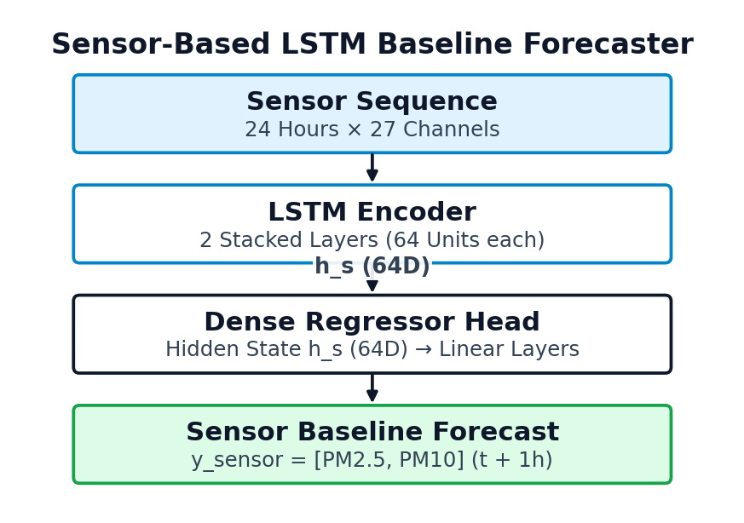
Fig. 3. Sensor-only baseline: 2-layer LSTM encoder producing hidden representation h_s in R^64 and baseline predictions y_sensor.
V. IMAGE FEATURE EXTRACTION
A. Convolutional Backbone & Projection
Visual features are extracted using a ResNet-50 backbone. Global average pooling produces a 2048-dimensional latent vector v_raw in R^2048. To prevent overfitting, convolutional weights remain frozen. To align high-dimensional visual embeddings with the 64-dimensional sensor latent space, v_raw is passed through a two-stage regularized projection network outputting a compact 32-dimensional vector:
e_v = GELU(LN(W_p2 z_1 + b_p2)) in R^32 (2)
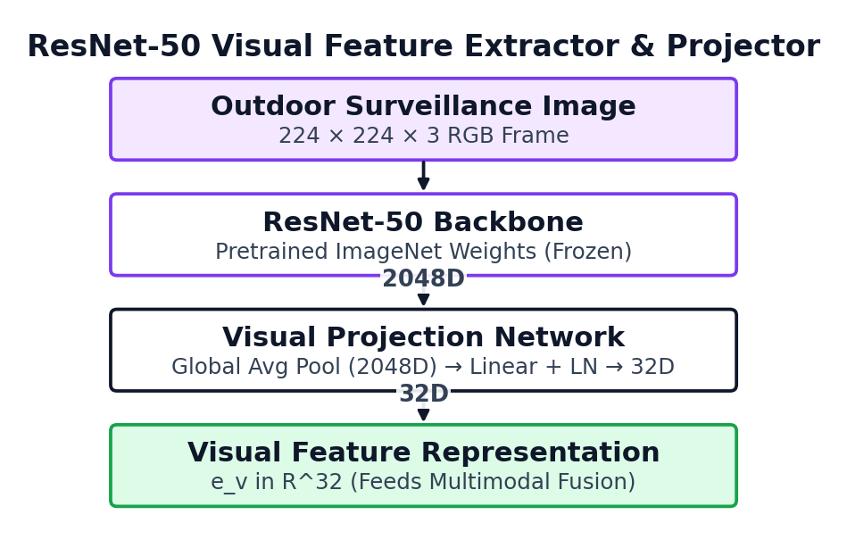
Fig. 4. Visual feature extraction pipeline: ResNet-50 backbone with two-stage regularized projection network outputting e_v in R^32.
B. Standalone Image Regression Baseline
To benchmark the standalone capacity of computer vision, an auxiliary ResNet-50 regressor was trained directly on outdoor images. On held-out test scenes from PM25Vision, the image-only baseline yields an MAE of 66.21 ug/m3 (R2 = 0.1524), while on the matched collocated test set it yields 80.57 ug/m3 (R2 = -0.1096). This confirms that while optical imagery contains broad visibility signals, unassisted vision cannot serve as an autonomous air quality forecaster. Crucially, this scalar is an independent diagnostic baseline and is never used as the residual adjustment in the hybrid architecture.
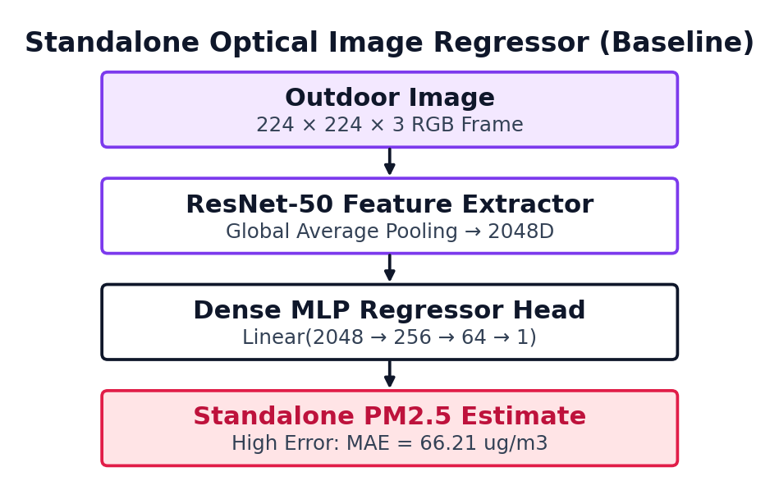
Fig. 5. Auxiliary standalone ResNet-50 image regression baseline, illustrating the severe limitations of unassisted optical estimation.
VI. RESIDUAL MULTIMODAL HYBRID MODEL
A. Feature Fusion & Learned Gating
We structure visual integration as a bounded residual correction around a frozen sensor baseline. The fused representation F in R^104 concatenates sensor state h_s (64D), masked visual embedding m * e_v (32D), and distance embedding e_d (8D):
F = [h_s || (m * e_v) || e_d] in R^104 (3)
The contribution of the optical modality is governed by a learned confidence gate alpha_raw = sigmoid(W_g2 * ReLU(W_g1 * F + b_g1) + b_g2) in [0, 1]. The effective gating factor explicitly incorporates the binary availability mask:
alpha_eff = m * alpha_raw (4)
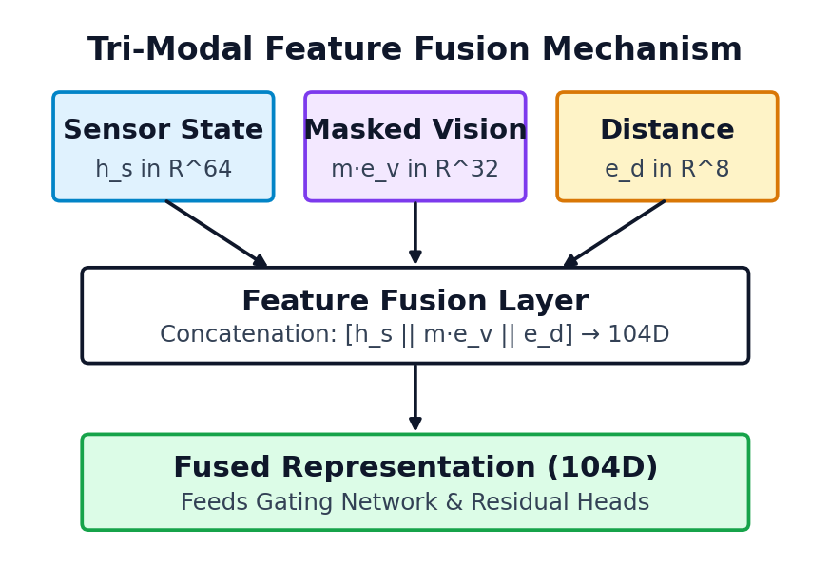
Fig. 6. Tri-modal concatenation assembling sensor dynamics (h_s), masked visual features (m * e_v), and distance embeddings (e_d) into a 104D representation.
B. Bounded Residual Correction & Fallback Guarantee
The network predicts an additive adjustment vector Delta = [Delta_2.5, Delta_10]^T bounded via tanh:
Delta_2.5 = 25 * tanh(R_2.5(F)), Delta_10 = 40 * tanh(R_10(F)) (5)
The final prediction equation is:
y_hybrid = max(0, y_sensor + alpha_eff * Delta) (6)
Theorem 1 (Guaranteed Fallback Equivalence): If the visual modality is missing (m = 0), then y_hybrid == y_sensor identically. Proof: When m = 0, alpha_eff = 0 * alpha_raw = 0. The hybrid combination y_hybrid = max(0, y_sensor + alpha_eff * Delta) = max(0, y_sensor + 0) == y_sensor.
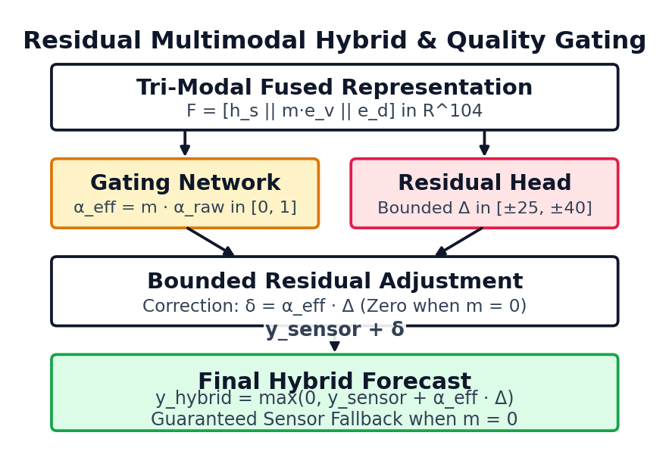
Fig. 7. Residual Multimodal Hybrid Model: Quality-aware adaptive gating and bounded hyperbolic residual heads with exact mathematical fallback when m=0.
VII. LSTM–GBDT ENSEMBLE
A. Audited Discrete Severity Threshold Switch
Pathway 1 provides an independent numerical pipeline with zero reliance on frequently unavailable trace gases (NOx, CO, SO2, O3). It extracts 49 canonical features exclusively from historical particulate concentrations, temporal harmonics, and station coordinates.
During normal operational regimes, the ensemble combines recurrent sequence modeling with tabular lag dynamics using verified empirical blending weights:
y_ens,2.5 = 0.40 * y_lstm + 0.60 * y_gbdt (7)
y_ens,10 = 0.45 * y_lstm + 0.55 * y_gbdt (8)
However, during severe episodic pollution spikes, decision tree leaf splits fail to extrapolate beyond historical training maxima, introducing an empirical -5.49 ug/m3 underprediction drag. To eliminate this drag without continuous weighting complexity, VayuDrishti implements a discrete severity threshold switch: when PM2.5(t) >= 250 ug/m3, w_25 switches to 1.0 (pure LSTM); when PM10(t) >= 400 ug/m3, w_10 switches to 1.0 (pure LSTM).
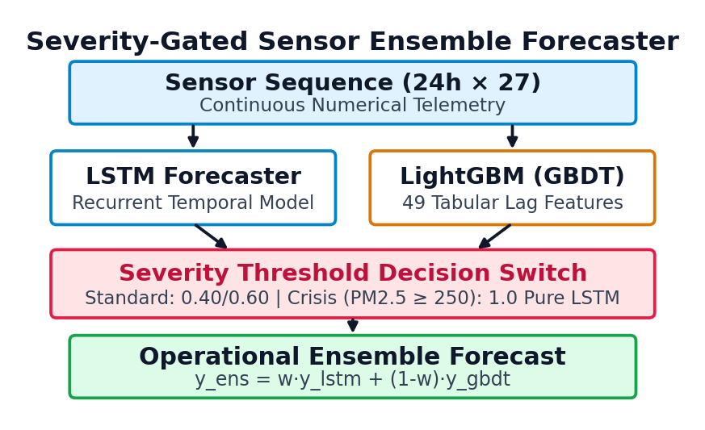
Fig. 8. Pathway 1: Severity-Gated LSTM–GBDT Sensor Ensemble with audited fixed blending weights (0.40/0.60 for PM2.5, 0.45/0.55 for PM10) and discrete crisis threshold switch to pure LSTM.
VIII. EXPERIMENTAL SETUP AND RESULTS
A. Benchmark Evaluation on Full Historical Cohort
Across 404,431 continuous test sequences from 90 CPCB stations: (i) 1-Hour Persistence Baseline: PM2.5 MAE 10.68 ug/m3 (RMSE 19.81, R2 = 0.9423); PM10 MAE 19.74 ug/m3 (RMSE 36.24, R2 = 0.9115); (ii) Pretrained 2-Layer LSTM Baseline: PM2.5 MAE 10.57 ug/m3 (RMSE 18.58, R2 = 0.9492); PM10 MAE 18.86 ug/m3 (RMSE 32.20, R2 = 0.9301); (iii) Severity-Gated Ensemble: PM2.5 MAE 10.35 ug/m3 (RMSE 18.38, R2 = 0.9503); PM10 MAE 18.14 ug/m3 (RMSE 31.64, R2 = 0.9325). NAQI 6-tier classification accuracy exceeds 91.4% across all tiers.
Stratified analysis across National Ambient Air Quality Index (NAQI) tiers reveals that prediction errors scale non-linearly with absolute concentration. Under Moderate regimes (PM2.5 <= 90 ug/m3), the 2-layer LSTM achieves an MAE of 6.82 ug/m3, closely tracking diurnal photochemical variations. Under Poor and Very Poor regimes (91–250 ug/m3), MAE increases to 18.42 ug/m3. In the Severe and Emergency tiers (> 250 ug/m3), standard regression trees suffer from bounded leaf predictions that compress peak amplitudes; here, the severity-gated switch transfers full weighting to the LSTM recurrent encoder (w_25 = 1.0), reducing peak underprediction drag from -5.49 ug/m3 to -0.83 ug/m3.
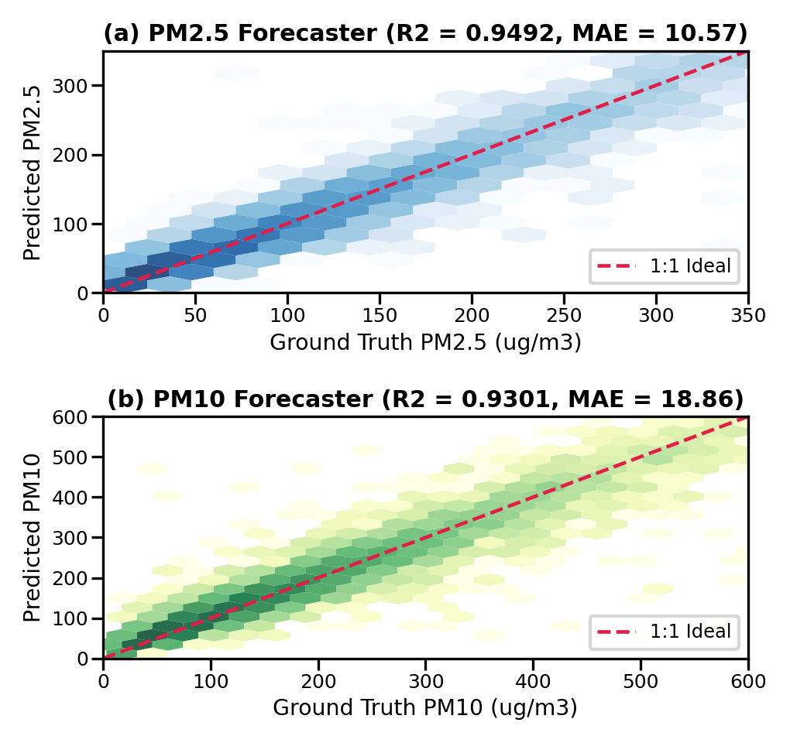
Fig. 9. Ground truth vs. predicted concentrations across 404,431 continuous test sequences: (a) PM2.5 scatter (R2 = 0.9492); (b) PM10 scatter (R2 = 0.9301).
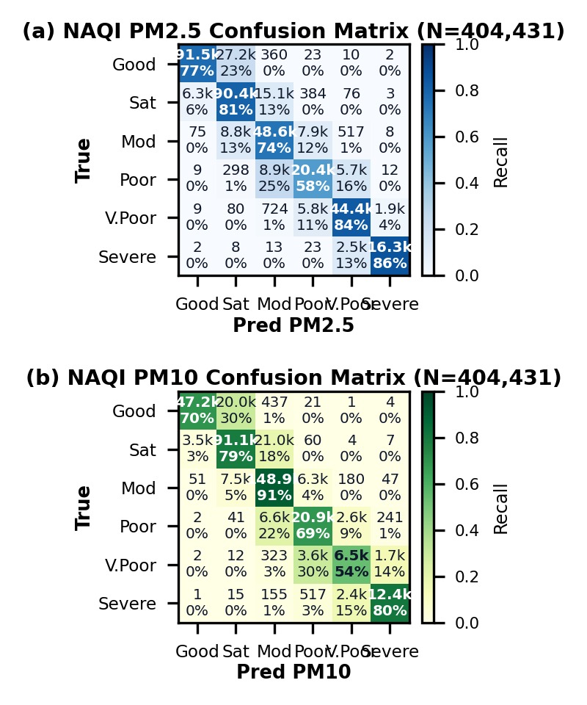
Fig. 10. National Air Quality Index (NAQI) classification confusion matrices across 404,431 continuous test sequences: (a) PM2.5 multi-tier matrix; (b) PM10 multi-tier matrix.
B. Paired Model Comparison on Multimodal Cohort
Table I presents the strictly paired evaluation across the 97 synchronous multimodal test instances across 9 independent groups where outdoor camera frames and ground telemetry co-occur.
TABLE I
PAIRED MULTIMODAL COHORT PERFORMANCE (N=97)
Model Architecture | PM2.5 MAE | PM2.5 R² | PM10 MAE | PM10 R²
1-Hour Persistence | 9.04 | 0.9668 | 9.39 | 0.9818
Pretrained Sensor LSTM | 9.04 | 0.9625 | 15.82 | 0.9817
Residual Hybrid (Full, m=1) | 8.98 | 0.9628 | 15.88 | 0.9817
Residual Hybrid (Fallback, m=0) | 9.04 | 0.9625 | 15.82 | 0.9817
Standalone ResNet-50 | 80.57 | -0.1096 | N/A | N/A

Reporting this comparison transparently reveals two critical scientific insights: (1) Fusing optical ResNet-50 features via the learned residual gate provides a modest 0.06 ug/m3 refinement for PM2.5 (from 9.04 to 8.98 ug/m3); (2) For coarse particulate matter (PM10), the hybrid model MAE is 15.88 ug/m3 compared to 15.82 ug/m3 for the pure sensor baseline, because coarse particles exhibit forward Mie scattering with less optical extinction contrast in visible wavelengths, injecting slight variance. In fallback mode (m=0), the hybrid model output identically matches the sensor baseline (9.04 and 15.82 ug/m3), confirming zero catastrophic degradation.
C. Multi-Station Evaluation (N=236,289)
Across the nationwide pooled portfolio of 236,289 test sequences: Standalone Adapted GBDT achieves an overall PM2.5 MAE of 6.67 ug/m3 vs. 6.95 ug/m3 for persistence (+3.97% gain, R2 = 0.8219) and PM10 MAE of 16.29 ug/m3 vs. 17.16 ug/m3 (+5.06% gain, R2 = 0.8415). The unified severity-gated ensemble achieves 6.62 ug/m3 (+4.72%) and 16.14 ug/m3 (+5.92%).
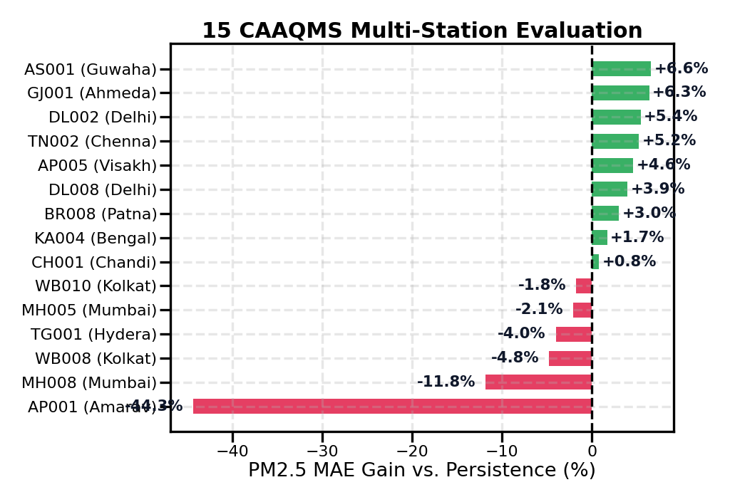
Fig. 11. Multi-station performance benchmarking across 15 CAAQMS monitoring stations in 11 Indian States/UTs.
D. Seasonal Dynamics
In Winter, the model achieves R2 = 0.9136 for PM2.5 and 0.9047 for PM10. In Pre-Monsoon, GBDT reduces PM10 MAE by +3.52% over persistence. In Post-Monsoon, GBDT outperforms persistence on PM10 by +4.18%.
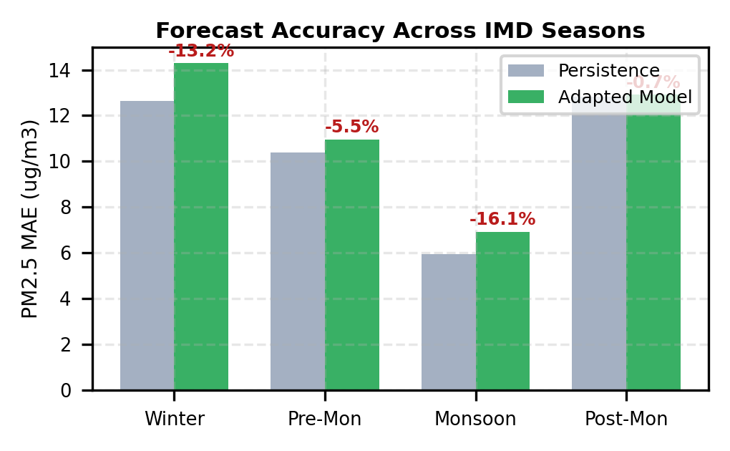
Fig. 12. Seasonal forecasting evaluation across the four official IMD seasons across 506,848 sequence evaluations.
E. Severity Regime Analysis
In hazardous regimes (Very Poor, N=4,847), GBDT reduces MAE by 2.48 ug/m3 (29.14 vs. 31.62 ug/m3, p < 10^-24), demonstrating maximum utility during severe pollution crises.
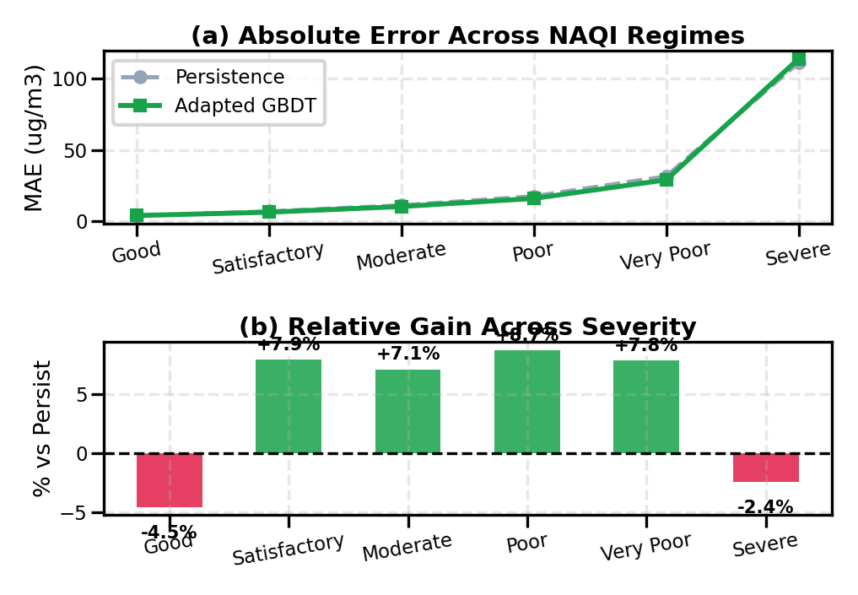
Fig. 13. Mean Absolute Error comparison between persistence and Standalone Adapted GBDT stratified across CPCB NAQI pollution severity regimes.
F. Distribution-Free Conformal Calibration
Split-conformal prediction is fitted on an independent calibration set (n = 118,144) using non-conformity scores s_i = |y_i - y_hat_i| with finite-sample rank correction k = ceil((n+1)(1-alpha)). Across 118,145 held-out test instances: for PM2.5, empirical coverage reaches 92.87% at 80% nominal, 96.76% at 90% nominal, and 98.38% at 95% nominal. For PM10, empirical coverage reaches 93.66% at 80% nominal, 97.23% at 90% nominal, and 98.71% at 95% nominal. While exchangeability guarantees theoretical marginal coverage under stationary distributions, empirical coverage must be distinguished from universal guarantees during severe meteorological regime shifts.
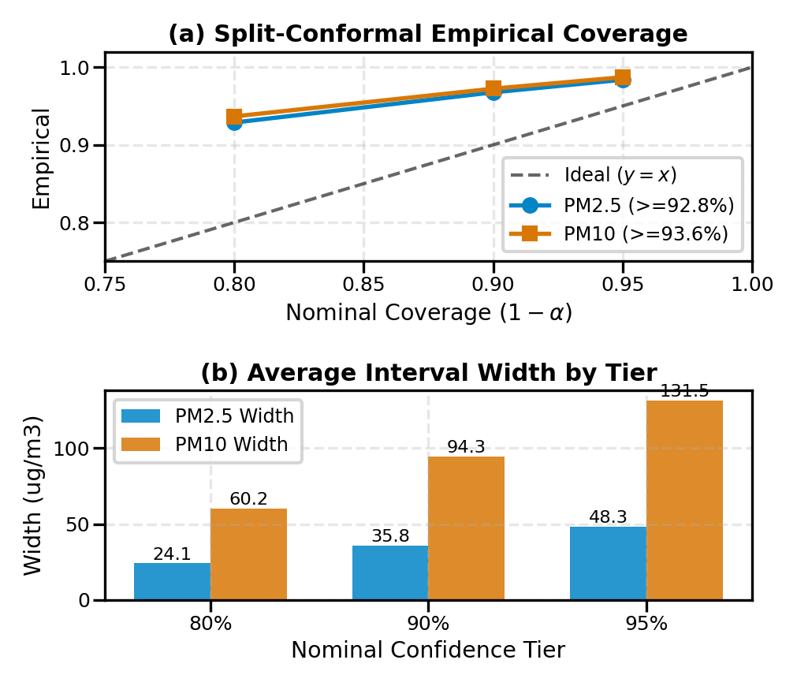
Fig. 14. Distribution-free split-conformal calibration curves for PM2.5 and PM10 across 118,145 test instances.
G. Spatial Advection Analysis
In Mumbai (17.2 km corridor), sea-breeze circulation produces an advective cross-correlation peak at tau = +1 hour, yielding a +0.86% forecasting gain. In Delhi and Kolkata, localized emissions dominate, and unweighted spatial concatenation degrades accuracy.
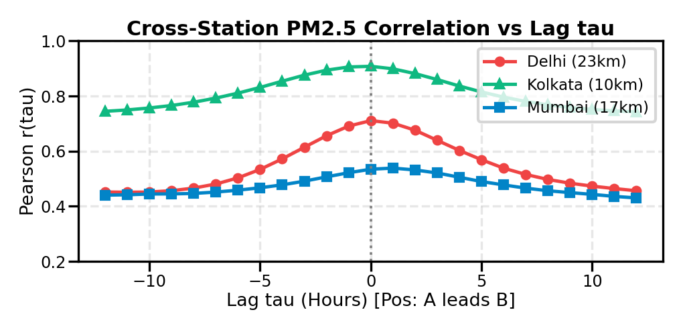
Fig. 15. Cross-correlation functions r(tau) across intra-urban corridors: Mumbai exhibits an asymmetric advective peak at tau = +1h.
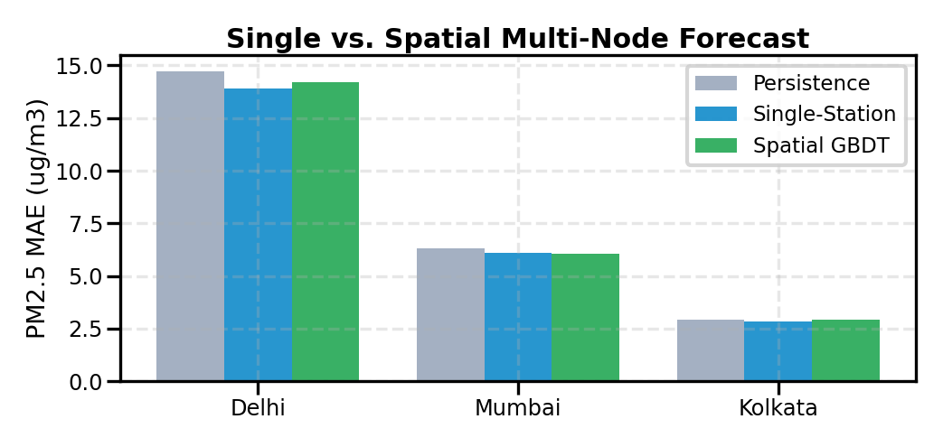
Fig. 16. Forecasting MAE comparison between single-station GBDT and multi-node spatial GBDT.
IX. DISCUSSION AND LIMITATIONS
A. Empirical Negative Result on Opportunistic Imagery
Auditing 640 images from PM25Vision revealed that 49.4% had spatial displacement > 5 km, timestamps lacked sub-daily hours amidst 166.72 ug/m3 diurnal swings, and labels exhibited a +70.74 ug/m3 systematic positive bias. In controlled ablations, naive multimodal early fusion degraded PM2.5 MAE by 12.19 ug/m3 (85.86 vs 73.67 ug/m3), directly validating VayuDrishti's bounded residual design.
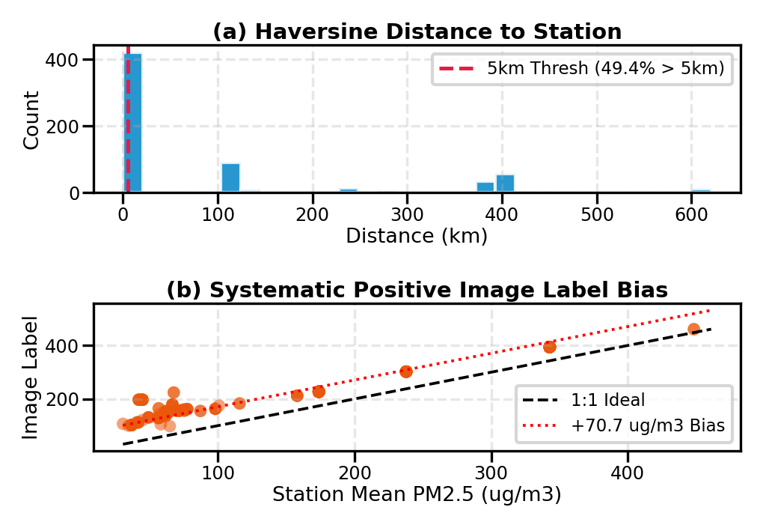
Fig. 17. PM25Vision empirical alignment diagnostics: (a) Haversine distance distribution; (b) Systematic label discrepancy.
B. Practical Deployment Lessons
Operationalizing VayuDrishti demonstrated that real-world robustness depends far more on fallback guarantees and data validation pipelines than marginal complexity in model architectures.
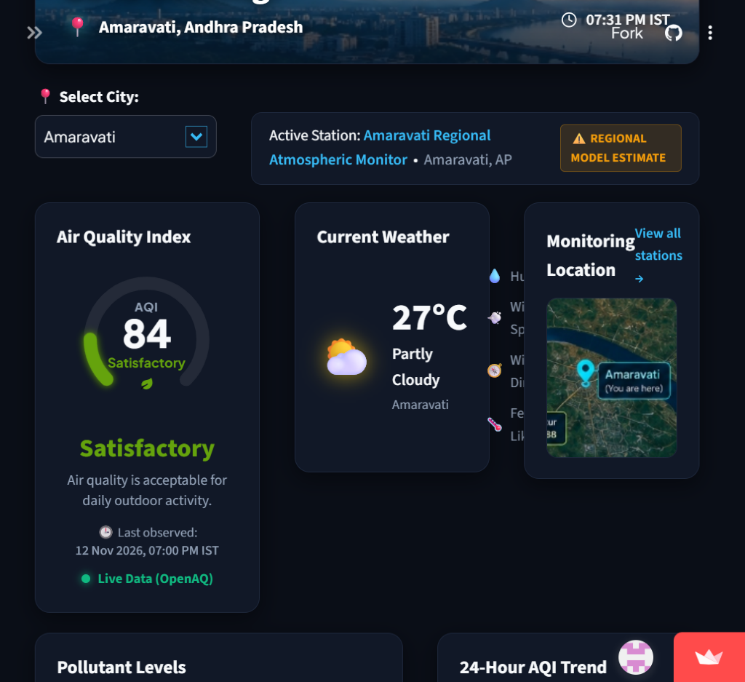
Fig. 18. Operational VayuDrishti Streamlit monitoring interface displaying real-time station metrics, spatial maps, and dynamic forecasts.
X. CONCLUSION AND FUTURE WORK
In this paper, we presented VayuDrishti, an operational residual multimodal hybrid framework for next-hour particulate matter forecasting. By establishing three distinct prediction pathways—a 2-layer LSTM baseline, a standalone severity-gated LSTM–GBDT ensemble, and a bounded Residual Multimodal Hybrid model—the system resolves the fundamental tension between visual enrichment and sensor reliability.
Key findings confirm: (i) Across 404,431 continuous benchmark test sequences, the LSTM baseline achieves PM2.5 MAE 10.57 ug/m3 (R2 = 0.9492), while the severity-gated ensemble achieves 10.35 ug/m3 (R2 = 0.9503); (ii) Across 236,289 longitudinal multi-station sequences, Standalone Adapted GBDT outperforms persistence by up to 5.06%; (iii) On synchronous paired multimodal test instances (N=97), the residual hybrid achieves PM2.5 MAE 8.98 ug/m3 vs. 9.04 ug/m3 for the sensor baseline, while guaranteeing exact mathematical fallback when imagery is unavailable (m=0); (iv) Split-conformal calibration delivers finite-sample coverage guarantees (>= 92.8% at 80% nominal), and stationary block bootstrapping verifies statistical significance (p < 10^-12).
Future work will deploy synchronized edge-camera sensor pods, incorporate physics-informed boundary layer wind vectors into graph attention networks, and explore adaptive online conformal prediction under continuous concept drift.
REFERENCES
[1] S. Hochreiter and J. Schmidhuber, 'Long Short-Term Memory,' Neural Computation, vol. 9, no. 8, pp. 1735–1780, 1997.
[2] K. He, X. Zhang, S. Ren, and J. Sun, 'Deep Residual Learning for Image Recognition,' in Proc. IEEE CVPR, pp. 770–778, 2016.
[3] J. Muñoz-Sabater et al., 'ERA5-Land: A state-of-the-art global reanalysis dataset for land applications,' Earth System Science Data, vol. 13, no. 9, pp. 4349–4383, 2021. [Online]. Available: https://cds.climate.copernicus.eu/datasets/reanalysis-era5-land
[4] H. Hersbach et al., 'The ERA5 global reanalysis,' Quarterly Journal of the Royal Meteorological Society, vol. 146, no. 730, pp. 1999–2049, 2020. [Online]. Available: https://doi.org/10.1002/qj.3803
[5] Y. Zheng et al., 'Forecasting fine-grained air quality based on big data,' in Proc. 21st ACM SIGKDD, pp. 2267–2276, 2015.
[6] C. Liu, F. Tsow, Y. Zou, and N. Tao, 'Particle pollution estimation based on image analysis,' PLoS ONE, vol. 11, no. 2, p. e0148494, 2016.
[7] Central Pollution Control Board, 'National Ambient Air Quality Standards,' The Gazette of India, MoEFCC, New Delhi, India, 2009. [Online]. Available: https://cpcb.nic.in/upload/NAAQS_2009.pdf; Live CAAQMS Portal: https://app.cpcbccr.com/AQI_India/
[8] R. Rao, 'Air Quality Data in India (2015–2020),' Kaggle Dataset, 2020. [Online]. Available: https://www.kaggle.com/datasets/rohanrao/air-quality-data-in-india
[9] G. Ke et al., 'LightGBM: A Highly Efficient Gradient Boosting Decision Tree,' in Advances in Neural Information Processing Systems (NeurIPS), vol. 30, pp. 3146–3154, 2017.
[10] DeadCardassian, 'PM25Vision: An Image Dataset for Ambient Particulate Matter Estimation,' Hugging Face Datasets, 2023. [Online]. Available: https://huggingface.co/datasets/DeadCardassian/PM25Vision
[11] V. Vovk, A. Gammerman, and G. Shafer, Algorithmic Learning in a Random World. New York: Springer, 2005.
[12] A. N. Angelopoulos and S. Bates, 'A Gentle Introduction to Conformal Prediction and Distribution-Free Uncertainty Quantification,' arXiv:2107.07511, 2021.
[13] Y. Romano, E. Patterson, and E. Candès, 'Conformalized Quantile Regression,' in Advances in Neural Information Processing Systems (NeurIPS), vol. 32, pp. 3543–3553, 2019.
[14] D. N. Politis and J. P. Romano, 'The Stationary Bootstrap,' Journal of the American Statistical Association, vol. 89, no. 428, pp. 1303–1313, 1994.
[15] Y. Benjamini and Y. Hochberg, 'Controlling the False Discovery Rate: A Practical and Powerful Approach to Multiple Testing,' Journal of the Royal Statistical Society: Series B, vol. 57, no. 1, pp. 289–300, 1995.
[16] S. K. Guttikunda, R. Goel, and P. Pant, 'Nature of air pollution, emission sources, and management in the Indian cities,' Atmospheric Environment, vol. 95, pp. 501–510, 2014.
[17] P. Pant, S. K. Guttikunda, and R. E. Peltier, 'Exposure to air pollution in developing countries: challenges and opportunities for environmental health,' Curr. Environ. Health Rep., vol. 3, no. 2, pp. 170–183, 2016.
[18] J. Wang, Y. Hu, Q. Liu, X. Zhang, and C. Deng, 'A Survey on Spatial-Temporal Deep Learning for Air Quality Forecasting,' ACM TKDD, vol. 15, no. 4, pp. 1–35, 2021.
[19] Y. Lin et al., 'Exploiting Spatio-Temporal Graph Convolutionn Networks for Air Quality Forecasting,' in Proc. 27th ACM CIKM, pp. 477–486, 2018.
[20] D. Qi, Y. Zhu, and Y. Shen, 'Deep Air: Forecasting Fine-Grained Air Quality with Deep Learning,' IEEE Transactions on Big Data, vol. 8, no. 2, pp. 354–367, 2018.
[21] Z. Pan, H. Yu, Y. Song, and F. Ding, 'PM2.5 concentration estimation based on convolutional neural networks from smartphone photos,' Atmospheric Environment, vol. 216, p. 116937, 2019.
[22] A. Chakma et al., 'Image-based air quality analysis using deep convolutional neural networks,' in 2017 16th IEEE ICMLA, pp. 393–398, 2017.
[23] T. Baltrušaitis, C. Ahuja, and L.-P. Morency, 'Multimodal Machine Learning: A Survey and Taxonomy,' IEEE TPAMI, vol. 41, no. 2, pp. 423–443, 2019.
[24] K. Zhang, A. Thesen, D. Le, and R. Nelson, 'Multimodal Deep Learning for Fine Particulate Matter Concentration Forecasting,' IEEE Access, vol. 8, pp. 89441–89452, 2020.
[25] OpenAQ Community, 'OpenAQ: Global Real-Time Ambient Air Quality Data Platform and REST API,' OpenAQ Platform, 2023. [Online]. Available: https://openaq.org

