SkillNest – Open Course-ware and Technical Skill Development Platform
Prompt for each Member

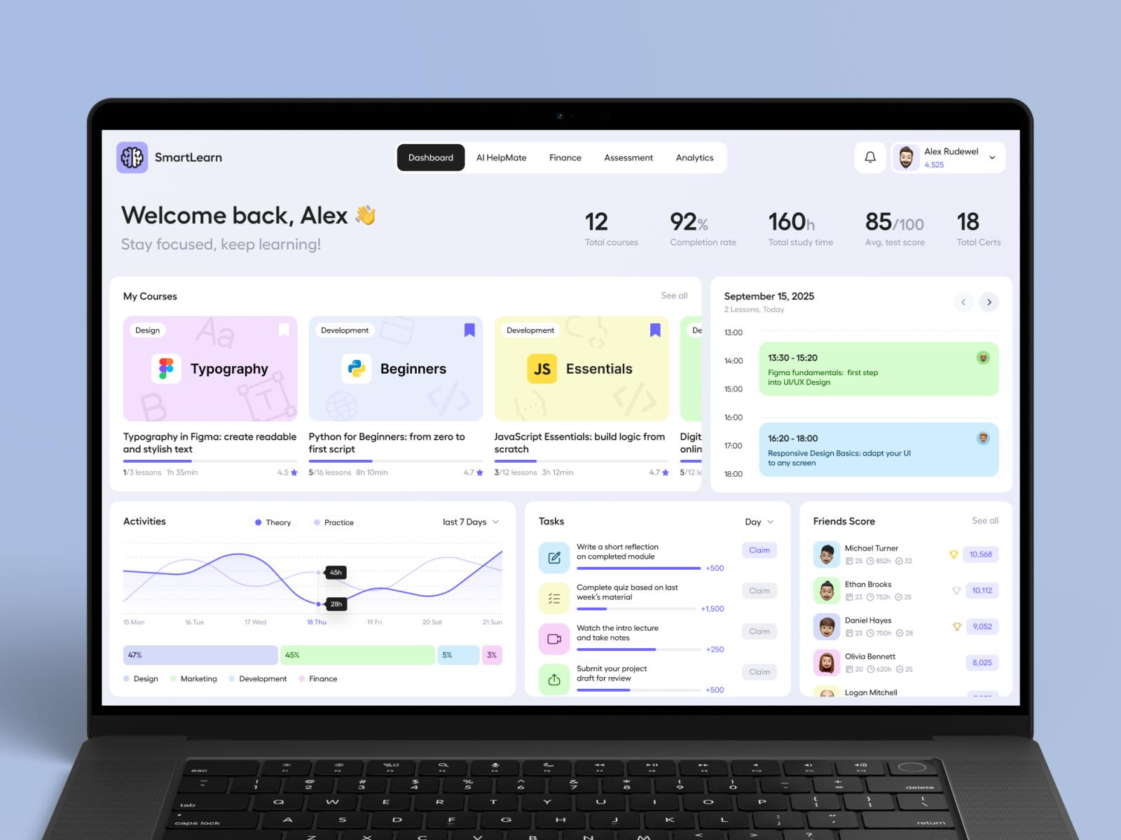
Main Interface

Member 01 – Course & Learning Material Management
Member 01
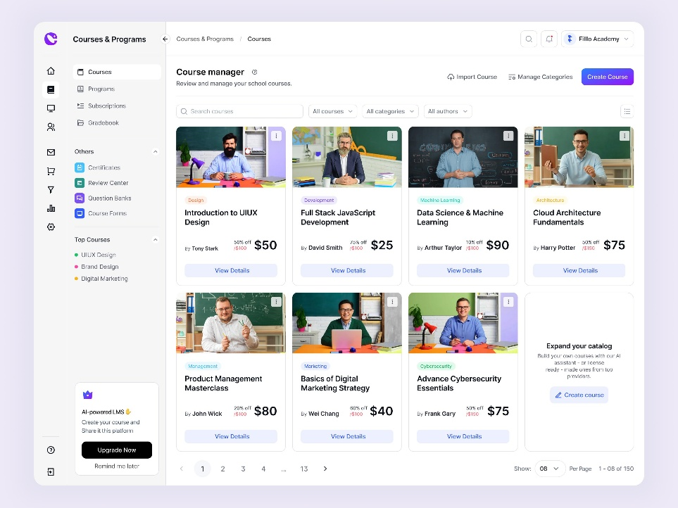
L.M.R.C. Bandara

ANTIGRAVITY DEVELOPMENT PROMPT – MEMBER 01
I am developing Module 1 of our university group project called "SkillNest – Open Course-ware and Technical Skill Development Platform".
My assigned module is Course & Learning Material Management.

Project Technologies
- Frontend: React.js, HTML5, CSS3, JavaScript
- Backend: Node.js and Express.js
- Database: MongoDB with Mongoose
- Authentication: JWT
- HTTP requests: Axios

Main Objective
Develop a complete course management system that allows approved instructors to create and manage courses, organize topics, upload learning materials, and allow learners to browse approved courses and access learning resources.

Frontend Requirements
- Create a Course Dashboard for instructors.
- Create a form to add new courses.
- Include course title, description, category, thumbnail, and learning objectives.
- Create course editing and deletion functionality.
- Create a course structure management interface.
- Allow instructors to add, edit, delete, and reorder topics.
- Create a learning material upload interface.
- Support PDF, document, video links, and external learning resources.
- Create a learner course browsing page.
- Create course details and topic viewing pages.
- Display course approval status: Draft, Pending, Approved, Rejected.
- Only display approved courses in the learner's public course catalogue.

Backend Requirements
Create:
- Course model
- Course structure/topic model
- Learning material model
Create REST API endpoints for:
- Create course
- Get instructor courses
- Get all approved courses
- Get course details
- Update course
- Delete course
- Add course topics
- Update topics
- Delete topics
- Upload learning materials
- Retrieve course materials
- Submit a course for administrator approval

Business Rules
- Only approved instructors can create courses.
- Instructors can manage only their own courses.
- New courses must initially be Draft or Pending.
- Courses must be approved by an administrator before learners can access them.
- Learners can only access approved courses and available learning materials.
- Protect all APIs using authentication and role-based authorization.

UI Design
Build a modern, professional educational platform.
Use a responsive dashboard, sidebar navigation, course cards, forms, status badges, and clean typography.
Use a consistent SkillNest design system throughout the application.

Important Integration Instructions
- First inspect the existing GitHub repository.
- Do not create a new separate project.
- Follow the existing folder structure and coding conventions.
- Integrate with the existing authentication system.
- Do not modify another member's module.
- Use reusable React components and Axios services.
- Use environment variables for configuration.
- Do not hardcode database credentials.
- Test all APIs and frontend functionality.

Expected Deliverables
A fully functional Course & Learning Material Management module integrated into the existing SkillNest MERN application.
At the end, explain:
- Files created or modified.
- Database models created.
- API endpoints created.
- How to run and test the module.
- Any remaining integration requirements.

Member 02 – Instructor & Course Approval Management
Member 02
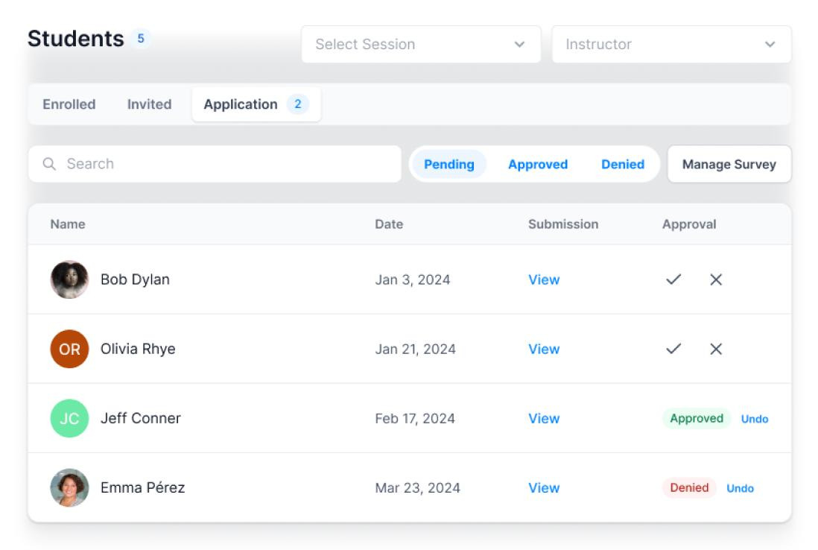
W.M.A.P.S. Abeyrathne

ANTIGRAVITY DEVELOPMENT PROMPT – MEMBER 02
I am developing Module 2 of the SkillNest university group project.
My assigned module is Instructor & Course Approval Management.

Project Technologies
Use the existing MERN stack:
- React.js
- Node.js
- Express.js
- MongoDB and Mongoose
- JWT authentication
- Axios

Main Objective
Develop an administrator approval system where administrators can review instructor applications and submitted courses, approve or reject them, and manage approval statuses.

Frontend Requirements
Create an Admin Dashboard containing:
- Dashboard overview with statistics.
- Total registered users.
- Pending instructor applications.
- Approved and rejected instructors.
- Pending course approvals.
- Approved and rejected courses.

Instructor Application Management
- Display all instructor applications.
- Show applicant information and application details.
- Allow administrators to view individual applications.
- Approve instructor applications.
- Reject instructor applications with remarks.
- Display application status and review date.

Course Approval Management
- Display courses submitted by instructors.
- View course details, topics, and learning materials.
- Approve submitted courses.
- Reject submitted courses with reasons.
- Display course approval status.

Backend Requirements
Create or integrate:
- InstructorApplication model
- ApprovalRecord model
Create REST API endpoints for:
- Submit instructor application.
- Retrieve all instructor applications.
- Retrieve individual applications.
- Approve instructor application.
- Reject instructor application.
- Retrieve pending courses.
- Approve submitted courses.
- Reject submitted courses.
- Retrieve approval history.
- Retrieve administrator dashboard statistics.

Business Rules
- Only administrators can approve or reject applications.
- Users must apply before receiving instructor access.
- Instructors must be approved before creating courses.
- Courses must be reviewed before publication.
- Approved courses become available to learners.
- Rejected courses must remain unavailable to learners.
- Record reviewer ID, remarks, review date, and status.
- Prevent unauthorized users from accessing administrative APIs.

UI Design
Create a professional administrative dashboard with:
- Sidebar navigation.
- Dashboard statistics cards.
- Application management tables.
- Course review pages.
- Approval and rejection dialogs.
- Search and filtering.
- Status indicators.
- Responsive layouts.

Integration Requirements
- Inspect the existing repository before coding.
- Integrate with the shared User and Course models.
- Coordinate the approval status fields with Member 01.
- Reuse the existing authentication and role-based authorization middleware.
- Do not create a separate authentication system.
- Avoid modifying unrelated modules.
- Implement proper validation and error handling.

Expected Deliverables
A functional administrator module for managing instructor applications and course approvals.
At the end, provide:
- Files created or modified.
- API endpoint documentation.
- Approval workflow explanation.
- Database model details.
- Testing instructions.
- Remaining integration requirements.

Member 03 – Code Playground
Member 03
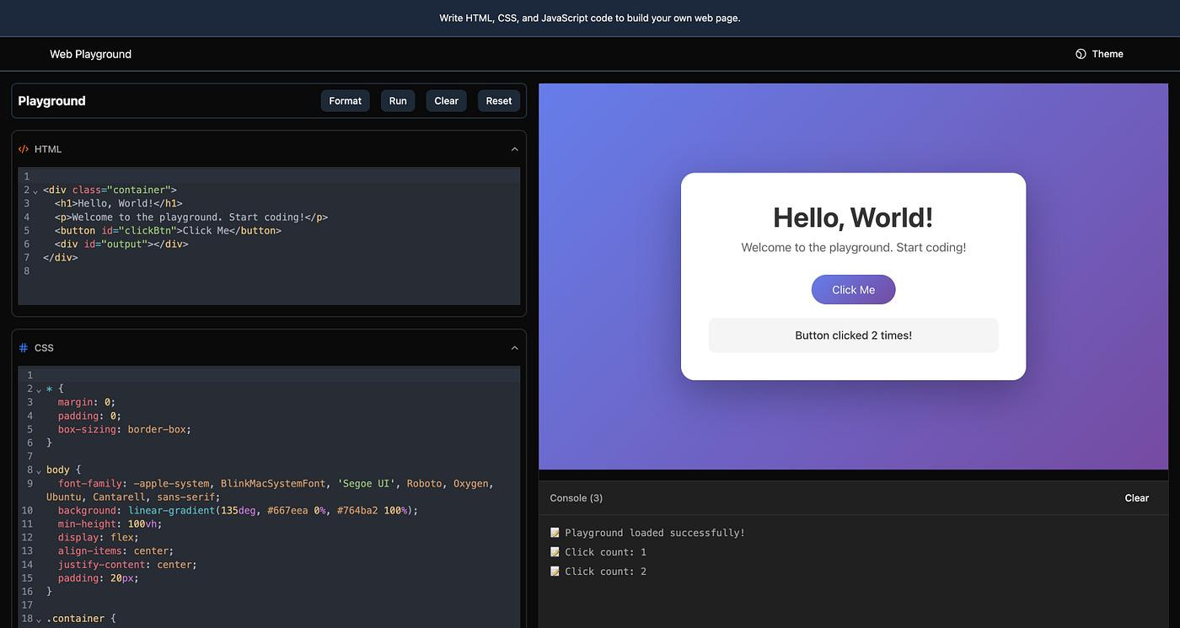
B.S.D.P. Wickramasingha

ANTIGRAVITY DEVELOPMENT PROMPT – MEMBER 03
I am developing Module 3 of the SkillNest university group project.
My assigned module is Code Playground.

Project Technologies
- React.js
- Node.js
- Express.js
- MongoDB
- Mongoose
- Axios
- JWT authentication

Main Objective
Create an interactive online programming environment where learners can select a programming language, write source code, execute programs, and view output or error messages.

Frontend Requirements
Create a professional Code Playground interface containing:
- Code editor.
- Programming language selection.
- Run Code button.
- Clear Code button.
- Reset Code button.
- Code input area.
- Program output panel.
- Error display panel.
- Execution status indicator.
- Execution history.
Support the following languages if the execution provider supports them:
- JavaScript
- Python
- Java
- C
- C++
Use a suitable editor component such as Monaco Editor or CodeMirror.

Backend Requirements
Create a CodeExecution model to store:
- User ID
- Programming language
- Source code
- Output
- Error message
- Execution status
- Execution date
Create API endpoints for:
- Execute source code.
- Retrieve execution history.
- Retrieve individual execution records.
- Delete execution history records if appropriate.

Code Execution Requirements
Integrate a suitable secure code execution service/API.
Important:
- Never execute arbitrary submitted code directly using Node.js child_process or the host server shell.
- Use an isolated execution service or sandbox.
- Apply execution timeouts and resource limits.
- Validate supported programming languages.
- Handle compilation errors and runtime errors.
- Return output and error messages to React.
- Never expose API secrets to the frontend.
If no execution service credentials are available, build the editor and backend integration structure with a clearly labelled demonstration mode. Do not pretend that simulated execution is real execution.

UI Design
Create a modern developer-style coding interface:
- Dark editor theme.
- Professional toolbar.
- Language dropdown.
- Syntax highlighting.
- Output console.
- Error messages.
- Responsive layout.

Business Rules
- Only authenticated learners can access the playground.
- Users should only access their own execution history.
- Validate code execution requests.
- Do not store sensitive execution credentials.
- Protect all APIs.

Integration Requirements
- Inspect the existing project.
- Use the shared frontend and backend.
- Reuse existing authentication middleware.
- Do not modify other members' modules.
- Follow the common API response structure.
- Use environment variables for execution service configuration.

Expected Deliverables
A working Code Playground integrated with SkillNest, including a code editor, execution interface, backend integration, and execution history.
Provide files changed, API endpoints, configuration requirements, and testing instructions.

Member 04 – Hackathon Challenge Management
Member 04
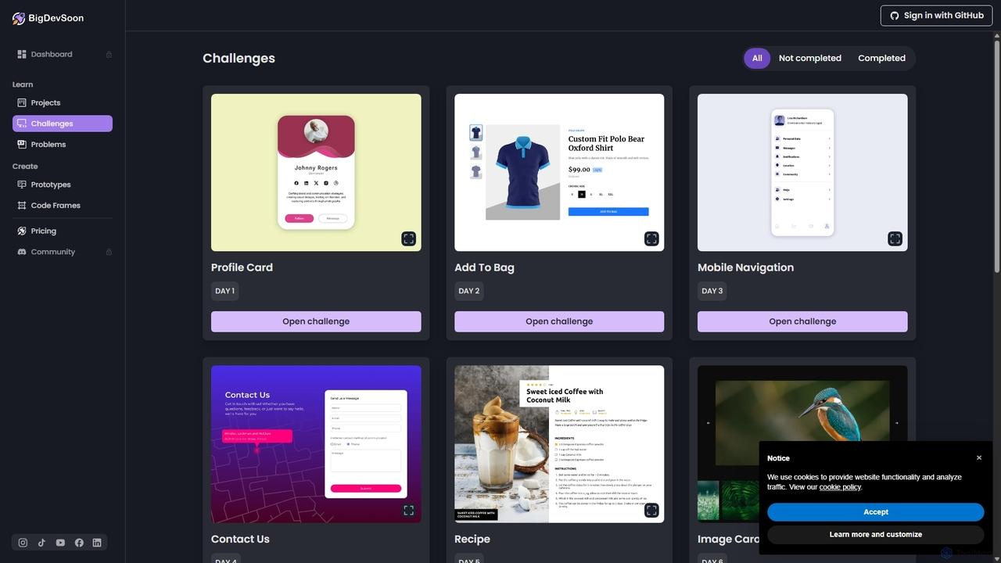
H.A.K. Madhushan

ANTIGRAVITY DEVELOPMENT PROMPT – MEMBER 04
I am developing Module 4 of the SkillNest university group project.
My assigned module is Hackathon Challenge Management.

Project Technologies
- React.js
- Node.js
- Express.js
- MongoDB
- Mongoose
- Axios
- JWT

Main Objective
Develop a programming challenge management system where instructors can create technical challenges and learners can participate by submitting their solutions.

Frontend Requirements

Instructor Interface
- Create new programming challenges.
- Edit existing challenges.
- Delete challenges.
- Set challenge title.
- Add detailed problem descriptions.
- Define input and output requirements.
- Add constraints.
- Set difficulty level: Easy, Medium, Hard.
- Set submission deadline.
- View learner submissions.

Learner Interface
- Browse available challenges.
- Search challenges.
- Filter by difficulty.
- View challenge details.
- View problem descriptions and constraints.
- Submit programming solutions.
- View submission history.
- Check submission status and results.

Backend Requirements
Create the following MongoDB models:

HackathonChallenge
- Title
- Description
- Constraints
- Difficulty
- Instructor ID
- Deadline
- Status
- Created date

ChallengeSubmission
- Challenge ID
- Learner ID
- Source code or uploaded solution
- Submission date
- Status
- Result or feedback
Create REST API endpoints for:
- Create challenge.
- Retrieve all active challenges.
- Retrieve challenge details.
- Update challenge.
- Delete challenge.
- Submit solution.
- Retrieve learner submissions.
- Retrieve challenge submissions for instructors.
- Update submission status or feedback.

Business Rules
- Only approved instructors can create challenges.
- Learners can participate in active challenges.
- Prevent submissions after deadlines.
- Only the relevant instructor or authorized administrator can manage challenge records.
- Learners can only view their own submission records.
- Validate all incoming data.
- Maintain challenge and submission statuses.

UI Design
Create a modern hackathon platform with:
- Challenge cards.
- Difficulty badges.
- Deadline countdown display.
- Challenge details page.
- Solution submission interface.
- Submission history.
- Instructor management dashboard.

Integration Requirements
- Work inside the existing SkillNest repository.
- Use shared authentication and role-based authorization.
- Follow the existing MongoDB and Express architecture.
- Do not create another standalone project.
- Do not modify unrelated modules.
- Make the design consistent with the rest of SkillNest.

Expected Deliverables
A complete Hackathon Challenge Management module integrated with the main application.
Provide database models, API endpoints, frontend pages, validation rules, and testing instructions.

Member 05 – Quiz & Assessment Management
Member 05
R.D.T.S. Karunarathna
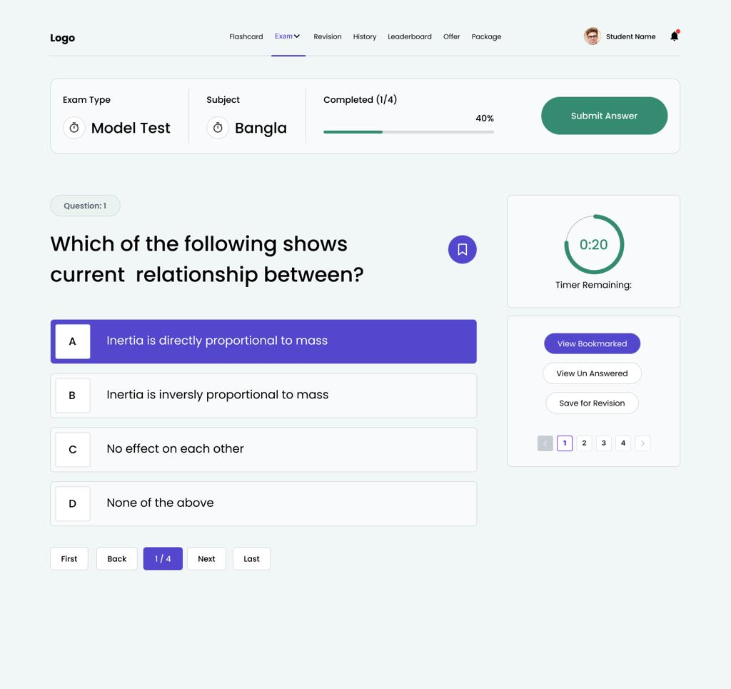

ANTIGRAVITY DEVELOPMENT PROMPT – MEMBER 05
I am developing Module 5 of the SkillNest university group project.
My assigned module is Quiz & Assessment Management.

Project Technologies
- React.js
- Node.js
- Express.js
- MongoDB
- Mongoose
- Axios
- JWT

Main Objective
Develop a quiz and assessment system where approved instructors can create quizzes and learners can attempt assessments, submit answers, and receive automatically calculated results.

Frontend Requirements

Instructor Interface
- Create quizzes.
- Edit quizzes.
- Delete quizzes.
- Add quiz titles and descriptions.
- Set quiz duration.
- Set quiz availability.
- Add multiple-choice questions.
- Add answer options.
- Select correct answers.
- Assign marks for each question.
- View learner attempts and results.

Learner Interface
- Browse available quizzes.
- View quiz information.
- Start a quiz.
- Display questions and answer options.
- Display countdown timer.
- Navigate between questions.
- Submit answers.
- Display calculated scores.
- View previous quiz results.

Backend Requirements
Create the following MongoDB models:

Quiz
- Title
- Description
- Course ID
- Instructor ID
- Duration
- Availability
- Status
- Created date

QuizQuestion
- Quiz ID
- Question
- Answer options
- Correct answer
- Marks

QuizAttempt
- Quiz ID
- Learner ID
- Submitted answers
- Score
- Total marks
- Start time
- Submission time
- Attempt status
Create API endpoints for:
- Create quiz.
- Update quiz.
- Delete quiz.
- Retrieve available quizzes.
- Retrieve quiz details.
- Add questions.
- Update questions.
- Delete questions.
- Start quiz attempt.
- Submit quiz answers.
- Calculate results.
- Retrieve learner results.
- Retrieve instructor quiz results.

Business Rules
- Only approved instructors can create and manage quizzes.
- Learners can attempt available quizzes.
- Automatically calculate marks based on correct answers.
- Validate submitted answers on the backend.
- Enforce quiz duration and availability.
- Prevent unauthorized access to correct answers before submission.
- Learners can only access their own attempts and results.
- Instructors can access results for their own quizzes.

UI Design
Create a modern educational assessment interface with:
- Quiz management dashboard.
- Quiz creation forms.
- Question builder.
- Multiple-choice question cards.
- Countdown timer.
- Quiz navigation.
- Result summary.
- Score and performance display.

Integration Requirements
- Inspect the existing SkillNest repository.
- Reuse the shared authentication system.
- Connect quizzes to the existing Course model.
- Follow the existing API conventions.
- Do not create a separate application.
- Do not modify unrelated modules.
- Use proper validation and error handling.

Expected Deliverables
A functional Quiz & Assessment Management module integrated with SkillNest.
Provide models, API documentation, frontend pages, automatic scoring logic, and testing instructions.

Member 06 – Forum & Q&A
Member 06
G.K.M.K.J. Kaushalya
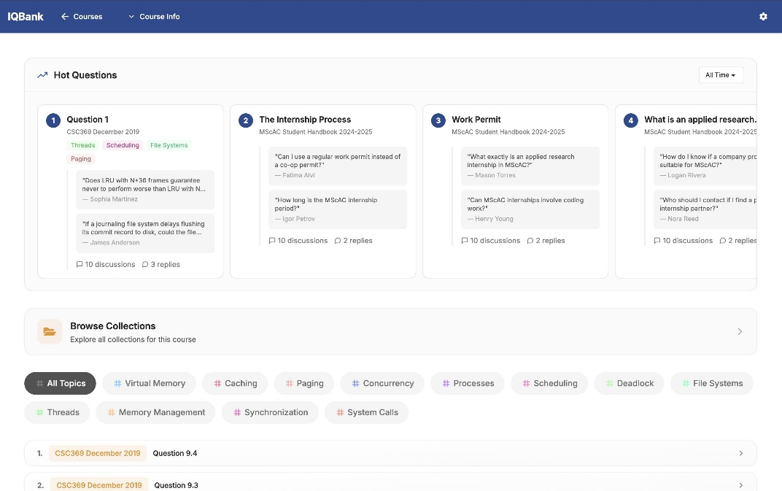

ANTIGRAVITY DEVELOPMENT PROMPT – MEMBER 06
I am developing Module 6 of the SkillNest university group project.
My assigned module is Forum & Q&A.

Project Technologies
- React.js
- Node.js
- Express.js
- MongoDB
- Mongoose
- Axios
- JWT

Main Objective
Develop a collaborative discussion platform where learners can ask academic questions, provide answers, reply to discussions, categorize questions, and filter discussions.

Frontend Requirements

Forum Dashboard
- Display all discussion questions.
- Display question titles and descriptions.
- Display question authors.
- Display categories.
- Display creation dates.
- Display answer counts.
- Search discussions.
- Filter discussions by category.
- Sort discussions by latest activity.

Question Management
- Create a new question.
- Edit own questions.
- Delete own questions.
- Select a category.
- View question details.

Answer Management
- Submit answers.
- Reply to answers.
- Edit own answers.
- Delete own answers.
- Display answers under relevant questions.

Discussion Categories
Create these categories:
- Programming
- Database
- Web Development
- Software Engineering
- Networking
- Algorithms

Moderation
- Allow administrators to moderate inappropriate content.
- Allow authorized moderators to hide unsuitable discussions.
- Display suitable content statuses.

Backend Requirements
Create the following MongoDB models:

ForumQuestion
- User ID
- Title
- Content
- Category
- Created date
- Updated date
- Status

ForumAnswer
- Question ID
- User ID
- Content
- Parent answer ID (optional, for replies)
- Created date
- Updated date
Create REST API endpoints for:
- Create question.
- Retrieve all questions.
- Retrieve question details.
- Update question.
- Delete question.
- Filter questions by category.
- Search questions.
- Submit answers.
- Retrieve question answers.
- Reply to answers.
- Edit answers.
- Delete answers.
- Moderate discussion content.

Business Rules
- Authenticated learners can create questions and answers.
- Users can edit or delete only their own content.
- Administrators can moderate discussions.
- Answers must be linked to the correct questions.
- Validate question titles and content.
- Prevent unauthorized operations.
- Implement appropriate discussion statuses.

UI Design
Create a modern academic community interface:
- Forum dashboard.
- Category sidebar.
- Search bar.
- Discussion cards.
- Question details page.
- Answer and reply section.
- Create-question form.
- Responsive design.

Integration Requirements
- Work inside the shared SkillNest repository.
- Reuse existing authentication and role-based authorization.
- Follow common backend conventions.
- Do not create a separate project.
- Do not modify other members' modules.
- Use reusable React components.
- Handle loading, errors, and empty states.

Expected Deliverables
A complete Forum & Q&A module integrated into SkillNest.
Provide database models, APIs, frontend pages, category filtering, discussion functionality, and testing instructions.

