# Technical solution description

## Mobile operator

Content

Technical solution description 1

Mobile operator 1

1 Task 3

2 Used technologies 4

3 Database schema 5

4 Architecture 6

4.1 Main application 6

4.2 Advertising stand 10

5 Tests and quality of code 11

6 Deployment 13

7 GUI 14

# Task

Main goal was to develop an application that models information system of mobile operator.

Application must provide following functionality:

* For clients:
  + View contracts;
  + View all tariffs, change tariff;
  + View all tariff options, add new options.
  + Block / unblock contract.
* For managers:
  + Create new contracts with unique numbers/change old contracts;
  + View all clients and their contracts;
  + Block / unblock contracts;
  + Find client by number;
  + Manage tariffs and options.

Second goal was to develop an application for advertising stand, showing tariffs from first application. Applications should communicate by MQ.

# Used technologies

|  |  |
| --- | --- |
| **Technology** | **Version** |
| AspectJ | 1.8.11 |
| FasterXML Jackson | 2.9.1 |
| H2 Database | 1.4.196 |
| Hibernate | 5.2.12 |
| IntelliJ IDEA | 2017.2.5 |
| Java | 8 |
| JSP | 2.2 |
| JUnit | 4.12 |
| Log4J | 1.2.17 |
| Maven | 3.5.0 |
| MySQL | 5.7 |
| Primefaces | 6.1 |
| SonarQube | 5.6.0 |
| Spring and Spring security | 5.1.0 |
| Wildfly | 14.0.1 |
| Jenkins | 2.150.1 |

# Database schema

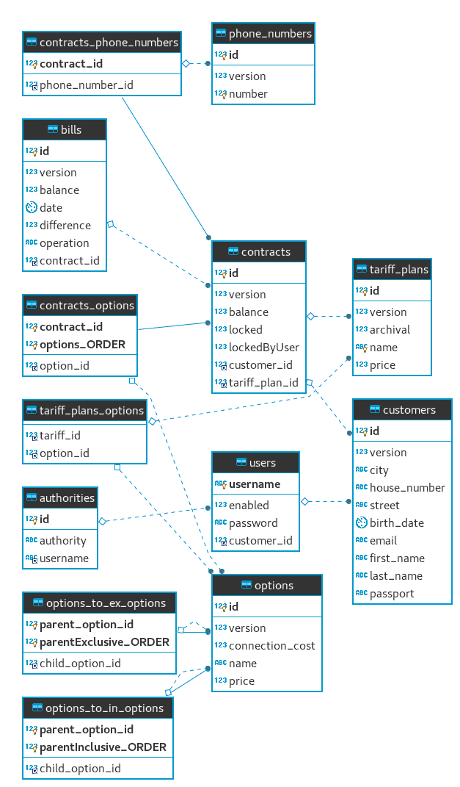

Picture 1 - database schema

# Architecture

## Main application

According to MVC, main application has next structure:

* Model level: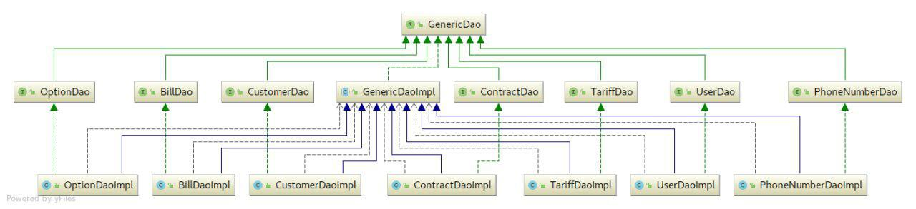

Picture 2 - model level diagram

* Controllers level: 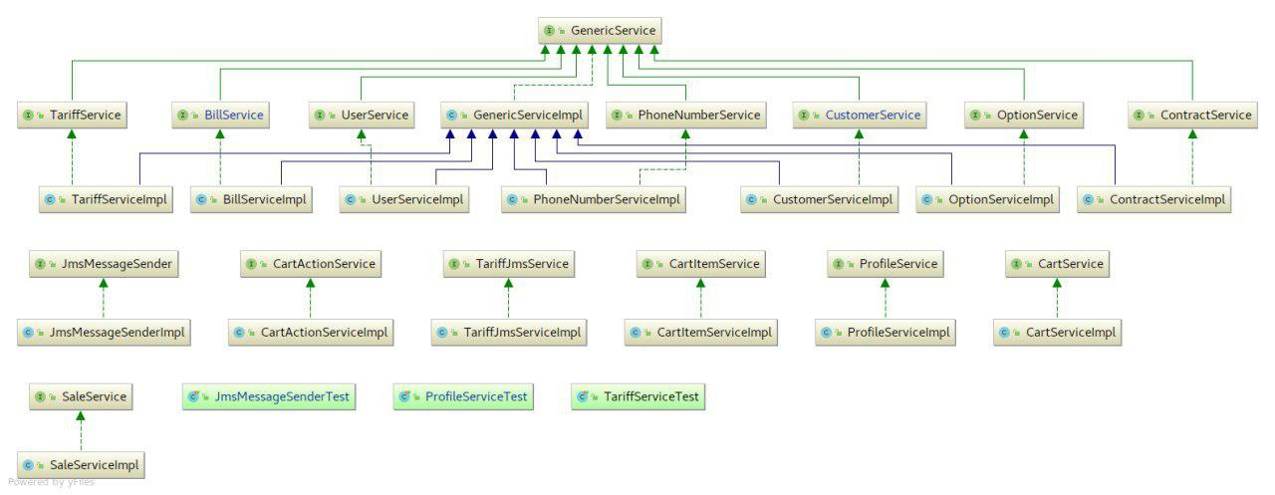

Picture 3 - controllers level diagram

* View level:

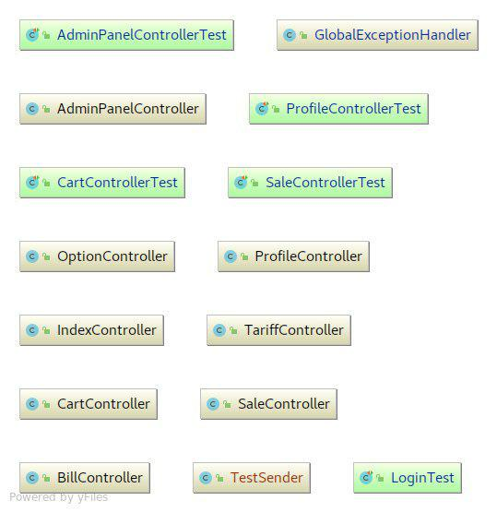

Picture 4 - server side view level

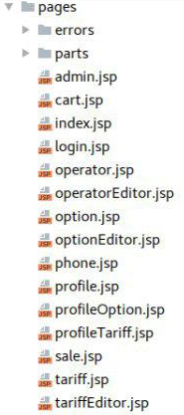

Picture 5 - client side view level

* Custom exceptions:

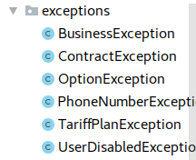

Picture 6 - custom exceptions list

* Utility classes:

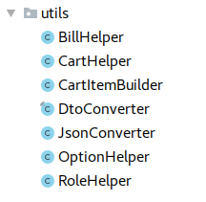

Picture 7 - utility classes

* For logging was used AOP.

## Advertising stand

Advertising stand has next structure:

* Views:

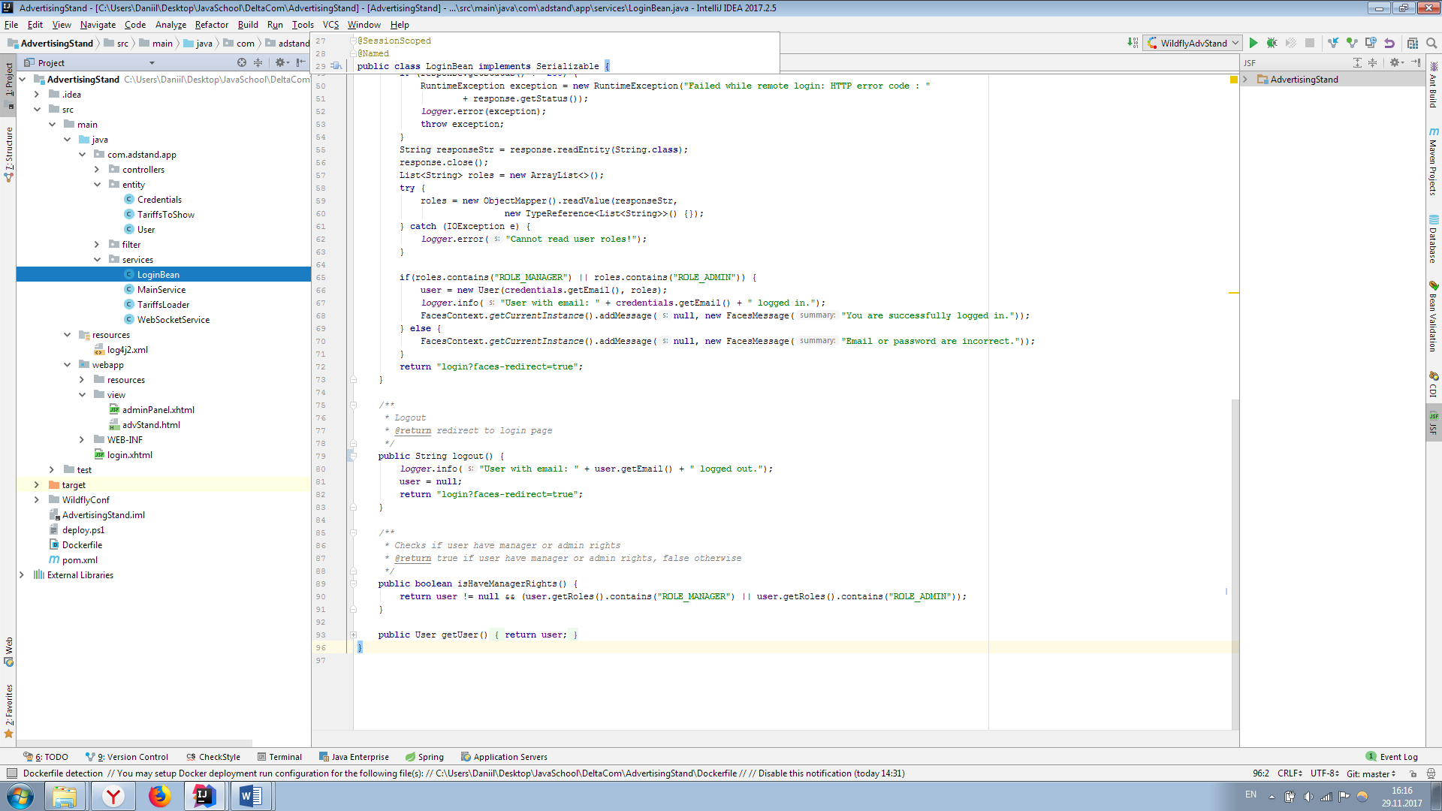

Picture 8 - advertising stand views

* Dtos:



Picture 9 - advertising stand entities

* Business logic:

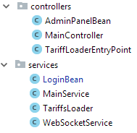

Picture 10 - advertising stand views

# Tests and quality of code

JUnit tests:

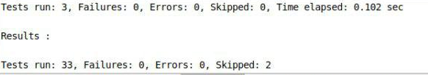

Picture 11 - JUnit tests result

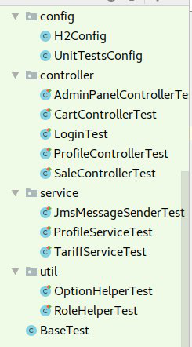

Picture 12 - Unit tests structure

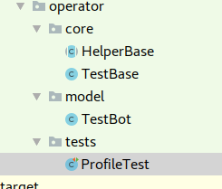

Picture 13 - UI tests structure

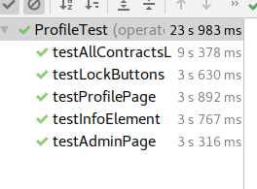

14 – UI tests results

# Deployment

Available deploy to wildfly via Jenkins.

Manual build and deploy with maven is also available:

1. In working directory enter in console: *mvn clean install*;
2. Then enter: *mvn wildfly:deploy*. (if wildfly is running)

# GUI

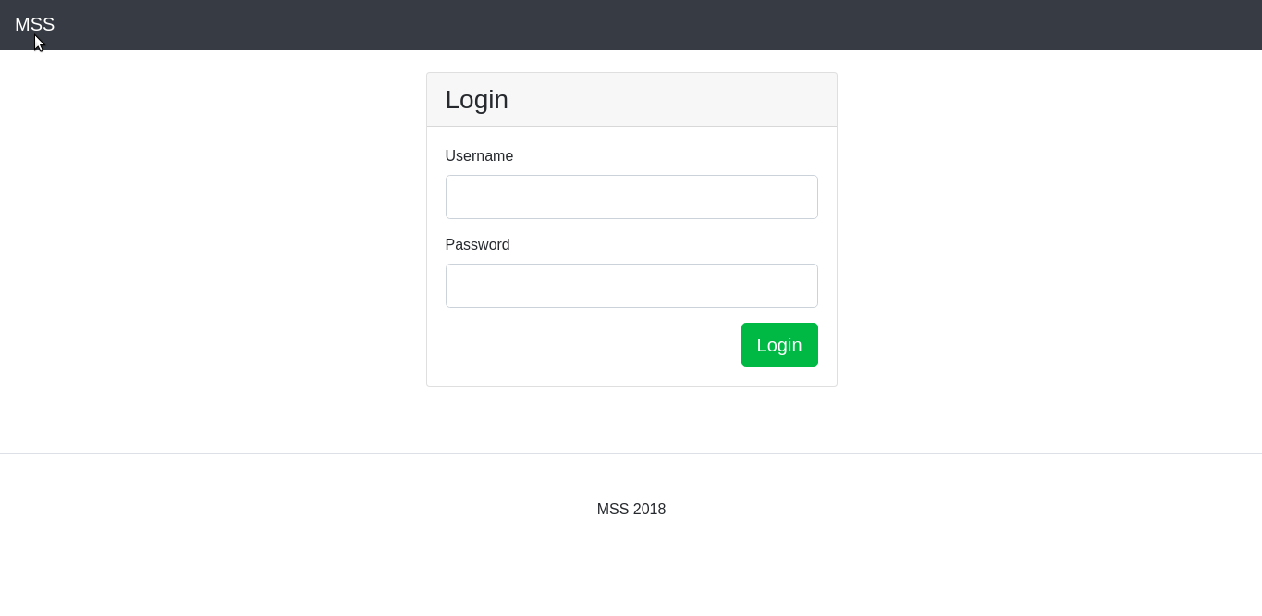

Picture 11 - login page

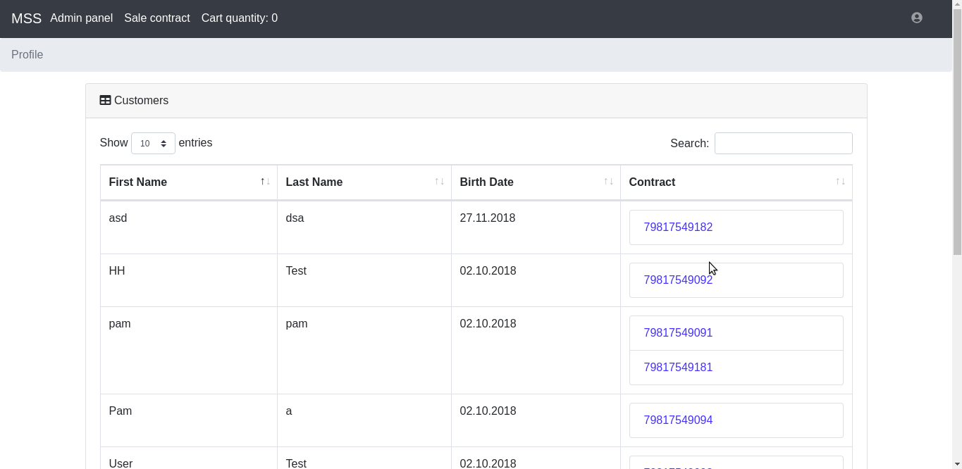

Picture 12 - managers index page

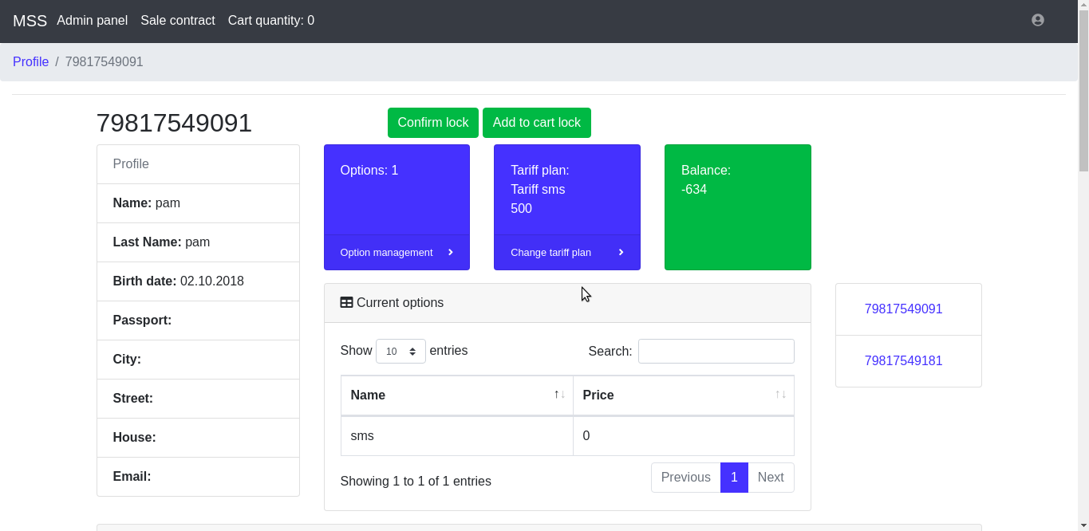

Picture 17 - clients index page