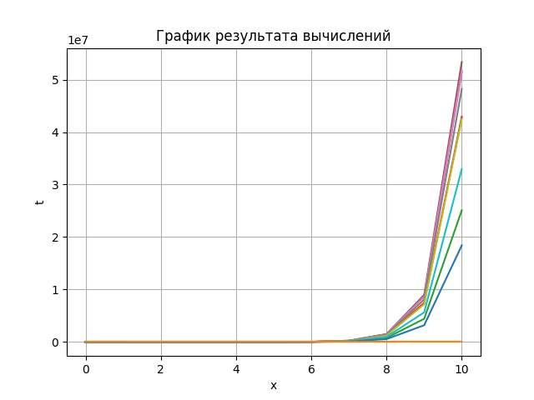

|  |  |  |
| --- | --- | --- |
| x | t | u_yav |
|  | 1.0 | 0.995 |
|  | 1.02 | 5.96 |
|  | 1.04 | 30.731 |
|  | 1.06 | 159.129 |
|  | 1.081 | 843.246 |
|  | 1.101 | 4561.19 |
|  | 1.122 | 25062.536 |
|  | 1.143 | 139351.717 |
|  | 1.163 | 781877.061 |
|  | 1.184 | 4418287.701 |
|  | 1.205 | 25110070.655 |