%%% Laboratory work # 11

%%% Noise statistics identification to construct tracking filter of a moving object

%%% Group 5: Andrei Chemikhin, Valery Nevzorov, Ruslan Agishev

% Part 1  
% trajectory generation  
close all;  
clear;  
N = 500000;  
T=1;  
v1=1;  
sigmaA=3;  
sigmaN=10;  
x1=5;  
q = 6;  
t=1:N;  
[x, z] = trajgen_acc(x1, sigmaN, sigmaA, N, T, v1, q);  
  
figure(1)  
plot(t,x, t,z)  
xlim([t(1), 10])  
ylim([x(1), 100])  
  
[sA,sN,qz] = getstat(z,T);

Based on measurements: $σ_{a}=2.9838, σ_{η}=9.9984, q=5.9966$

Real parameters: $σ_{a}= 3, σ_{η}=10, q=6$

% Part 2  
N = 200;  
[x, z] = trajgen_acc(x1, sigmaN, sigmaA, N, T, v1, q);  
% state space - form of equations  
[F,G,H] = state_space(T);  
% initial covariance matrix  
P0 = [1e10 0; 0 1e10];  
X0 = [2;0];  
R = sN^2;  
Q = G*G'*sA^2;  
  
[~,~,Xfl,Pfl,K] = kalman_filter_bias(X0,P0,F,Q,H,R,G,z,qz);  
p = nan(1,N);  
for i=1:(N-1)  
 p(i) = sqrt(Pfl{i}(1,1));  
end  
  
t=1:N;  
figure(2)  
plot(t,x, t,z,':', t,Xfl(1,:));  
xlim([t(1), 10])  
ylim([x(1), 100])  
legend('real', 'measurements', 'filtr')  
  
% final error  
% generation of M=500 realiztions of trajectories  
M=500;  
X = cell(1,M);  
Z = cell(1,M);  
for i=1:M  
 [X{i}, Z{i}] = trajgen_acc(x1, sigmaN, sigmaA, N, T, v1, q);  
end  
% Kalman-filtration of generated trajectories  
Xfl_ = cell(1,M);  
xfl = cell(1,M);  
Pfl = cell(1,M);  
for i=1:M  
 [~,~,Xfl_{i},~,~] = kalman_filter_bias(X0,P0,F,Q,H,R,G,Z{i},qz);  
 xfl{i} = Xfl_{i}(1,:);  
end  
  
fe = final_error(xfl, X);  
  
figure(3)  
plot(t,fe, t,p);  
legend('final error', 'standart deviation');  
ylabel('Final error')  
xlabel('Time step')  
ylim([5,20])  
title('Comparison of errors')  
grid on;

Estimated parameters of noise and bias are very close to real ones.

Real trajectory and measurements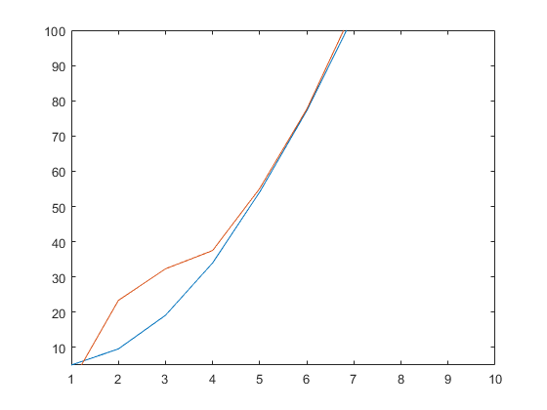

Real trajectory, measurements and filtered trajectory for short period of time

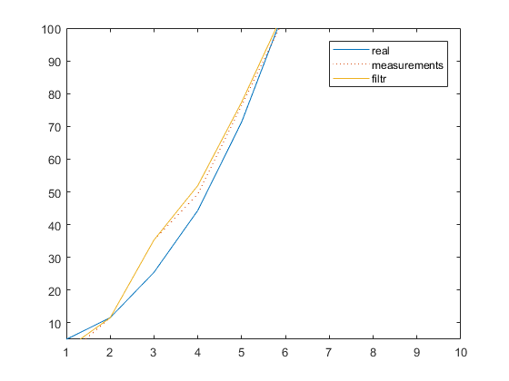

|  |  |  |  |  |  |
| --- | --- | --- | --- | --- | --- |
| estimated params | N=500 | N=5 000 | N=50 000 | N=500 000 | N = 5 000 000 |
| sA (real sA = 3) | 3.3061 | 3.8284 | 2.6721 | 2.9984 | 3.0309 |
| sN (real sN = 10) | 9.8811 | 9.9134 | 10.0541 | 9.9926 | 9.9995 |
| q (real q = 6) | 6.0149 | 6.0031 | 5.998 | 6.0037 | 5.9979 |

3) Applying filter to M=500 trajectories and comparison of true estimation error of coordinate 𝑥𝑖 with errors of estimation 𝑃𝑖.𝑖 provided by Kalman filter algorithm. 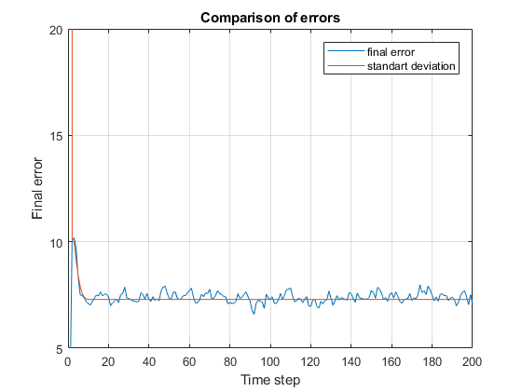

4) Changing the values of noise statistics and analyzing sensitivity of Kalman filter output to these changes.

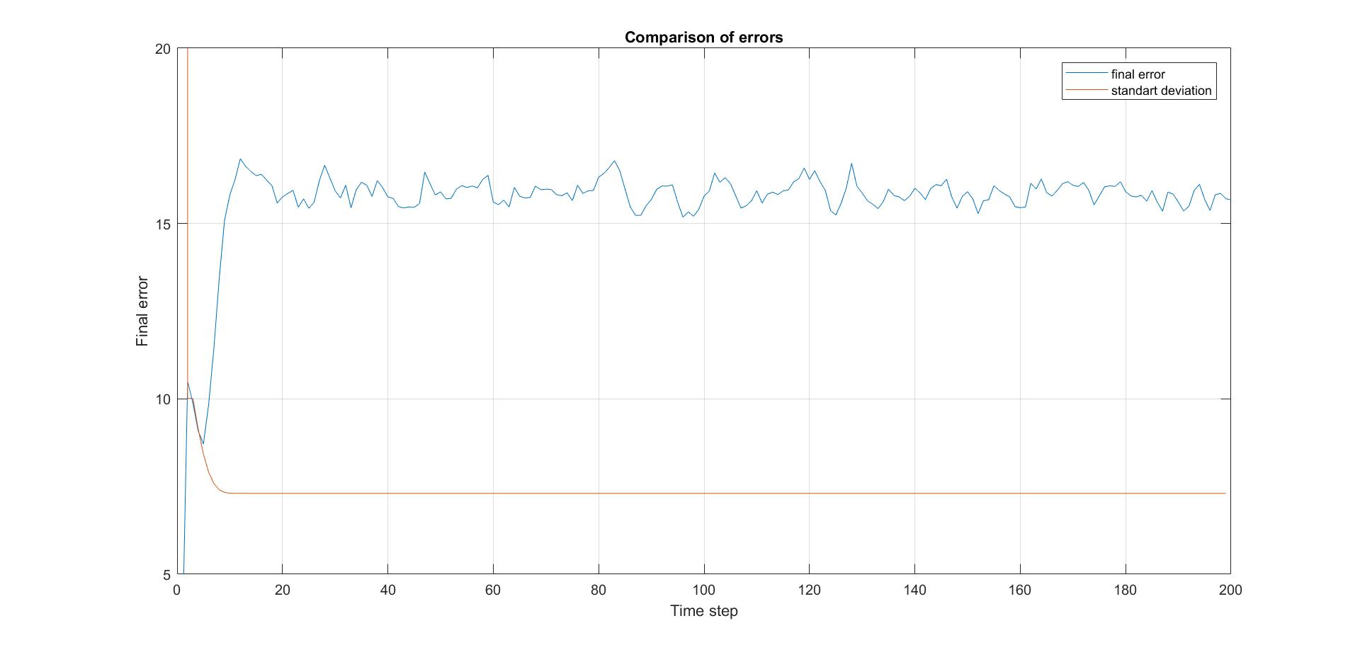

4a) q=0;

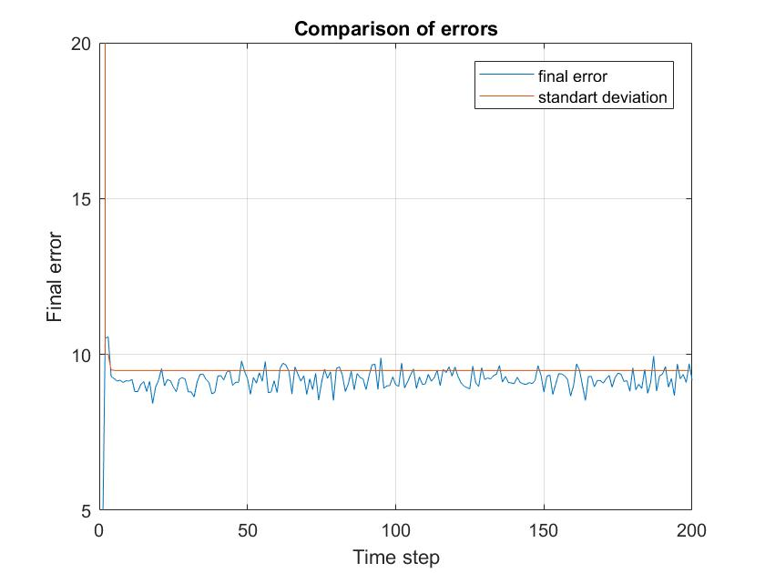

4b) $σ_{a}{=10σ_{a}}_{}$;

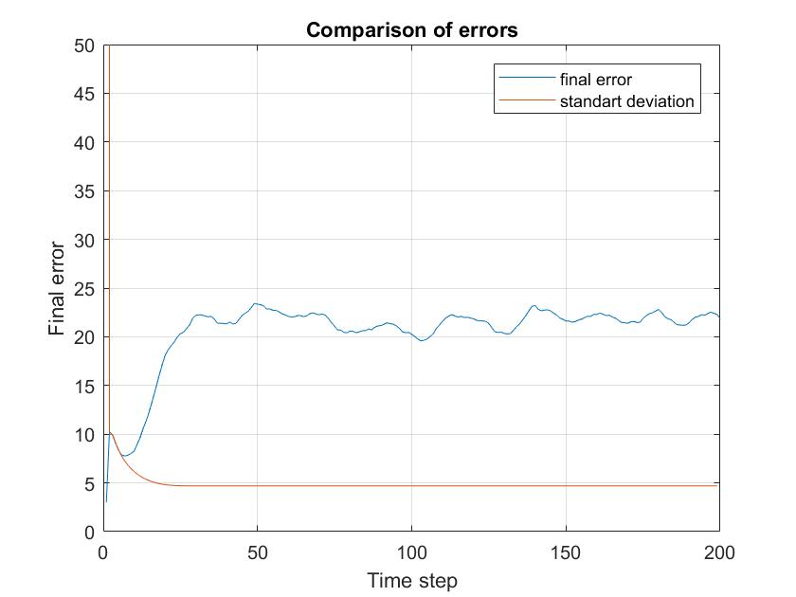

4c) $σ_{a}{=σ_{a}/10}_{}$;

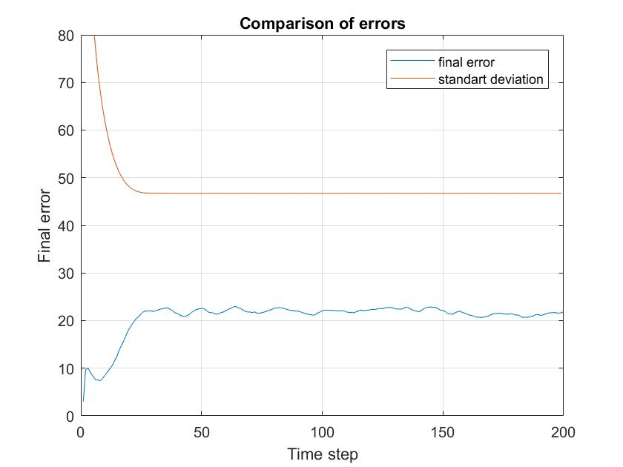

4d) $σ_{n}{={10σ}_{n}}_{}$;

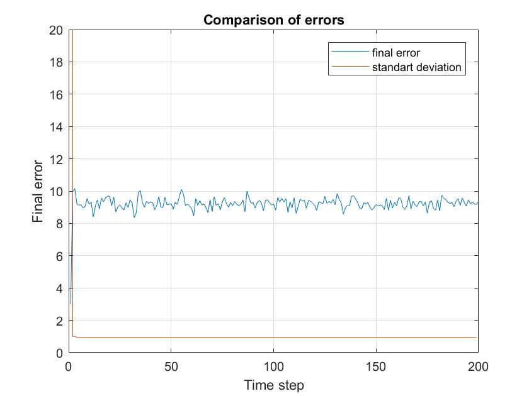

4e) $σ_{n}{=σ_{n}/10}_{}$

**Conclusion.** Sensitivity of filter is depend on accuracy of estimation of noise parameters.

Published with MATLAB® R2017b